

Project Title

DESIGN THINKING AND IDEA INNOVATION

PROJECT REPORT

Submitted by

ANUSHCA VIJIL | 312325105007

APARNA DHARUMAN 312325105009
fulfilment for the award of the degree of

BACHELOR OF ENGINEERING
IN

ELECTRICAL AND ELECTRONICS ENGINEERING
St. JOSEPH’S COLLEGE OF ENGINEERING

(An Autonomous Institution)
CHENNAI - 600 119

ANNA UNIVERSITY: CHENNAI - 600 025

OCT 2026

BONAFIDE CERTIFICATE

Certified that this Design thinking and Idea innovation project report “Wearable sensor for fall detection in elderly people ” is the bonafide work of “ANUSHCA VIJIL (312325105007) , APARNA DHARUMAN (312325105009)” who carried out the work under my supervision. Certified further, that to the best of my knowledge the work reported herein does not form part of any other project report or dissertation on the basis of which a degree or award was conferred on an earlier occasion on this or any other candidate.

SIGNATURE  Dr.JAYARAMA PRADEEP M.E.,Ph.D.  PROFESSOR  HEAD OF THE DEPARTMENT  Department of Electrical and  Electronics Engineering  St. Joseph’s College of Engineering  Old Mamallapuram Road  Chennai-600 119 | SIGNATURE  Ms. S. GOMATHI M.E., Ph.D,  ASSOCIATE PROFESSOR  SUPERVISOR  Department of Electrical and Electronics Engineering  St. Joseph’s College of Engineering  Old Mamallapuram Road  Chennai-600 119

CERTIFICATION OF EVALUATION

College Name: St. JOSEPH’S COLLEGE OF ENGINEERING
Branch : ELECTRICAL AND ELECTRONICS ENGINEERING
Semester : 03

S.No. | Name of the Student | Title of the project | Name of the supervisor  With Designation
1.  2. | ANUSHCA VIJIL  (312325105007)  APARNA DHARUMAN  (312325105009) | WEARABLE SENSOR FOR FALL DETECTION IN ELDERLY PEOPLE | Ms. S. GOMATHI M.E., (Ph.D)  Associate Professor  Department of Electrical and Electronics Engineering

The report of the Design thinking and Idea innovation project work submitted by the above students in the partial fulfilment for the award of Bachelor of Engineering degree in Electrical and Electronics Engineering of Anna University was evaluated and confirmed to be the work done by the above students.

Submitted for the project viva-voice held on: ______________

(INTERNAL EXAMINER) | (EXTERNAL EXAMINER)

ACKNOWLEDGEMENT

We take immense pride and pleasure in conveying our sincere and eternal gratitude to Chairman Dr. B. Babu Manoharan, M.A., M.B.A., Ph.D., Managing Director Mr. B. Shashi Sekar, M.Sc., and Executive Director Mrs. B. Jessie Priya, M.Com., and St. Joseph‘s College of Engineering, St. Joseph‘s Group of Institutions for providing an opportunity to study in their esteemed Institution.

We are extremely happy to express our sincere thanks and gratitude to Dr. Vaddi Seshagiri Rao, M.E., M.B.A., Ph.D., Principal, St. Joseph‘s College of Engineering for his encouragement throughout the course.

We also express our sincere thanks and most heartfelt sense of gratitude to Dr. Jayarama Pradeep, M.E., Ph.D., Professor, Head of the Department of Electrical and Electronics Engineering for her dedication, commendable support and encouragement for the completion of project work with perfection.

We are glad to express our cordial thanks to our Design thinking and Idea innovation Project coordinators Dr. P. Velmurugan M.E., Ph.D Associate Professor, Ms. S. Gomathi ME., (Ph.D)., Assistant Professor and Dr.Gopinath . Associate Professor for their valuable guidance and support in this work.

It is with a deep sense of gratitude that I acknowledge my indebtedness to our beloved supervisor Ms. S. Gomathi M.E., Ph.D Associate Professor, for his expert guidance and connoisseur suggestion.

Last but not the least, we thank our family members and friends who have been the greatest source of support to us.
ABSTRACT

Falls are a common and serious issue for elderly people. A sudden fall can cause injury, and it can turn dangerous fast when the person is alone and cannot get help right away. This project proposes a Wearable Sensor with AI for the Prevention of Falls in Elderly People. Its main goal is to track the user's movements all the time and spot unusual motion that could lead to a fall.

The system uses an MPU6050 accelerometer and gyroscope to detect changes in body movement, acceleration and orientation. The sensor connects to an ESP32 microcontroller, which gathers and processes the data. Everyday actions such as walking, sitting, standing and bending create different movement patterns. Some are subtle. By studying these patterns with Artificial Intelligence, the system can detect sudden or abnormal movement that may point to a possible fall.

When the system detects risky movement, it can give an immediate warning through a buzzer. That matters. The system can also be developed further to send alerts to family members or caregivers through the ESP32's wireless communication feature. This makes quick assistance possible when an elderly person is in danger.

Because the user can wear it, the system can track movement without disrupting normal daily activity. Wearable sensors, the ESP32 and AI make it useful for real-time monitoring and early detection of fall risk. This project aims to improve older adults' safety and give them more confidence and independence in daily life.

TABLE OF CONTENT

Chapter  No |  |  | Title | Page  No
 |  |  | ABSTRACT | 5
1 |  |  | INTRODUCTION | 8
 | 1.1 |  | Introduction | 8
2 |  |  | Literature Survey | 10
3 |  |  | Proposed System | 00
 | 3.1 |  | Block diagram | 11
 | 3.2 |  | Working Principle | 11
4 |  |  | Hardware Description | 00
 | 4.1 |  | Circuit Diagram | 13
 | 4.2 |  | Components Used | 13
 | 4.3 |  | Hardware Output | 18
5 |  |  | CONCLUSION | 23
6 |  |  | REFERENCE | 24

LIST OF FIGURES

Figure No | Title | Page No
3.1 | BLOCK DIAGRAM | 11
4.1 | CIRCUIT DIAGRAM | 13
4.2 | COMPONENTS USED | 13 - 17
4.3 | HARDWARE SETUP | 19

CHAPTER 1

1.1 INTRODUCTION

The world's elderly population is increasing rapidly due to advancements in healthcare, improved living conditions, and longer life expectancy. As people age, they become more vulnerable to various health problems, including reduced mobility, muscle weakness, balance disorders, and chronic diseases. One of the most serious concerns among older adults is the risk of falling. Falls are a major cause of injury, hospitalization, disability, and even death in elderly individuals. According to health organizations worldwide, millions of older adults experience falls each year, and many suffer fractures, head injuries, or other severe complications. In addition to physical harm, falls can also lead to psychological effects such as fear of falling, loss of confidence, and reduced independence.

Early detection and immediate response are crucial in minimizing the consequences of falls. However, elderly people often live alone or spend long periods without direct supervision, making it difficult for caregivers or family members to provide immediate assistance. Delayed medical attention after a fall can significantly increase the risk of serious health complications. Therefore, there is a growing need for reliable technologies that can continuously monitor elderly individuals and quickly alert caregivers when a fall occurs.

Wearable sensor technology has emerged as an effective solution to address this challenge. Wearable sensors are small electronic devices that can be attached to the body or integrated into accessories such as wristbands, smartwatches, belts, or clothing. These devices continuously monitor body movements and physiological signals in real time. By collecting and analyzing movement data, wearable sensors can identify unusual activities and detect falls with high accuracy. Their compact size, portability, and ease of use make them particularly suitable for elderly individuals who require continuous monitoring during their daily activities.

Most wearable fall detection systems use sensors such as accelerometers, gyroscopes, and magnetometers. An accelerometer measures changes in acceleration and movement, while a gyroscope measures angular velocity and body orientation. By combining data from these sensors, the system can distinguish between normal activities, such as walking, sitting, or lying down, and actual fall events. Advanced algorithms and machine learning techniques can further improve detection accuracy by analyzing movement patterns and reducing false alarms.

The Internet of Things (IoT) has further enhanced the capabilities of wearable fall detection systems. Modern wearable devices can communicate wirelessly with smartphones, cloud servers, and healthcare monitoring platforms. When a fall is detected, the device can automatically send an alert message containing the user's location and health information to caregivers, family members, or emergency services. This rapid communication helps ensure timely assistance and can significantly reduce the severity of injuries caused by prolonged periods without help.

Wearable fall detection systems offer several advantages over traditional monitoring methods. They provide continuous real-time monitoring, require minimal user intervention, and support independent living for elderly individuals. These systems can also reduce healthcare costs by preventing complications associated with delayed treatment. Furthermore, wearable devices are becoming increasingly affordable, energy-efficient, and user-friendly, making them accessible to a larger population.

CHAPTER 2
2.1 Literature Survey

Wearable fall-detection systems commonly use inertial sensors such as accelerometers and gyroscopes to monitor body movement continuously. Sensors such as the MPU6050 can measure acceleration and angular motion, allowing sudden changes in movement, body orientation, and impact patterns to be identified. Compared with camera-based systems, wearable sensors provide greater mobility and privacy because they can operate independently of fixed infrastructure. These systems are therefore suitable for elderly people who require continuous monitoring during daily activities. Recent studies have explored machine-learning and artificial-intelligence techniques to improve the accuracy of fall detection. Traditional threshold-based systems mainly identify a fall after a sudden change in acceleration or orientation, which can sometimes result in false alarms during activities such as sitting quickly or climbing stairs. AI-based approaches can analyze movement patterns and distinguish between normal activities and potentially dangerous movements. Based on this concept, the proposed project combines an MPU6050 sensor with an ESP32 to monitor movement and uses an AI-oriented approach for early fall prediction, immediate alert generation, and reduction of false alarms.

CHAPTER -3
3.1 PROPOSED SYSTEM

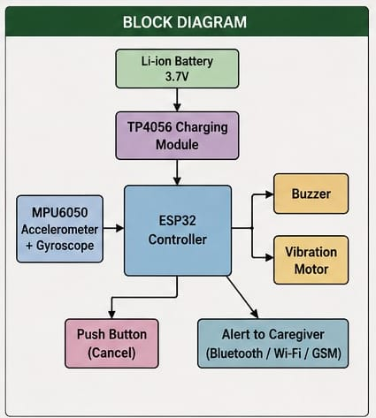

WORKIG PRINCIPLE
The wearable fall detection system operates by continuously monitoring body movement using motion sensors. The primary sensors used in this project are the accelerometer and gyroscope. The accelerometer measures acceleration along different axes, while the gyroscope measures angular velocity and orientation changes. These sensors provide real-time data about the user's movement and posture.

The sensor data is transmitted to a microcontroller such as Arduino or ESP32. The microcontroller processes the incoming information and compares it with predefined threshold values. During normal activities such as walking, standing, sitting, or lying down, the acceleration and orientation values remain within expected limits. However, when a fall occurs, a sudden change in acceleration is detected, followed by a significant change in body position.

The microcontroller continuously analyzes the sensor readings. If the acceleration exceeds the threshold value and the body orientation changes abruptly, the system identifies the event as a possible fall. To avoid false alarms, the system may verify the condition for a short period before confirming the fall. Once the fall is confirmed, the controller activates a buzzer to generate a local alarm.

Simultaneously, a communication module such as GSM, Bluetooth, or Wi-Fi sends an alert message to caregivers, family members, or emergency contacts. Some advanced systems also provide location information using GPS modules. The alert ensures that assistance can be provided quickly.

The entire process occurs automatically without requiring user intervention. The system remains active throughout the day and continuously monitors body movement. This real-time operation enables rapid emergency response and improves the safety of elderly individuals. By combining sensor technology, data processing, and wireless communication, the wearable fall detection system provides a reliable healthcare monitoring solution.

CHAPTER -4
4.1 CIRCUIT DIAGRAM
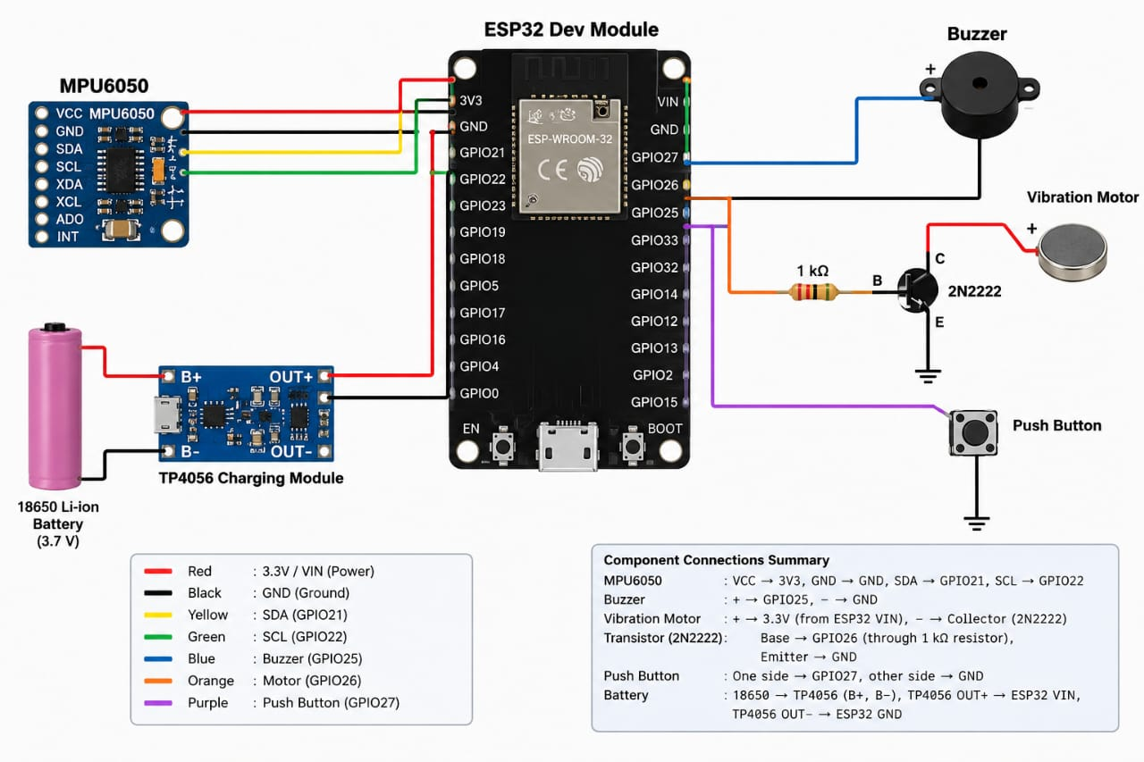

4.2 COMPONENTS USED
1. ESP32 Dev Module – main controller and data-processing unit.

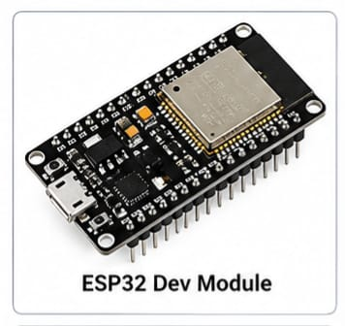

2. MPU6050 – 3-axis accelerometer and 3-axis gyroscope for motion sensing.
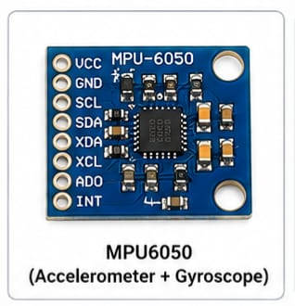
3. Buzzer – audible emergency alert.
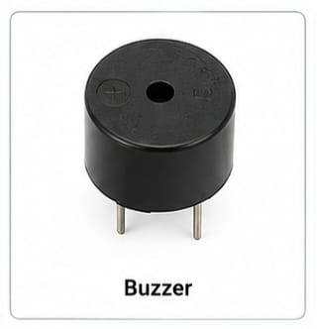
4. Vibration motor – silent/local tactile alert.
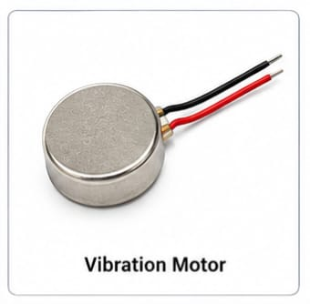

5. 2N2222 transistor – drives the vibration motor from the ESP32 output.
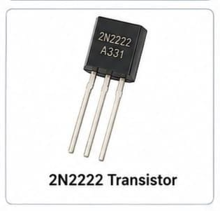
6. 1 kΩ resistor – transistor base-current limiting resistor.
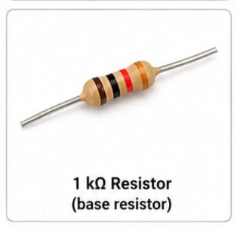
7. Push button – alarm cancellation/acknowledgement input.
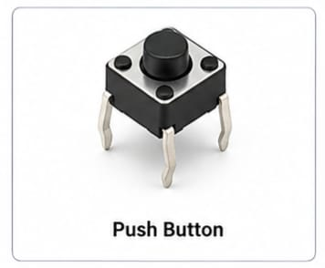
8. TP4056 charging module – charging and protection interface for the Li-ion battery.

9. 18650 Li-ion battery – portable power source (3.7V).

10. Power switch – turns the wearable system ON/OFF.
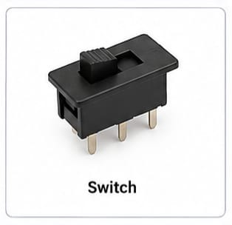

11. Diode – prevents voltage spikes (1N40077)
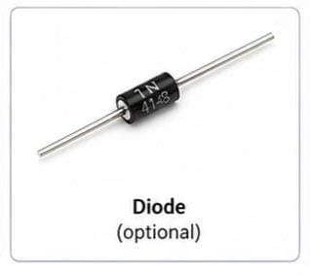

12. Jumper wire – connection between components
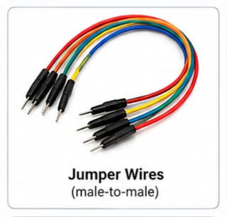

13. Bread board – assemble circuit
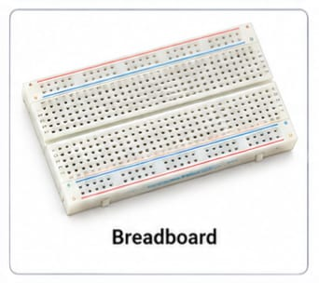

4.3 HARDWARE IMPLEMENTATION AND OUTPUT

The hardware implementation of the wearable fall detection system involves assembling all electronic components into a functional prototype. The MPU6050 sensor is connected to the microcontroller through the I2C communication interface. The sensor continuously measures acceleration and orientation changes during user movement.

The communication module is connected using serial communication pins. Depending on the project requirements, GSM, Bluetooth, or Wi-Fi technology may be used. A buzzer is connected to a digital output pin to provide audible alerts whenever a fall is detected.

A rechargeable battery powers the entire system. A voltage regulator is included to provide stable power to the microcontroller and sensors. All components are mounted on a compact circuit board and enclosed within a lightweight protective case.
The microcontroller is programmed using embedded software that continuously reads sensor values. The software analyzes acceleration and orientation data to identify abnormal motion patterns. Threshold values are defined to distinguish falls from normal activities.

Testing is performed by simulating various movements such as walking, sitting, standing, climbing stairs, and intentional falls. Sensor data is collected and analyzed to verify system accuracy. Calibration is performed to optimize threshold values and minimize false alarms.

The completed hardware system is portable, lightweight, and suitable for daily use. It can be attached to a wristband, belt, or clothing. Continuous monitoring ensures real-time detection of falls and immediate notification of caregivers. The hardware implementation demonstrates the practical application of wearable sensor technology in healthcare monitoring and elderly safety systems.

The wearable fall detection system produces outputs based on sensor measurements and movement analysis. During normal activities such as walking, standing, sitting, and lying down, the sensor values remain within predefined limits. In these situations, the system continues monitoring without generating alerts.

When a fall occurs, the accelerometer detects a sudden change in acceleration, and the gyroscope identifies a significant change in body orientation. These abnormal readings are processed by the microcontroller. If the values exceed the predefined threshold, the system confirms the fall event.

After detection, the buzzer is activated immediately to provide a local warning signal. At the same time, the communication module transmits an alert message to caregivers or emergency contacts. The message may contain information about the detected fall and the user's condition.

The wearable fall detection system produces outputs based on sensor measurements and movement analysis. During normal activities such as walking, standing, sitting, and lying down, the sensor values remain within predefined limits. In these situations, the system continues monitoring without generating alerts.

When a fall occurs, the accelerometer detects a sudden change in acceleration, and the gyroscope identifies a significant change in body orientation. These abnormal readings are processed by the microcontroller. If the values exceed the predefined threshold, the system confirms the fall event.

After detection, the buzzer is activated immediately to provide a local warning signal. At the same time, the communication module transmits an alert message to caregivers or emergency contacts. The message may contain information about the detected fall and the user's condition.

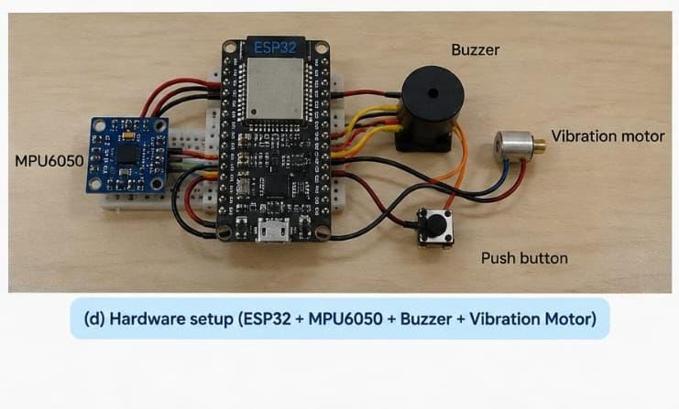

PROGRAM :

#include <Wire.h>
#include <MPU6050.h>
MPU6050 mpu;

// Pin connections
const int buzzerPin = 25;
const int vibrationPin = 26;
const int buttonPin = 27;

// Fall detection threshold
const float FALL_THRESHOLD = 2.5;

// Variables
int16_t ax, ay, az;
float acceleration;

void setup() {
Serial.begin(115200);

// I2C connection
Wire.begin(21, 22);

// Output pins
pinMode(buzzerPin, OUTPUT);
pinMode(vibrationPin, OUTPUT);

// Push button
pinMode(buttonPin, INPUT_PULLUP);

// Initially OFF
digitalWrite(buzzerPin, LOW);
digitalWrite(vibrationPin, LOW);

// Start MPU6050
Serial.println("Starting MPU6050...");
mpu.initialize();

if (mpu.testConnection()) {
Serial.println("MPU6050 connected successfully!");
} else {
Serial.println("MPU6050 connection failed!");
}
}

void loop() {

// Read accelerometer values
mpu.getAcceleration(&ax, &ay, &az);

// Convert raw values into g
float Ax = ax / 16384.0;
float Ay = ay / 16384.0;
float Az = az / 16384.0;

// Calculate total acceleration
acceleration = sqrt(
(Ax * Ax) +
(Ay * Ay) +
(Az * Az)
);

// Display acceleration
Serial.print("Acceleration: ");
Serial.print(acceleration);
Serial.println(" g");

// Fall detection
if (acceleration > FALL_THRESHOLD) {

Serial.println("!!! FALL DETECTED !!!");

// Turn ON buzzer and vibration motor
digitalWrite(buzzerPin, HIGH);
digitalWrite(vibrationPin, HIGH);

// Alarm for 10 seconds
unsigned long startTime = millis();

while (millis() - startTime < 10000) {

// Push button cancels alarm
if (digitalRead(buttonPin) == LOW) {
Serial.println("Alert cancelled by user.");

digitalWrite(buzzerPin, LOW);
digitalWrite(vibrationPin, LOW);

delay(500);
return;
}

delay(50);
}

// Turn OFF alarm
digitalWrite(buzzerPin, LOW);
digitalWrite(vibrationPin, LOW);

Serial.println("Alarm stopped.");
}
delay(100);
}

CHAPTER 5

5.1 CONCLUSION
This project presents a wearable sensor with AI-oriented fall detection for elderly people using an ESP32 and MPU6050. The system continuously monitors acceleration and angular velocity to identify sudden and abnormal body movements. Local buzzer and vibration alerts provide immediate feedback when a possible fall is detected, while a push button allows the user to acknowledge the alarm. The proposed wearable is compact, portable, and suitable for low-cost implementation. The addition of AI-based motion classification can help distinguish falls from normal activities and can support early identification of unstable movement before a fall. Future improvements can include wireless caregiver alerts, GPS location sharing, larger datasets for AI training, personalized gait analysis, and integration with health-monitoring sensors.

REFERENCE

No. | Reference / Paper | Year | Content Taken From the Paper

1 | A Systematic Review of Wearable Sensor-Based Technologies for Fall Risk Assessment in Older Adults, Sensors | 2022 | Literature survey on wearable sensor technologies, accelerometers, gyroscopes, and methods used for assessing fall risk in older adults.

2 | Fall Detection Systems for Internet of Medical Things Based on Wearable Sensors: A Review, IEEE Internet of Things Journal | 2024 | Fall-detection techniques, wearable sensor applications, IoT-based monitoring systems, and communication methods for elderly care.

3 | Investigating the Performance of Wearable Motion Sensors on Recognizing Falls and Daily Activities via Machine Learning, Digital Signal Processing | 2022 | Use of accelerometer and gyroscope data, feature extraction, and machine learning methods for distinguishing falls from normal daily activities.

4 | AI Based Elderly Fall Prediction System Using Wearable Sensors: A Smart Home-Care Technology with IoT, Measurement: Sensors | 2023 | AI/ML-based fall prediction approaches, IoT-enabled smart healthcare systems, and wearable sensor integration for elderly monitoring.

5 | Wearable Sensor-Based Fall Detection for Elderly Care Using Ensemble Machine Learning Techniques, Measurement: Sensors | 2025 | Ensemble machine learning techniques for fall detection, performance analysis, accuracy improvement methods, and future enhancement possibilities.

