UNIVERSITY INSTITUTE OF COMPUTING

PROJECT REPORT
ON
E-COMMERCE SALES DASHBOARD
Program Name: BCA
DATA ANALYTICS
24CAT-293

SUBMITED BY:

Name : Anushka Panwar UID : 24bcd10144
Branch : BCA- datascience Section/ Group: BCD-2A
Semester : 4th D.O.SUBMITION : 13-04-2026

SUBMITED TO:

Name : Mr. Rajat Kapoor DO.SUBMITION : 13-04-2026

Desigination: Assistant Professor Sign:

BONAFIDE CERTIFICATE

Certified that this project report “E-Commerce Sales Dashboard ” is the Bonafide work of ”Anushka Panwar” under UID “24BCD10144” who carried out the project work under my supervision.

………………………………………
SIGNATURE
UIC DEPARTMENT
ASSISTANT PROFESSOR
RAJAT KAPOOR

E-COMMERCE SALES DASHBOARD
1. Abstract
In today’s competitive business environment, organizations rely heavily on data to make strategic decisions. Raw transactional data, especially from E-commerce platforms, is vast and unstructured, making manual analysis inefficient and error-prone. This project focuses on analyzing E-commerce sales data using Power BI to generate meaningful insights through interactive dashboards.The dashboard highlights key performance indicators (KPIs) such as revenue, profit, profit margin, total orders, and average order value using DAX (Data Analysis Expressions) measures. The project demonstrates the complete analytics workflow: from importing raw CSV data, preprocessing, data modeling, and visualization to generating actionable business insights. The final output is an interactive dashboard that allows stakeholders to filter by time, category, or product to understand sales trends and profitability drivers.
2. Introduction
E-commerce platforms generate large volumes of transactional data daily, including order details, customer information, product categories, and financial metrics. Analyzing this data manually is difficult, time-consuming, and prone to oversight. Without proper tools, businesses struggle to identify trends, track performance, or respond quickly to market changes.
Therefore, tools like Power BI are used to simplify data analysis and visualization. Power BI enables end-to-end business intelligence by connecting to multiple data sources, transforming raw data, creating relationships, and building dynamic dashboards. This project aims to design a dashboard that presents sales performance in a clear and interactive manner, helping stakeholders at various levels—managers, analysts, and executives—understand trends, monitor KPIs, and make better, data-driven decisions.
3. Aim of the Project
The primary aim of this project is:
To design and develop an interactive E-commerce Sales Dashboard using Power BI that analyzes sales data and provides meaningful insights for better business decision-making.
Specific Aims:
- To analyze sales, revenue, and profit data across different product categories and time periods.
- To calculate key performance indicators (KPIs) using DAX measures.
- To visualize business performance using intuitive charts, cards, and dashboards.
- To identify trends and patterns in sales data (seasonality, top performers, etc.).
- To enhance decision-making through data analytics by making insights accessible and interactive.

4. Objectives of the Project
The following objectives were set to achieve the above aims:
- To import and preprocess sales data (cleaning, type conversion, handling missing values).
- To build relationships between datasets (Sales table and Date table) for time intelligence.
- To create DAX measures for KPI calculations (Revenue, Profit, Margin %, Orders, AOV).
- To design an interactive dashboard with filters, cards, and charts.
- To interpret data insights and derive business recommendations.
5. Problem Statement
Businesses, especially in E-commerce, face several analytical challenges:
- Difficulty in analyzing large datasets – Millions of rows make Excel impractical.
- Lack of visualization tools – Raw numbers do not reveal trends or outliers.
- Inability to track real-time performance – Static reports become outdated quickly.
- Poor decision-making due to unstructured data – Without dashboards, decisions are based on guesses rather than evidence.
This project solves these problems by providing a structured, visual, and interactive analytics solution using Power BI. It transforms raw sales data into a central dashboard that answers key business questions at a glance.
6. Scope of the Project
The scope is defined as follows:
- Sales performance analysis – Total revenue, profit, margin, orders.
- Revenue and profit tracking – Over time and across categories.
- Time-based trend analysis – Daily, monthly, quarterly patterns.
- Category-wise comparison – Which product categories drive the most profit?
- Geographical analysis – (If data available) – Not included in current scope but noted for future.
The project does not include customer segmentation, inventory analysis, or predictive modeling.

7. Tools and Technologies Used
Tool/Technology | Purpose
Power BI Desktop | Data visualization, dashboard creation
DAX (Data Analysis Expressions) | Calculated columns & measures for KPIs
CSV Datasets | Source data (Sales & Date tables)
Data Modeling Techniques | Star schema design for optimized performance
Power Query Editor | Data cleaning & transformation
8. Dataset Description
8.1 Sales Dataset
This is the fact table containing transactional data.
Column Name | Description
Order ID | Unique identifier for each order
Product Name | Name of the product sold
Category | Product category (e.g., Electronics, Clothing)
Revenue | Total sales amount for the order
Profit | Profit earned from the order
Order Date | Date of transaction

8.2 Date Dataset
This is a dimension table used for time-based analysis.
Column Name | Description
Date | Individual date (continuous range)
Month | Month name/number
Year | Calendar year
Quarter | Quarter of the year (Q1, Q2, etc.)
Usage: The Date table is linked to the Order Date in the Sales table, enabling time intelligence functions (YTD, MTD, period-over-period comparisons).

9. System Architecture
The architecture follows a standard ETL (Extract, Transform, Load) pipeline for BI:
text
CSV Files → Data Cleaning → Data Modeling → DAX Measures → Dashboard → Insights
Detailed steps:
- Extract: Load Sales.csv and Date.csv into Power BI.
- Transform (Power Query): Remove duplicates, handle nulls, change data types.
- Load: Load cleaned tables into Power BI data model.
- Model: Create star schema relationship (Sales.Order Date → Date.Date).
- Calculate: Write DAX measures for KPIs.
- Visualize: Build dashboard with cards, charts, slicers.
- Publish (optional): Share to Power BI Service.

10. Data Flow Diagram (DFD)
Level 0 (Context Diagram):
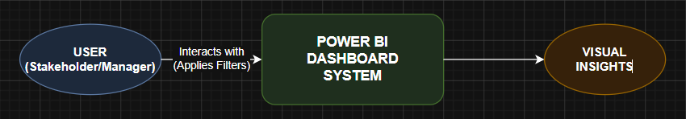
Level 1 (Detailed DFD):
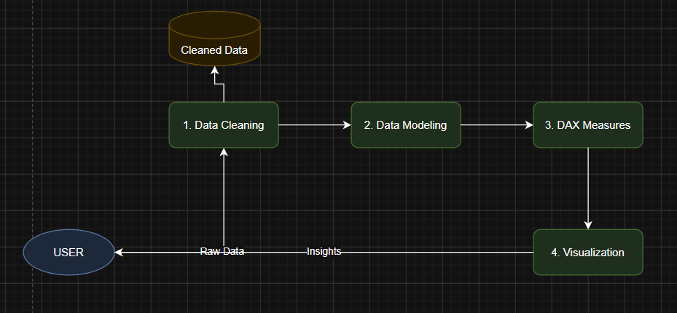

11. MAIN PROCESS FLOWCHART
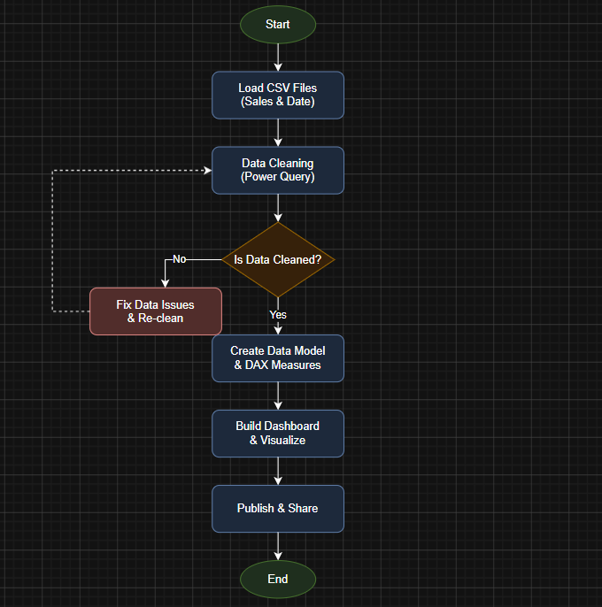
Flowchart Explanation
The flowchart (as you created) represents the step-by-step process followed in this project:
- Start – Begin the project.
- Load Data – Import Sales and Date CSV files.
- Data Cleaning – Remove duplicates, handle missing values, fix data types.
- Data Transformation – Create calculated columns if needed (e.g., Year/Month from date).
- Create Relationships – Link Sales[Order Date] to Date[Date].
- DAX Calculations – Write measures for Revenue, Profit, Margin %, Orders, AOV.
- Dashboard Creation – Add cards, charts, slicers, and arrange layout.
- Publish/Share – Save and optionally publish to Power BI Service.
- End – Dashboard ready for insights.
12. Data Preprocessing
Using Power Query Editor, the following steps were performed:
- Removed duplicates – Checked for duplicate Order IDs.
- Handled missing values – Rows with null Revenue or Profit were removed or imputed with zero (based on context).
- Converted data types – Revenue/Profit to Decimal, Order Date to Date type.
- Cleaned inconsistent values – Standardized category names (e.g., "Electronics" vs "electronic").
- Trimmed text fields – Removed leading/trailing spaces in Product Name and Category.
13. Data Modeling
A Star Schema Model was implemented:
- Fact Table: Sales Dataset (contains measurable events – revenue, profit)
- Dimension Table: Date Dataset (contains descriptive attributes – month, year, quarter)
Relationship: Many-to-one from Sales[Order Date] to Date[Date] (Single direction filter).
Benefits of this model:
- Better query performance
- Easy DAX calculations (time intelligence works seamlessly)
- Structured and scalable analysis
- Simplified filtering across all visualizations

Flowchart of Star Schema Model:
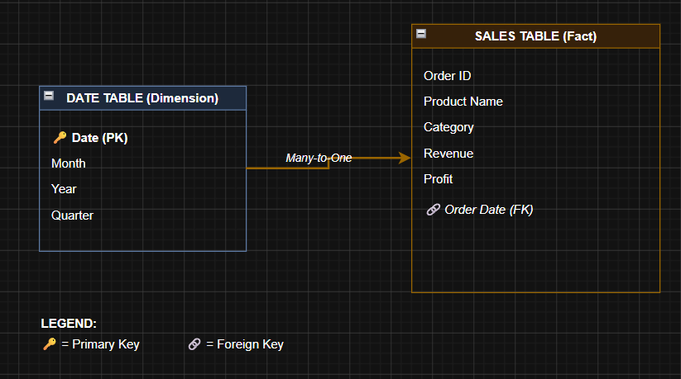
14. DAX Measures Used
Measure Name | DAX Formula (Conceptual) | Description
Total Revenue | SUM(Sales[Revenue]) | Sum of all revenue
Total Profit | SUM(Sales[Profit]) | Sum of all profit
Profit Margin % | DIVIDE([Total Profit], [Total Revenue]) * 100 | Profit as percentage of revenue
Total Orders | DISTINCTCOUNT(Sales[Order ID]) | Count of unique orders
Average Order Value (AOV) | DIVIDE([Total Revenue], [Total Orders]) | Average spend per order
Revenue YTD, Previous Month Growth, Top N Products.
15. Dashboard Design
The dashboard is designed as a single-page interactive report with three main sections:

1. KPI Cards (Top row)
- Revenue (e.g., $1.2M)
- Profit (e.g., $320K)
- Profit Margin % (e.g., 26.7%)
- Total Orders (e.g., 18.5K)
- Average Order Value (e.g., $64.80)
2. Charts (Middle section)
- Line Chart → Sales Trend (Revenue over time by month)
- Bar Chart → Category Performance (Revenue or Profit by Category)
- Pie Chart → Revenue Distribution (Share by Category or Product)
3. Detailed Data & Filters (Bottom/Side)
- Table → Detailed transactional data (Order ID, Product, Revenue, Profit)
- Filters (Slicers) → Date range slicer, Category dropdown slicer
16. Key Insights
From the dashboard analysis, the following insights were derived:
- Sales show time-based trends – Revenue peaks in November/December (holiday season) and dips in Q1.
- Some products generate more profit – High-revenue products are not always high-profit; e.g., Electronics have thin margins, while Accessories have higher margins.
- High revenue ≠ high profit – Certain categories (e.g., Furniture) show high revenue but low profit due to costs.
- Customer spending varies – Average order value differs significantly across categories (luxury items vs. daily essentials).
17. Business Impact
The dashboard provides tangible business value:
- Helps in decision-making – Identify which categories to promote or discount.
- Identifies profitable products – Focus marketing spend on high-margin items.
- Improves strategy – Adjust inventory based on seasonal trends.
- Saves time – Automated refresh vs. manual Excel reporting.

18. Advantages
- Interactive dashboard – Users can filter, drill down, and explore data.
- Easy visualization – Complex numbers become understandable charts.
- Fast analysis – Real-time calculations using DAX.
- User-friendly – No coding required for end-users.
19. Limitations
- Static data – Currently based on historical CSV files, not live connection.
- No predictive analytics – Does not forecast future sales (can be added later).
- Depends on data quality – Insights are only as good as input data.
- Limited scope – No customer or geographical analysis.
20. Future Enhancements
The project can be extended in the following ways:
- Add forecasting – Use Power BI's native forecasting on line charts.
- Use real-time data – Connect to a live database (SQL, API) instead of CSV.
- Add customer segmentation – RFM analysis (Recency, Frequency, Monetary).
- Advanced analytics – Integrate with Python or R scripts for clustering.
- Mobile-optimized view – Design a separate mobile layout in Power BI.
21. Conclusion
This project successfully demonstrates the use of Power BI in analyzing E-commerce sales data. Starting from raw CSV files, the data was cleaned, modeled using a star schema, and enriched with DAX measures to calculate critical KPIs such as revenue, profit, margin, orders, and average order value.
The final interactive dashboard transforms raw data into meaningful visual insights, helping businesses quickly identify trends, compare category performance, and track financial health. By solving the core problem of unstructured and hard-to-analyze data, this project provides a practical, scalable template for data-driven decision-making in E-commerce and retail environments.

22. OUTPUTS
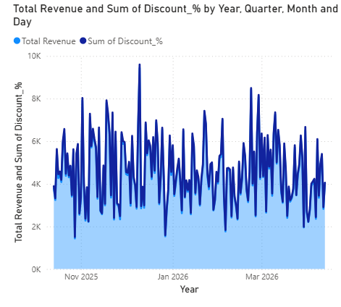VISU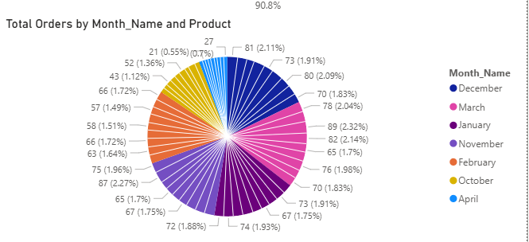
VISUALISATION: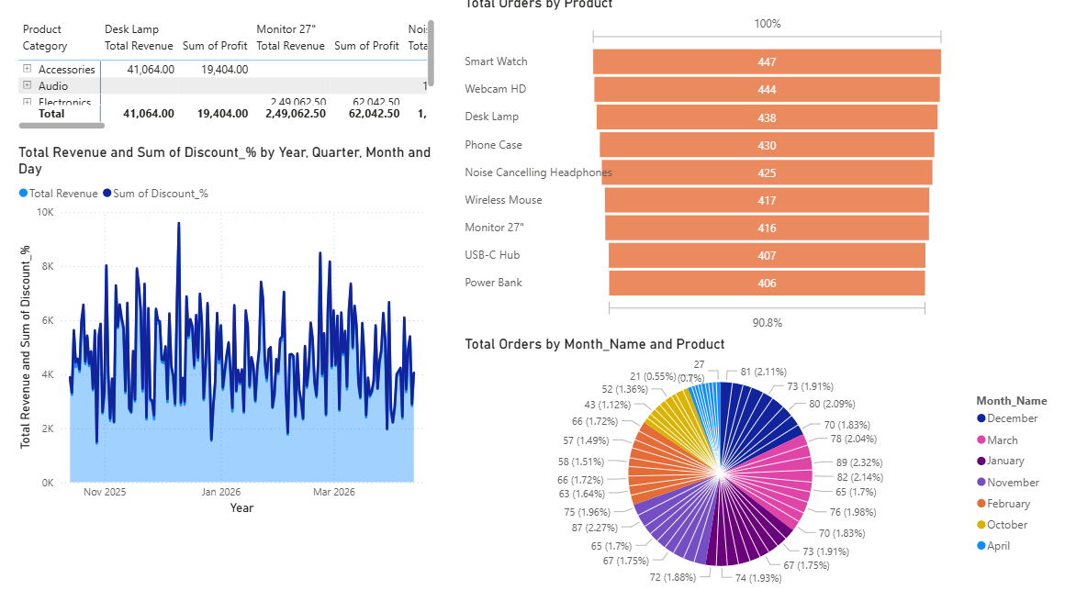
DAX MEASURES: 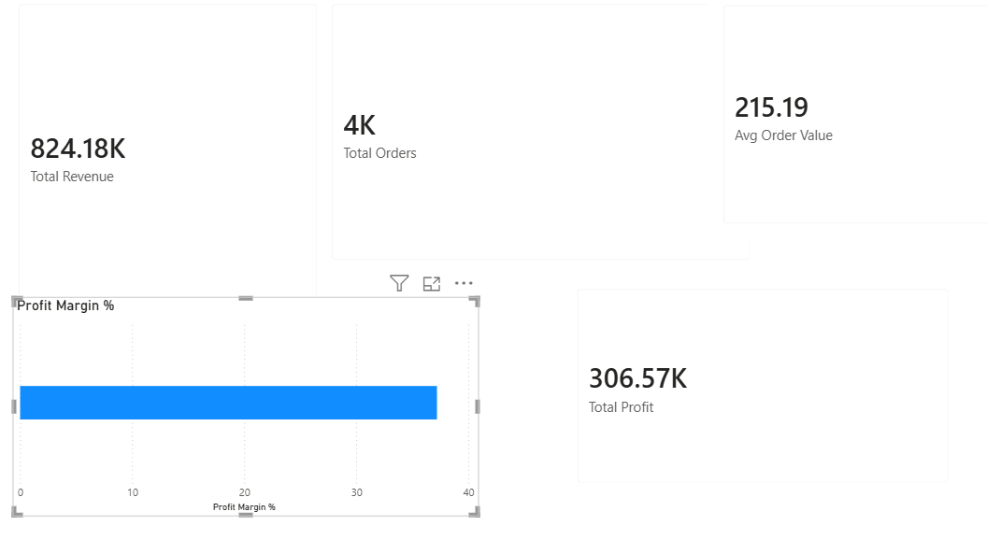

23. LinkedIn Screenshot:
