**INDEX**

|  |  |  |
| --- | --- | --- |
| **S.No.** | **Topic** | **Page No.** |
| 1. | Certificate | 3 |
| 2. | Acknowledgement | 4 |
| 3. | Title of the project | 5 |
| 4. | Problem Definition | 5 |
| 5. | Team Members | 6 |
| 6. | Objective | 6 |
| 7. | System requirements | 7 |
| 8. | Source Code | 8-27 |
| 9. | Output Screens | 28-49 |
| 10. | Future Scope | 49 |
| 11. | Bibliography | 50 |

**Certificate**

This is to certify that this project titled "RWA Management" is prepared by Ananyaa M of class XII of Amity International School, Sector 46, Gurgaon, Haryana, under the guidance of Mrs. Gurminder Kaur, PGT Computer Science (CS), and has been submitted for evaluation as partial fulfillment of curriculum for the session 2022-23. This is also certified that the project is originally written and does not indulge in any form of plagiarism. It is acknowledged that a lot of information and understanding has been collected/ sourced from sources that are already published and accessible to the general public, which is separately acknowledged at the end of the report.

Signature of Teacher  
**Mrs. Gurminder Kaur**

Signature of Student  
**Name:** Ananyaa M  
**Board Roll Number:** 17642809

Signature of Principal  
**Mrs. Arti Chopra  
Principal, AISG-46**

**Acknowledgement**

At the onset, I must express my heartfelt thanks and gratitude to the Principal Ma'am and the School Management for inspiring us to take challenges and work on practical projects.

I sincerely acknowledge the support and guidance of my Computer Science teacher, Mrs. Gurminder Kaur, in completing this Project Report successfully and on time.

I would also like to acknowledge the contributions of all the team members.

**Title of the Project**

**RWA Management**

Based on Python

**Problem Definition**

The Residents' Welfare Association (RWA), a group of individuals chosen by the residents from amongst themselves, exists in almost every housing complex. Such housing complexes are typically preferred for their safety, open areas, and amenities. However, for an efficiently working RWA group, significant maintenance is required for various issues such as the rents, location, security, events, etc. If we try to do all this manually, abundant labor is needed simultaneously. For individuals having tight schedules, it is hard to find common free time for social work. Storage becomes a more significant issue, as saving information in a temporary placement is futile. If all of this could be done digitally, the work would be accomplished more proficiently, and it would help society by saving effort and time.

**Team Members**

(17642810) **Anushka Srivastava**

(17642809) **Ananyaa M**

(17642820) **Divyanka Dixit**

**Objective**

The project is designed bearing in mind the importance of a well-maintained community and improvement in the working of a society and its RWA group. It provides a digital way to take care of a residential society effortlessly. We have tried to make a user-friendly program where one can enter a new record, display specific records, and perform other functions with the help of Data Files or SQL connecting with Python. A section shares information related to the RWA group, such as the members and their roles; it also takes inputs from the user for any inquiry. A billing department is present to manage the several fees in the society; a grocery department supervises the shops for the residents' convenience. Another sub-topic superintends the events that take place to have a more engaging experience among the people. It also touches on the requirements for an orphanage or a nursing home that is made for people in need. This project will help an RWA group overcome the troubles they face due to storage and allow the people to work for the betterment of their society with minimal labor.

**System Requirements**

Hardware Requirements:  
Working Personal Computer (PC)

Software Requirements:  
OS: Windows version 8 and above  
Compiler: Python Compiler with the latest updates  
SQL connectivity  
System CSV/TXT/BINARY files

**Source Code**

**RWA_Management.py**

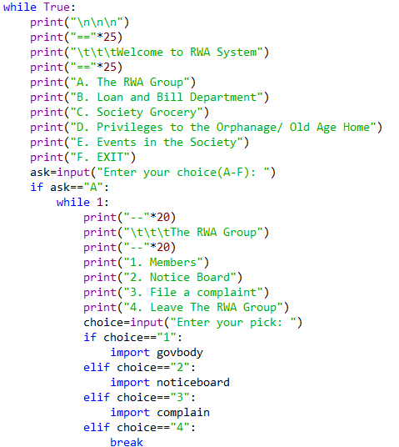

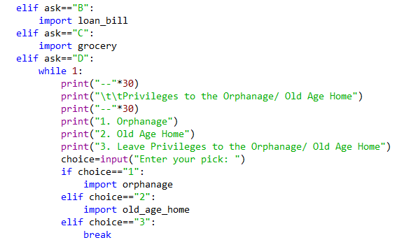

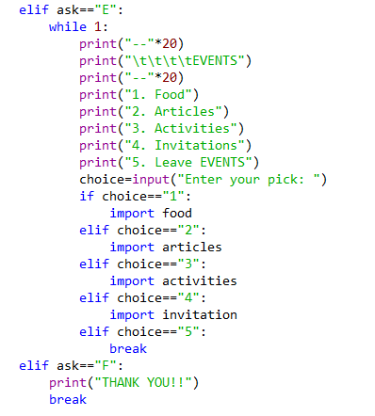

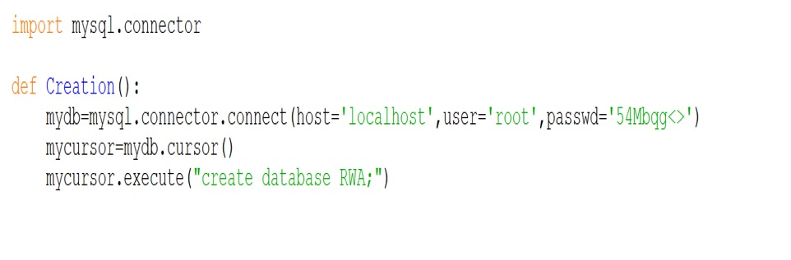**govbody.py**

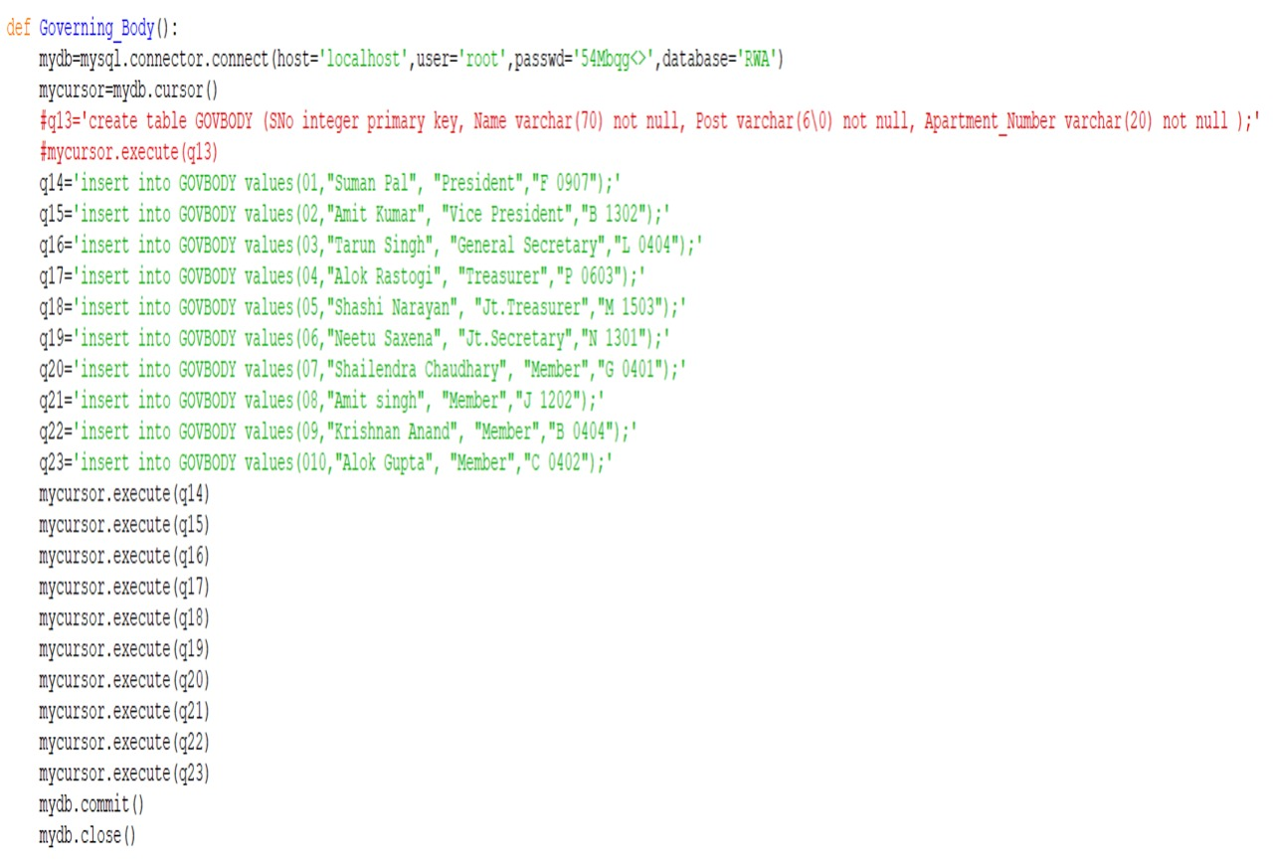

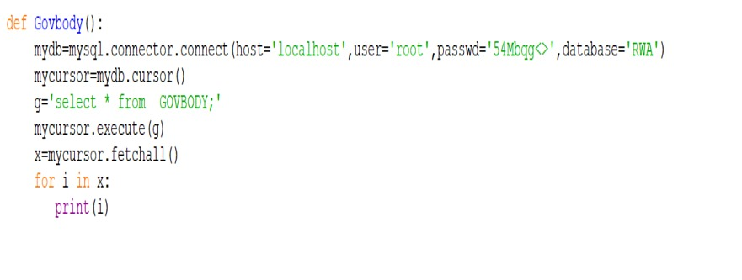

**1.PNG**

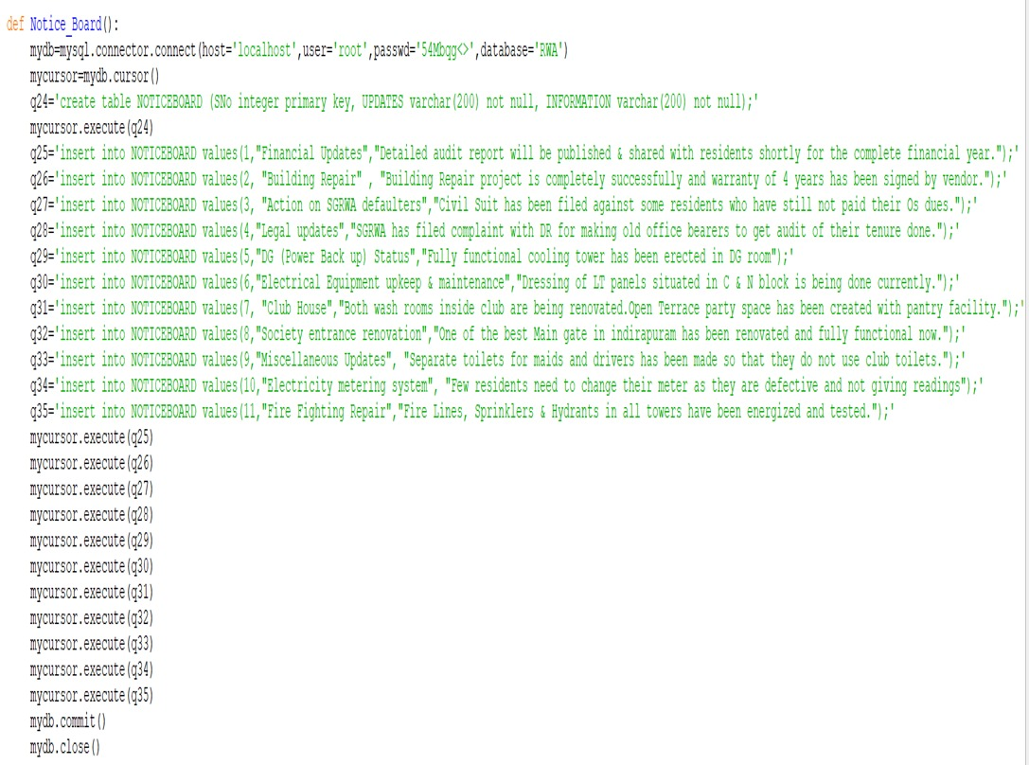**noticeboard.py**

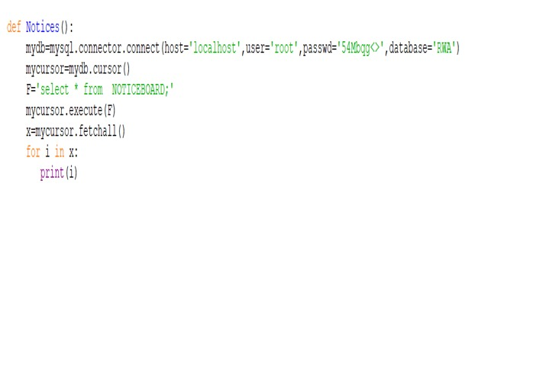

**2.PNG  
complain.py**

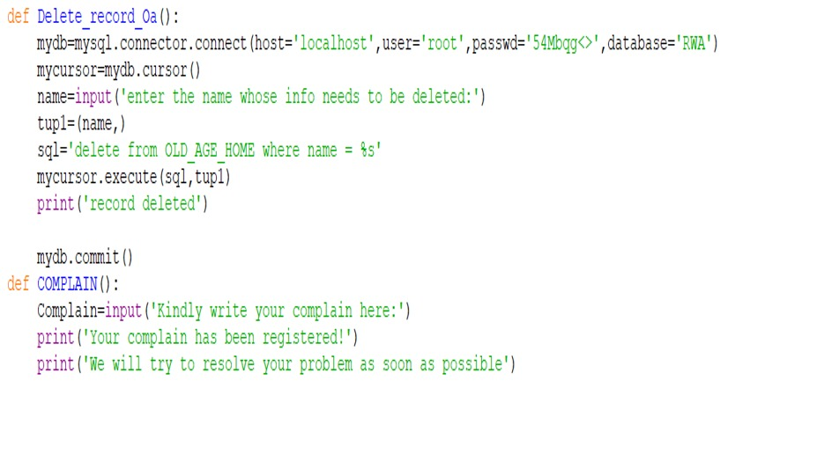

**3.PNG**

**loan_bill.py**

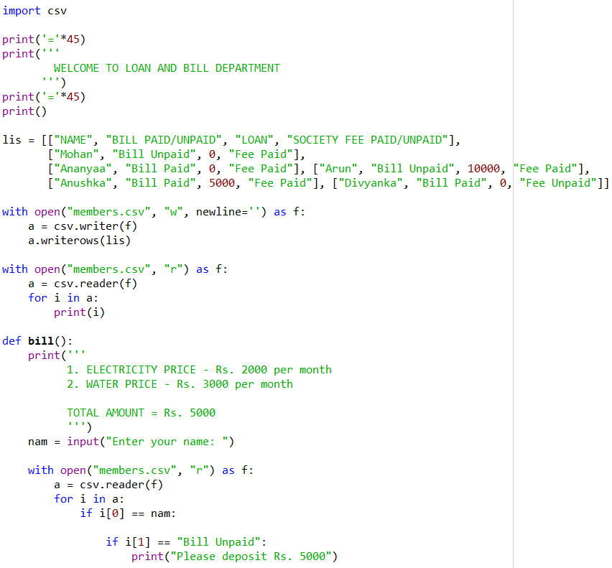

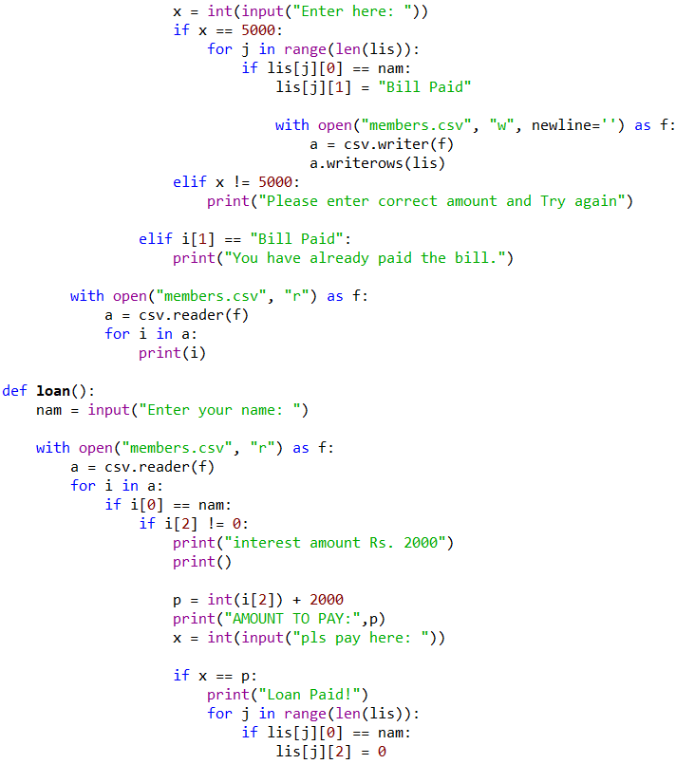

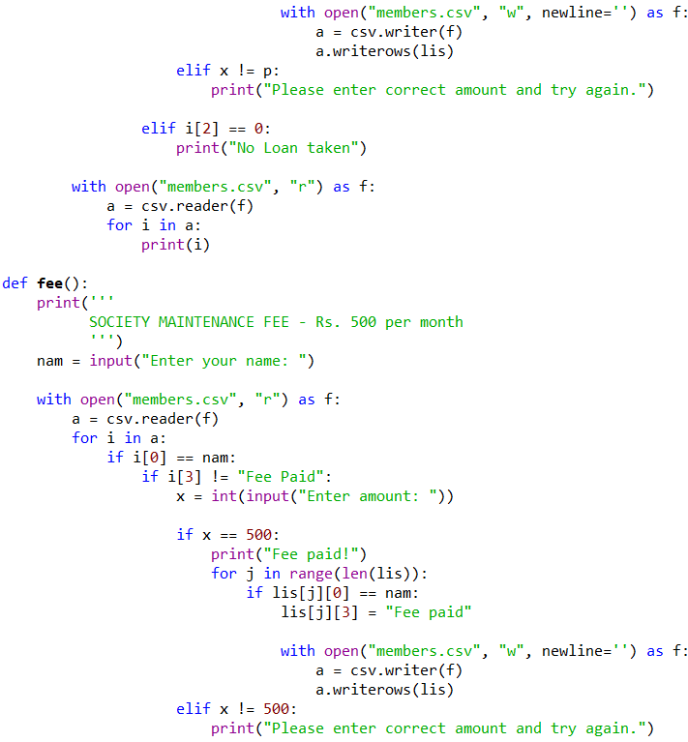

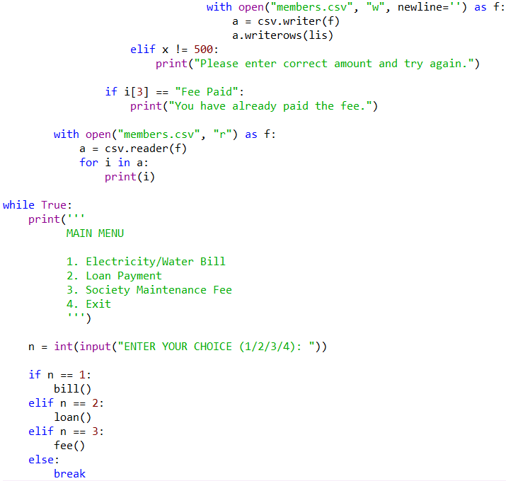



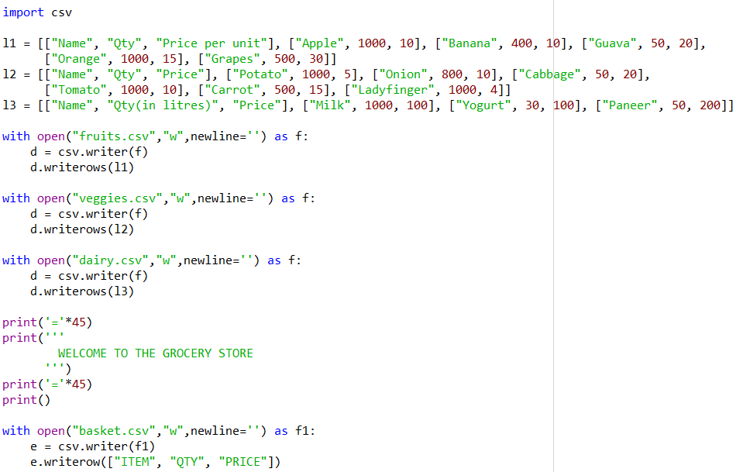**grocery.py**

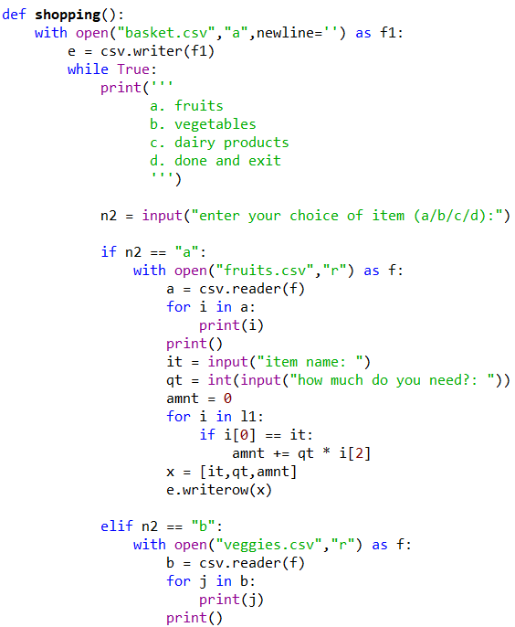

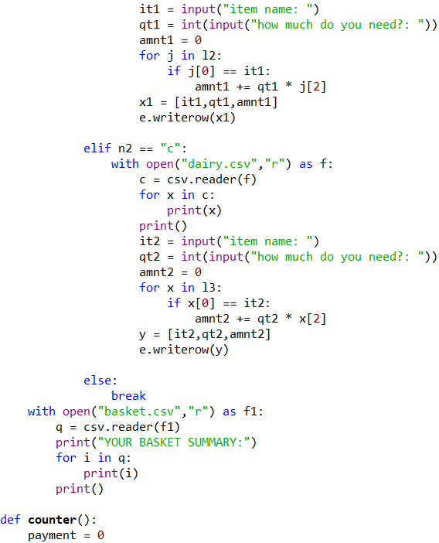

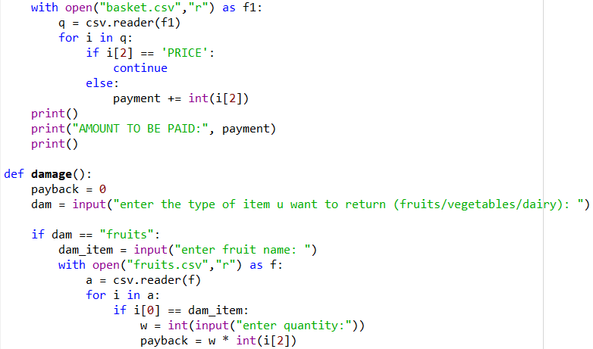

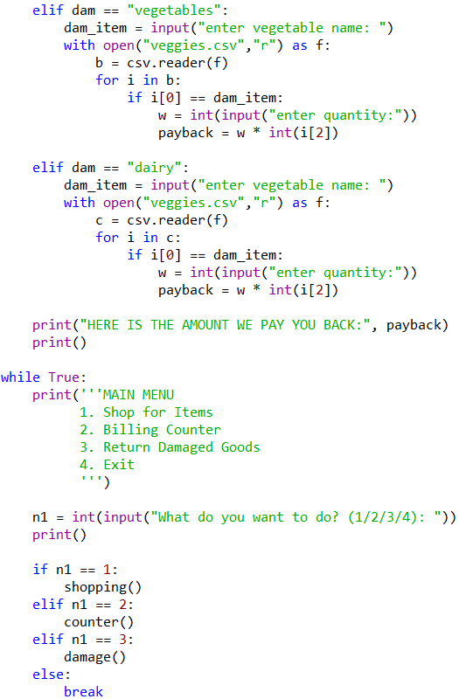

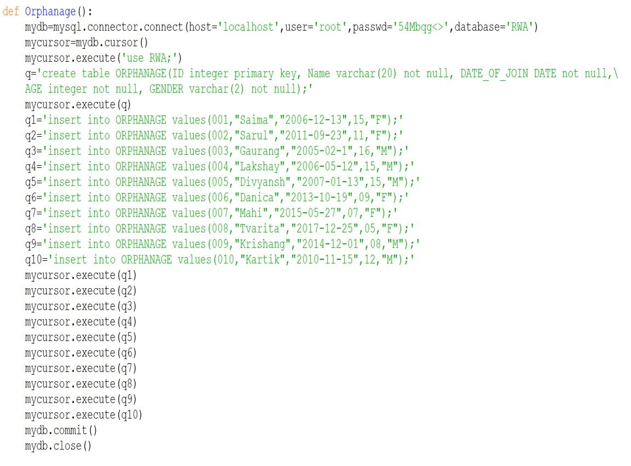

**orphanage.py**





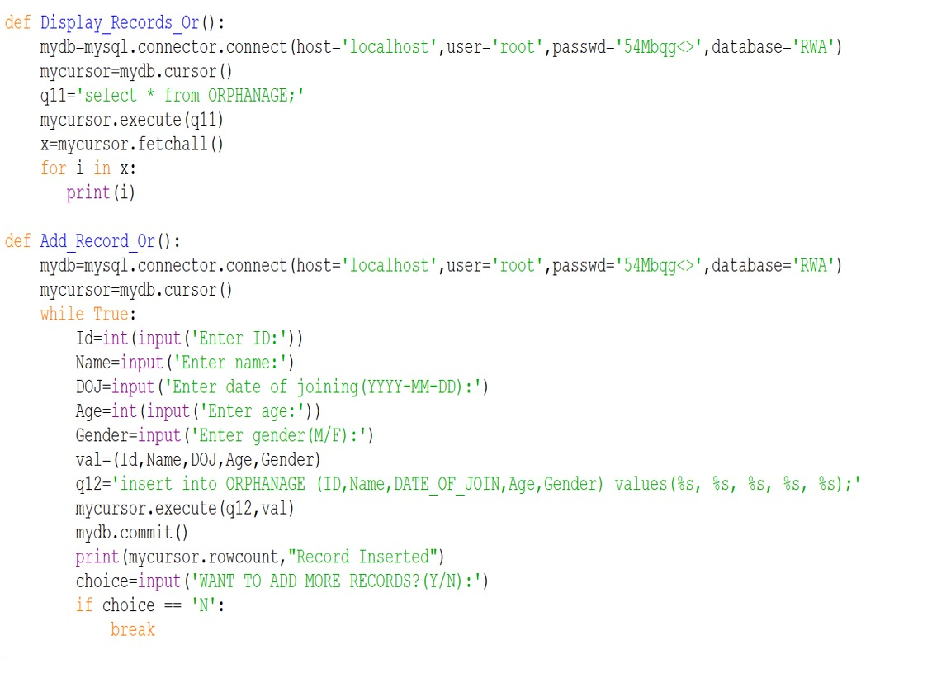

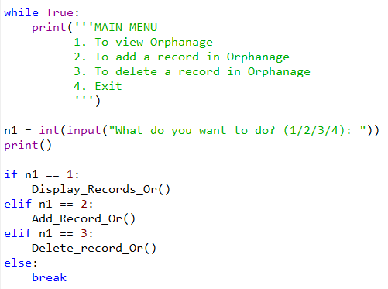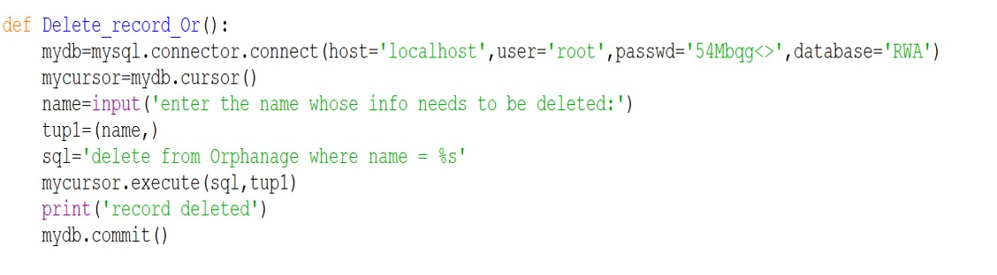



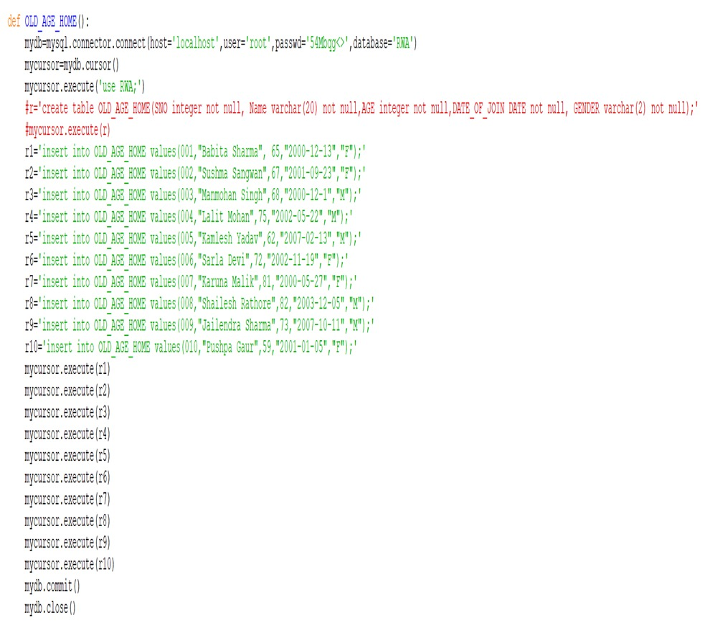**old_age_home.py**



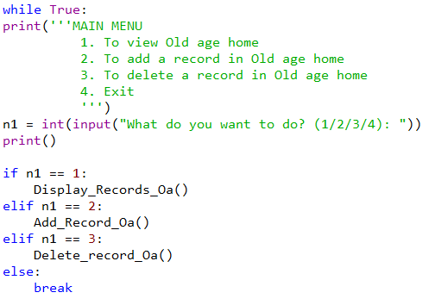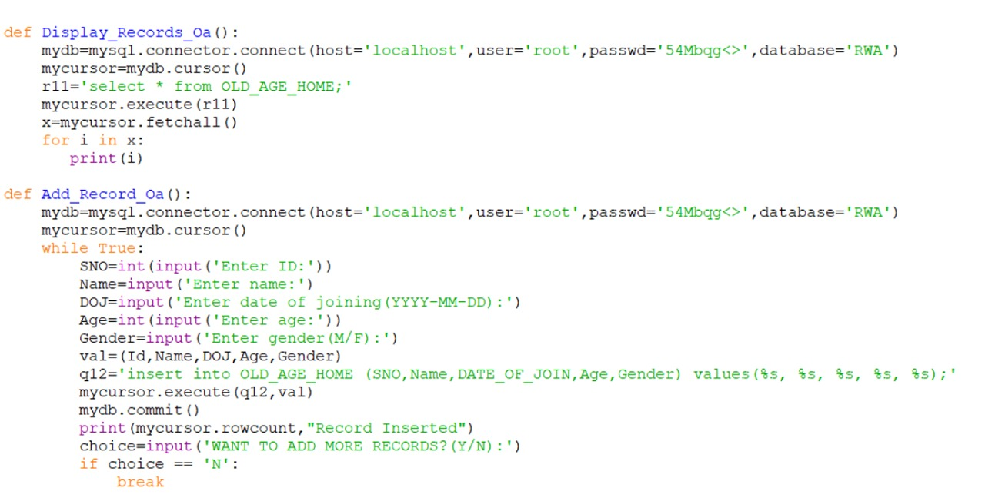

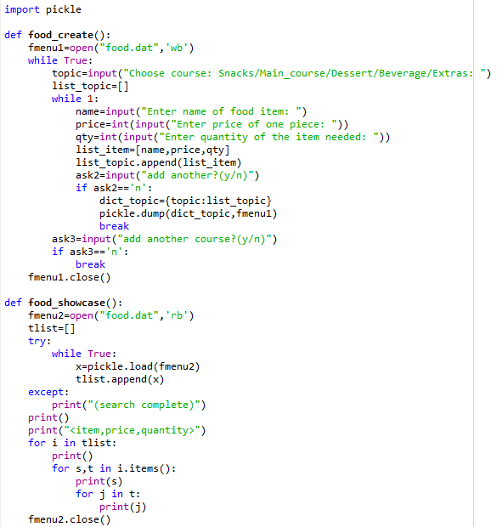**food.py**

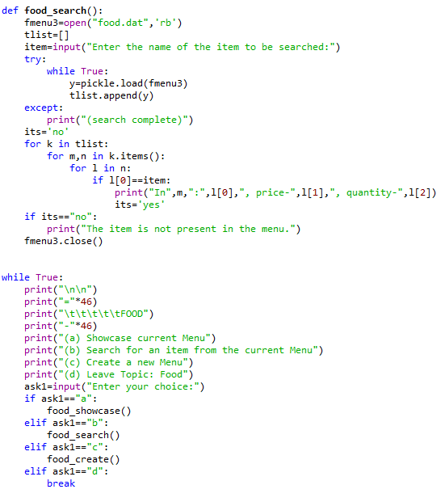

**articles.py**

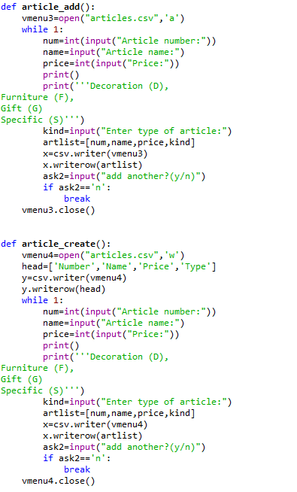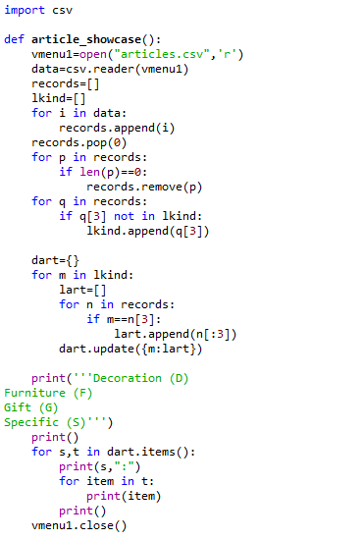

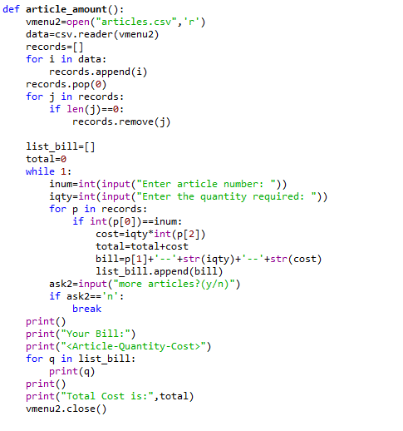



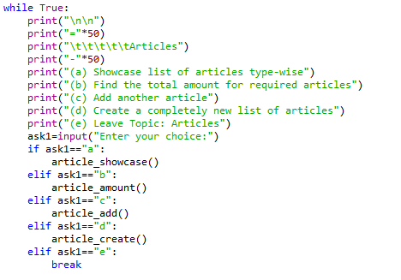

**activities.py**

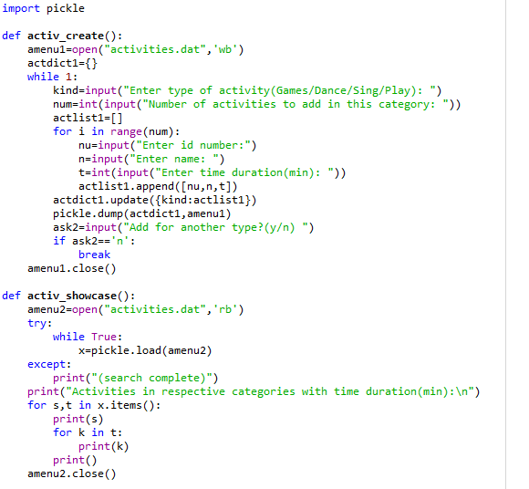

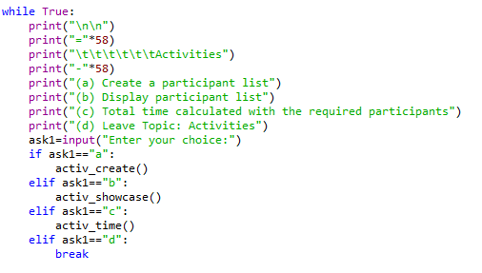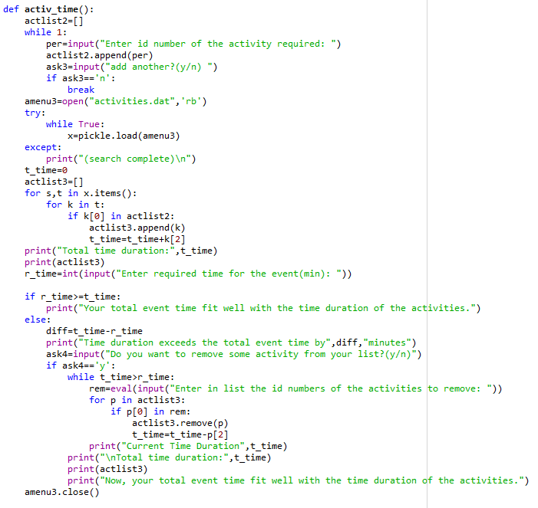

**invitation.py**

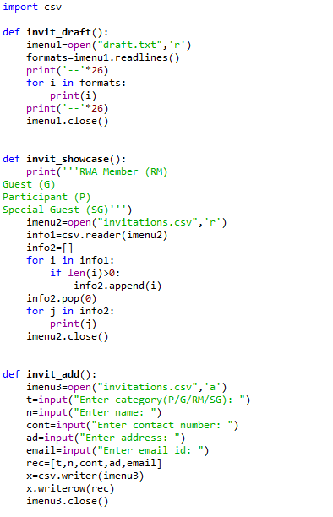

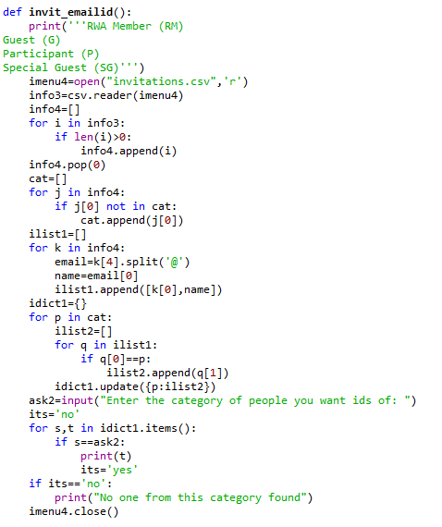

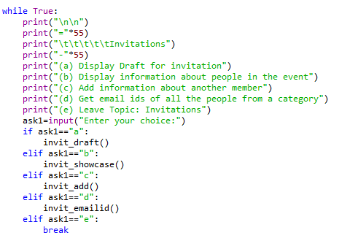

**Output Screens**

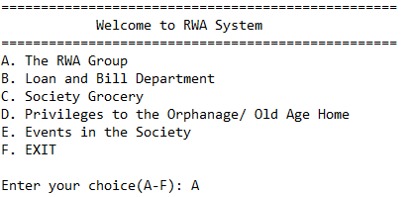

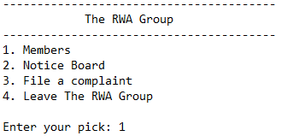

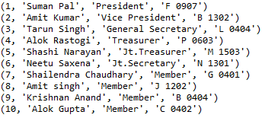

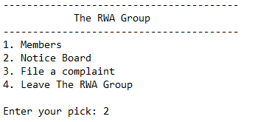

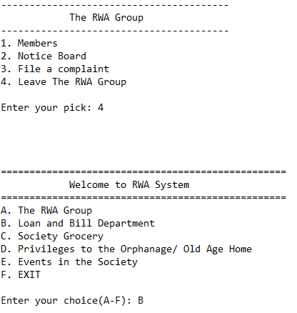3.PNG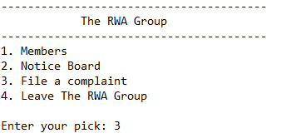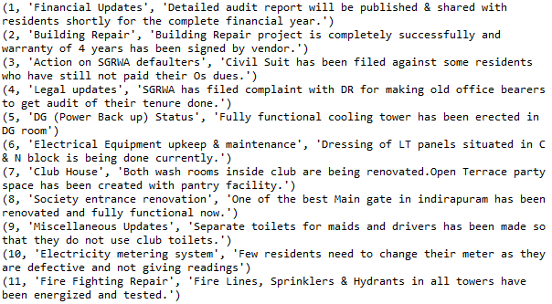



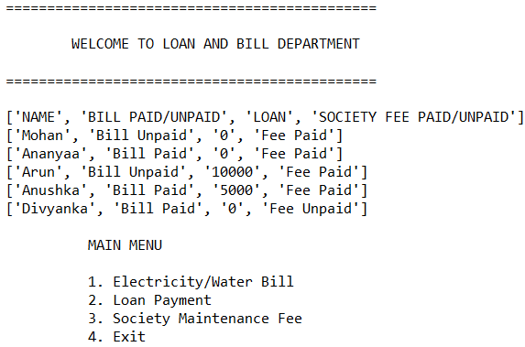

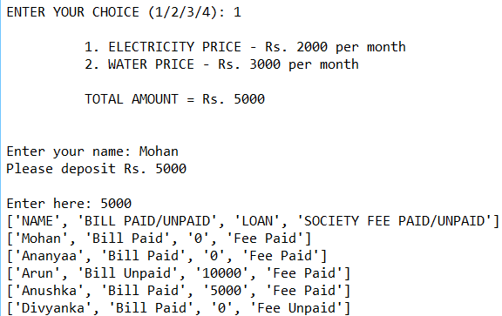

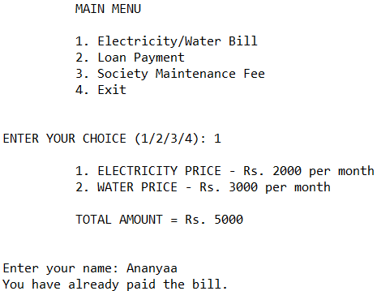

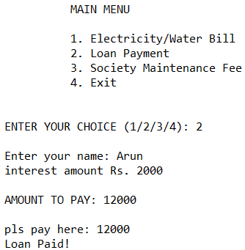

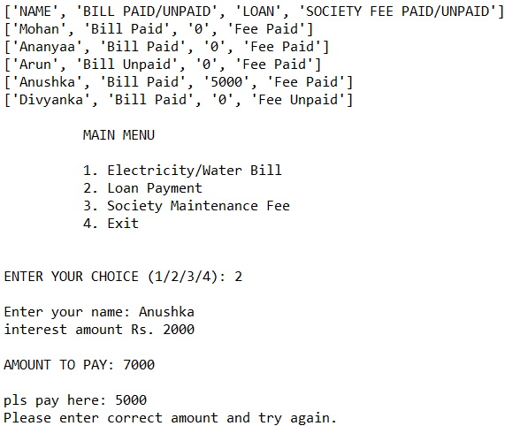



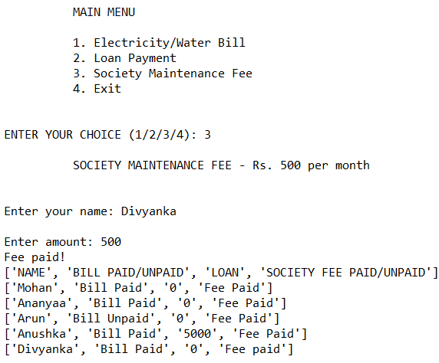

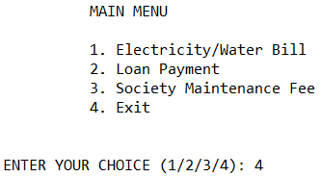

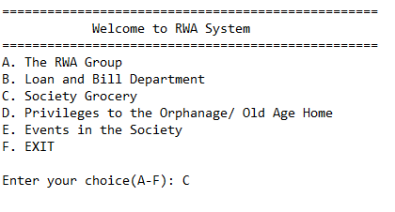

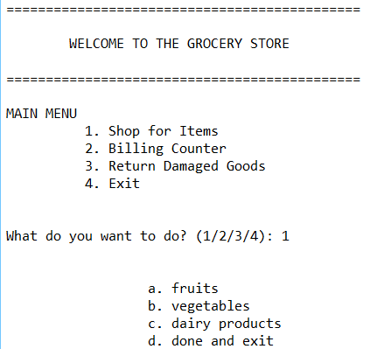

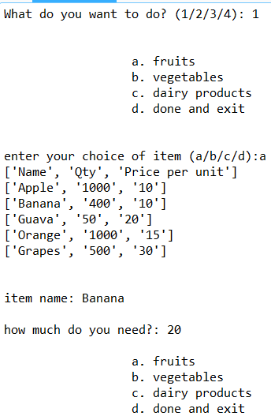

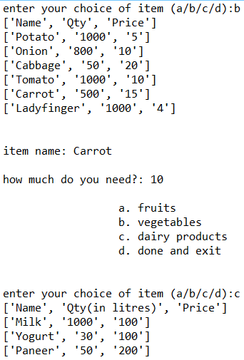

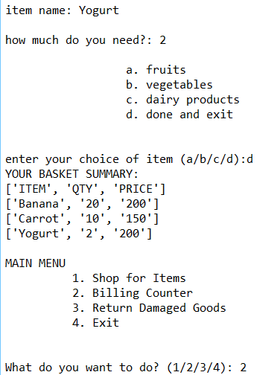

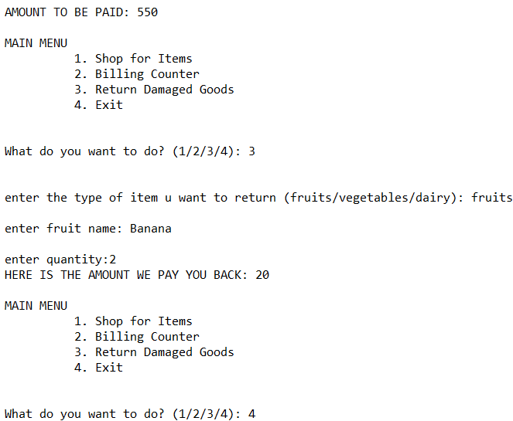

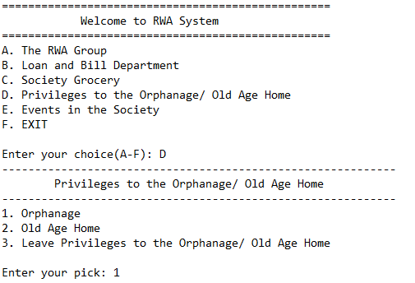

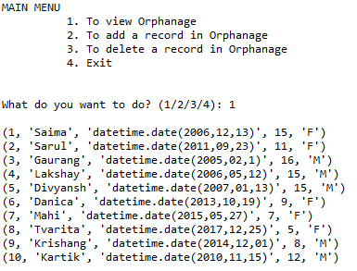

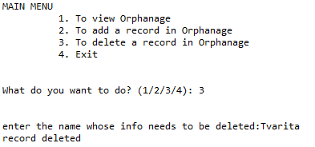

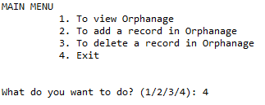

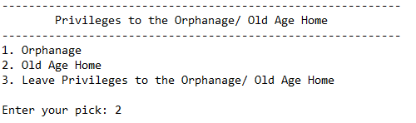

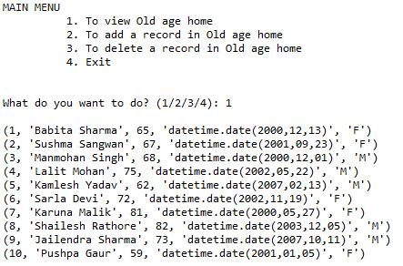

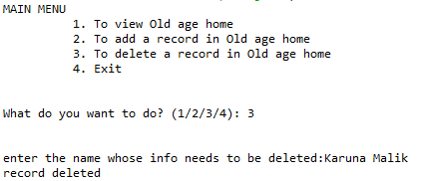

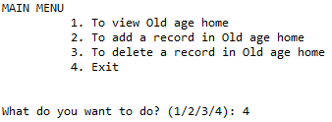

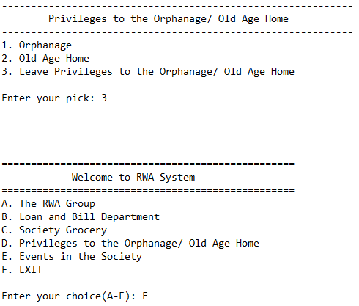

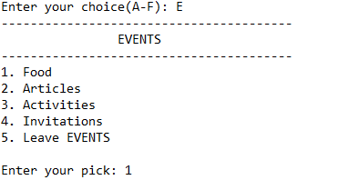

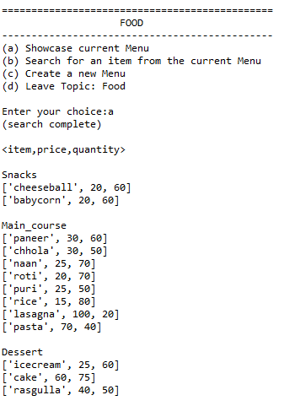



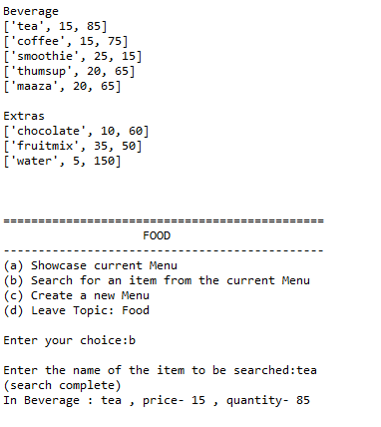

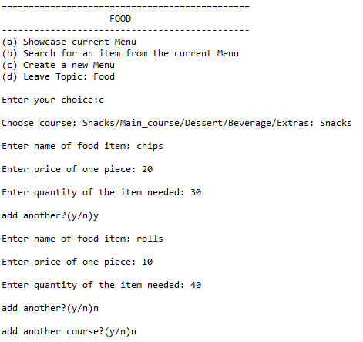

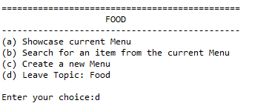

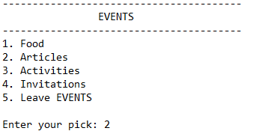

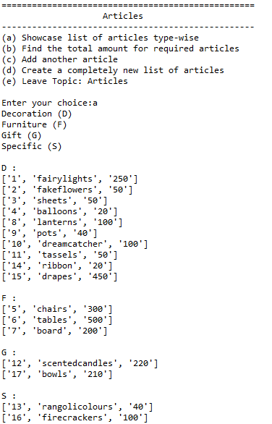

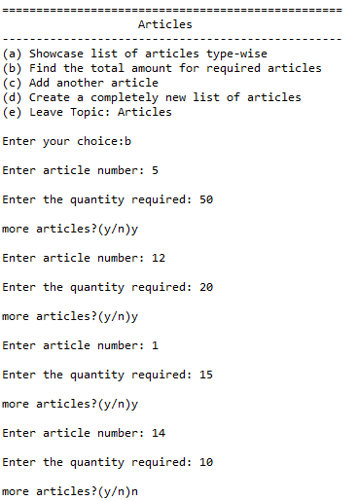



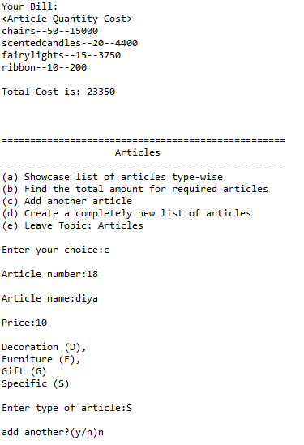

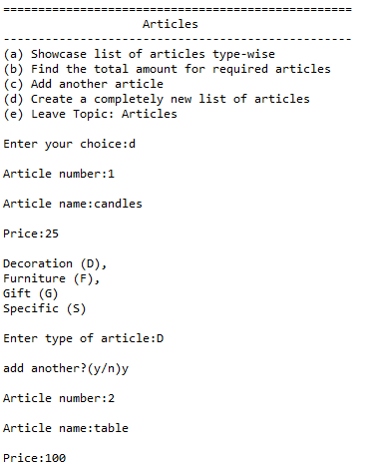

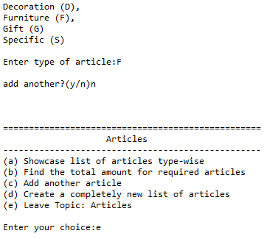

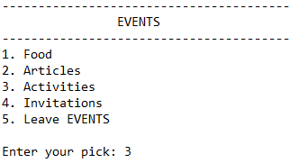

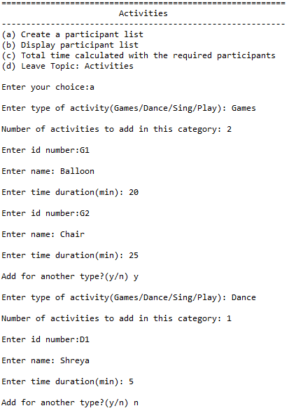

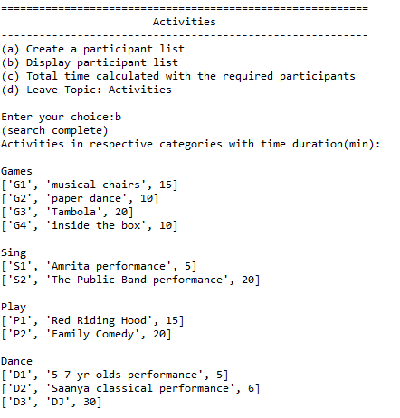

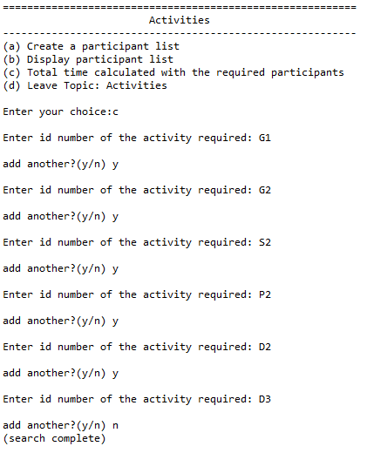



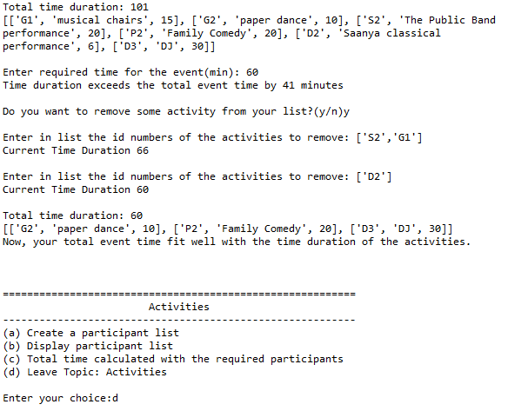

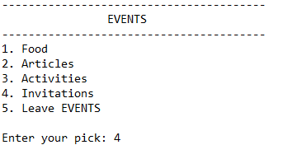

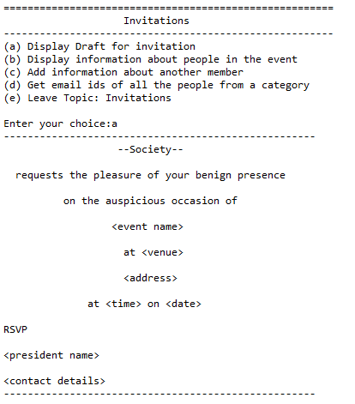

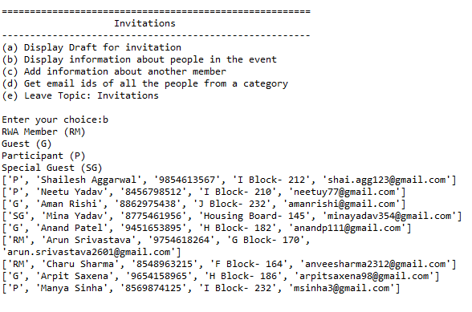

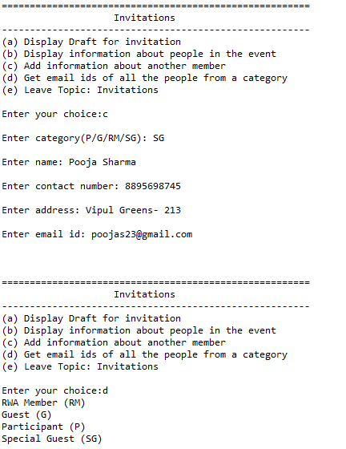

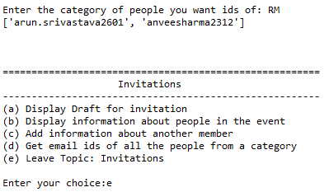

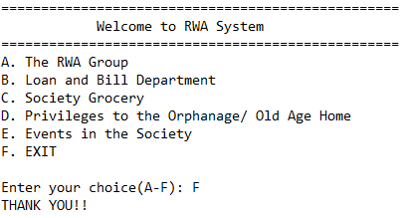

**Future Scope of the Project**

The project will help residents go paperless and quickly get their work done at their homes. It holds a lot of potential as implementing the idea will benefit society. In the future, this project can be given a place in an internet portal where it can aid any organization. It can be used to pay fees, whether it is about paying water or electricity bills or taking financial aid without any hustle and bustle, directly through the platform. A voting system can also be included so that the association is fair and accessible. Subsequently, we can take ideas from different people from various cultures and backgrounds and embrace them in the project. With further walk in the advancement of technology, one can see the gradual development of rudimentary programs that can progress them to greater levels.

**Bibliography**

* Computer Science with Python by Preeti Arora
* [geeksforgeeks.org/](http://www.geeksforgeeks.org/)
* stackoverflow.com/
* docs.python.org/3/
* google.com