Task 1: Research & Summarize

**What is SORA?**

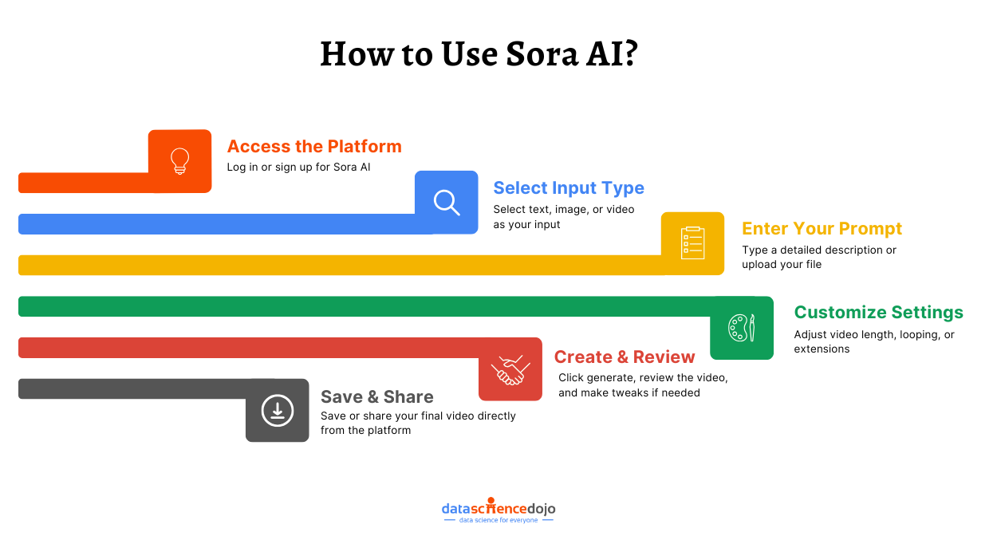

Sora is a test-to-video AI model developed by OpenAI. It generates high quality**,** realistic videos from textprompts, similar to how DALL·E generates images. Some key features:

* Generates videos up to a minute long.
* Handles complex scenes, motion, and visual consistency.
* Aims to help in film, education, simulation, and creative storytelling.

Sora is OpenAI’s groundbreaking test to videogenerative model, capable of producing video clips—up to one minute long—from simple textual prompts. It was first previewed in February 2024, with follow-up technical documentation explaining its architecture: a diffusion transformer operating on compressed spatiotemporal video “patches”

* By December 2024, OpenAI had expanded access, releasing a version called Sora Turbo for ChatGPT Plus and Pro subscribers. This version supports shorter videos (around 20 seconds), up to 1080p resolution, with added tools like storyboard-based input, C2PA metadata for provenance, and watermarking for transparency
* While Sora showcases impressive visual realism—complex scenes, multiple characters, dynamic camera angles—it still faces challenges. These include flawed physics (e.g. a bitten cookie without a bite mark), spatial confusion, and difficulty tracking precise movements over time.

**Comparison with DALL·E or alternatives like Pika Labs or RunwayML :**

DALL·E: Also from OpenAI, DALL·E is a text-to-image model (with its latest version being DALL·E 3) and doesn't generate video. Sora builds upon some of its safety systems but takes them into the temporal dimension.

Runway Gen‑2 / Gen‑3 Alpha: These are among Sora’s primary competitors. Runway Gen‑2 can generate short, high-quality clips (typically up to 16 seconds) from text or image inputs. Gen‑3 Alpha pushes the envelope further with refined control and cinematic quality.

Pika Labs: Another up-and-coming option in 2024, Pika Labs generates brief clips (~3 seconds) with camera motion controls and is praised for creative consistency.

According to a recent review (performed after 200 hours of testing), Sora fares well in storyboardingand creative flexibility, though it trails some rivals in realism and prompt fidelity. Runway’s newer models excel in industry-grade control, while Pika is a standout for character consistency and creative ease.

**Ethical considerations in video generation:**

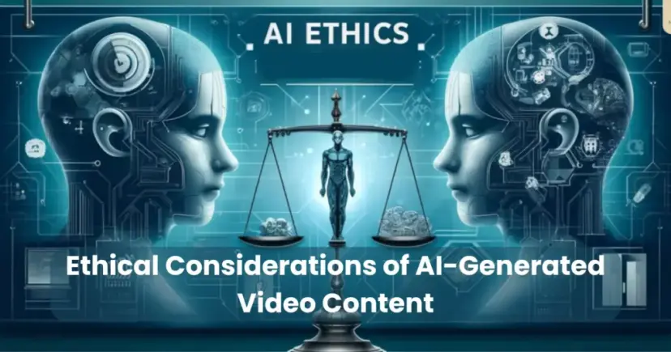

Video generation — especially using AI — raises several important ethical considerations that span privacy, consent, misinformation, bias, and broader societal impacts.

## **1. Consent and Privacy**

* **Deepfakes and Impersonation**: AI-generated videos can mimic real individuals without their consent, violating their privacy and potentially harming reputations.
* **Non-consensual Content**: People may be featured in AI-generated videos (e.g., pornographic content or political statements) without knowledge or permission.
* **Surveillance Concerns**: AI video tools could enhance surveillance capabilities and be used in ethically questionable ways (e.g., state
* monitoring, face tracking).

## **2. Misinformation and Manipulation**

* **Fake News**: AI-generated videos can be used to spread false information, making it harder for the public to distinguish between real and fake.
* **Political Propaganda**: Synthetic videos can be weaponized in election interference, public manipulation, or to stoke division.
* **Erosion of Trust**: As fake videos become more convincing, public trust in legitimate media can be undermined (the "liar’s dividend").

## **3. Bias and Representation**

* **Training Data Bias**: Video generation models trained on biased or limited datasets may produce discriminatory or stereotypical content.
* **Cultural Misrepresentation**: Misappropriating cultural elements or reinforcing harmful stereotypes through generated videos can perpetuate systemic biases.

## **4. Intellectual Property and Attribution**

* **Use of Copyrighted Materials**: Generated videos might replicate or remix copyrighted content, raising questions about ownership.
* **Attribution Issues**: It can be unclear who should be credited — the creator, the model, the data source, or the prompt designer.

Ethics play a crucial role in shaping how society uses and responds to emerging technologies. With the rise of AI in media production, it has become increasingly important to address the ethical considerations of AI generated videos content. This technology doesn’t just influence creative industries, it affects trust, privacy, and the public’s perception of truth.

AI-generated videos can convincingly replicate real people’s faces and voices. If used without proper boundaries, these tools can distort reality, spread disinformation, or manipulate public opinion. For instance, deepfake videos can impersonate political leaders, causing confusion or harm. In such cases, the line between innovation and deception becomes dangerously thin.