Report
Of
DATA ANALYST INTERNSHIP
End-to-End Predictive Modeling & Social Media Sentiment Analysis
Submitted
To
School of Computer Science and Engineering
IILM University, Greater Noida, U.P.
In partial fulfilment of the requirement of degree of
B.Tech CSE
By
ANUSHKA SINGH
Roll Number: 25SCS1003004411
Program: B.Tech CSE AI/ML IBM | Semester 3
Batch: 2026-27
Internship Organization: Codec Technologies Pvt. Ltd.
Internship Role: Data Analyst Intern
Internship Duration: 10 July 2026 – 10 August 2026

CANDIDATE’S DECLARATION
I, ANUSHKA SINGH, do hereby declare that the internship report titled “Data Analyst Internship: End-to-End Predictive Modeling & Social Media Sentiment Analysis” has been completed by me to fulfil the requirement for the award of the degree of Bachelor of Technology in CSE. The report presents the internship work and project material supplied for the internship. All references used in preparing this report have been acknowledged. I affirm that this report is my own work and has not been submitted to any other institute for any degree or diploma requirement. I shall be solely responsible for any copyright violation in this regard.

Signature: ______________________________
Student Name: ANUSHKA SINGH
Roll No.: 25SCS1003004411

ACKNOWLEDGEMENT
I am using this opportunity to express my gratitude to everyone who supported me throughout the Internship Program. I am thankful for their guidance, constructive criticism and advice during this work. I sincerely acknowledge the learning opportunities provided through the internship projects in data analysis, predictive modelling and social media sentiment analysis.
I am grateful to the mentors and professionals associated with the internship for their guidance in understanding data preparation, model development, evaluation and reporting. I also express my gratitude to IILM University, School of Computer Science and Engineering, for providing the academic framework in which this internship report has been prepared.
Finally, I express my gratitude to my parents for their blessings and continued support.

Signature: ______________________________
Student Name: ANUSHKA SINGH
Roll No.: 25SCS1003004411

INTERNSHIP COMPLETION CERTIFICATE
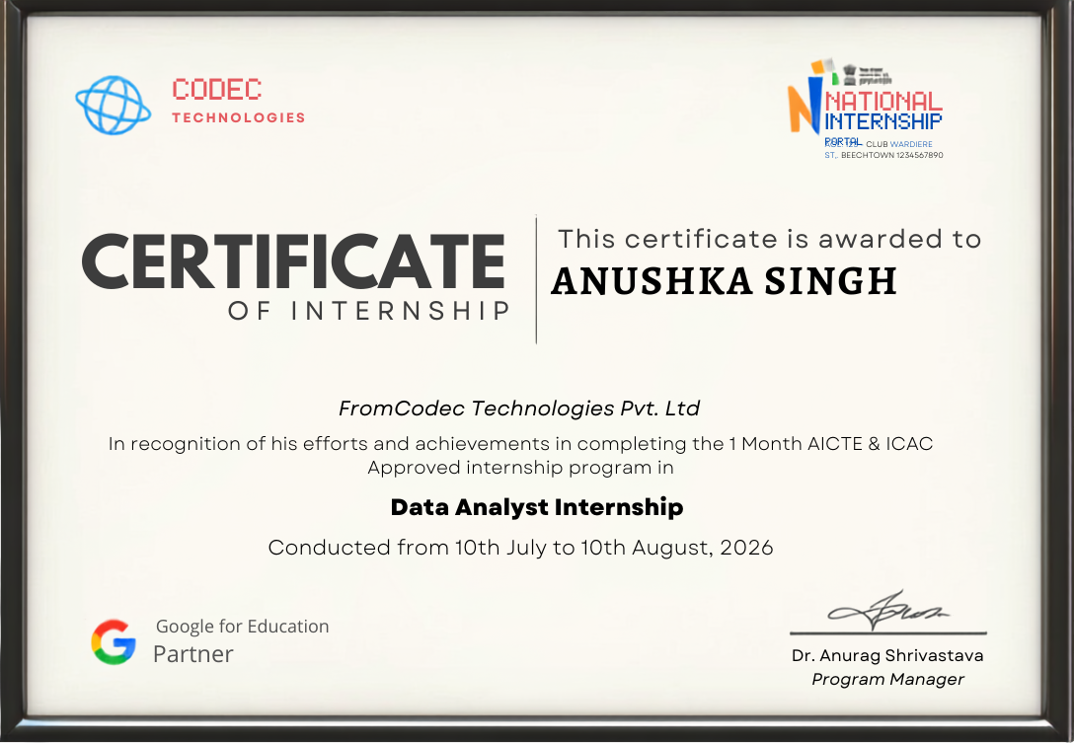
Figure 3.1: Internship Completion Certificate

TABLE OF CONTENTS
Chapter No. | Chapter Name | Page Nos.
1. | Candidate’s Declaration | i
2. | Acknowledgment | ii
3. | Internship Completion Certificate | —
4. | Project Description | 1
4.1 | Introduction | 1
4.2 | Organization Profile | 2
4.3 | Problem Statement | 3
4.4 | Project Objectives | 4
4.5 | Scope of the Project | 5
4.6 | Technologies and Tools Used | 6
4.7 | System Architecture | 7
4.8 | Methodology | 8
4.9 | Expected Outcomes / Results | 11
4.10 | Certificates of Completion and Communication Proof | 12
5. | Bibliography / References | 13

Note: Page numbers are arranged according to the report structure and may update slightly if the document is reflowed after editing.

4.1 Introduction
This internship report presents the work described in the supplied Data Analyst Internship presentation and the internship completion certificate. The internship was a one-month Data Analyst Internship conducted from 10 July 2026 to 10 August 2026. The project portfolio focused on two applied data problems: Customer Churn Prediction and Twitter Sentiment Analysis.
The first project addressed the identification of customers who may leave telecommunication services using supervised machine learning. The second project addressed the extraction of public sentiment and brand perception from unstructured Twitter data using natural language processing. Together, the projects demonstrate an end-to-end workflow involving data preparation, feature representation, model training, evaluation and business-oriented reporting.
The presentation identifies the student as Anushka Singh, enrollment number 25scs1003004411, enrolled in B.Tech CSE AI/ML IBM, Semester 3. The internship certificate identifies the role as Data Analyst Internship and the issuing organization as Codec Technologies Pvt. Ltd.
Table 4.1: Internship Overview
Student | Anushka Singh
Enrollment Number | 25scs1003004411
Program | B.Tech CSE AI/ML IBM
Semester | 3
Internship Role | Data Analyst Intern
Duration | 10 July 2026 – 10 August 2026
Primary Projects | Customer Churn Prediction; Twitter Sentiment Analysis

4.2 Organization Profile
The internship completion certificate supplied with this report is issued by Codec Technologies Pvt. Ltd. and states that the internship was a one-month AICTE & ICAC approved Data Analyst Internship. The certificate records the internship period as 10 July to 10 August 2026 and identifies Dr. Anurag Shrivastava as Program Manager.
The accompanying presentation describes the working environment as an Enterprise Data & AI Team and lists collaboration with senior data scientists and machine learning engineers. Its stated objectives were to develop scalable predictive models, transform raw business data into actionable insights and automate end-to-end NLP analytics pipelines.
For this report, the organization name and internship duration are taken from the certificate, while the project portfolio, responsibilities and technical workflow are taken from the supplied presentation.
Table 4.2: Core Internship Responsibilities
Area | Work Described in Presentation | Tools / Approach
Data Engineering | Extracted, cleaned and normalized structured tabular data and unstructured text pipelines. | Pandas, Scikit-Learn
Model Development | Trained and cross-validated supervised ML and NLP classifiers. | Precision, recall, classification models
Reporting & BI | Generated dashboards and model evaluation metrics for stakeholders. | Dashboards, evaluation metrics

4.3 Problem Statement
Project 1 – Customer Churn Prediction: Telecommunication businesses need to identify customers who are at risk of leaving. Customer churn can affect recurring revenue, making it useful to detect high-risk accounts before cancellation and support proactive retention strategies.
The presentation describes the problem as a supervised machine learning classification task using customer demographics, usage metrics, tenure and billing or payment patterns. Because customer churn data can contain an imbalanced target, the project pipeline included SMOTE before feature scaling.
Project 2 – Twitter Sentiment Analysis: Social media contains large volumes of unstructured customer feedback. The challenge is to convert raw tweet text into a structured representation that can be classified into sentiment categories, allowing organizations to monitor public perception and identify negative sentiment spikes.
The presentation describes a natural language processing pipeline that removes URLs and mentions, converts text to lowercase, removes stop words, applies lemmatization and transforms the processed text into TF-IDF vectors before classification.
Table 4.3: Problem-to-Solution Mapping
Project | Input | Analytical Goal
Customer Churn Prediction | Structured customer records | Identify customers at risk of leaving
Twitter Sentiment Analysis | Unstructured tweet text | Measure sentiment and flag negative trends

4.4 Project Objectives
The internship projects were designed around practical data analytics and machine learning objectives. Based on the supplied presentation, the principal objectives were:
- Identify customers who are at risk of churn using supervised machine learning classification.
- Prepare and normalize customer demographic, tenure, usage and payment information for modelling.
- Address class imbalance in the churn dataset using SMOTE before feature scaling.
- Evaluate classification performance using measures such as accuracy, ROC-AUC, precision and recall.
- Process unstructured Twitter text through an NLP preprocessing pipeline.
- Represent cleaned text using TF-IDF vectorization and apply a classification model for sentiment analysis.
- Generate business-oriented insights from model results, including retention risk and public sentiment trends.
- Communicate analytical findings through dashboards, evaluation metrics and stakeholder-oriented reporting.
These objectives connect technical data preparation and model development with the practical requirement of translating analytical results into actionable information for business stakeholders.

4.5 Scope of the Project
The scope of the internship work covers two complementary data analytics applications. The Customer Churn Prediction project works with structured customer information and focuses on supervised classification. The Twitter Sentiment Analysis project works with unstructured text and focuses on natural language processing and sentiment classification.

Scope of Customer Churn Prediction
- Data preparation and normalization of customer records.
- Feature preparation involving customer demographics, tenure and payment-related information.
- Class-imbalance handling using SMOTE.
- Training and cross-validation of supervised classification models.
- Evaluation using accuracy and ROC-AUC together with churn-detection performance.

Scope of Twitter Sentiment Analysis
- Cleaning and normalization of raw tweet text.
- Removal of URLs and mentions, lowercasing, stop-word removal and lemmatization.
- TF-IDF vectorization of processed text.
- Classification of sentiment and analysis of positive/negative proportions.
- Identification of negative sentiment spikes for potential business attention.
The supplied material does not specify deployment to a live production system, a particular cloud platform, or a complete operational monitoring system; therefore these are outside the documented scope of this report.

4.6 Technologies and Tools Used
The presentation identifies Python and the following libraries or techniques as part of the internship workflow. The technology stack differs slightly between the two projects because the first operates on structured data while the second operates on text.
Table 4.4: Technologies and Tools
Technology / Tool | Use | Project
Python | Primary programming environment | Both
Pandas | Data extraction, cleaning and normalization | Churn
Scikit-Learn | Preprocessing, model training and evaluation | Both
XGBoost | Supervised classification model | Churn
SMOTE | Handling class imbalance | Churn
NLTK | NLP preprocessing | Twitter
TF-IDF | Text vectorization | Twitter
Linear SVM | Sentiment classification model | Twitter

Analytical Techniques
The documented workflow includes supervised classification, cross-validation, feature engineering, hyperparameter tuning, class-imbalance handling, TF-IDF vectorization, NLP preprocessing and model evaluation. The internship presentation also describes dashboards and model evaluation metrics as reporting outputs.

4.7 System Architecture
The overall architecture can be represented as two parallel analytical pipelines. Both begin with raw data, move through data preparation, apply a project-specific analytical representation, train a classifier and end with evaluation and business reporting.
Figure 4.1: End-to-End Analytical Architecture
Stage | Customer Churn Pipeline | Twitter Sentiment Pipeline
1. Input | Customer demographic, usage, tenure and payment records | Raw Twitter / tweet text
2. Preparation | Cleaning, normalization, feature preparation, SMOTE | URL/mention removal, lowercase, stop-word removal, lemmatization
3. Representation | Scaled features | TF-IDF vectors
4. Modelling & Output | Classification → evaluation → retention insight | Classification → sentiment proportions → trend insight
The presentation's workflow emphasizes an end-to-end process: raw business data is transformed into a modelling-ready form, models are trained and evaluated, and the resulting metrics are translated into information that can support business decisions.

4.8 Methodology

4.8.1 Project 1 – Customer Churn Prediction
The Customer Churn Prediction project follows a supervised machine learning methodology. The goal is to classify customers according to their churn risk using customer characteristics and activity-related information.

Step 1: Data Preparation
Customer demographic, tenure, usage and payment logs were preprocessed and normalized. The presentation identifies Pandas and Scikit-Learn as core tools used for structured data preparation.

Step 2: Handling Class Imbalance
The project used the Synthetic Minority Over-sampling Technique (SMOTE) to address class imbalance before feature scaling. This step is intended to provide the classifier with a more balanced training representation.

Step 3: Model Development
Supervised classification models were trained and cross-validated. The presentation highlights optimization for precision and recall and reports XGBoost as the optimal model for the documented benchmark.

Step 4: Evaluation
The supplied presentation reports an optimal ROC-AUC score of 0.89 and accuracy of 86%, with 84% of churn-prone customers identified in the reported result.
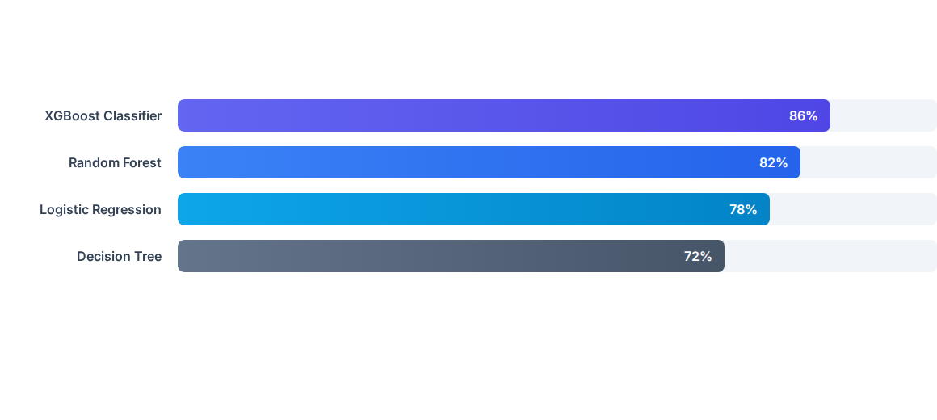
Figure 4.2: Model Accuracy Benchmarks from the Internship Presentation

4.8 Methodology (Continued)

4.8.2 Project 2 – Twitter Sentiment Analysis
The Twitter Sentiment Analysis project follows an NLP pipeline designed to transform unstructured social media text into sentiment information. The project focuses on public sentiment and brand perception.

Step 1: Text Preprocessing
The raw tweet text was cleaned using regular expressions to remove URLs and mentions. Text was converted to lowercase, stop words were removed and lemmatization was applied.

Step 2: Vectorization
The cleaned text was transformed into numerical features using Term Frequency–Inverse Document Frequency (TF-IDF). This converts text into a form suitable for conventional machine learning classifiers.

Step 3: Classification
The project used classification models for sentiment analysis. The project comparison in the supplied presentation identifies Linear SVM as the optimal model, with a reported accuracy of 84%.

Step 4: Sentiment Reporting
The presentation reports 48% overall positive sentiment polarity and identifies negative spikes of 22% for immediate customer-support attention.
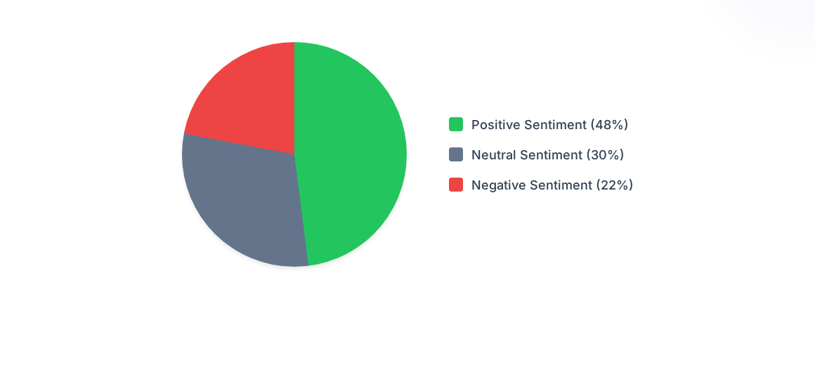
Figure 4.3: Tweet Sentiment Proportions from the Internship Presentation

4.8 Methodology (Comparative Analysis)
The two projects demonstrate how the same broad analytical workflow can be adapted to different data types. The churn project begins with structured tabular records and focuses on predictive classification, whereas the sentiment project begins with unstructured text and requires language-specific preprocessing before classification.
Table 4.5: Projects and Tech Stack Comparison
Metric / Dimension | Project 1: Churn Prediction | Project 2: Twitter Sentiment
Data Format | Structured tabular records (CSV) | Unstructured text (Twitter stream)
Tech Stack & Tools | Python, Pandas, Scikit-Learn, XGBoost | Python, NLTK, TF-IDF, Linear SVM
Optimal Model | XGBoost Classifier – 86% accuracy | Linear SVM – 84% accuracy
Business Impact | Reported reduction in customer attrition by ~18% | Automated real-time brand sentiment tracking
The comparison above reproduces the project-level comparison supplied in the presentation. The reported business impacts are presented as stated in that material.

4.9 Expected Outcomes / Results
The internship outcomes documented in the presentation include both technical learning and measurable project results. The Customer Churn Prediction model achieved a reported ROC-AUC of 0.89 and accuracy of 86%, while the Twitter Sentiment Analysis project reported an accuracy of 84%.

Technical Outcomes
- Hands-on experience with an end-to-end machine learning workflow, including feature engineering, hyperparameter tuning and model evaluation.
- Experience with NLP preprocessing, tokenization, stop-word filtering and vectorization using NLTK and Scikit-Learn.
- Understanding of model evaluation through accuracy, ROC-AUC, precision and recall.
- Experience converting analytical results into business-oriented insights and reports.

Business-Oriented Outcomes
- Customer churn analysis can support proactive retention strategies by identifying high-risk customers.
- Social media sentiment analysis can provide continuous insight into public perception.
- Dashboards and evaluation metrics can help stakeholders interpret model outputs.
- Negative sentiment spikes can be highlighted for potential customer-support intervention.
The presentation also states that the internship involved agile sprint meetings, peer code reviews and cross-functional team presentations, contributing to professional collaboration skills.

4.10 Certificates of Completion and Communication Proof
The internship completion certificate is attached as evidence of completion. It records the internship as a one-month AICTE & ICAC approved Data Analyst Internship conducted from 10 July to 10 August 2026 and names Codec Technologies Pvt. Ltd. as the issuing organization.

Figure 4.4: Copy of Internship Completion Certificate
No separate communication email proof was supplied with the source materials used for preparing this report. If required by the university, the student may attach relevant internship communication separately in this section.

5. Bibliography / References
The following references are based on the sources identified in the supplied internship presentation and the documents used to prepare this report.
- Codec Technologies Pvt. Ltd. Internship Completion Certificate issued to Anushka Singh for the one-month Data Analyst Internship, 10 July 2026 – 10 August 2026.
- DATA ANALYST INTERN PPT.pptx, supplied internship presentation: “Data Science & Machine Learning Internship – End-to-End Predictive Modeling & Social Media Sentiment Analysis.”
- IILM University, School of Computer Science and Engineering, “Internship Report Format updated 26-27,” supplied report-format document.
- Leadsquared / IILM University logo source identified in the supplied presentation: admissions.iilm.edu.
- SlideTeam customer metrics dashboard image source identified in the supplied presentation.
- Thematic social-media text analytics image source identified in the supplied presentation: getthematic.com.

Source note: The certificate identifies Codec Technologies Pvt. Ltd. as the issuing organization, while the supplied presentation contains the name “Analytics Solutions Ltd.” in its organization-profile text. This report uses Codec Technologies Pvt. Ltd. for the official internship identity because it is the organization named on the completion certificate, and retains the presentation’s project descriptions and technical details as supplied.

