BABU BANARASI DAS
UNIVERSITY

2026-2027

SCHOOL OF COMPUTER APPLICATIONS
No SQL On Project
Student Management System Using MongoDB

Submitted by: Submitted to:
Name: Anushka Gupta Mr. Harendra Singh
University Rollno. 1250258114
Course: BCA (DS & AI)

1. CREATE DATABASE
MongoDB Query:
use Anushka
Explanation: Creates or switches to the Student database
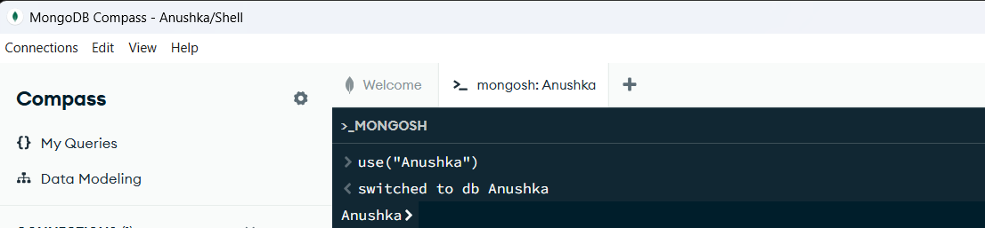
2. CREATE COLLECTION
MongoDB Query:
Explanation: Create a collection named student
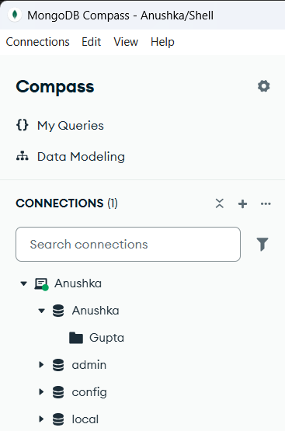
3. INSERT 50 STUDENTS
MongoDB Query:
db. Gupta. Insert Many([ ])
{roll:1, name:"Anushka", age:19,marks:96,city:"Lucknow"},
{roll:2, name:"Arjun", age:18,marks:76,city:"Jaunpur"},
{roll:3, name:"Abhishek ", age:19,marks:94,city:"Kanpur"},
{roll:4, name:"Nikhil", age:18,marks:69,city:"Ayodhya"},
{roll:5, name:"Sakshi", age:19,marks:81,city:"Varanasi"},
{roll:6, name:"Rohit", age:20,marks:85,city:"Lucknow"},
{roll:7, name:"Pooja", age:19,marks:73,city:"Prayagraj"},
{roll:8, name:"Kunal", age:19,marks:90,city:"Lucknow"},
{roll:9, name:"Simran", age:20,marks:78,city:"Gorakhpur"},
{roll:10, name:"Mohit", age:18,marks:65,city:"Kanpur"},
{roll:11, name:"Deepak", age:20,marks:71,city:"Jaunpur"},
{roll:12, name:"Ishita", age:19,marks:95,city:"Lucknow"},
{roll:13, name:"Nandini", age:18,marks:84,city:"Ayodhya"},
{roll:14, name:"Ritika", age:19,marks:87,city:"Prayagraj"},
{roll:15, name:"Manish", age:20,marks:74,city:"Varanasi"},
{roll:16, name:"Tanya", age:18,marks:89,city:"Lucknow"},
{roll:17, name:"Aarav", age:19,marks:82,city:"Kanpur"},
{roll:18, name:"Rajat", age:18,marks:58,city:"Gonda"},
{roll:19, name:"Shivani", age:20,marks:91,city:"Lucknow"},
{roll:20, name:"Varun", age:19,marks:63,city:"Bareilly"},
{roll:21, name:"Rishabh", age:18,marks:77,city:"Lucknow"},
{roll:22, name:"Muskan", age:19,marks:86,city:"Jaunpur"},
{roll:23, name:"Komal", age:20,marks:72,city:"Kanpur"},
{roll:24, name:"Saurabh", age:19,marks:80,city:"Ayodhya"},
{roll:25, name:"Payal", age:18,marks:67,city:"Prayagraj"},
{roll:26, name:"Radhika", age:20,marks:92,city:"Lucknow"},
{roll:27, name:"Apurvi ", age:19,marks:88,city:"Lucknow"},
{roll:28, name:"Gaurav", age:18,marks:61,city:"Gorakhpur"},
{roll:29, name:"Mansi", age:19,marks:75,city:"Kanpur"},
{roll:30, name:"Amit", age:20,marks:79,city:"Lucknow"},
{roll:31, name:"Shivam", age:18,marks:68,city:"Jaunpur"},
{roll:32, name:"Preeti", age:19,marks:90,city:"Lucknow"},
{roll:33, name:"Ravi", age:20,marks:55,city:"Ayodhya"},
{roll:34, name:"Pallavi", age:18,marks:83,city:"Kanpur"},
{roll:35, name:"Yash", age:19,marks:93,city:"Prayagraj"},
{roll:36, name:"Nisha", age:20,marks:70,city:"Lucknow"},
{roll:37, name:"Harshit", age:18,marks:81,city:"Varanasi"},
{roll:38, name:"Pankaj", age:19,marks:66,city:"Gorakhpur"},
{roll:39, name:"Sneha", age:20,marks:90,city:"Lucknow"},
{roll:40, name:"Aditi", age:19,marks:85,city:"Kanpur"},
{roll:41, name:"Vikas", age:18,marks:74,city:"Jaunpur"},
{roll:42, name:"Payal", age:20,marks:89,city:"Lucknow"},
{roll:43, name:"Monika", age:19,marks:62,city:"Ayodhya"},
{roll:44, name:"Shubham", age:18,marks:78,city:"Prayagraj"},
{roll:45, name:"Divya", age:20,marks:84,city:"Lucknow"},
{roll:46, name:"Akash", age:19,marks:73,city:"Kanpur"},
{roll:47, name:"Ramesh", age:18,marks:59,city:"Gonda"},
{roll:48, name:"Swati", age:20,marks:87,city:"Lucknow"},
{roll:49, name:"Vivekanand", age:19,marks:64,city:"Bareilly"},
{roll:50, name:"Kriti", age:18,marks:91,city:"Varanasi"}

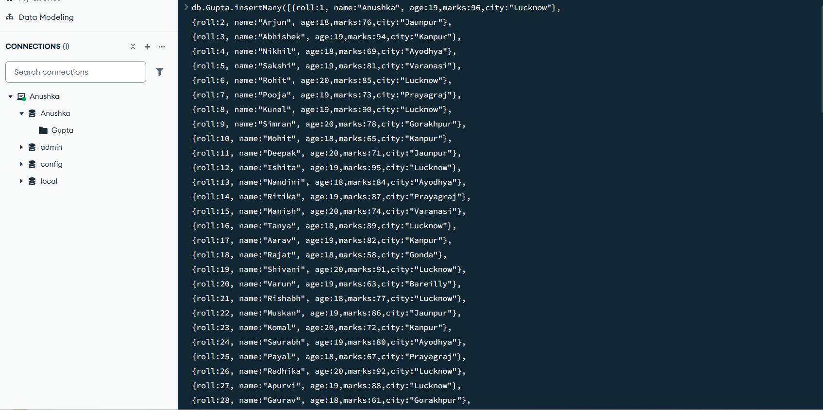

4. DISPLAY ALL STUDENTS
MongoDB Query:
db. Gupta. Find ()
Explanation: Retrieves documents from the students collection.
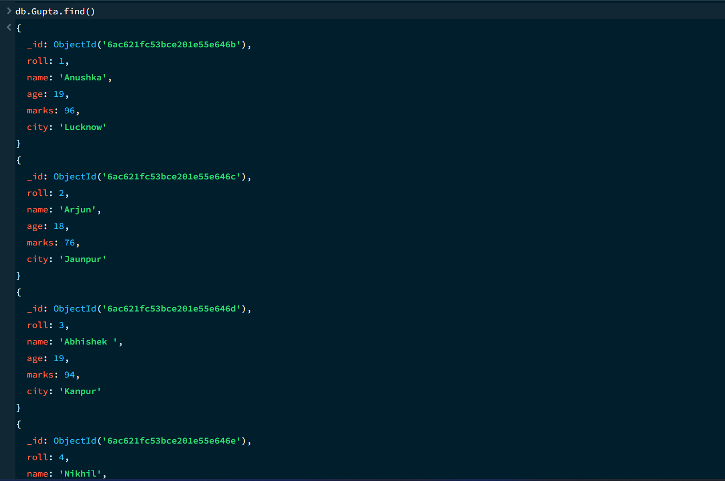

5. EQUAL TO — $eq
MongoDB Query:
db. Gupta. Find ({marks: {$eq: 88}})
Explanation: Finds students whose marks are exactly 88.

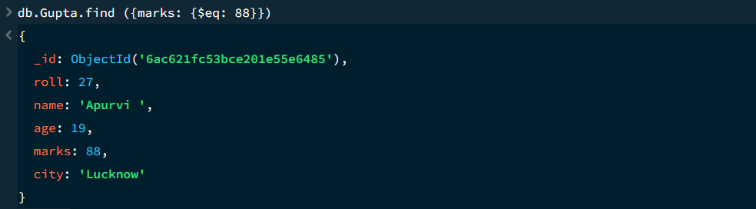

6. GREATER THAN — $gt
MongoDB Query:
db.Gupta.find({marks: {$gt: 85}})
Explanation: Finds students whose marks are greater than 85.
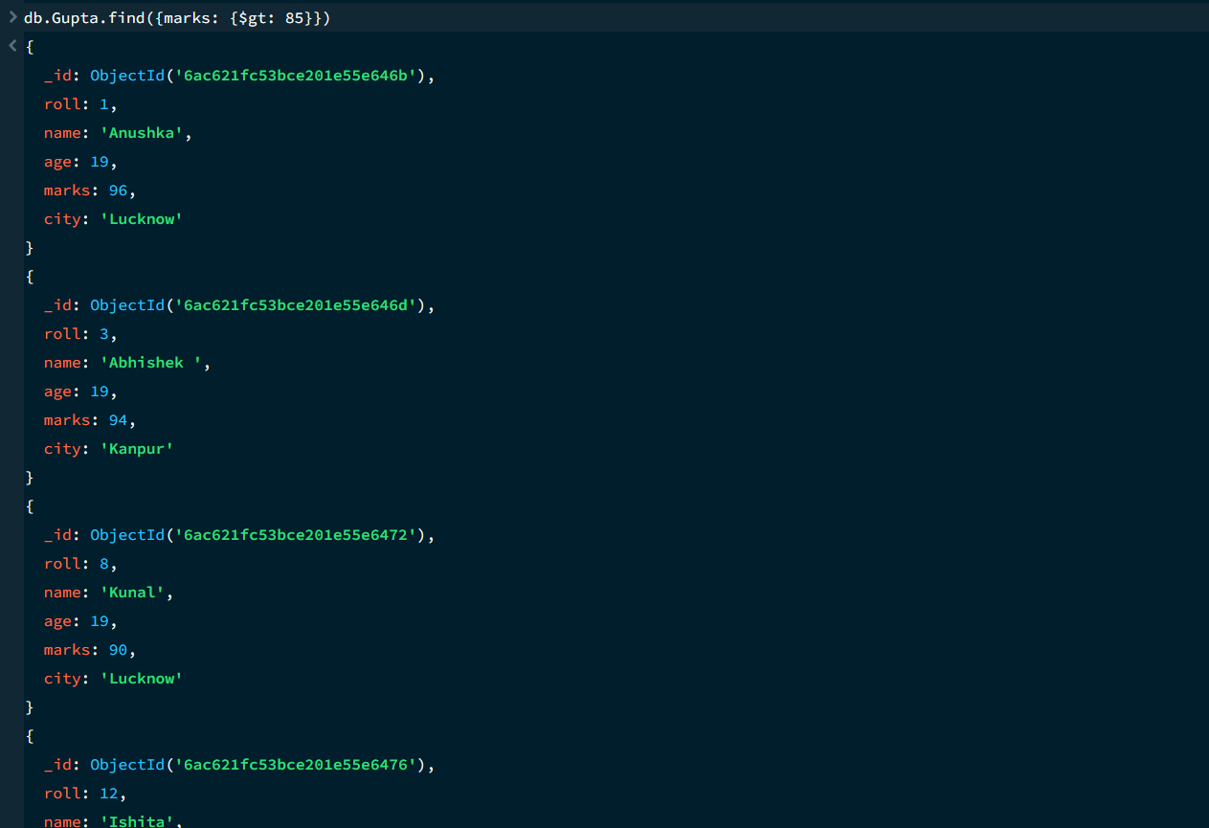

7. LESS THAN — $lt
MongoDB Query:
db. Gupta. find ({marks: {$lt: 60}})
Explanation: Finds students whose marks are less than 60.
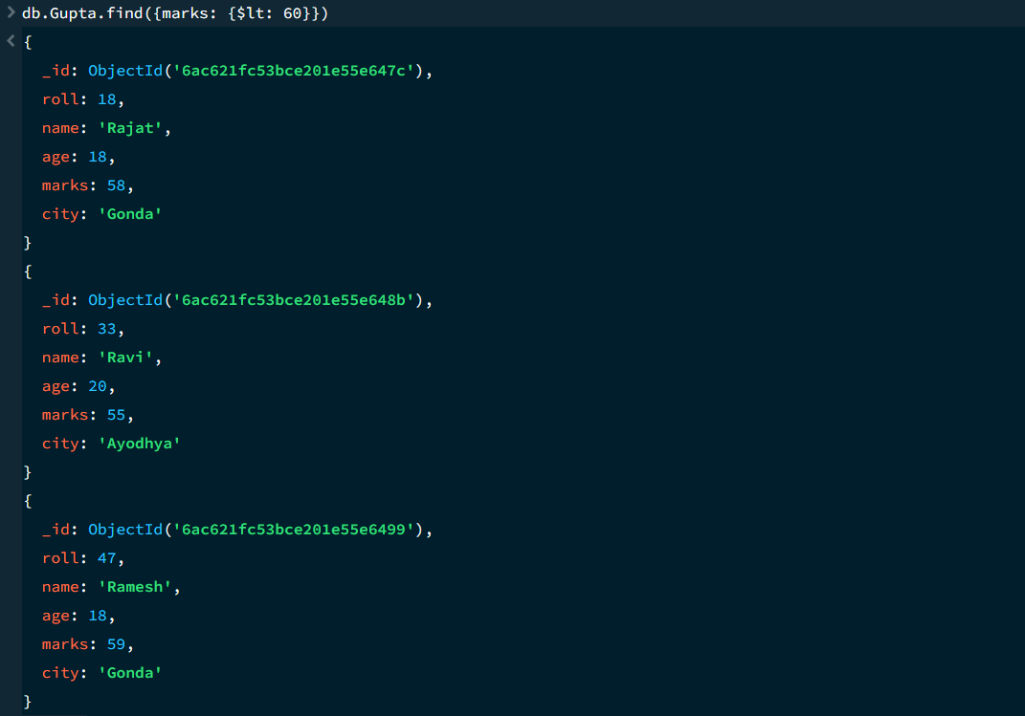

8. GREATER THAN OR EQUAL TO — $gte
MongoDB Query:
db. Gupta. find({marks: {$gte: 90}})
Explanation: Finds students whose marks are 90 or above.
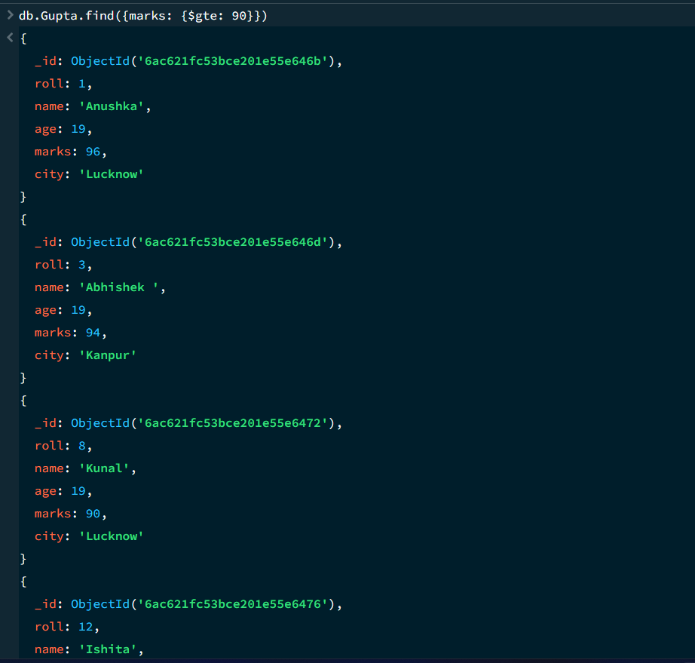

9. LESS THAN OR EQUAL TO — $lte
MongoDB Query:
db. Gupta. find({marks: {$lte: 70}})
Explanation: Finds students whose marks are 70 or below.

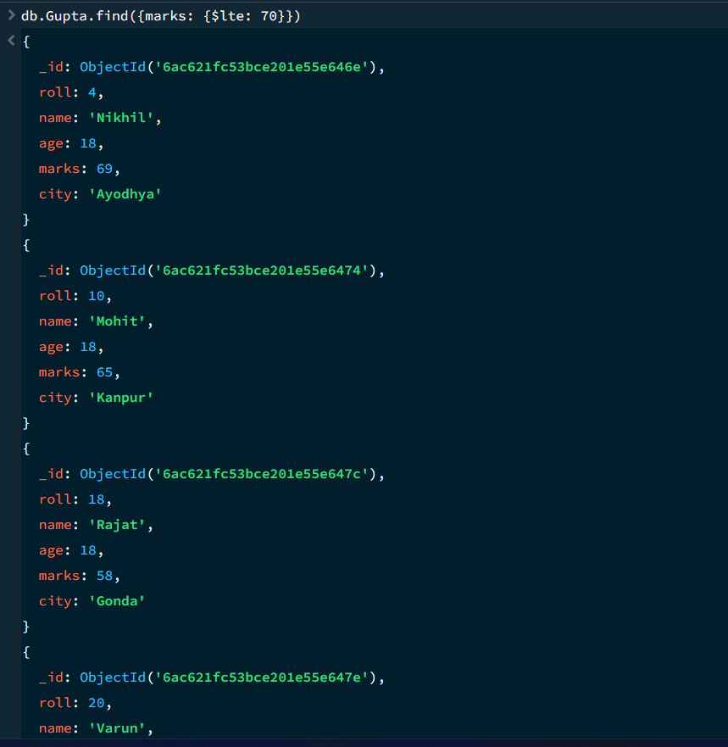

10. UPDATE OPERATION
MongoDB Query:
db.Gupta.updateOne(
{roll:5},
{$set:{marks:95}}
)
Explanation: Updates the marks to 95 of the student with roll number 5.

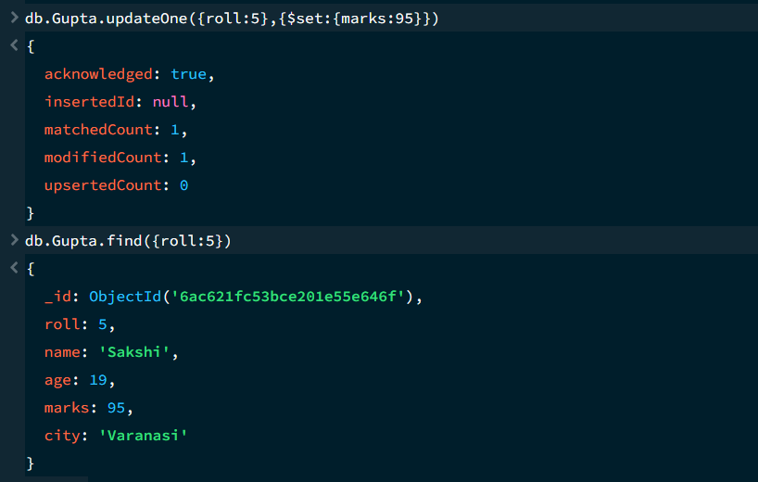

11. DELETE ONE OPERATION
MongoDB Query:
db.Gupta.deleteOne({roll:10})
Explanation: Deletes one document matching roll number 10.

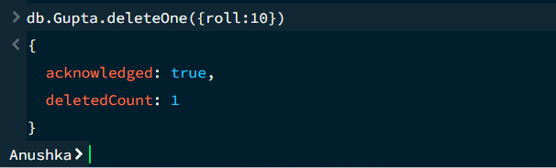

12. DELETE MANY OPERATION
MongoDB Query:
db.Gupta.deleteMany({
marks: {$lt:60}
})
Explanation: Deletes all students having marks below 60.

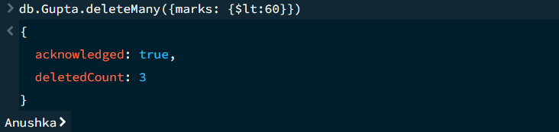

13. AND OPERATION — $and
MongoDB Query:
db. Gupta. find({
$and:[
{marks:{$gt:80}},
{age:19}
]
})
Explanation: Finds students satisfying both conditions.
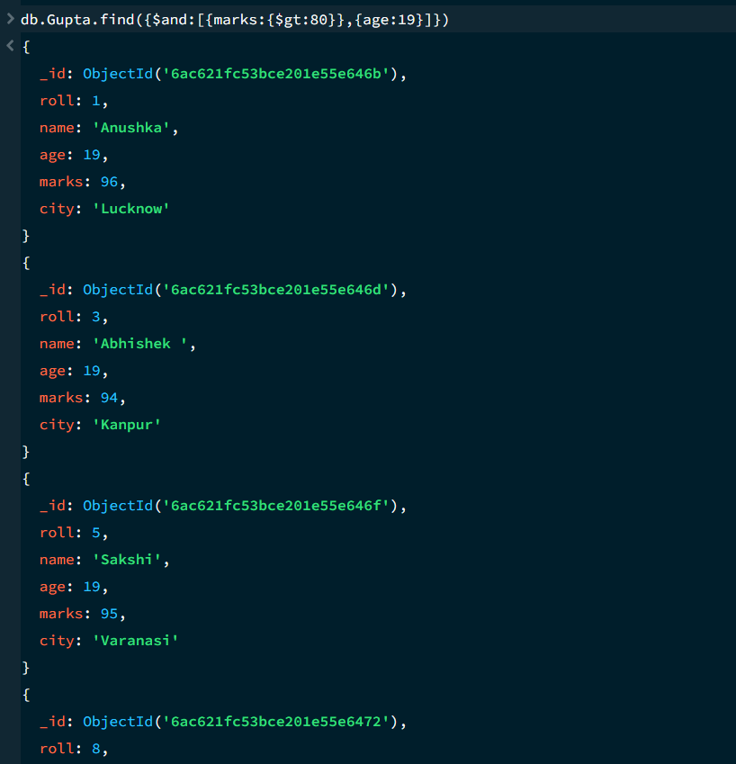

14. OR OPERATION — $or
MongoDB Query:
db.Gupta.find({
$or:[
{city:"Lucknow"},
{city:"Kanpur"}
]
})
Explanation: Finds students from Lucknow or Kanpur.

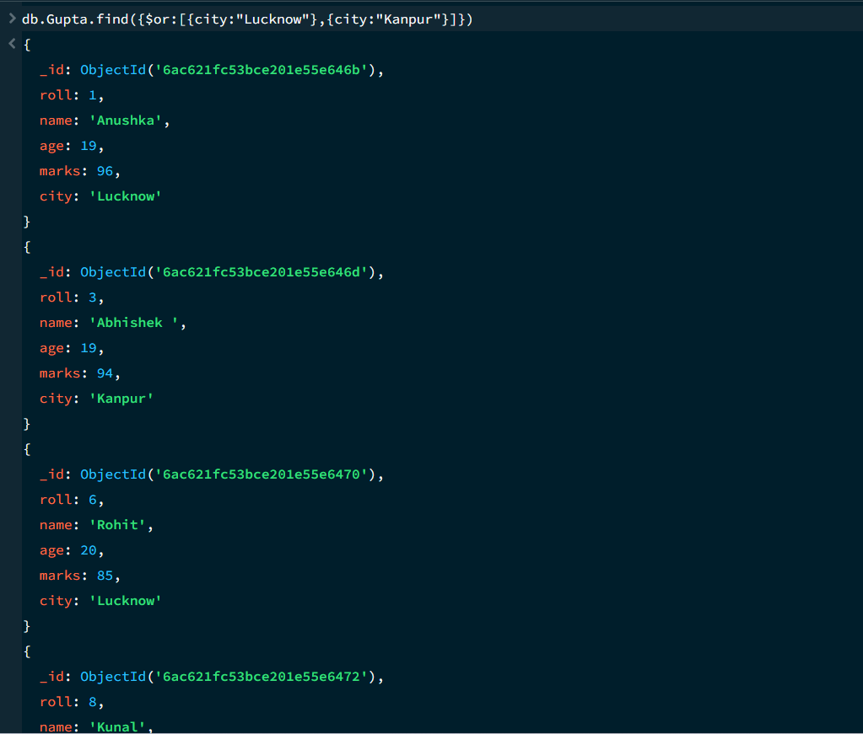

15. SORT OPERATION
A.MongoDB Query:
db. Gupta. find (). sort({marks : 1})
Explanation: Sorts students by marks from lowest to highest. Use 1 for ascending order.

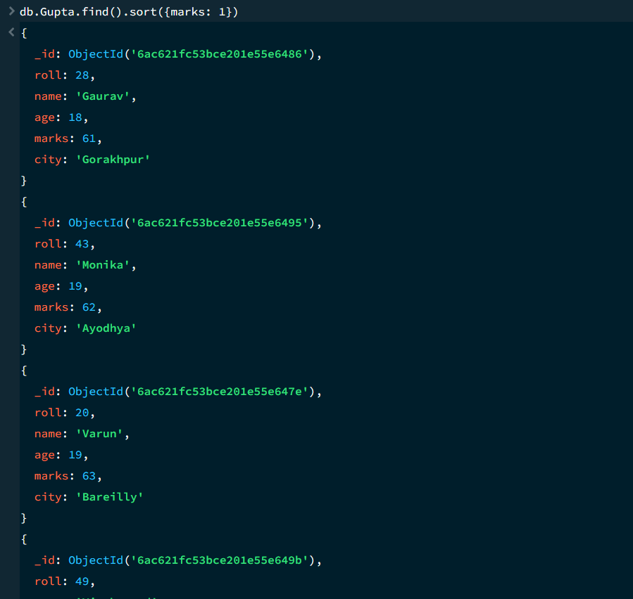

B. MongoDB Query:
db. Gupta. find (). Sort ({marks: -1})
Explanation: Sorts students by marks from highest to lowest. Use -1 for descending order.
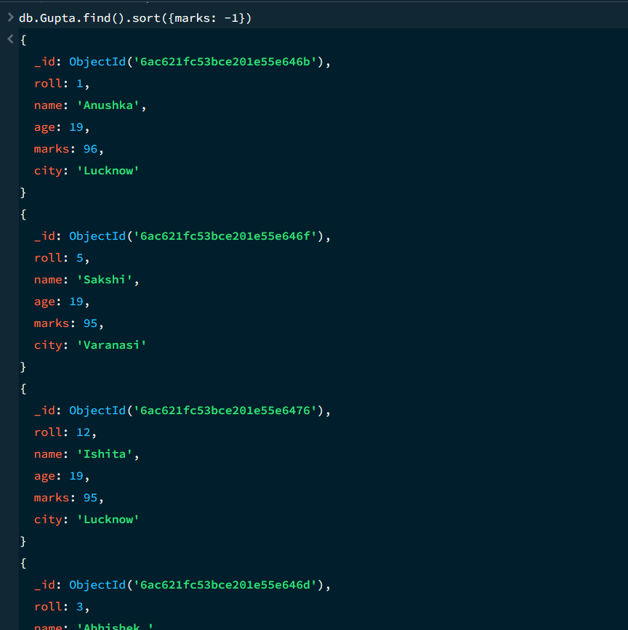

16. LIMIT OPERATION
MongoDB Query:
db. Gupta. find (). limit (5)
Explanation: Displays only the first five documents.

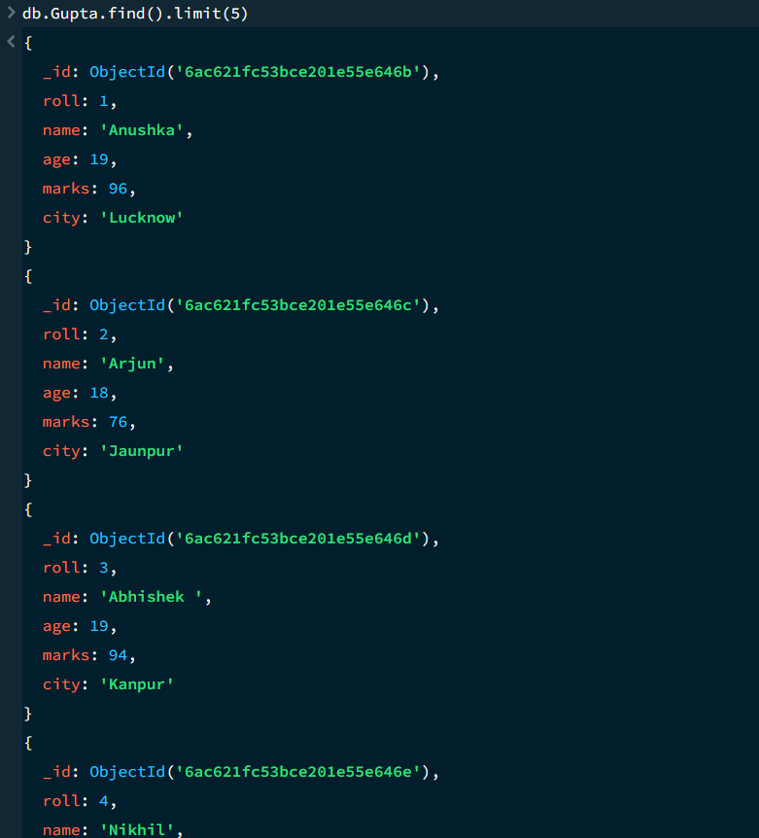

17. SEARCH BY CITY
MongoDB Query:
db.Gupta.find({city:"Lucknow"})
Explanation: Finds all students whose city is Lucknow.

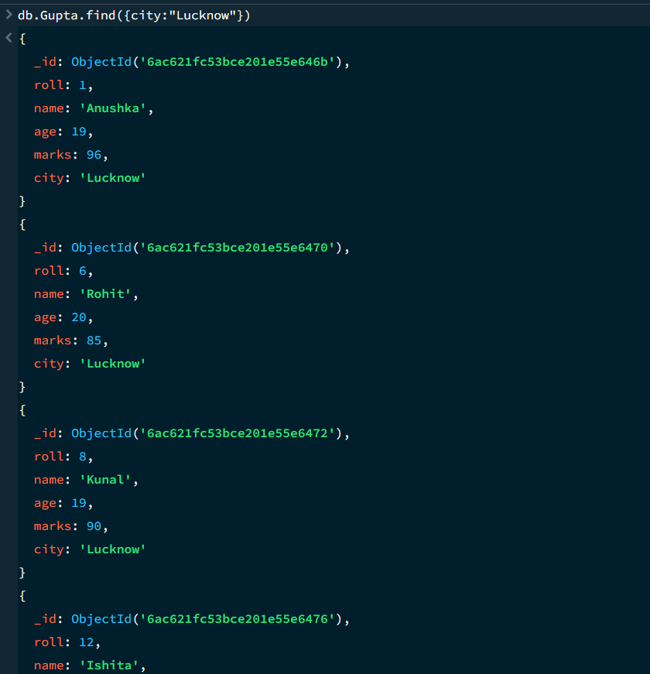

18. COUNT DOCUMENTS
MongoDB Query:
db. Gupta. count Documents ()
Explanation: Counts documents currently present in the collection (performing after the delete function).

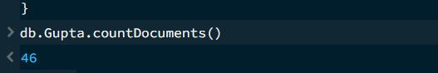
MONGODB OPERATORS USED:

Operator | Meaning | Example
$eq | Equal to | marks: {$eq:88}
$gt | Greater than | marks: {$gt:85}
$lt | Less than | marks: {$lt:60}
$gte | Greater than or equal to | marks: {$gte:90}
$lte | Less than or equal to | marks: {$lte:70}
$and | All conditions true | $and:[...]
$or | At least one condition true | $or:[...]

CONCLUSION
This project provided practical knowledge of NoSQL databases using MongoDB. A Student Management System containing student information was created and different MongoDB operations were performed on the data.
Through this project, I learned how to insert, retrieve, update, and delete documents. I also learned how to Ascending order & descending order data, comparison operators such as $eq, $gt, $lt, $gte, and $lte work, along with logical operators such as $and and $or.
Overall, this project helped me understand how MongoDB can be used to manage and query student data efficiently.

