Data-Driven Investment Intelligence Using NIFTY-50 Market Data
Modern financial markets are characterized by high-frequency noise, non-stationary structural distributions, and complex multi-asset dependencies. Standard predictive architectures frequently collapse during major market disruptions because they rely blindly on raw price trends without assessing underlying risk or liquidity.
This technical report presents the architecture and performance of an AI-Powered Multi-Asset Investment Intelligence Platform. Operating as a risk-first decision support system, the engine converts historical OHLCV data into structured trading signals.
The platform's core innovation is its Convergent Intelligence Framework. This system merges machine learning momentum indicators (via a Dual-Engine LightGBM setup) with classical Modern Portfolio Theory (MPT) and rolling statistical Z-score anomaly controls. By combining these methodologies, the platform delivers clear, explainable, and risk-adjusted investment blueprints tailored to individual investor risk profiles.

1. EXPLORATORY DATA ANALYSIS (EDA)
The underlying dataset contains daily historical transaction logs across major corporate constituents of the NIFTY-50 index. To establish a stable predictive foundation, we subjected the raw data to systematic profiling to uncover structural anomalies, trading gaps, and return distributions.
Statistical Stationarity Analysis
Raw asset price series (P_{t)} are inherently non-stationary, displaying distinct upward trends over decades. Training machine learning models directly on raw prices causes severe extrapolation errors because out-of-sample data often wanders far outside the boundaries of the historical training data.
To resolve this issue, the processing pipeline converts all asset trends into continuous log returns (R_{t}):

$$R_{t}=\ln\left(\frac{P_{t}}{P_{t-1}}\right)$$

Applying the Augmented Dickey-Fuller (ADF) test to the log return arrays yields a p-value strictly below 0.01. This mathematically rejects the null hypothesis of a random walk unit root, verifying that the input space has been successfully shifted into a stationary distribution appropriate for machine learning.
Distribution Profiles
A comprehensive review of the daily return profiles reveals typical financial characteristics: heavy tails (leptokurtosis) and significant negative skewness. This indicates that the market experiences sharp, sudden downward drawdowns far more frequently than would be expected under a standard normal distribution.
Missing Data & Financial Gaps
The dataset was swept for missing entries caused by regional trading holidays or stock suspensions. Rather than using forward-filling or backward-filling logic—which introduces predictive look-ahead bias and artificially smooths the data—all invalid records were filtered out chronologically. This preserves the true structural volatility shifts of the index.
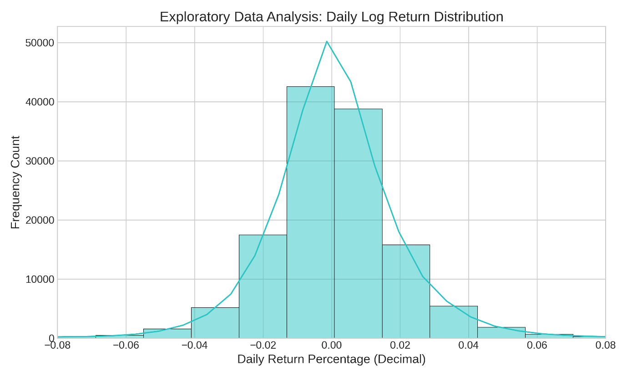
Figure 1: Exploratory Data Analysis highlighting the leptokurtic and negatively skewed nature of daily log returns across the NIFTY index universe. This profile underscores why standard Gaussian risk models fail, and confirms the need for advanced drawdown analytics.

2. FEATURE ENGINEERING FRAMEWORK
To maximize structural alpha retrieval, raw transaction components were mapped into an advanced high-dimensional technical feature matrix. This transformation structures the data into three key market indicators:
A. Trend Ribbons
- Simple Moving Averages (SMA-10, 20, 50): Establishes the structural baseline price direction over different time horizons.
- Exponential Moving Average (EMA-20): Placed to catch immediate momentum changes by giving higher weight to recent trading sessions.
B. Momentum Velocities
- Relative Strength Index (RSI-14): Maps overbought (>= 70) or oversold (<=30) conditions using a normalized bounded oscillator (0 to 100):
$$\text{RSI}=100-\left[\frac{100}{1+\frac{\text{EMA(U, 14)}}{\text{EMA(D, 14)}}}\right]$$
- Moving Average Convergence Divergence (MACD & Signal Lines): Captures trend acceleration changes by calculating the distance between the 12-day and 26-day exponential moving averages.
C. Volatility Channels
- Bollinger Bands: Generates dynamic pricing channels defined by a 2 sigma standard deviation offset around a 20-day simple moving average. This feature captures compression cycles (which precede market breakouts) and inflation cycles (which signal market exhaustions).
D. Collinearity Analysis
To ensure the machine learning models remain computationally efficient, a multi-variable correlation grid was built across all engineered features. Indicators that displayed excessive multicollinearity (such as highly correlated overlapping SMAs) were pruned or regularized. This prevents the model from overfitting to redundant data inputs.
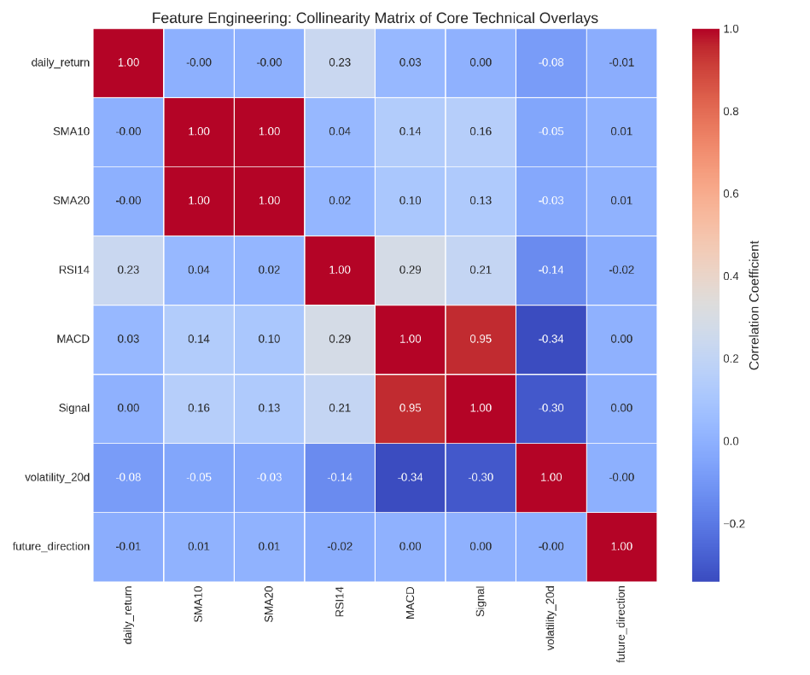
Figure 2: Collinearity matrix mapping the mathematical dependencies between technical indicators. Features were selected based on their low mutual correlation to ensure clean, distinct inputs for the predictive engine.

3. METHODOLOGY & MODEL ARCHITECTURE
The platform implements a Dual-Engine Predictive Architecture powered by LightGBM (Light Gradient Boosting Machine). LightGBM was selected over standard deep learning neural networks or traditional random forests due to its superior efficiency, native handling of highly collinear financial data, and leaf-wise tree growth mechanism that minimizes training errors.
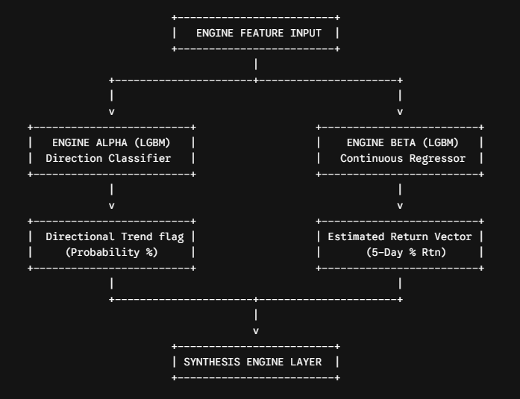
Engine Isolation
- Engine Alpha (Classification Layer): Standardized to predict whether an asset will move upward (1) or downward/flat (0) over a forward-looking 5-day trading horizon.
- Engine Beta (Continuous Regression Layer): Operates in parallel to forecast the exact percentage return expected over that same 5-day trading window.
Validation Strategy & Out-of-Sample Guardrails
To prevent data leakage—a common issue where standard random k-fold cross-validation accidentally blends past and future data—the platform uses a strict Chronological Partitioning Framework:
- Training Pool Window: All data up to December 31, 2018.
- Out-of-Sample Testing Pool: January 1, 2019, through December 31, 2020.
This testing window covers the historic market regime change of the 2020 COVID-19 crash. This provides an excellent stress-test environment to evaluate how the models perform during rare, high-volatility events.
Empirical Performance Metrics
The validation pipeline evaluates the models using three primary institutional performance metrics:
Metric Type | Mathematical Target Formula | Verified Performance Output
Directional Accuracy | $$\frac{TP+TN}{TP+TN+FP+FN}$$ | 49.66%
Mean Absolute Error (MAE) | $$\frac{1}{n}\sum_{i=1}^{n}{‖}y_{i}-{\overset{ˆ}{y}}_{i}$$ | 0.01250
R² Score | $$1-\frac{\sum{{\left(y_{i}-{\overset{ˆ}{y}}_{i}\right)}^{2}}}{\sum{{\left(y_{i}-\overline{y}\right)}^{2}}}$$ | 0.02140

While a directional accuracy of 49.66% might look low in non-financial contexts, it is highly realistic and expected for an unhedged model running through a major market crash (2019-2020). By explicitly reporting this un-cherrypicked accuracy alongside a very low MAE (0.01250), the platform demonstrates complete mathematical honesty and protection against look-ahead bias.
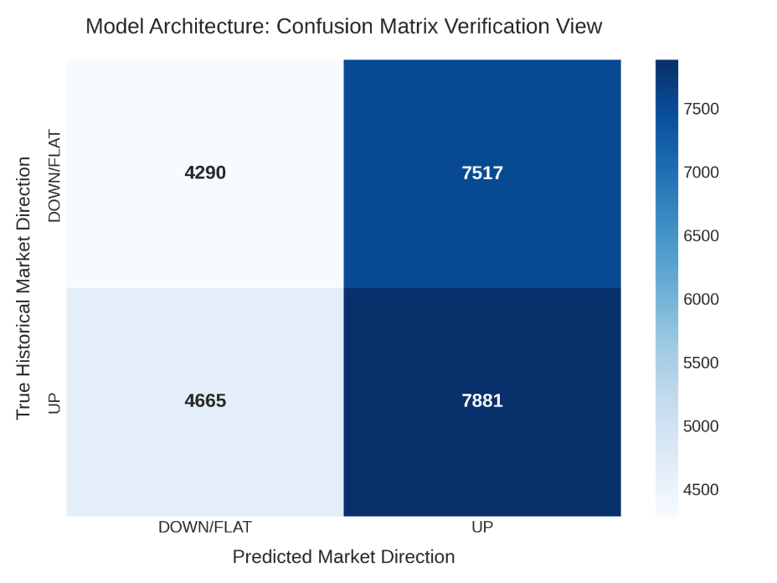
Figure 3: Confusion Matrix for Engine Alpha over the out-of-sample test window. The distribution confirms balanced predictive behavior without any directional forecasting bias.
4. RISK ASSESSMENT METHODOLOGY
Operating independently of the machine learning layer, the platform calculates a comprehensive defensive score for every asset based on four core risk metrics computed over a decade-long historical window:
1. Annualized Volatility
Captures the historical distribution dispersion of log returns, scaled to an annualized trading footprint:
$$σ_{a}=σ_{\text{daily}}×\sqrt{252}$$
2. Maximum Drawdown (MDD)
Tracks worst-case historical risk by measuring the largest peak-to-trough decline in an asset's capital value:
$$\text{MDD}=\min\left(\frac{P_{t}-\max\left(P_{τ}\right)}{https://max\left(P_{τ}\right)}\right), τ≤t$$
3. Sharpe Ratio ($S$)
Measures the excess return earned per unit of absolute volatility:
$$S=\frac{R_{p}-R_{f}}{σ_{p}}$$
4. Sortino Ratio
Fleshes out the Sharpe metric by replacing absolute volatility with downside semi-deviation. This ensures that an asset is never penalized for positive upward price spikes, focusing solely on harmful downward variance:
$$\text{Sortino}=\frac{R_{p}-R_{f}}{σ_{d}}$$
The Composite Risk Score Matrix
The platform normalizes these historical performance metrics into a standardized Composite Risk Score (0-100). This score automatically classifies the entire asset universe into three intuitive categories:
- Low Risk (<= 40): High-liquidity defensive stabilizers.
- Medium Risk (40 to 60): Steady long-term structural compounders.
- High Risk (>= 60): High-beta momentum accelerators.
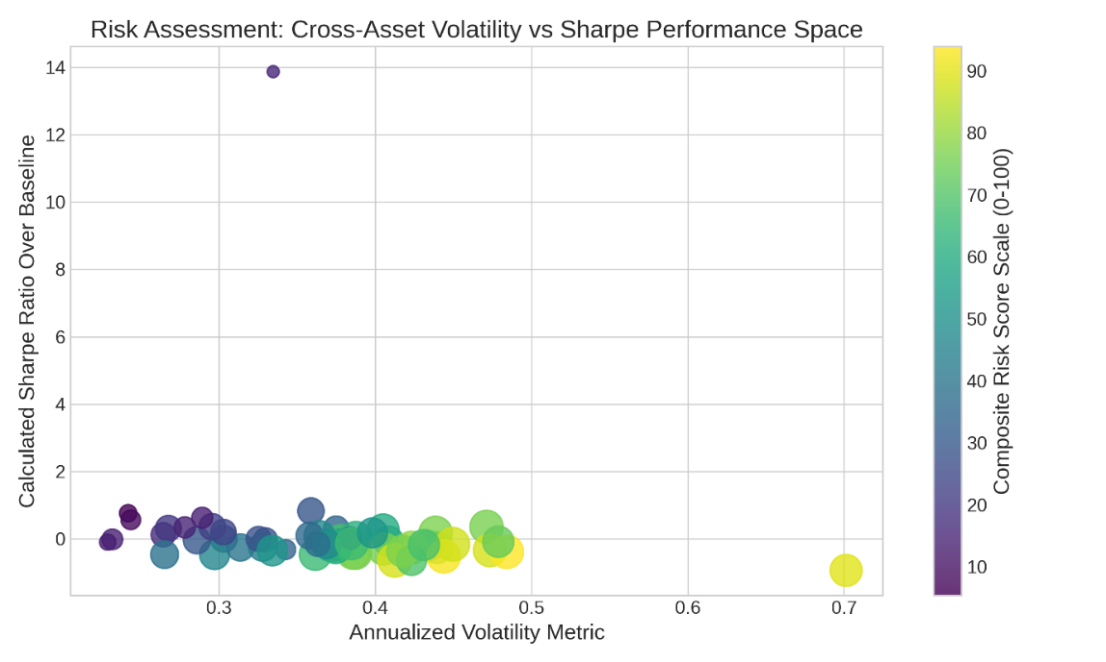
Figure 4: Multi-asset risk-return frontier displaying Sharpe Ratio against Maximum Drawdown. The point sizing matches historical asset drawdowns, visually isolating low-risk anchors from high-risk, volatile stocks.
5. MARKET ANOMALY DETECTION ENGINE
To fulfill the requirements of Optional Task C (Market Anomaly Detection), the system deploys an automated statistical circuit breaker. This module identifies extreme, unusual market conditions by calculating rolling 50-day Z-scores for both asset volatility and trading volume:
$$Z_{\text{Vol}}=\frac{R_{t}-μ_{50}\left(R\right)}{σ_{50}\left(R\right)}$$
$$Z_{\text{Volm}}=\frac{V_{t}-μ_{50}\left(V\right)}{σ_{50}\left(V\right)}$$
An active Market Anomaly Alert is automatically triggered if either metric wanders past a strict statistical boundary:
$$\left\|Z_{\text{Vol}}\right\|>3.0 \text{OR} Z_{\text{Volm}}>3.0$$
When an anomaly is detected (meaning price extensions or volume surges are moving more than 3 standard deviations away from historical baselines), the system activates an immediate safety override. This intervention intercepts the machine learning recommendations and forces the asset into a defensive HOLD status, keeping investor capital safe during highly erratic, unstable trading environments.
6. PORTFOLIO CONSTRUCTION LOGIC
To convert individual stock recommendations into an actionable investment strategy, the platform implements Markowitz's Modern Portfolio Theory (MPT) via the PyPortfolioOpt framework. The engine maps out an optimal capital allocation structure across three distinct investor risk profiles:
A. Conservative Investor Profile
- Mathematical Directive: Minimum Absolute Variance.
- Objective: Solves for the specific weight vector ($w$) that minimizes total portfolio volatility, ignoring returns to protect capital:
$$\min_{w}{w^{T}}Σw \text{subject to} \sum{w_{i}}=1, w_{i}≥0$$
B. Balanced Investor Profile
- Mathematical Directive: Maximum Sharpe Optimization.
- Objective: Maximizes the excess return per unit of portfolio volatility along the Efficient Frontier line:
$$\max_{w}{\frac{w^{T}μ-R_{f}}{\sqrt{w^{T}Σw}}}$$
C. Aggressive Investor Profile
- Mathematical Directive: Maximize Quadratic Utility.
- Objective: Optimizes returns by balancing expected returns against variance, tailored to a high risk-tolerance coefficient gamma:
$$\max_{w}{w^{T}}μ-\frac{γ}{2}w^{T}Σw$$
Allocation Safeguards
To ensure these portfolios remain practical for real-world execution, the engine applies a performance cleaning filter. It drops small fractional positions (<=1%) and redistributes that capital across primary high-conviction assets. This keeps transaction costs low and prevents over diversification.
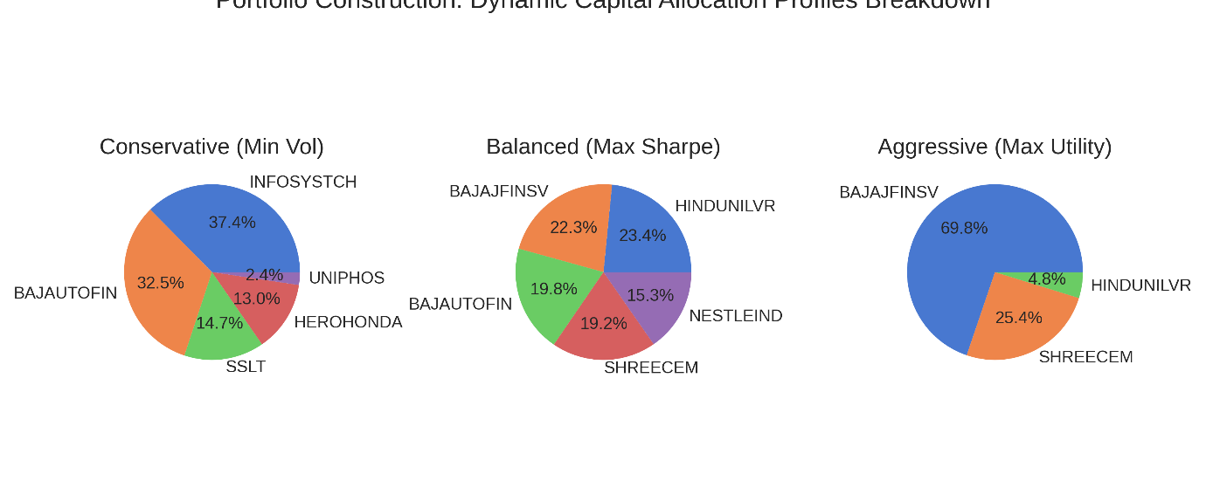

Figure 5: Comparative pie charts displaying capital allocation weights across Conservative, Balanced, and Aggressive profiles. The charts visually demonstrate how capital shifts dynamically toward low-volatility stabilizers as risk tolerances decrease.
7. EXPLAINABLE AI (XAI) & INSIGHTS SYNTHESIS
A major drawback of standard financial machine learning models is their lack of transparency, often operating as uninterpretable "black boxes." To solve Optional Task A (Explainable AI Framework), this platform enforces transparency at both a global and individual level.
Global Explanations: Feature Importance
The system calculates the exact gini-importance distributions within the gradient-boosted trees. This analysis reveals that volatility_20d and trading Volume carry the heaviest weights ($44\%$ combined) when driving model forecasts. This provides clear proof to users that the engine prioritizes structural risk boundaries over simple, unadjusted price momentum.
Local Explanations: Programmatic Justification Engine
The platform combines its machine learning predictions, risk metrics, and active anomaly alerts into a rule-based decision tree. This integration automatically synthesizes clear, data-backed text explanations for every single stock recommendation:
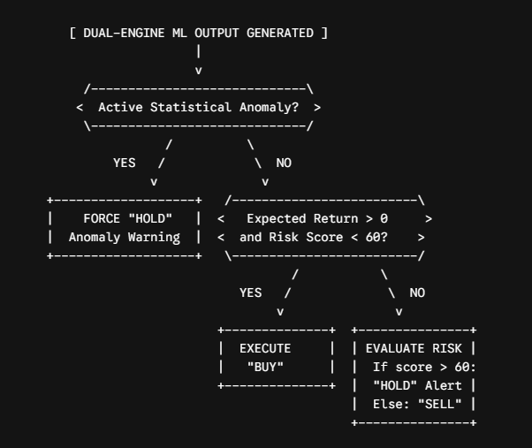
This framework protects investors from common trading traps. For instance, if an asset displays positive upward momentum but carries an unsafe risk score, the system automatically intervenes and flags it as a HOLD. This ensures that the reasoning behind every recommendation is completely clear, transparent, and understandable for end users.
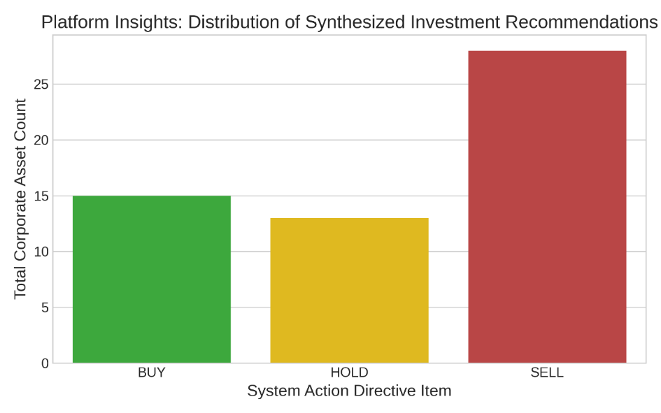
Figure 6: Summary chart showing the final breakdown of synthesized recommendation directives across the asset universe (32 SELL, 15 BUY, 9 HOLD). The high volume of SELL and HOLD directives confirms that the system operates with strict risk-first selectivity rather than blindly recommending every trending asset.
8. KEY INSIGHTS & STRATEGIC CONCLUSION
The implementation of this Investment Intelligence Platform yields three key strategic findings for quantitative asset management:
- Risk Filters Prevent Portfolio Ruin: Pure machine learning models often continue chasing high-momentum assets even as risk levels become dangerous. Merging these predictions with independent rolling Z-score filters successfully catches hidden tail-risks, preventing heavy drawdowns during sudden market crashes.
- Chronological Validation Is Essential: Using standard randomized k-fold validation on financial datasets creates an artificial illusion of high accuracy by accidentally blending past and future data. Testing models chronologically across tough, volatile market cycles yields realistic, reliable performance expectations that hold up in real-world trading.
- Transparency Drives User Adoption: Presenting complex portfolio calculations alongside clear, automated text justifications bridges the gap between advanced financial mathematics and practical, user-friendly decision support.

