MINI PROJECT

**(2021-22)**

**“WHATSAPP CLONE”**

Project Report

****

**Institute of Engineering & Technology**

**Submitted By –**

Anushka Singh Rathore(191500143)

**Under the Supervision Of**

**Mr. Amir Khan**

**Technical Trainer**

**Department of Computer Engineering & Applications**

****

**Declaration**

We hereby declare that the work which is being presented in the Bachelor of technology. Project **“WhatsApp Clone”**, in partial fulfillment of the requirements for the award of the ***Bachelor of Technology*** in Computer Science and Engineering and submitted to the Department of Computer Engineering and Applications of GLA University, Mathura, is an authentic record of my own work carried under the supervision of **Mr. Amir Khan, Technical Trainer, Dept. of CEA, GLA University.**

The contents of this project report, in full or in parts, have not been submitted to any other Institute or University for the award of any degree.

**Sign**: Anushka Singh Rathore

**Name of Candidate**: Anushka Singh Rathore

**University Roll No.:191500143**

****

**Certificate**

This is to certify that the project entitled “WhatsApp Clone”, carried out in Mini Project – 2 Lab, is a bonafide work by Anushka Singh Rathore and is submitted in partial fulfillment of the requirements for the award of the degree Bachelor of Technology (Computer Science & Engineering).

**Signature of Supervisor:**

**Name of Supervisor:** Md. Amir Khan

**Date:**

**Training Certificates**

**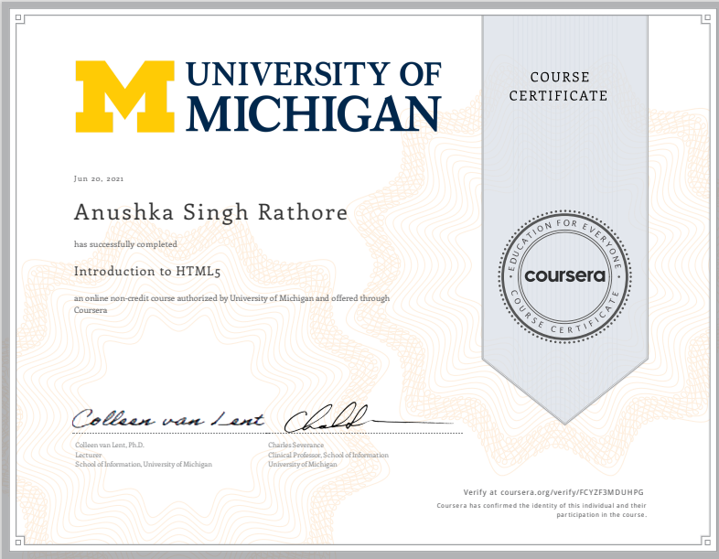**

**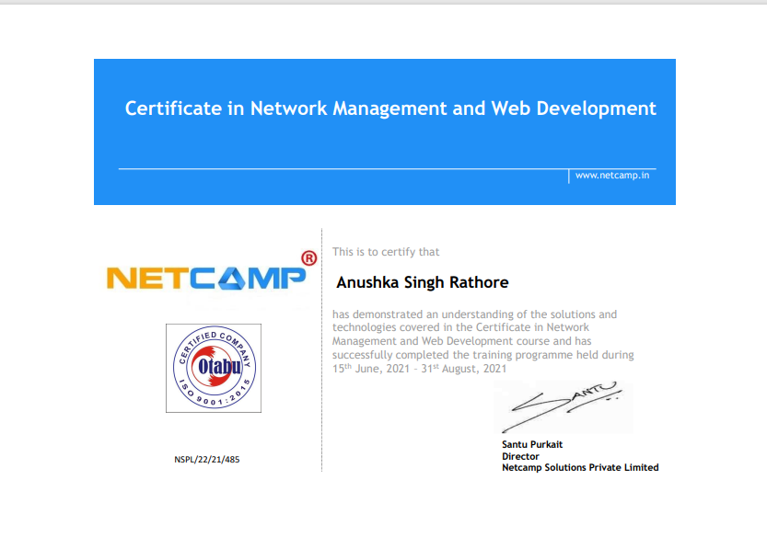**

****

**ACKNOWLEDGEMENT**

Presenting the ascribed project paper report in this very simple and official form, we would like to place my deep gratitude to GLA University for providing us with the instructor Mr. Amir Khan, our technical trainer and supervisor.

He has been helping us since Day 1 in this project. He provided us with the roadmap, the basic guidelines explaining how to work on the project. He has been conducting regular meetings to check the progress of the project and providing us with the resources related to the project. Without his help, we wouldn’t have been able to complete this project.

And last but not least we would like to thank our dear parents for helping us to grab this opportunity to get trained and also my colleagues who helped me find resources during the training.

Thanking You

**Sign**:Anushka Singh Rathore

**Name of Candidate**: Anushka Singh Rathore

**University Roll No. : 191500143**

**ABSTRACT**

**WhatsApp Messenger**, or simply **WhatsApp**, is an internationally available American [freeware](https://en.wikipedia.org/wiki/Freeware" \o "Freeware), [cross-platform](https://en.wikipedia.org/wiki/Cross-platform" \o "Cross-platform) [centralized](https://en.wikipedia.org/wiki/Centralized_computing" \o "Centralized computing) [instant messaging](https://en.wikipedia.org/wiki/Instant_messaging" \o "Instant messaging) (IM) and [voice-over-IP](https://en.wikipedia.org/wiki/Voice_over_IP" \o "Voice over IP) (VoIP) service owned by [Meta Platforms](https://en.wikipedia.org/wiki/Meta_Platforms" \o "Meta Platforms). It allows users to send [text messages](https://en.wikipedia.org/wiki/Text_message" \o "Text message) and [voice messages](https://en.wikipedia.org/wiki/Voice_message" \o "Voice message), make voice and video calls, and share images, documents, user locations, and other content.WhatsApp's client application runs on [mobile devices](https://en.wikipedia.org/wiki/Mobile_device" \o "Mobile device) but is also accessible from desktop computers.

"There is no better way to understand a framework, library and its features, than by making projects." You will be making the following features :

* WhatsApp Web UI
* Create rooms or groups
* Sign in with Google account
* Last seen for groups
* Messaging boxes [green for own and white for the replies of others]
* Send message in group with timestamp

WhatsApp has quickly emerged as the go-to messaging app for over 1.6 billion consumers around the globe. It's a fast, simple, and convenient way for family and friends to chat, create group texts, share photos and videos, send and receive documents, and engage in private, secure conversations anytime, day or night.

**CONTENTS**

Cover Page …………………………………………………………… i

Declaration …………………………………………………………….ii

Certificate ……………………………………………………………..iii

Training Certificate………………….……………………..…………..iv

Acknowledgment……………………..………………………………...v

Abstract ……………………..………………………………………....vi

Content ……………………………………………………………..….vii

List Of figures ……………………………………………………...….ix

List Of tables ……………………………………………………………...…..xi

Chapter1

Introduction……………………………..……..……………………….12

1.1 Context…………………………………………………………...12

1.2 Motivation…………………………………………………..........12

1.3 Objective………………………………………………………....13

1.4 Existing System……………………………………………….....13

1.4 Sources…………………………………………………………...14

Chapter 2

Software Requirement Analysis…………………………………….....15

2.1 Problem Statement……………………………………………….15

2.2 Hardware and Software Requirements……….……………….....16

2.3 Modules and Functionalities………………….……………...….15

2.4 WhatsApp Clone..................................………………….....……16

Chapter 3

Software Design……………………………………………………....17

3.1 Use Case Diagram………………………………………….…..17

3.2 Data Flow Diagram…………………………………….…....…18

3.3 Sequence Diagram………………………………………….….18

Chapter 4

Technology Used………………………………………………..………19

4.1 Virtual studio Code.........……………………………………...….20

4.2 Version of VSCode...……………………………………………..21

4.3 Tools and Languages……………………………….....…………22

4.4 Basic Terminology………………………………...……………..25

Chapter 5

Implementation and User Interface……………...…………………..….29

5.1 Implementation of WhatsApp Clone.......................……………...29

5.2 User Interface…………………………………………………….31

Chapter 6

Testing……………………………………………...……….………..…32

6.1 Installation Testing……………………………………………….33

6.2 Unit Testing…………………………………………….…...……34

6.3 User Testing………………………………………………………35

6.4 Performance Testing……………………………………..……… 36

6.5 Compatibility Testing…………………………………..………. 37

Chapter 7

Conclusion……………………………………………………………38

References……………………….……………….…………………..*.*40

**LIST OF FIGURES**

1. Existing System………………………………………………………13

2. Use Case Diagram……………………………………………………18

3. Data Flow Diagram…………………………………………………..19

4. Sequence Diagram……………………………………………………20

5. VSCode ...........………………………………………………………21

6. Flow Chart for User………………………………………………….22

7. Splash Screen…………………………………………………………34

8. Login Page……………………………………………………………33

9. SideBar Page...…………………………………….....………………34

10. Chat Page………..………………………………...………………..34

11. Complete View of Chat Page...............................…………………..33

12. Firebase Database…………………………………………………………………………35

**LIST OF TABLES**

1. Version of VSCode Editor...…………………………………22

2. Unit testing of WhatsApp Clone……..…………….………...39

**CHAPTER-1**

**INTRODUCTION**

* 1. **CONTEXT**

This Web-Based Application “**WhatsApp Clone**” has been submitted in partial fulfillment of the requirements for the award of the degree of Bachelor of Technology in Computer Science and Engineering at GLA University, Mathura supervised by Mr.Farmanul Haque. This project has been completed approximately three months and has been executed in modules, meetings have been organized to check the progress of the work and for instructions and guidelines.

* 1. **MOTIVATION**

React was primarily used to render views in web or mobile applications. It allowed developers to create reusable components that are independent of each other. So when any critical feature of a web application broke, they were still better off with the remaining elements.

For instance, while building a dynamic front-end or a SPA, you also want client-side routing to ensure a quick navigational experience for the end-user. Now, navigation is not something you would want to lose when you implement SSR. Thankfully, you can still use Reactjs on the client-side and implement navigation. What this means is that the initial render uses SSR, and the subsequent navigations behave like a SPA. Also, **with React, you are not moving away with SSR; you are just utilizing it whenever needed.**

For instance, while building a dynamic front-end or a SPA, you also want client-side routing to ensure a quick navigational experience for the end-user. Now, navigation is not something you would want to lose when you implement SSR. Thankfully, you can still use Reactjs on the client-side and implement navigation. What this means is that the initial render uses SSR, and the subsequent navigations behave like a SPA. Also, **with React, you are not moving away with SSR; you are just utilizing it whenever needed.**

**1.3 OBJECTIVE**

WhatsApp helps in keeping contact with friends,relatives,family,lovers,classmates n moreover nowadays most of the news spread through WhatsApp faster than any other means.A college student knows the importance of WhatsApp, If some class is cancelled,then immediately message comes and thinking or considering the negative points,many demerits are there .Using WhatsApp is just a waste of time.We gossip about all the nonsense stuffs and waste a lot of time.

**1.4 EXISTING SYSTEM**

Over the years, developers unified calls and chat into a single app and added more features. WhatsApp introduced the video call feature into its app, and the instant messaging (IM) industry suddenly came alive with many other novel features.

IM apps start adding features like API for messaging, masks, bots, status updates, payment integration, public chat channels, and many others. However, platforms with massive users find it challenging to add novel features or make significant changes in their structure. For instance, major players such as Whatapp did not include API or chatbot in their platform. Today instant messaging users have access to multiple app options, each having compelling features that attract its userbase.

Since the IM industry is competitive, it is essential to build an app in a way that makes it easy to add new features in the future. That is why the development architecture plays a critical role while building a Whatsapp clone on Android and iOS platforms.

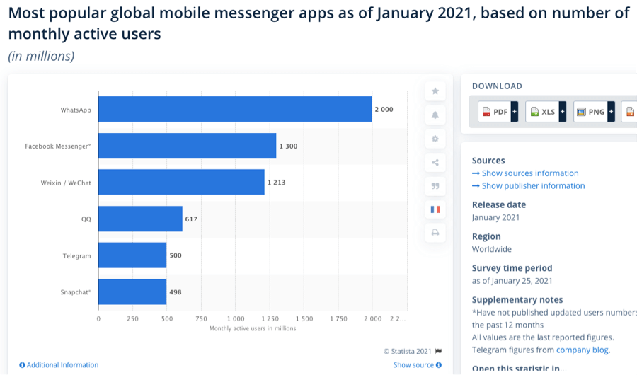

**1.5 SOURCES**

The source of our project is available at the following link

<https://github.com/anushka-rathore2/WhatsAppClone>

**CHAPTER -2**

**SOFTWARE REQUIREMENT ANALYSIS**

**2.1 IMPACT OF REACT BASED WHATSAPP CLONE APP**

WhatsApp is a popular mobile application for providing instant messaging service in smartphones. It uses Internet services to communicate different type of text and multimedia messages between users or groups. Its users worldwide have crossed the figure of one billion in February 2016. The effect of WhatsApp on our lives, culture, and society keeps on increasing. It is also becoming popular tool for marketing in businesses and publicity in politics. This growth has also drawn the attention of researchers to understand the implications and effect of WhatsApp on its userâ€™s social and personal life. We investigated the usage and effect of WhatsApp in the regions of Northern India. We performed an internet based survey using open-source Lime survey software and obtained responses. Total 460 responses had been received in which only 136 responses were considered for analysis those have completed all questions and having more than 18 years of age. The users in India made a slow shift from all social networking sites to WhatsApp in a quick span of time. This survey results show that there is a significant impact of WhatsApp on its users. Around 66% of WhatsApp users believe that WhatsApp has improved their relationship with friends. More than 63% of its users think it is not harmful for them. There are several other analyses presented in this paper based on age-groups and gender of WhatsApp users.

**2.2 HARDWARE AND SOFTWARE REQUIREMENTS**

**Hardware Requirement**

* Processor: Intel i5
* Web Application – WhatsApp Clone
* Operating System: Any Operating System
* RAM: 4 GB (or higher)
* Hard disk: 256GB

**Software Requirement**

* Software used: Visual Studio Code Editor
* The language used : JavaScript
* Database: Firebase
* User Interface Design: HTML and CSS

**2.3 MODULES AND FUNCTIONALITIES**

* **Login Page**: This page is for Gmail login user who have a username and a password.
* **Chat Page**: This page is the main chat page having all the whatsappp like icons and users can chat with each other with their unique Id name.
* **SideBar Page:** This page consists of the search bar, icons ,chat names and group names. You can add any individual also and then start chatting there.

**2.4 WhatsApp Clone Web App on VS Code Editor**

[React](https://reactjs.org/" \t "_blank) is a popular JavaScript library developed by Facebook for building user interfaces. The Visual Studio Code editor supports React.js IntelliSense and code navigation out of the box.

**CHAPTER- 3**

**SOFTWARE DESIGN**

**3.1 USE-CASE DIAGRAM:**

**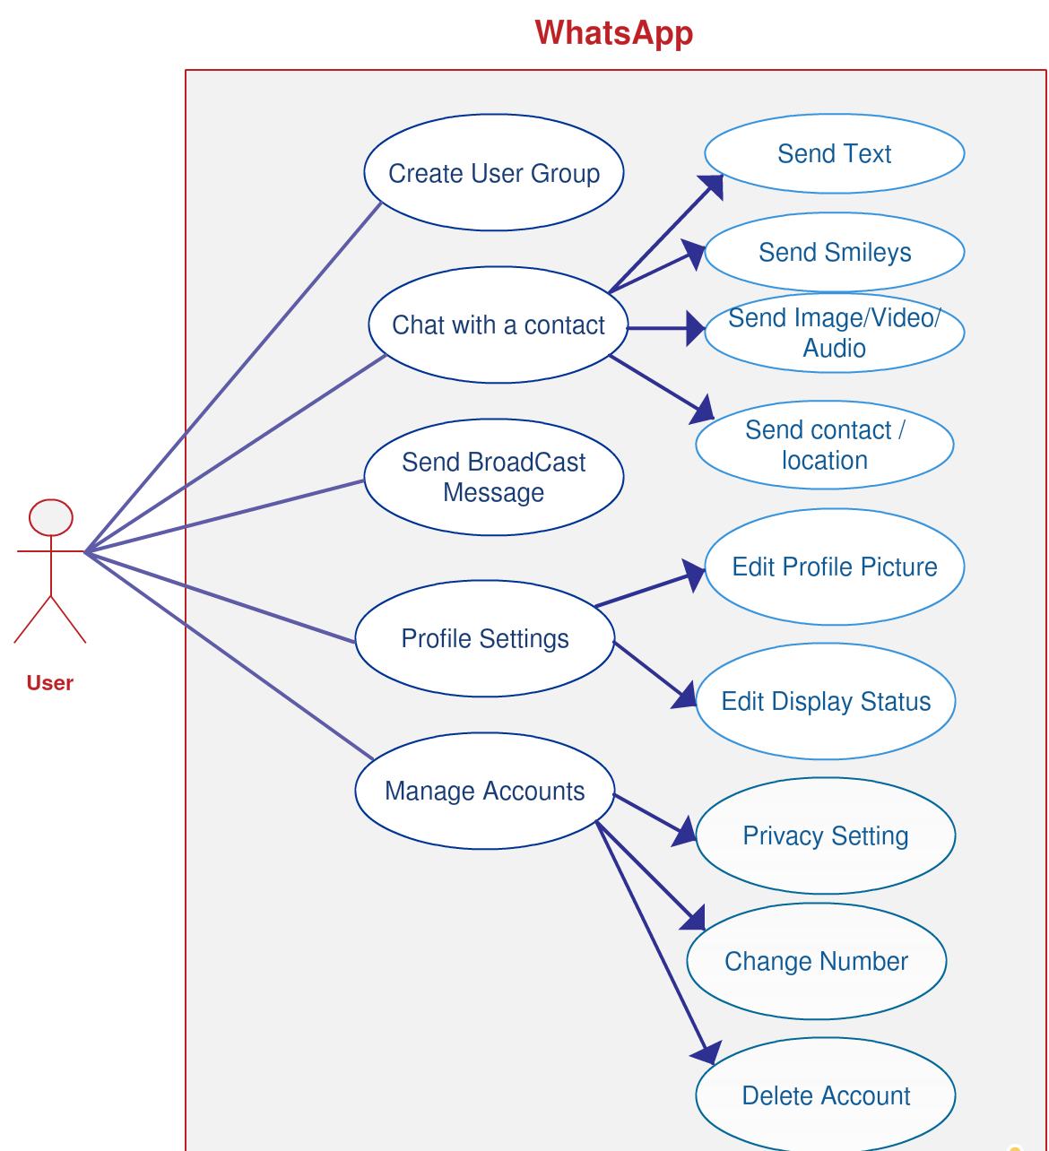**

**3.2 DATA FLOW DIAGRAM :**

**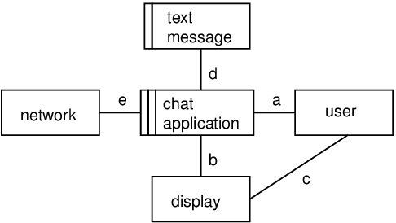**

**3.3 SEQUENCE DIAGRAM :**

**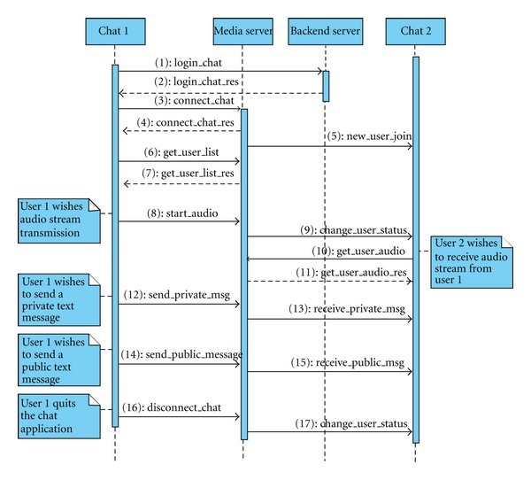**

**CHAPTER-4**

**TECHNOLOGY USED**

**4.1 VISUAL STUDIO CODE EDITOR**

**Visual Studio Code**, also commonly referred to as **VS Code**, is a [source-code editor](https://en.wikipedia.org/wiki/Source-code_editor" \o "Source-code editor) made by [Microsoft](https://en.wikipedia.org/wiki/Microsoft" \o "Microsoft) for [Windows](https://en.wikipedia.org/wiki/Windows" \o "Windows), [Linux](https://en.wikipedia.org/wiki/Linux" \o "Linux) and [macOS](https://en.wikipedia.org/wiki/MacOS" \o "MacOS). Features include support for [debugging](https://en.wikipedia.org/wiki/Debugging" \o "Debugging), [syntax highlighting](https://en.wikipedia.org/wiki/Syntax_highlighting" \o "Syntax highlighting), [intelligent code completion](https://en.wikipedia.org/wiki/Intelligent_code_completion" \o "Intelligent code completion), [snippets](https://en.wikipedia.org/wiki/Snippet_(programming)" \o "Snippet (programming)), [code refactoring](https://en.wikipedia.org/wiki/Code_refactoring" \o "Code refactoring), and embedded [Git](https://en.wikipedia.org/wiki/Git" \o "Git). Users can change the [theme](https://en.wikipedia.org/wiki/Theme_(computing)" \o "Theme (computing)), [keyboard shortcuts](https://en.wikipedia.org/wiki/Keyboard_shortcut" \o "Keyboard shortcut), preferences, and install [extensions](https://en.wikipedia.org/wiki/Plug-in_(computing)" \o "Plug-in (computing)) that add additional functionality.

In the [Stack Overflow](https://en.wikipedia.org/wiki/Stack_Overflow" \o "Stack Overflow) 2021 Developer Survey, Visual Studio Code was ranked the most popular developer environment tool, with 70% of 82,000 respondents reporting that they use it.

Visual Studio Code is **a streamlined code editor with support for development operations like debugging, task running, and version control**. It aims to provide just the tools a developer needs for a quick code-build-debug cycle and leaves more complex workflows to fuller featured IDEs, such as Visual Studio IDE.



But first it would be great to see the three different type of Web Based Apps:-

**• Static Web Apps:**The static web app directly delivers the content to the end user’s browser without fetching any data from the server. Most static web apps are known to be simple and effortless to develop across the web.

**• Dynamic Web Apps:**A web application that generates the data in real-time based on the user’s request and server response, is known as a dynamic web application.

**• Single Page Apps:**A single-page application runs entirely within a browser and doesn’t require page reloading. For example, while accessing an email app, its headers and sidebars will stay intact as you access your inbox.

**• Multiple Page Apps:**A web app that includes multiple pages and reloads the whole page whenever a user navigates to a different page is known as multiple page apps.

### • Animated Web Apps :A web application that supports animation and synchronization on the web platform is known as an animated web app. [Sqadeasy](https://www.squadeasy.com/en/about" \t "_blank) and [Miki Mottos](http://www.mikimottes.com/" \t "_blank) are some of the best examples of animated web apps.

### • E-commerce Web Apps :A web application that helps users electronically buy or sell goods over the internet is called an e-commerce web app. Payment integration and transaction integration are essential parts of [e-commerce web apps](https://www.spaceotechnologies.com/services/amazon-like-ecommerce-app-development/). For example, Amazon, and eBay.

**• Content Management Systems :**A software program that helps users manage digital content, improve the production and management of content is known as CMS (Content Management System)

**• Portal Apps :**A portal web app is a type of web application that is accessible over the web and brings out the details from different sources like emails, online forums, and search engines in a uniform way.

**• Progressive Web Apps :**Progressive web apps are known as cross-platform web applications which use the latest browser APIs (Application Programming Interface).

**CATEGORIES OF WEB APPS:**

There are 33 categories of apps in Google Play and 24 categories in Apple’s App Store. And there are just 7 app categories that have managed to reach more than 3% of users, according to [Statistica](https://www.statista.com/statistics/270291/popular-categories-in-the-app-store/) research.

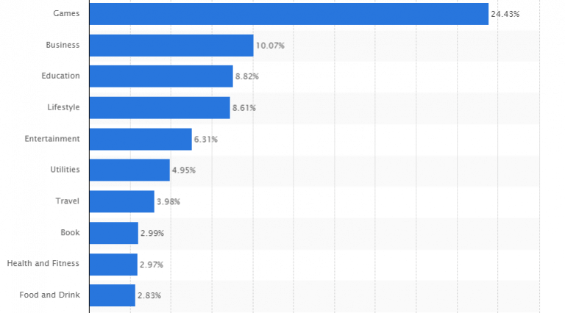

**4.2VERSION OF VSCODE EDITOR**

Visual Studio is available for Windows and Mac. [Visual Studio for Mac](https://docs.microsoft.com/en-us/visualstudio/mac/) has many of the same features as Visual Studio for Windows, and is optimized for developing cross-platform and mobile apps. This article focuses on the Windows version of Visual Studio.

There are three editions of Visual Studio: Community, Professional, and Enterprise. See [Compare Visual Studio editions](https://visualstudio.microsoft.com/vs/compare/) to learn about which features are supported in each edition

There are three editions of Visual Studio: **Community, Professional, and Enterprise**. See Compare Visual Studio editions to learn about which features are supported in each edition.

**4.3TOOLS AND LANGUAGES**

VS Code comes with a simple and intuitive layout that maximizes the space provided for the editor while leaving ample room to browse and access the full context of your folder or project. The UI is divided into five areas:

* **Editor** - The main area to edit your files. You can open as many editors as you like side by side vertically and horizontally.
* **Side Bar** - Contains different views like the Explorer to assist you while working on your project.
* **Status Bar** - Information about the opened project and the files you edit.
* **Activity Bar** - Located on the far left-hand side, this lets you switch between views and gives you additional context-specific indicators, like the number of outgoing changes when Git is enabled.
* **Panels** - You can display different panels below the editor region for output or debug information, errors and warnings, or an integrated terminal. Panel can also be moved to the right for more vertical space.

**4.4 BASIC TERMINOLOGY**

Visual Studio Code has a high productivity code editor which, when combined with programming language services, gives you the power of an IDE and the speed of a text editor. In this topic, we'll first describe VS Code's language intelligence features (suggestions, parameter hints, smart code navigation) and then show the power of the core text editor.

* **VS Code :** Visual Studio Code, also commonly referred to as VS Code, is a source-code editor made by Microsoft for Windows, Linux and macOS. Features include support for debugging, syntax highlighting, intelligent code completion, snippets, code refactoring, and embedded Git.
* **Firebase :** Firebase is a platform developed by Google for creating mobile and web applications. It was originally an independent company founded in 2011. In 2014, Google acquired the platform and it is now their flagship offering for app development.
* **React :** React is a free and open-source front-end JavaScript library for building user interfaces based on UI components. It is maintained by Meta and a community of individual developers and companies.
* **HTML :** The HyperText Markup Language or HTML is the standard markup language for documents designed to be displayed in a web browser. It can be assisted by technologies such as Cascading Style Sheets and scripting languages such as JavaScript.
* **CSS :** Cascading Style Sheets is a style sheet language used for describing the presentation of a document written in a markup language such as HTML. CSS is a cornerstone technology of the World Wide Web, alongside HTML and JavaScript
* **JavaScript :** JavaScript, often abbreviated JS, is a programming language that is one of the core technologies of the World Wide Web, alongside HTML and CSS. Over 97% of websites use JavaScript on the client side for web page behavior, often incorporating third-party libraries
* **Material Icon MIUI :** Under each application there are three images / optionwhich will allow us to change the app icons on MIUI in a different way: the first is the standard icon. the second allows us to put a photo as an app icon. the third allows us to put a photo already present in the gallery as an app icon.
* **JSON :** JSON is an open standard file format and data interchange format that uses human-readable text to store and transmit data objects consisting of attribute–value pairs and arrays. It is a common data format with diverse uses in electronic data interchange, including that of web applications with servers
* **Browser :** A web browser is application software for accessing the World Wide Web or a local website. When a user requests a web page from a particular website, the web browser retrieves the necessary content from a web server and then displays the page on the user's device.

**CHAPTER -5**

**IMPLEMENTATION AND USER INTERFACE**

Creating an web app concept design with screen sketches and functional flow diagrams is the best way to communicate your vision to the web app developer. Making the concept clear to the developer is probably the most important factor in successful mobile app development. Yet it is one of the most common problems or obstacles in a web app development outsourcing project.

No matter what the marketing and profit goals are or if you are outsourcing an app for your personal use, you need to fully design and document the app concept if you expect a programmer to make your vision a reality. Developers are not mind readers and even descriptions given during conversations can be very fleeting or interpreted differently. Fully documenting your concept, therefore, leaves little to chance. The two most important things to do are:

A) make a comprehensive description of how the web app works and what it does (functionality) and

B) create a comprehensive description of what the user sees and does (look and feel).

**5.1 Implementation of the WhatsApp Clone Web App:**

Implementation of this app is taken place in various phases. Firstly we build the login interface then Sidebar and Chat Screen and connect the app with the Firebase for fetch the required data. And finally we parse the React object to get the user data in the required format and then after matching ,it displays the result.

**5.1.1 Step to be followed to develop the Web-app:**

1. Firstly we create the Login Window screen with animated text using React and linked it with the chat screen through React.

2. After that we create login phase which comprises of various phases that are mentioned below:

* ∙ **Login Page**: allows user to login into the app if the user is existing one
* ∙ For authenticating the user we have used **firebase authentication**.

3. Then we have designed Side bar chat page where when user click **“Add New Chat”**

button it opens new room for user.

This consist of-

* Add New Chat Button
* Search Bar

4. Now user can create room to chat with anyone in real time.

5. After getting the message typed , this number is matched with our database present on firebase (Firestore Database).

6. In order to store data in Realtime database we apply following steps:-

* Opened npm server in our local computer.
* In the firestore database , created database of our products.
* Then by react code we fetched and put data in firebase..
* It is done by creating snapshot of object.

7. For user’s point of view , the display image in app is their Google account image.

**FLOW CHART OF USER**

Flow Chart for the User is given below:

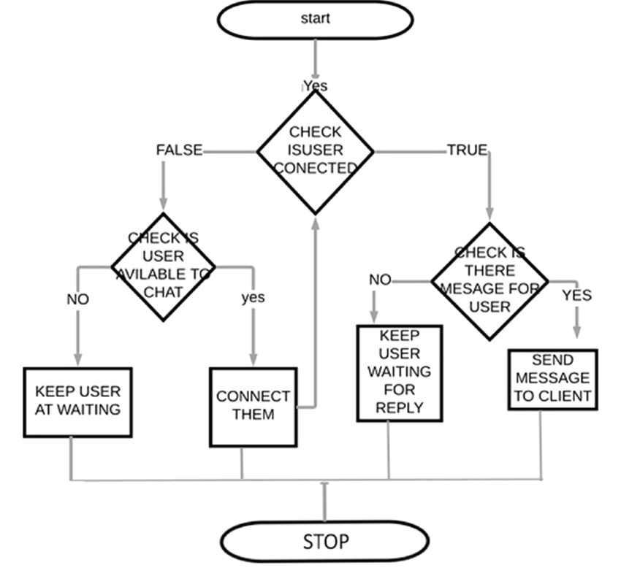

**5.1.2 Step to be followed by the user**

1. Firstly, go to website which we deployed on firebase also.

2. Then, we have the Login activity which consists of following steps

* ∙ Login: Google Authentication Login.

3. We authenticate and store the user information in the Firebase authentication.

4. Then user comes in Main Chat Window.

5. Chat Screen is divided into two parts:-

* Sidebar Chat
* Main Chat Window

6. In the Sidebar chat , user have –

* Search Icon
* Add New Chat Option
* All chats added
* All Icons

7. In the main chat screen, user have –

* Chat header containing name of user.
* Chat footer in which he/she can by text to send.
* In main chat screen the message by all user in that room is present.

8. At last , User can successfully logout from app.

**5.2 User Interface**

**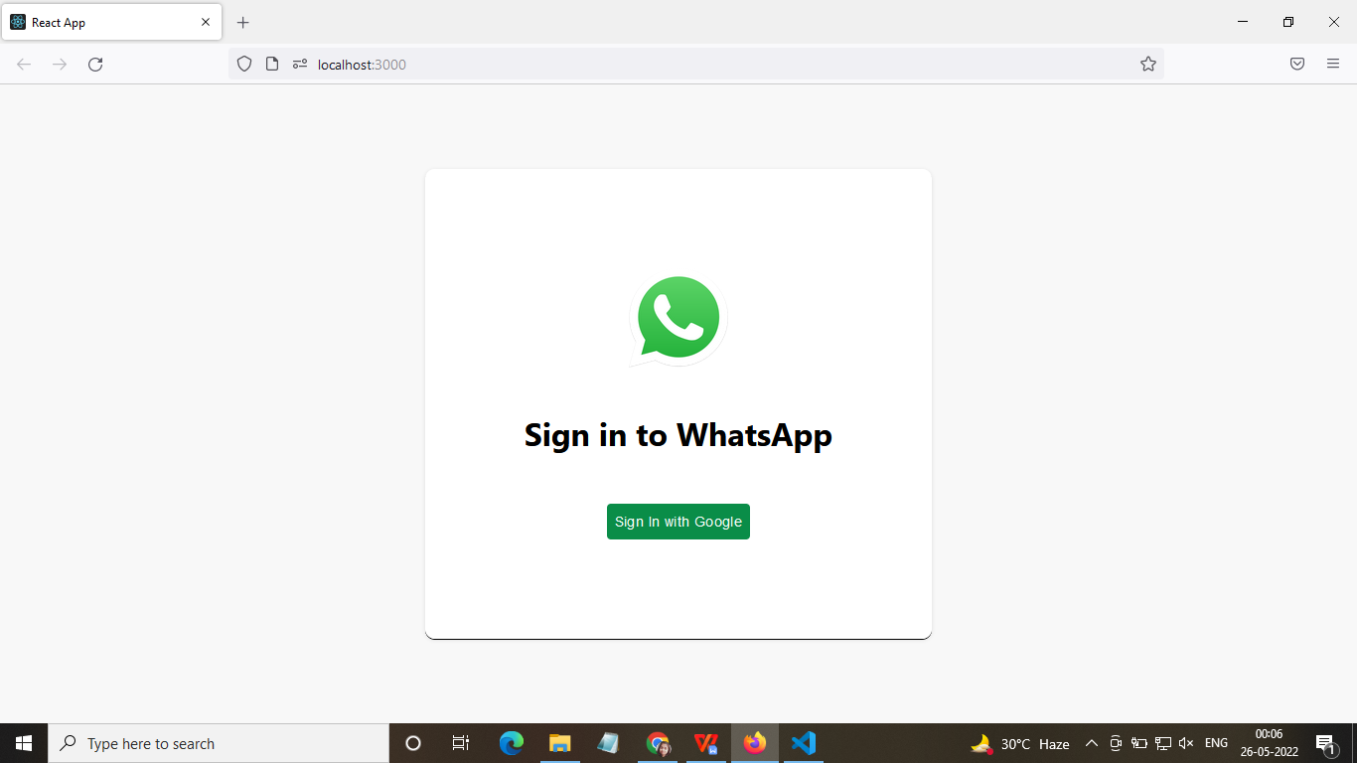**

**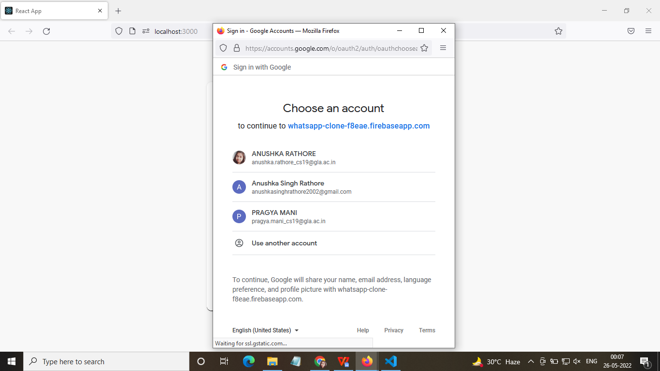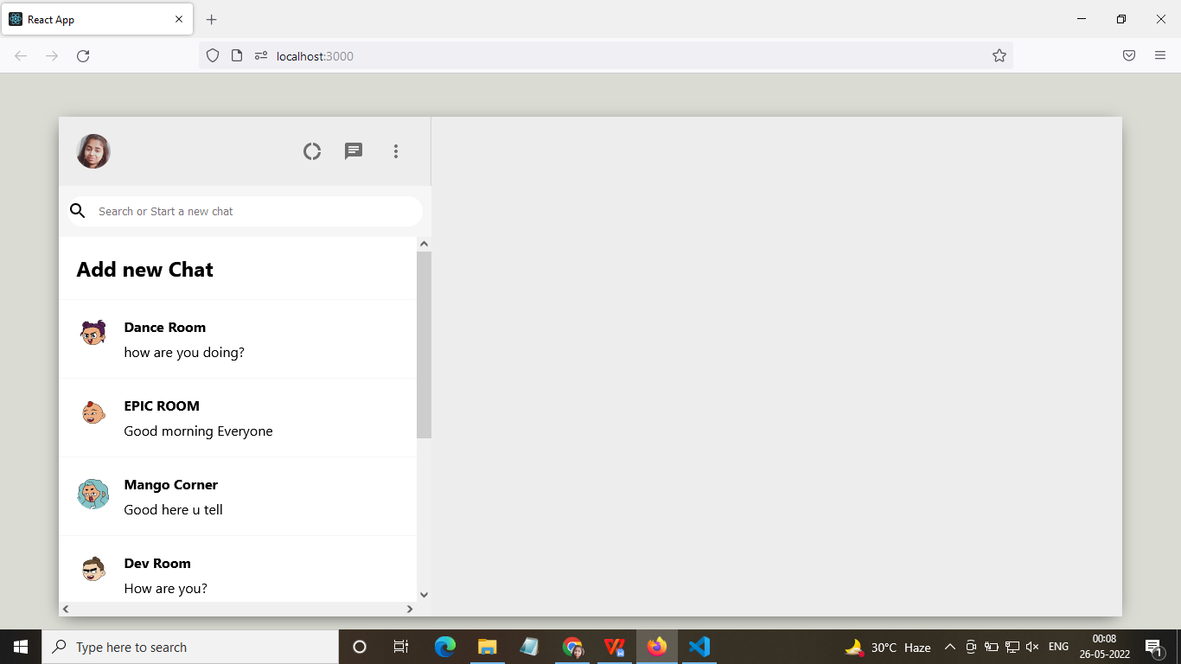**

**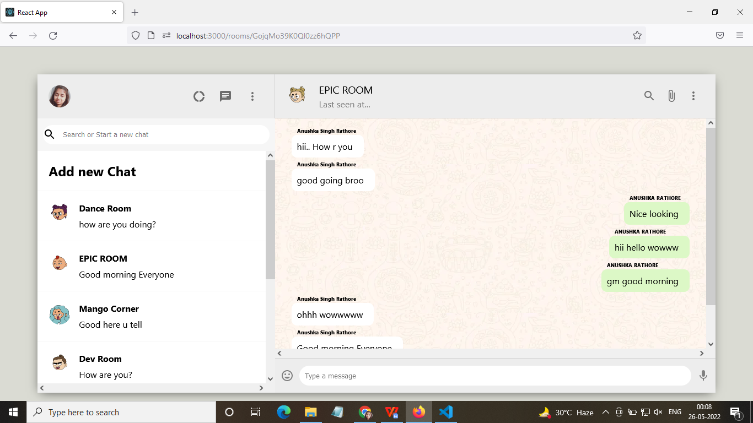**

**FIREBASE (DATABASE)**

**AUTHENTICATION OF USERS**

**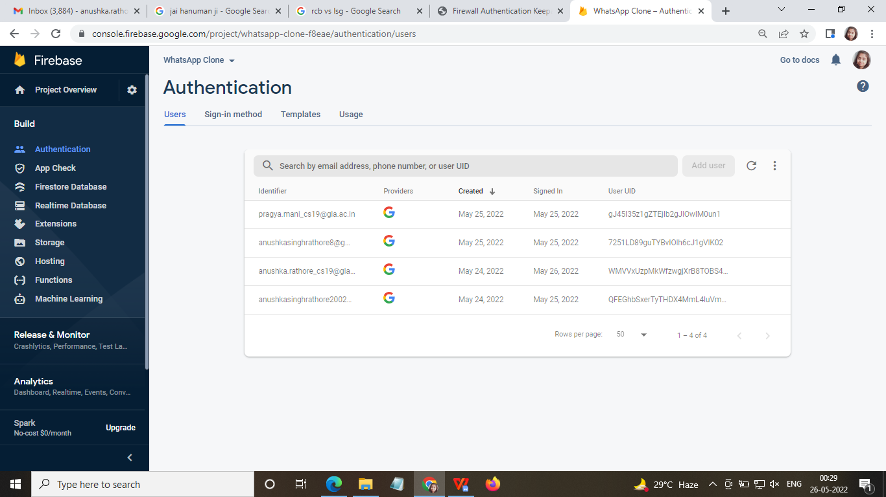**

**DEPLOY THE APP**

**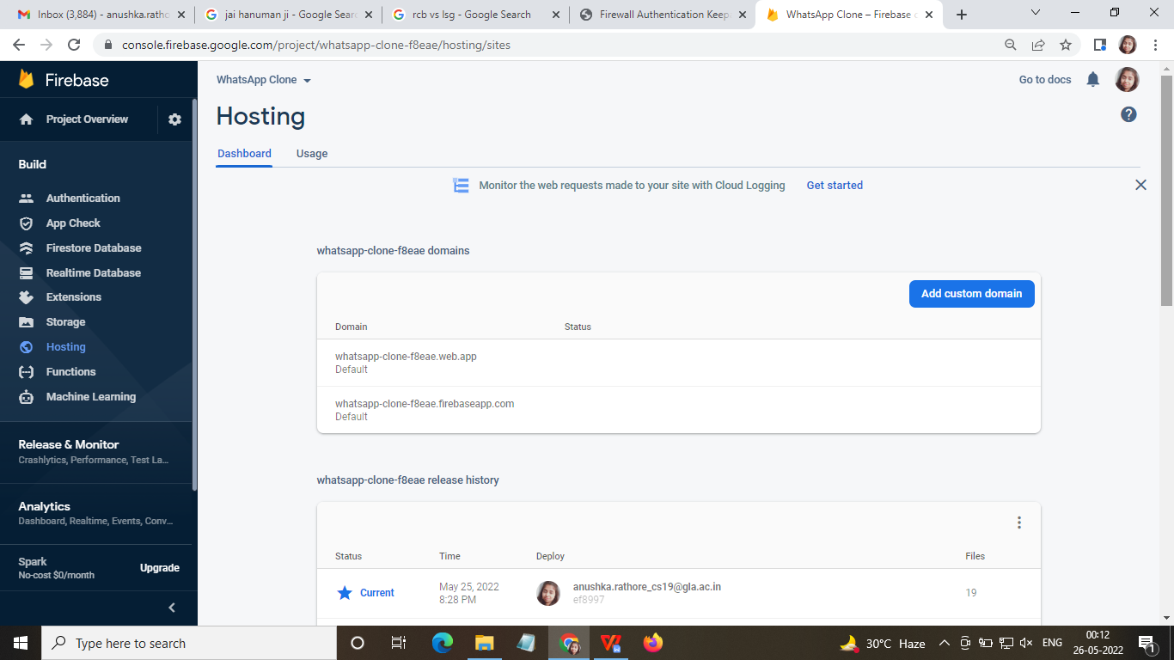**

**REALTIME DATABASE OF MEDICINES**

**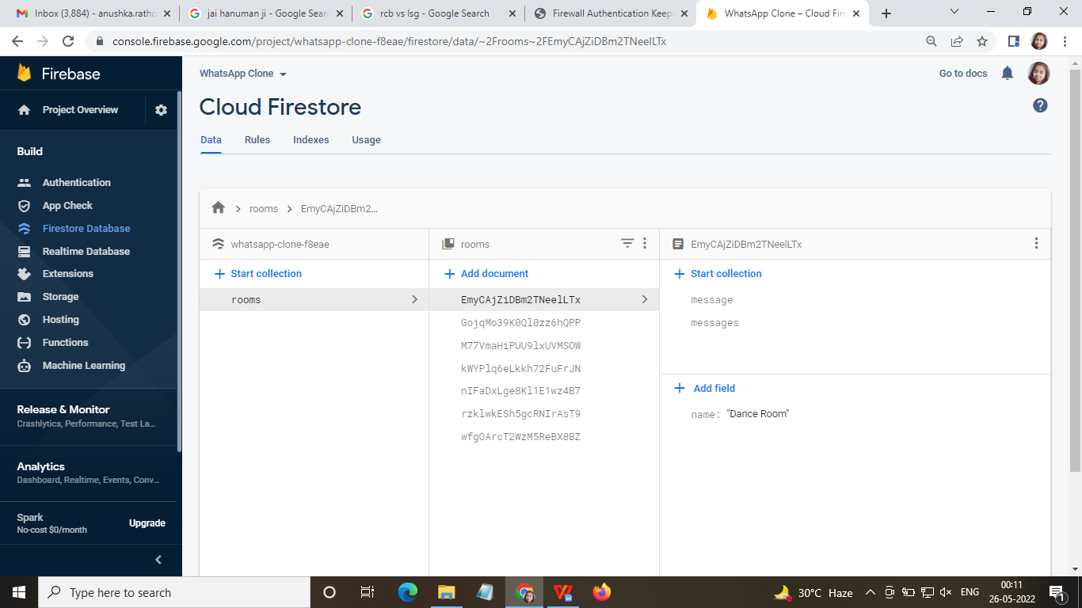**

**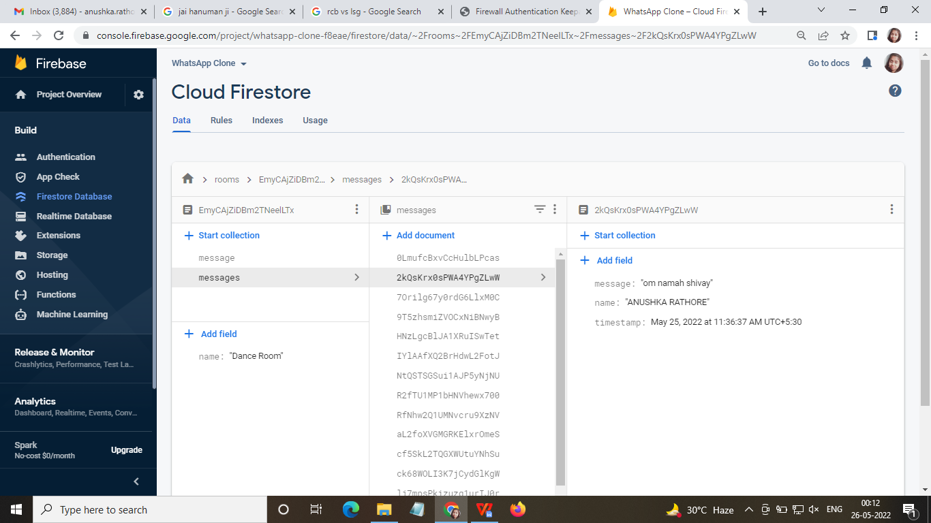**

**CHAPTER - 6**

**TESTING**

Once source code has been generated, software must be tested to uncover as many errors as possible before delivery. It is very important to work the system successfully and achieve high quality of software. Testing include designing a series of test cases that have a high likelihood of finding errors by applying software-testing techniques.

System testing makes logical assumptions that if all the parts of the system are correct, the goal will be successfully achieved. The system should be checked logically. Validations and cross checks should be there. Avoid duplications of record that cause redundancy of data.

In other Words, Testing is the process of evaluating a system or its component(s) with the intent to find whether it satisfies the specified requirements or not. It is executing a system in order to identify any gaps, errors, or missing requirements in contrary to the actual requirements.

The Android framework includes an integrated testing framework that helps you test all aspects of your application and the SDK tools include tools for setting up and running test applications. Whether you are working in Eclipse with ADT or working from the command line, the SDK tools help you set up and run your tests within an emulator or the device you are targeting.

There are different types of testing some of them are listed below:

**6.1 Installation Testing:**

There are two types of apps on an Web Based device i.e., Pre-installed applications and the applications which are installed later by the user.

For both of the above, installation testing is carried out by our teammates. It is ensuring smooth installation of the application without ending up in errors, partial installation etc.

**6.2 Unit Testing :**

It focuses on smallest unit of software design. In this we test an individual unit or groups of inter related units. It is often done by programmer by using sample input and observing its corresponding outputs. In this testing technique we are primarily focuses on

∙ Loop methods and function is working fine or not.

∙ Misunderstood or incorrect Arithmetic precedence

∙ Incorrect Initialization

**Unit Testing of the app:**

| **Test cases** | **Description** | **Expected Outcome** | **Result** |
| --- | --- | --- | --- |
| 1 | Start Page – Launch Screen | Should display splash screen with animated text | Pass |

| 2 | Login Screen | Should display login screen And ask for your credentials. | Pass |
| --- | --- | --- | --- |
| 3 | Chat Screen | Should display proper UI  and other icon. | Pass |
| 4 | Sidebar Chat | Should display three tabs:  Icons ,Search Bar and Room. | Pass |

| 5 | Main Chat Screen | Should display main chat which consist of 3 parts:-  Header, Main Screen and Footer. | Pass |
| --- | --- | --- | --- |
| 6 | Add New Chat | To add new user or room. | Pass |
| 7 | Last Seen time | Should come in Main Chat Header. | Pass |
| 8 | Last Message | Should display the last message of current room. | Pass |

| 9 | Logout | Should logout the current account of user and move to login page. | Pass |
| --- | --- | --- | --- |

**6.3 User Testing :**

User testing is the process through which the interface and functions of a website, app, product, or service are tested by real users who perform specific tasks in realistic conditions. The purpose of this process is to evaluate the usability of that website or app and to decide whether the product is ready to be launched for real users.

This app was tested by me and my friends who are using different mobile phones (and having different android version) also tested on different emulator to check its performance and it seems to be working fine and users of this app are satisfied with the facilities and performance of the app and like the way how the app is worked.

**6.4 Performance Testing**

In this type of testing we have checked the performances of our application under some peculiar conditions are checked. Those conditions include:

∙ Low memory in the device.

∙ The battery in extremely at a low level.

∙ Poor/Bad network reception.

Performance is basically tested from 2 ends, application end, and the application server end. Our app is also performing well in this phase of testing as well. And we are getting positive feedback from user of our app.

**6.5 Compatibility Testing**

This application was tested and used on different browsers like Google Chrome, Mozilla Firefox and Microsoft Edge . The application worked fine and is stable. The application worked fine in portrait mode and there isn't any problem with compatibility.

On all types of testing (that we have performed above) our performing well on our web app i.e. WhatsApp Clone Web App.

**CHAPTER -7**

**CONCLUSION**

The review contributes to ongoing research on WhatsApp in a number of ways. Linking users to their motivations, we found evidence of a variety of activities that take place via WhatsApp. While conversations in some groups are direct, serious and political, there are many examples of conversations in WhatsApp groups that are casual and depoliticised, made possible with emojis, satirical memes and multimedia content shared over WhatsApp. As our analysis shows, such conversations are not frivolous — they are purposeful in terms of building relationships, making everyday connections and contribute to political dissent and/or discourse.

Future research should also consider systematic reviews of other instant messaging platforms, basing the analysis on the similarities and differences in the affordances, users and associated motivations in using these platforms compared to WhatsApp. More research should also be conducted and reported especially from underresearched sites in Asia. Historical accounts of digital repertoires, especially in the contexts of political and civic engagement, are especially important to deepen understandings on the phenomenon of platform switching to, and from, WhatsApp. They are also crucial to deepen knowledge on the topic of digital democracy and how democracies are shaped by pivotal moments of citizenry afforded by digital platforms such as WhatsApp and other instant messaging platforms.

**REFERENCES**

1. **Introduction to VS Code:**

https://code.visualstudio.com/.

**2. React User Interfaces:**

<https://code.visualstudio.com/docs/nodejs/reactjs-tutorial>

**3. Layout:**

<https://www.figma.com/>

**4. React Training:**

<https://code.visualstudio.com/docs/nodejs/reactjs-tutorial>

**5. Internshala:**

https://trainings.internshala.com/

**6. VS Code Guide:**

https://code.visualstudio.com/.

**7. For rectifying the error :**

https://stackoverflow.com/