Test Case 10

Project:  New Haven Urgent Care                                 Team #8

Test Date: 12/11/2021

Test Case ID#: 10

Name(s) of Tester(s): Kinza Ahmed

Test Description (What are you testing? – you must be specific):

I am testing if a visit has to have at least one diagnosis. I will test this by creating a patient record, creating a service provider record, and checking the logs relationship for that specific patient to see if the visit still exists even without any diagnosis logged to the patient by the doctor.

Test Data:

-          **File name: Data/base.sql, Data/TC10data.sql**

**We’ll use the patient with the patient id of 2**

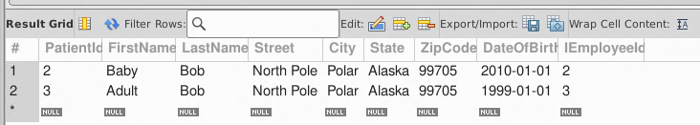

* **We’ll use the following DoctorId 2 for the visit**

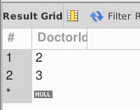

* **Logs table has 0 records associated to patientid 2**

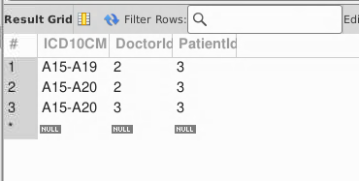

SQL Query(s) used for testing:

/* Expected Result: 0 Records

Actual Result: 0 Records

TEST CASE PASSED */

SELECT *

FROM Logs

Where PatientId=1

AND DoctorId = 2

Discussion/Explanation:

Return value indicates that the test case has passed because the output generated is the logs for the given patient identified by ID number 1. But we also want to be able to mark a visit which is something we missed and would have to go back and add because a patient can exist in the db without visiting the clinic. From a requirement perspective, we know that the patient can still come in and visit but not have to have a diagnosis logged on that visit.