Test Case 6

Project:  New Haven Urgent Care                                 Team #8

Test Date: 12/11/2021

Test Case ID#: 6

Name(s) of Tester(s): Kinza Ahmed

Test Description (What are you testing? – you must be specific):

I am testing if an insured patient's insurance information can be tracked and also if they come in for a second visit and the insurance has not changed we can still retrieve that information. I will test this by creating a patient record, creating 2 doctor records, creating insurance card info for the patient, and creating an insured record. Then querying the specific patient on the insured table to find an insurance card number. I will use that number to query from the Insurance Card table to retrieve all information. I will log another visit and then query once more to see if anything has changed.

Test Data:

-          **File name: Data/base.sql, Data/TC6data.sql**

**- We’ll use the patient with the patient id of 3**

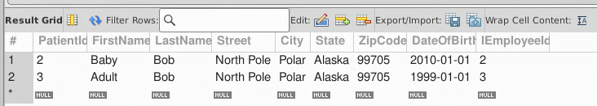

* **We’ll use the following 2 doctors - DoctorId 2 is for our first visit and DoctorId 3 is for our second visit**

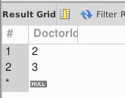

* **We’ll use the following insurance card info**
* 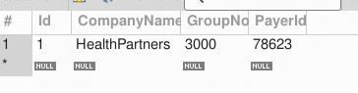
* **Credit Card that the insured patient is being billed to**

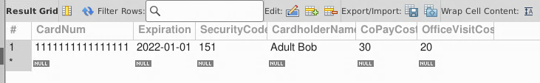

* **In order to associate that to a patient we’ll create a record in the insured table**

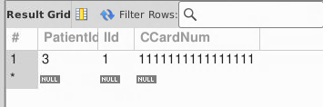

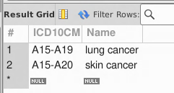

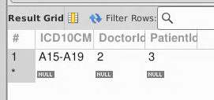

SQL Query(s) used for testing:

/* Expected Result: 1 Record

Actual Result: 1 Record

TEST CASE PASSED */

--get insurance card info for patient

SELECT *

FROM InsuranceCard

WHERE Id = (SELECT IId

            FROM Insured

            WHERE PatientId=1)

-- insert logs record for same patient another visit

--logs second diagnosis

INSERT VALUE INTO Logs(ICD10CM, DoctorId, PatientId)

VALUES('A15-A19', 2, 1);

--get insurance card info for the same patient

SELECT *

FROM InsuranceCard

WHERE Id = (SELECT IId

            FROM Insured)



Discussion/Explanation:

Return value is the same insurance card that the patient was first insured with. As of right now we can’t distinguish specific visits since that is a flaw within our design. From a requirement perspective, we know that the insured patient’s insurance information should stay the same unless updated later.