Test Case 9

Project:  New Haven Urgent Care                                 Team #8

Test Date: 12/11/2021

Test Case ID#: 9

Name(s) of Tester(s): Kinza Ahmed

Test Description (What are you testing? – you must be specific):

I am testing if a patient can have more than one diagnosis per visit. I will test this by creating a patient record, creating a service provider record, creating two diagnoses in the system, and then logging both diagnoses to that patient and the date of the visit. I will then query on the logs table against the patient to see if they can have multiple diagnoses per visit.

Test Data:

-          **File name: Data/base.sql, Data/TC9data.sql**

**We’ll use the patient with the patient id of 3**

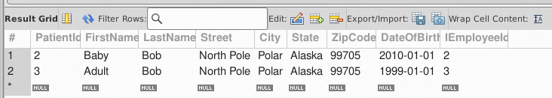

* **We’ll use the following DoctorId 2 for the first visit and doctorid 3 for the second visit**

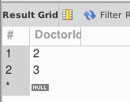

* **Log a visit and diagnosis**

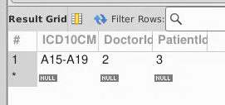

* **Log second visit**

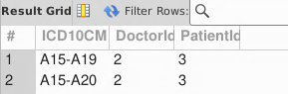

SQL Query(s) used for testing:

/* Expected Result: 2 Records

Actual Result: 2 Records

TEST CASE PASSED */

SELECT *

FROM Logs

Where PatientId=1

AND DoctorId = 2

Discussion/Explanation:

Return value indicates that the test case has passed because the output generated is all of the logs for the given patient identified by ID number 1. However, given the test requirement, I recognized that there is no way to differentiate specific logs in the system for a specific visit. Therefore, from a logic standpoint the requirement failed. In the next iteration of development, we would add a Date attribute for the Logs table to distinguish between specific visits.