Test Case 8

Project:  New Haven Urgent Care                                 Team #8

Test Date: 12/11/2021

Test Case ID#: 8

Name(s) of Tester(s): Kinza Ahmed

Test Description (What are you testing? – you must be specific):

I am testing if a patient can be seen by different service providers on different visits. I will test this by creating a patient record, creating two service provider records, creating two inputs for the LOGS table (each by different service providers but the same patient), and checking the logs relationship for that specific patient and doctor number 1 to see if that visit was logged and then another query to check the record exists for the next visit with doctor number 1 but the same patient.

Test Data:

-          **File name: Data/base.sql, Data/TC8data.sql**

**We’ll use the patient with the patient id of 3**

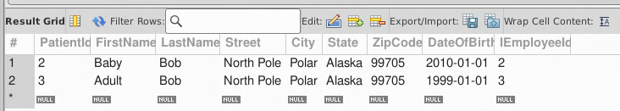

* **We’ll use the following DoctorId 2 for the first visit and doctorid 3 for the second visit**

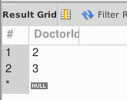

* **Log a visit and diagnosis**

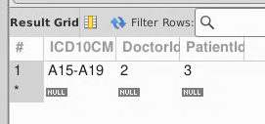

* Log another visit and diagnosis but with a different doctor

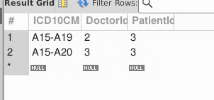

SQL Query(s) used for testing:

/* Expected Result: 1 Record

Actual Result: 1 Records

TEST CASE PASSED */

SELECT *

FROM Logs

Where PatientId=1

AND DoctorId = 1

/* Expected Result: 1 Record

Actual Result: 1 Records

TEST CASE PASSED */

SELECT *

FROM Logs

Where PatientId=1

AND DoctorId = 2

Discussion/Explanation:

Return value indicates that the test case has passed because the output generated is the logs for the given patient identified by ID number 1. From a requirement perspective, we know that the patient can see different doctors at different visits. While testing, I noticed that we had no way of measuring a specific visit by date - so we would need to go back and create a visit table.