Test Case 7

Project:  New Haven Urgent Care                                 Team #8

Test Date: 12/11/2021

Test Case ID#: 7

Name(s) of Tester(s): Kinza Ahmed

Test Description (What are you testing? – you must be specific):

I am testing if a patient can be seen by only one service provider per visit. I will test this by creating a patient record, creating service provider records, creating one input for the LOGS table and querying against that logs relationship with that doctor and patient.

Test Data:

-          **File name: Data/base.sql, Data/TC7data.sql**

**- We’ll use the patient with the patient id of 3**

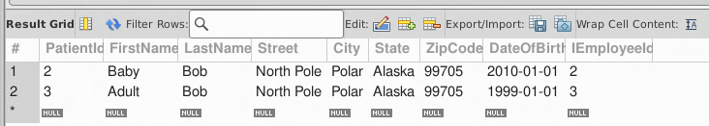

* **We’ll use the following DoctorId 2 for this visit**

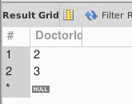

* **Log a visit and diagnosis**

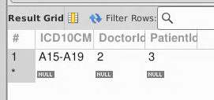

We can see that the patient is only tied to the one doctor and can not have multiple

SQL Query(s) used for testing:

/* Expected Result: 1 Record

Actual Result: 1 Record

TEST CASE PASSED */

SELECT *

FROM Logs

Where PatientId=1

AND DoctorId = 1

Discussion/Explanation:

Return value indicates that the test case has passed because the output generated is the logs for the given patient identified by ID number 1. From a requirement perspective, we know that the patient should be tied to a single doctor during a visit. Which is why we made sure that the LOGS table associates the doctor and the patient. We also forgot to specify the specific visit based on date which is one thing we’d go back in and update.