|  |  |
| --- | --- |
| **Project: New Haven Urgent Care Team# 8** | |
|  | **Test Date: 12/9/2021** |
| **Test Case ID#: 20** | **Name(s) of Tester(s): Kevin Le** |
| **Test Description (What are you testing? – you must be specific):**   * **I am examining whether a primary key column of a given table satisfies the requirements that a primary key should.** * **The table that I will be testing is the Patient’ table. I will be attempting to insert two records, both of which have the same primary key value. After attempting to insert those two records, I will query the table for the primary key value and check to see if there has only been a single record inserted.** * **I will also attempt to query all columns of the table given the primary key.** * **If there are two records in the resulting query table, then the test has failed.** * **If I am unable to query all of the columns in the table given the primary key, then the test has failed.** |  |
|  |  |

**NOTE: The following information must be provided to be given credit for any test.**

**Test Data (Provide the file name of the script used to insert data, provide a screen capture to reflect data, or provide script here):**

**File name: Data/base.sql, Data/TC22data.sql**

**SQL Query(s) used for testing:**

**/\*\***

**\* Expected Result: 1 Records**

**\* Actual Result: 1 Records**

**\*/**

**SELECT \***

**FROM C4707F21U8.Patient**

**WHERE PatientId = 2201;**

**Discussion/Explanation:**

**The return value of the SQL query indicates that the test case has passed. We expected only a single record to return since the primary key constraint barred a second record with the same `PatientId` value to be entered into the table.**

**We are also able to query and view all of the columns associated with the InitialAssessment table:**

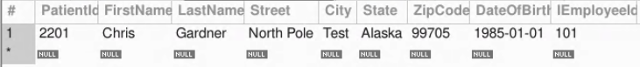

**In conclusion, the test case passes and the requirement is satisfied.**