**Electroencephalogram Brain Signal Processing to discriminate three different colors**

**for**

**Use these colors as two control commands.**

Project-II (I9MI10013) report submitted to

Indian Institute of Technology Kharagpur

in partial fulfilment for the award of the degree of

Bachelor of Technology

In

Mining Engineering

**By**

**Anushka Singh**

**(19MI10013)**

Under the Supervision of

**Professor Debasis Samanta**

**IIT kharagpur**

****

Department of Computer Science and engineering

Indian Institute of Technology Kharagpur

Spring Semester 2022-23

April 30, 2023

**DECLARATION**

I certify that,

1. The work contained in this report has been done by me under the guidance of my supervisor.
2. The work has not been submitted to any other Institute for any degree or diploma.
3. I have conformed to the norms and guidelines given in the Ethical Code of Conduct of the

Institute.

(d) Whenever I have used materials (data, theoretical analysis, figures, and text) from other sources, I have given due credit to them by citing them in the text of the thesis and giving their details in the references. Further, I have taken permission from the copyright owners of the sources, whenever necessary.

Date: April, 30, 2023 Anushka Singh

Place: Kharagpur 19MI10013

**I**

**DEPARTMENT OF COMPUTER SCIENCE AND ENGINEERING**

**INDIAN INSTITUTE OF TECHNOLOGY KHARAGPUR**

****

**CERTIFICATE**

This is to certify that the project report entitled “Electroencephalogram Brain Signal Processing to discriminate three different colors for Use these colors as two control commands” submitted by Anushka Singh (Roll No. 19MI10013) to Indian Institute of Technology, Kharagpur towards partial fulfilment of requirements for the award of degree of Bachelor of Technology in Mechanical Engineering is a record of bona fide work carried out by him under my supervision and guidance during Spring Semester, 2022-23.

Date: April 30, 2023 Professor Debasis Samanta

Place: Kharagpur Department of Computer Science and

Engineering, IIT kharagpur

II

**PROJECT DETAILS**

**……………………………………………………………………………………………………………………**

Name of the student: **Anushka Singh** Roll No: **19MI10013**

Degree for which submitted: **Bachelor of Technology**

Department: **Mining Engineering**

Project title: **Electroencephalogram Brain Signal Processing to discriminate three different colors for Use these colors as two control commands**

Project supervisor: **Professor Debasis Samanta**

Month and year of thesis submission: **April, 2023**

**……………………………………………………………………**

III

Acknowledgements

I would like to acknowledge and give special thanks to my supervisor Prof. Debasis Samanta, Department of Computer Science and Engineering, IIT Kharagpur and my mentor Mr. Tutan Nama, Department of Computer Science and Engineering,IIT Kharagpur for their guidance and support. Their immense knowledge and valuable advice carried me through all the stages of my B. Tech. project work, which wouldn’t have been possible without their supervision.

I would also like to give warmest thanks to my family and friends at IIT Kharagpur for their constant support and motivation throughout the course of my work.

IV

**Contents**

**Declaration I**

**Certificate II**

**Project Details III**

**Ackonowledgements IV**

**Contents**  **V**

**1.Abstract**\_\_\_\_\_\_\_\_\_\_\_\_\_\_\_\_\_\_\_\_\_\_\_\_\_\_\_\_\_\_\_\_\_\_\_\_\_\_\_\_\_\_\_\_\_\_\_\_\_\_\_\_\_\_\_\_\_\_\_\_\_\_\_\_\_\_\_\_\_\_\_\_\_\_ **1**

**2.Introduction**\_\_\_\_\_\_\_\_\_\_\_\_\_\_\_\_\_\_\_\_\_\_\_\_\_\_\_\_\_\_\_\_\_\_\_\_\_\_\_\_\_\_\_\_\_\_\_\_\_\_\_\_\_\_\_\_\_\_\_\_\_\_\_\_\_\_\_\_\_\_\_\_**2**

**3.Literature Review**\_\_\_\_\_\_\_\_\_\_\_\_\_\_\_\_\_\_\_\_\_\_\_\_\_\_\_\_\_\_\_\_\_\_\_\_\_\_\_\_\_\_\_\_\_\_\_\_\_\_\_\_\_\_\_\_\_\_\_\_\_\_\_\_\_\_\_\_**3**

**4.Proposed System**\_\_\_\_\_\_\_\_\_\_\_\_\_\_\_\_\_\_\_\_\_\_\_\_\_\_\_\_\_\_\_\_\_\_\_\_\_\_\_\_\_\_\_\_\_\_\_\_\_\_\_\_\_\_\_\_\_\_\_\_\_\_\_\_\_\_\_\_**11**

4.1 Back-end

4.1.1 Tools Description

4.1.1.1 Hardware tools used

4.1.1.2 Software Tools Used

4.1.2 ExperimentaL setup

4.1.3 Data Collection Through the Expriment

4.1.4 Data Description

4.1.5 Data Pre-Processing

4.1.6 Data Epoching

4.1.7 Feature Extraction

4.1.8 Feature Selection

4.1.8.1 Manual Experimentation of feature selection

4.1.8.2 Build in libraries to do feature selection(SelectKbest)

4.2 Front-End

4.3 Intigration

**5. Results and discussion** \_\_\_\_\_\_\_\_\_\_\_\_\_\_\_\_\_\_\_\_\_\_\_\_\_\_\_\_\_\_\_\_\_\_\_\_\_\_\_\_\_\_\_\_\_\_\_\_\_\_\_\_\_\_\_\_\_\_\_\_\_\_\_ **24**

**6. Conclusion and Future Work**\_\_\_\_\_\_\_\_\_\_\_\_\_\_\_\_\_\_\_\_\_\_\_\_\_\_\_\_\_\_\_\_\_\_\_\_\_\_\_\_\_\_\_\_\_\_\_\_\_\_\_\_\_\_\_\_\_\_\_ **25**

**Reference**

V

**1.ABSTRACT**

The EEG is an electrophysiological technique for the recording of electrical activity from the human brain. By placing electrodes on the scalp, one can record these signals. Brain-computer interface (BCI) systems are able to record, analyse and transform electroencephalography (EEG) or bio-signals into computer data so that researchers can observe the signal.

This research work is about using Electroencephalogram Brain Signal Processing technique, differentiate between the brain signals corresponding to three colors(red, green, blue). The proposed system includes data pre-processing, feature extraction, feature selection, model training and comes up with best accurate trained model by conduction various experiments.

This research work has pretty good application as if we are able to discriminate between brain signals corresponding to three different colors then we can use this as three control commands for controlling any dedicated computer application and this could be a very helpful solution for people suffering for paralysis, coma etc.

**………………………………………………………………………………………………………………………………………**

1

**2. INTRODUCTION**

In our day to day life, our brain signals gets triggered and influenced by the colors we see around us and accordingly we act and behave. This phenomena is explained by the detailed scientific explanation about the brain signals. A human brain consist of a large network of nerve cells. Electrical signals are generated by these brain neurons allow the brain to send instructions to the muscles corresponding to the motor organs. When these neurons unable to send the instructions then it leads to various disorder like paralysis etc. then in this situation BCI (brain computer interface) is solely required by these people. A brain–computer interface, sometimes called a brain–machine interface or smartbrain, is a direct communication pathway between the brain's electrical activity patterns and an external devices.

So the aim of our experiment is to develop BCI system for people suffering from paralysis or coma.

In which an individual will visualize any of these three colors(red, green or blue) in their mind and the corresponding brain signals generated could control the devices like electric chairs, desk bells etc.

Here we used OpenBCI device for the experiment. As described in paper [1], frontal, occipital and parietal lobe are more sensitive to and responsible for visual stimuli therefore we used fp1, fp2, p3, p4, o1, o2, c3, c4 lobe of headset of OpenBci device in the experiment for collecting the visual stimuli through brain signals. The brain signals from 7 subject, between age (20-25) was collected in 3 sessions, of which 6 were male and 1 was female. . As described in paper [2 ], EEG signals are mostly multicomponent and noisy signals, raw EEG signals do not provide useful information alone, and dedicated signal analysis is therefore required to extract relevant information contained within the signal and therefore Choosing suitable signal analysis method is a crucial step when extracting information from EEG data. So the very initial step of our proposed methodology is first to pre-process the brain signals . extracted some significant features from the pre-processed data. did features selection and model selection by conducting various experiments. Finally in the latter section of this paper we would talk about the results, conclusion and the future work.

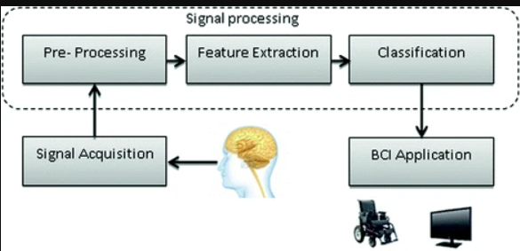

Figure 1.1 basic working of (brain computer interface) BCI system

**…………………………………………………………………………………………………………………………………………..**

2

**3. LITERATURE REVIEW**

I read these 11 papers to expand my knowledge regarding experiments to develop BCI systems and adapt any efficiency and techniques provided by these papers.

**PAPER NAME:** Analysis of brain activity and response to colour stimuli during learning tasks: an EEG study.

**AUTHOR NAME:** Raffaella Folgieri, Claudio Lucchiari, Daniele Marini

**PUBLISHING YEAR**: 2013

**SUMMARY**

The experiment is about analysing EEG data collected through BCI device from a sample of students during which they received visual stimuli based on colour variation of the text shown and its background on the screen and comes to the conclusion that which color has greater impact on remembering the words.

they organized four experimental sessions:

1. black words were shown on complementary and primary color backgrounds.
2. Primary and complementary colors words shown on white background.
3. Primary words shown on on primary background, complementary color shown on complementary background.
4. primary word shown on complementary or vice versa.

behavioural and EEG signal analysis was done.

As BCIs collect several cerebral frequency rhythms : Alpha,Beta,Delta,Theta,Gamma. The Pearson correlation index and the intra band synchronization index has been computed for all band couples and for each participant.

Finally as a conclusion the cyan background in the first experimental session, blue color words in the second experimental session, the red/blue blue/red combination, the cyan/magenta combination in the fourth experimental session had a greater impact on remembering the words.

……………………………………………………………………………………………………………………………………………………..

**PAPER NAME:** Brain response to color stimuli: an EEG study with nonlinear approach.

**AUTHORS NAME:** Souparno Roy, Archi Banerjee, Chandrima Roy, Sayan Nag, Shankha Sanyal, Ranjan Sengupta, Dipak Ghosh

**PUBLISHING YEAR**: 2021

**SUMMARY**

this paper attempts to explore the neural responses of the brain response change corresponding to each individual color of the VIBGYOR shown.

3

the corresponding EEG signals were analysed using two of the latest state of the art non-linear techniques (MFDFA and MFDXA) of dealing complex time series.

a comparative analysis of the multifractal spectral width using MFDFA technique and multifractal cross correlation coefficient using MFDXA technique was done for different pairs of experimental conditions, where each pair consists of a color from VIBGYOR and the adjacent grey just appearing before that particular color (for example, Violet—Grey1 or Green—Grey4).

Similarly, to identify the changes among the response from different electrodes corresponding to a particular color, a comparative study of spectral widths and cross-correlation was done for different electrode pairs.

As a result MFDFA revealed that for all the participants the spectral width, and the complexity of the EEG signals, reaches a maximum while viewing color Blue, followed by colors Red and Green in all the brain lobes.

MFDXA, on the other hand, suggests a lower degree of inter and intra lobe correlation while watching the VIBGYOR colors compared to baseline Grey, hinting towards a post processing of visual information.

the areas in the brain that are traditionally related to visual perception are Frontal and Occipital lobes, but their have indicated that Parietal lobe too plays key role in visual information processing.

The value of spectral width from their experiment is maximum in case of Blue, followed by Red and then Green. For all the subjects on which experiment was done.

From this research , it is noteworthy that, three of the primary colors exhibit clearer complexity changes than the other colors in the spectrum. This supports the reasoning behind the usage of Red, Blue and Green in most of the studies in this field.

F8, O2 and P4 has the highest complexity among the Frontal, Occipital and Parietal electrodes, respectively. So, the even electrodes show higher complexity than odd electrodes, which is an indicator that in our experimental setup, the long range correlations found during color perceptions are higher in the right hemisphere in the brain. the complexity measures changes to Frontal > Occipital > Parietal.

………………………………………………………………………………………………………………………

**PAPER NAME:** Analysis of Visual color perception using EEG spectral features.

**AUTHORS NAME:** *Paulraj* M P1, *Abdul Hamid Adom',* Hema *C R2, Divakar Purushothaman'*

**PUBLISHING YEAR**: 2012

**SUMMARY**

In this paper, a simple BMI system based on EEG signal was proposed based on the brain signal’s response on visualization of 8 colors (black, blue, cyan, green, magenta, red, white, yellow) was done.

The proposed MBI uses the color visualization tasks(CVT) and aims to provide a communication link using brain activity control signal.

EEG brain signals were recorded using Mindset-24 topographic neuro-mapping instrument is also called as 1.5 to 34 hz data acquisition system. For each FFG signal, using spectral analysis, alpha, beta and gamma band frequency statistical spectral features such as spectral energy, mean spectral energy and standard deviation spectral energy are obtained.

The extracted features we then used to train the probabilistic neural network model.

As a result Visualization of classification accuracy of these three features (spectral energy, mean spectral energy and standard deviation spectral energy) individually are done.

MSE features performed well as compared to SE and SDSE features

4

This work has pretty good application for individual suffering from paralysis, quadriplegics, amyotrophic, lateral sclerosis brain stem stoke, and spinal cord injury to drive computers directly by brain activity rather than physical means.

As a conclusion, The proposed BMI using CVT is new in the development of BMI and it will be easy to implement, hence it involves less mental stress and no need of special training to control the BMI.

Ne

………………………………………………………………………

**PAPER NAME:** Classification of color imagination using Emotiv EPOC and event-related potential in electroencephalogram.

**AUTHORS NAME:** Je-Hun Yu, Kwee-Bo Sim

**PUBLISHING YEAR**: 2016

**SUMMARY**

In the experiment. In the experiment, the subjects gaze at a non-flicker visual stimulus of color (i.e., red, green, blue, white, and yellow) and then proceed to imagine the color.

In the experiment, the subjects gaze at a non-flicker visual stimulus of color (i.e., red, green, blue, white, and yellow) and then proceed to imagine the color.

The flickered visual stimulus was made using an Arduino microcontroller board and LEDs with the purpose of prompting color imagination.

As a result,they obtained significant EEG responses of thoughts related to certain colors. The EEG response is classified using classification algorithms including a support vector machine (SVM) with linear discriminant analysis (LDA), an artificial neural network (ANN) with LDA, and an ANN without LDA.

Ten healthy volunteers participated (males: 10, age: 23–27) in this experiment. Only three subjects had previously participated in research involving any type of BCI system. Each subject was instructed to focus his sight on a fixed LED when the LED was on, and to imagine the LED color when hearing a beep from the speaker. Before the LED is turned on, the subjects have a rest period of 5 s.

The red LED is then turned on for 5 s, followed by another 5 s rest period, followed by 2 beeps with an interval of 7 s. During this period, the subject is asked to imagine the red color of the LED. The entire cycle, which is repeated 5 times in the following color progression: red, green, blue, white, and yellow.

a band pass filter was applied to the EEG data to avoid noise and distortion. The range of the filter is 1–30 Hz, which includes alpha and beta waves.

51.5%. In the case of ANN without LDA, the classification rate was greater than 61.5%. In addition, electrodes T7 and F4 have high values in the results of all classifiers.

The results of this research showed that, using a person’s simple perception of a basic color, a machine can recognize the person’s thoughts.

5

With further research and experiments, it will be possible to assist paralyzed individuals and the elderly using this technology. Thus, color imagination has the potential to be adopted in medical institutions and public areas.

………………………………………………………………………………………….

**PAPER NAME:** Classification of EEG from Black Color Stimuli to Command a Remote-Controlled Car: Ongoing Study.

**AUTHORS NAME:** Gerson Guillermo ∗, Bryan De Lama†, Christian Flores∗

**PUBLISHING YEAR**: 2023

**SUMMARY**

This paper presents a pilot study to use the black color stimuli and resting state to wirelessly control a remote-controlled car.

Power Spectral Density (PSD) was calculated on EEG signals to extract features and Multilayer Perceptron (MLP) was proposed to classify the EEG features using a 5-fold cross validation.

Their results reported that best score classification was on 100% for Delta band using six electrodes.

In this work, the dataset was recorded from a healthy subject aged 23 years old during he develops two mental activities i.e Sat in a comfortable chair during watching a black image (color stimuli) and resting condition with eyes-closed.

An acoustic stimulus indicates the beginning of the trial and a message was displayed for 1s to indicate the mental activity . After that the EEG data was recorded during 10 seconds per trial. According to protocol of the experiment consist of 3 sessions with 20 trials each which was separated by break of 3 minutes. In summary, 60 trials were recorded from 3 sessions and 30 trials for each task.

Six dry electrodes (FC6, P8, O2, O1, P7 and T7) we used.

As a preprocessing, An Elliptic filter of order five was used to filter twice (once forward and reverse) the EEG data to remove phase distortion effects and eliminate the artifacts.Then the analysis of the pass band spectral range of 1 − 4Hz (Delta), 4−8Hz (Theta), 8−15Hz (Alfa) and 15−30Hz (Beta) was done. Then The order of bandpass filter was calculated to obtain a -30 dB for frequencies 0.5 Hz.

As a feature extraction they calculated a Spectral Power Density (PSD) over each trial, brain band and electrodes to characterize EEG signals. Then they created two approaches of raw features: (i) five higher peaks of PSD (5-PSD) and (ii) five higher peaks of PSD and five higher peaks of histogram with 20 bins from PSD (5-Hist-PSD). These new parameters represent the features of each mental activity so feature extraction process converted EEG data into a new data set.

In the training process, A supervised learning called back propagation algorithm is used to training the Multilayer Perceptron (MLP) which is feedforward Artificial Neural Network (ANN).

In this work, MLP was used to classify EEG data related to two mental states. Different topologies with two-layer hidden were tested and we selected the best topologies. For both layers hidden, the numbers of neurons were calculated by means of all combinations since 5 until 100 neurons in multiples of 5 neurons.

6

In the testing process, The training processes of MLP was carried out in a computer using MATLAB and testing data was converted into commands to control our Arduino car.

The testing data were processed in MATLAB and the outputs were sent by means of bluetooth to Arduino plataform.

As future work, different color stimuli and mental states to control remote-controlled car will be explored and tested.

………………………………………………………………………………..

**PAPER NAME:** Decoding visual colour from scalp electroencephalography measurements.

**AUTHORS NAME:** Jasper E. Hajonides, Anna C. Nobre, Freek van Ede, Mark G. Stokes

**PUBLISHING YEAR**: 2021

**SUMMARY**

This study is about to track visual colour processing by using Linear Discriminant Analysis on patterns of EEG activity. Building on other recent demonstrations, we show that colour decoding: (1) reflects sensory qualities (as opposed to, for example, verbal labelling) with a prominent contribution from posterior electrodes contralateral to the stimulus, (2) conforms to a parametric coding space, (3) is possible in multi-item displays, and (4) is comparable in magnitude to the decoding of visual stimulus orientation.

This work showed that while colour decoding can be sensitive to subtle differences in luminance, our colour decoding results are primarily driven by measured colour differences between stimuli. they showed that colour decoding is possible from scalp EEG measurements.

Building on this related recent work, we have now shown that this colour decoding reflects visual processing with a clear posterior-contralateral topography; that it conforms to a parametric colour-coding space; that it is possible in multi-item display; and that it is comparable to the decoding of stimulus orientation.

This opens a relevant new dimension in which to track visual processing using scalp EEG measurements.

……………………………………………………………………..

**PAPER NAME:** Discriminating Different Color from EEG Signals using Interval-Type 2 Fuzzy Space Classifier

**AUTHORS NAME:** Arnah Rakshit, Rimita lahiri

**PUBLISHING YEAR**: 2016

**SUMMARY**

This study employs four color stimuli; e.g. red; green; yellow and blue; that were shown to various subjects and EEG signal corresponding to the mentioned stimulus was acquired.

Power spectral density of each color was estimated and different activation areas of brain for each

Stimulus.

7

This paper also employs an Interval-Type-II fuzzy space classifier for distinguishing between different stimuli that are considered for the concerned experiment.

Neuro-marketing plays a vital role here; according to Lee. et al. neuro-marketing is a study discipline that concerns about application of neuroscientific procedure for analysing and understanding human psychology related to marketing.

the paper introduces the colour perception as new tool of neuro-marketing.

According to some studies; it has been found that colour perception of human brain is mainly caused due to activation of lingual and fusiform gyri situated in occipital lobes and further information about the color is processed in left inferior temporal; left frontal and left posterior parietal cortices.

As EEG signal is stochastic in nature; therefore uncertainty is always associated with it. Fuzzy logic has been applied here to take of the uncertainty. Type 1 Fuzzy space classifier uses a single membership function to represent variation in signal but EEG response evoked for same stimulus for same subject is different for different time; therefore

Type 2 Fuzzy space classifier employing secondary membership value has been used here. Interval Type 2 Fuzzy classifier uses constant and uniform secondary membership function [13].

context EEG signal has been acquired for four different colour stimuli and Power spectral density has been estimated by Welch method. Extracted features have been classified by IT2FS classifier.

Results showed that red color is the most responsible for mental arousal and cognitive activity followed by green; blue and yellow color.

It has got highest accuracy of 85.26% in case of red.

………………………………………………………………………………………………

**PAPER NAME**: Effects of colour towards underwear choice based on electroencephalography (EEG)

**AUTHORS NAME:** Fitri Aprilianty, Mustika Sufiati Purwanegara, Suprijanto

**PUBLISHING YEAR**: 2016

**SUMMARY**

The purpose of this paper is to investigate whether colours as stimuli can affect underwear choice based on consumers’ EEG recording as biological response to reveal preferences towards underwear products.

Twenty underwear buyers were asked to evaluate several underwear colours (red, white, blue, brown, grey and black) by using wireless EEG headset with 6 channels to collect EEG signals from participants’ frontal, temporal and occipital brain areas that can give us a measure to estimate consumers’ choice.

The result indicated there was a clear and significant change (p < 0.05) of EEG brain waves activities of right and left hemisphere in the frontal (F3 and F4), temporal (T7 and T8), and occipital (O1 and O2) brain areas when participants indicated their preferred colour.

8

Limitation is the study only focuses on colour and neglects other product cues and other psychographic variables that can influence consumers’ choice.

…………………………………………………………………………………………

**PAPER NAME**: ELECTROENCEPHALOGRAM (EEG) STUDIES ON HUMAN PERCEPTION IN COLOURS

**AUTHORS NAME**: S.H.N.S. Azwar1, M.K.M. Amin1, A.K.M. Muzahidul Islam2 and O. Mikami3

**PUBLISHING YEAR**: 2019

**SUMMARY:**

The aim of this study is to observe the human perception and its level of calmness in the brain.

Observation was made on the alpha band that was generated from various kinds of colors to different human.

This study further focused on the EEG frequency of Alpha brainwaves and its relation to the brain lobes.

Subjects were instructed to look into different colors displays during the experiment.

The EEG data was analyzed using the Fourier transform of Power Spectral Density (PSD).

Alpha wave was detected by the Electroencephalogram (EEG) and predominantly originated from

the brain lobe. When the strength of the alpha wave was high during observation, the participant is considered in relax mode and in calm condition.

The analysis result from this study showed that the alpha wave produced from different participants are affected through different colors. This observation further depicted that human are calm through their color of interest.

This observation depicted that human are calm through their color of interest.

In future, the study suggested to include several emotion parameters during implementing the experiment.

………………………………………………………………………………………

**PAPER NAME**: Environmental Colour Impact upon Human Behaviour: A Review

**AUTHORS NAME**: Nurlelawati Ab. Jalila, Rodzyah Mohd Yunusb & Normahdiah S. Saidc

**PUBLISHING YEAR**: 2012

**SUMMARY:**

This paper analyses 40 previous colour studies selected from various disciplines discussing previous methods and colour effects in order to find its significant impact on humans.

It reviews factors such as type of setting, method of assessment, instruments and type of colours.

9

Secondly, it discuss how colours or coloured environment have influence working performances; causing certain behavior; creating negative or positive perception to surroundings and task given; and influencing moods and emotions.

Finally, this paper highlights the potential scientific approach in finding colour effects on human behaviour. The paper summarized factors to be included for further steps of current investigation.

…………………………………………………………………………………………………..

**PAPER NAME**: TOWARDS EEG-BASED SIGNALS CLASSIFICATION OF RGB COLOR-BASED STIMULI

**AUTHORS NAME**: Sara Åsly1, Luis Alfredo Moctezuma1, Monika Gilde1, Marta Molinas1

**PUBLISHING YEAR**: 2019

**SUMMARY:**

This research looks at the possibility to actuate devices by looking at primary colors, thought to be

especially useful for individuals having restricted motor control.

Analytic and empirical signal analysis methods for analyzing EEG signals produced by subjects exposed to primary colors (RGB) are presented.

Methods used are short time Fourier transform (STFT) and Empirical mode decomposition (EMD).

Intrinsic mode functions (IMFs) are obtained using EMD, three of which are used for feature extraction.

The features are used as inputs for the machine learning algorithms: random forest (RF), support vector machine (SVM), k-nearest neighbors (kNN), decision tree (DT) and naive Bayes (NB).

Using data from 7 subjects, a general model classifies RGB with 0.37 accuracy, while the best subject-specific model achieves an accuracy of 0.58, which is above the chance level of 0.33.

The classification accuracy between gray and any one of RGB is 0.98 with NB.

………………………………………………………………………………………………………………………………………………………..

10

**4.PROPOSED SYSTEM**

4.1Back-end

4.1.1 Tools Description-

4.1.1.1 Hardware Tools used -

1.OpenBCI Cyton Board

The openBCI collects 8 sensor channel data from the brain using electrodes and transfers wirelessly to a computer via the the OpenBCI USB dongle using [RFDuino](https://docs.rs-online.com/32f2/0900766b8138299e.pdf" \t "_blank) radio modules for further signal processing.

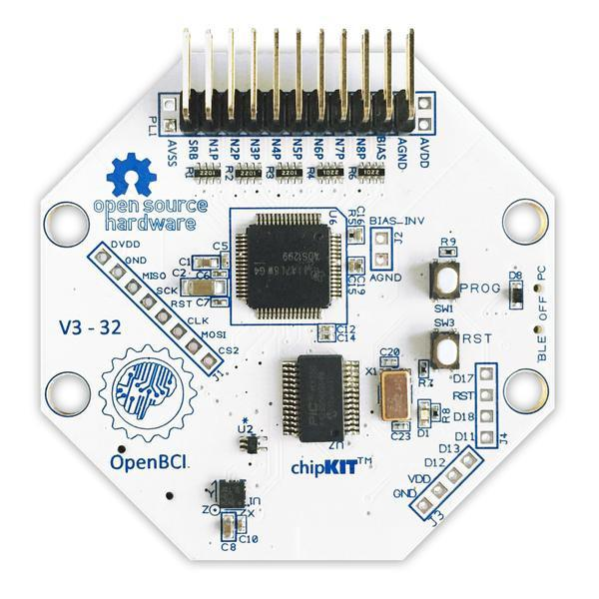

Figure 4.1

2. OpenBCI USB Dongle

The OpenBCI USB Dongle has an integrated RFDuino that communicates with the RFDuino on the Cyton board. The dongle establishes a serial connection with the computer's on-board FTDI chip. In this way signals on the board communicates and stored wirelessly to a computer via the the OpenBCI USB dongle.

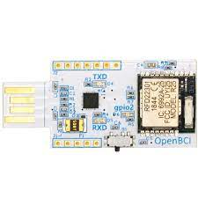Figure 4.2

11

3. Ultracortex "Mark IV" EEG Headset

The ultra “Mark IV” EEG headset consist of headwear and electrodes and collect the brain signals from the subject through the electrodes. Headset Consist of 2 types of electodes i.e supporting(do not collect brain signals) and non-supporting(actually collect brain signals) .

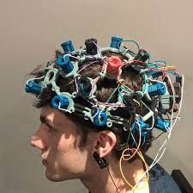

Figure 4.3

4.1.1.2 Software Tools used –

1.OpenBCI GUI

The OpenBCI GUI is an interface for the user to visualizing, record, and stream data from the OpenBCI Boards.

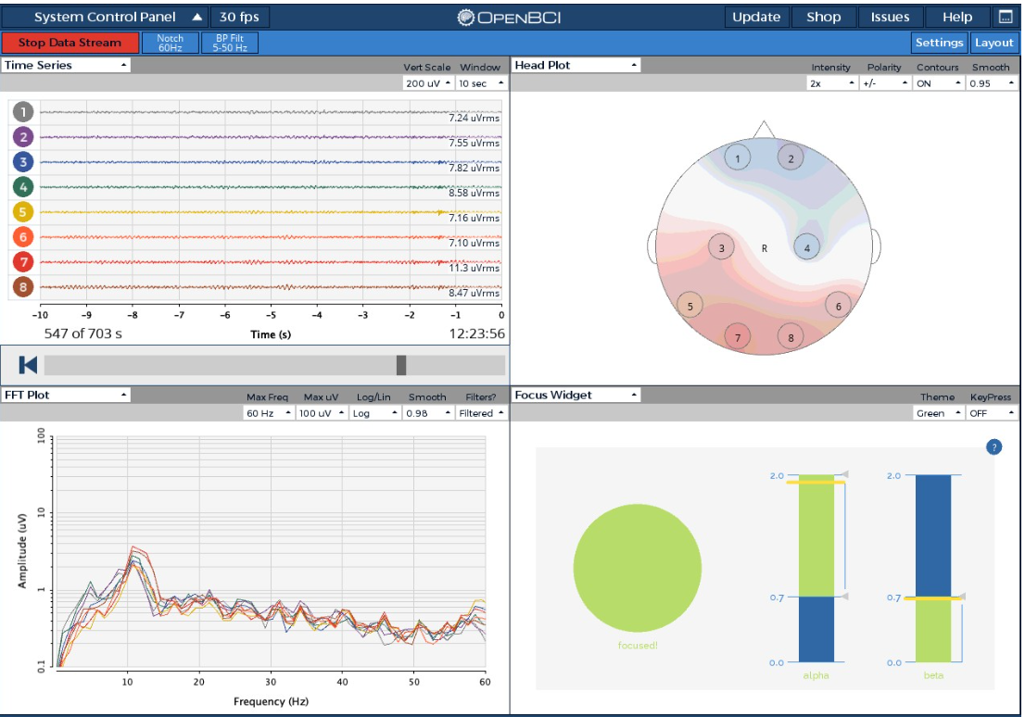

12

2. Bi\_Color.py

Bi\_Color.py is a code script written by us for the experiment. we run this script during the experiment so that any of the 3 color(red, green or blue) are automatically displayed one by one 75 times in each session.

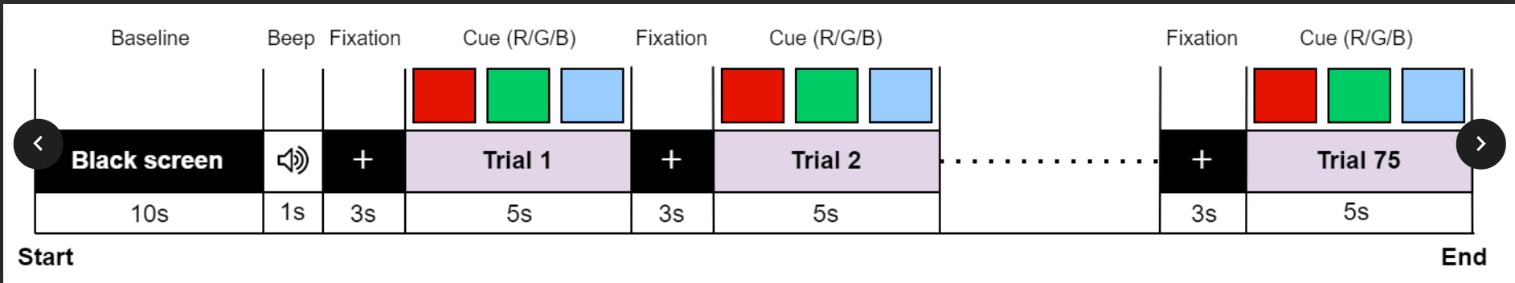

………………………………………………………………………………………………………………………………………………………………….

4.1.2 Experimental Setup-

1.select the proper lobes of the EEG headset through which we want to collect the data. As discussed in research paper [1], frontal, occipital and parietal lobe are more sensitive to and responsible for visual stimuli therefore we used fp1, fp2, p3, p4, o1, o2, c3, c4 lobe of headset of OpenBci device in our experiment.

2.Make the subject wear the ultra “Mark IV” EEG headset and tight the plugs of the electrodes so that they just touch the scalp.

2.connect the OpenBCI USB Dongle to the computer system on which we want to collect and store the data.

3.put the SRB pin clip to the right ear to get  all be measured against this reference pin.

4.Install the following softwares in the computer – a) openBCI GUI, b) drivers for support for windows<11.

5. Open the openBCI GUI then Click on system control panel -> CYTON(live) ->Serial from Dongle . and then  click on  SERIAL CONNECT->AUTO-CONNECT. to get the data from the electrodes in headset into the PC through the dongle.

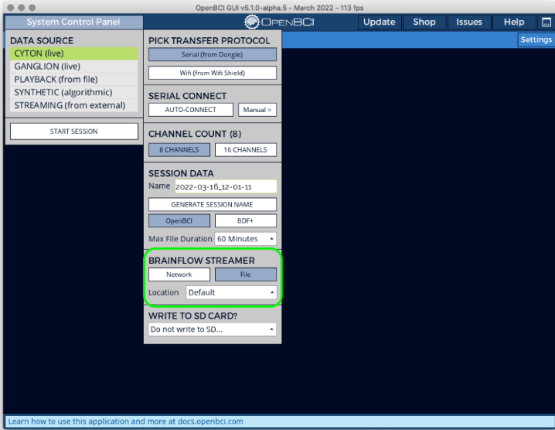

6.Now session is started. Modify the hardware settings by setting PGA gain = 4 because as we are using thin pulse active electrodes so active electrodes have in built amplifier. So it is suggested that we should use gain as 8 or lower than 8. Also set the bias include = No because thin pulse electrode has its own bias.

13

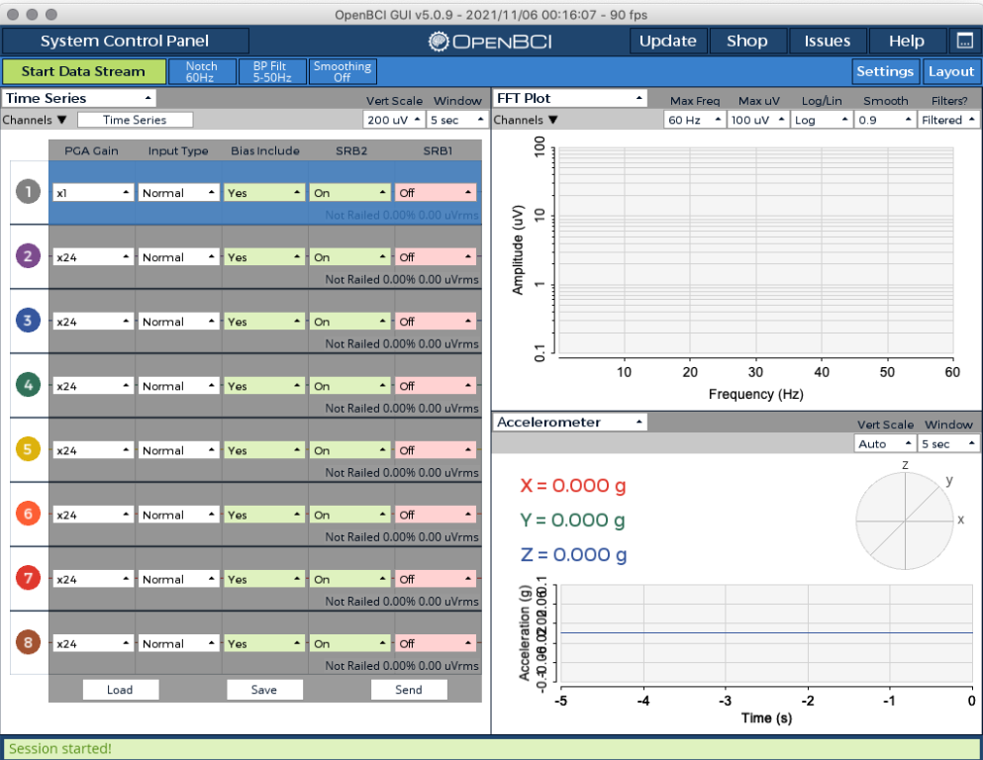

7.start the session by clicking on ‘start Data Stream’ .

8.selecting ’check All Channels’ from the drop down menu ‘cyton signal’ to check the impedence for all the channels

9. If Impedence of any of the channels is more that 5 ohm then adjust the headset and loose or tighten the plugs of electrodes accordingly to set the impedence of all the channels less than 5 ohm.

10. once the impedence of all the channels are less than 5 ohm. Now we are ready to collect the data.

……………………………………………………………………………………………………………………………………………………………………………

4.1.3 DATA COLLECTION THROUGH THE EXPERIMENT

1. switch off the lights of the room where the experiment is done.

2.adjust the temperature of the room accordingly.

3. make sure the subject is at a distance of 50 cm from the screen.

4.In the openBCI GUI click on ‘start data stream’ .

5. Run the python file Bi\_Color.py .

6. Run the Lab Recorder app .

7.

8. As each session takes 10 minutes. after the Bi\_Color.py stops running, switch off the button of cyton board. Click on ‘stop data stream’ on openBCI GUI.

14

9. stop the recording in the lab recorder.

10. the events.txt and trials.txt file got generated and saved corresponding to particular session of a particular subject in some location in the computer system.

…………………………………………………………………………………………………

4.1.4 DATA DESCRIPTION

The data from 7 subjects, between ages of 20-25, of which 6 of them was males, 1 of them was female, was taken in 3 sessions of each of them.

In each session, red, green or blue color was shown 75 times for 5 sec each with a baseline of 3 sec. in general total time of each session is 10 minutes.



each session of each subject has events.txt and trials.txt file.

**events.txt** – stores the time stamp vs color information of EEG signals corresponding to the time when red, green or blue color was shown to the subject.

**trials.txt** – contains EEG brain signals data of all the 8 channels and their time stamps using OpenBCI.

……………………………………………………………………………………………………………………………………………….

4.1.5 DATA PREPROCESSING

As discussed in paper [2], raw EEG signals do not provide useful information therefore first of all we did data pre-processing as follows-

**Steps**- Raw data -> common average referencing -> scaling factor -> 50 hz notch filter ->  0-40 hz band pass filter

Common average referencing is done because taking a common average reference in the EEG data, also corresponds to taking a common average reference in the forward model. The consequence of subtracting the average potential (from each channel) is that the model error is averaged over all channels. Since there is no reason to assume that the model error is specifically positive or negative, the model error tends to average out and the forward solution at each channel will have a much smaller forward model error.

15

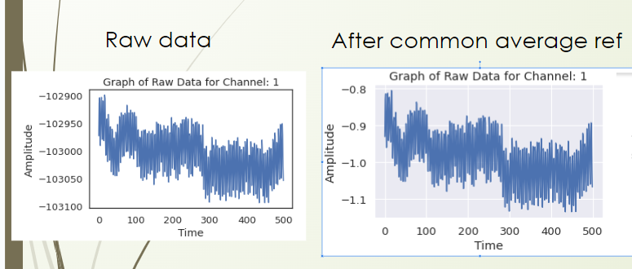

Scale factor is a correction of EEG spectra data improves the diagnostic accuracy for detecting pathological EEG spectra from an almost random level.

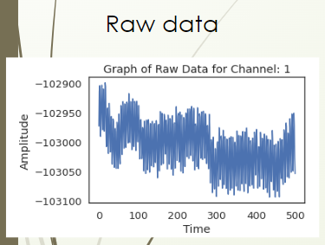 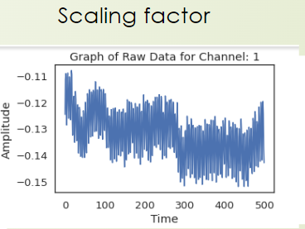

Notch filter is used when signals can often be exposed to strong power line interference at 50 or 60 Hz. A widely used method to remove line noise is notch filter. (here we used 50 hz notch filter)

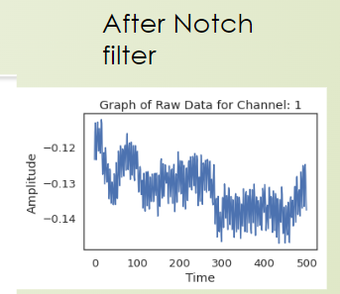

16

bandpass filter is used to filter the eeg signals from noise i.e involuntary eye movements, unneccessary light from lamps, etc. Studies generally use a bandpass filter from 1Hz to 40Hz on EEG signals because the literature does not report interest in data below 1Hz, and above 40Hz. Above the frequency of 40Hz, interferences of lamps and devices on EEG signals that operate at an approximate frequency can occur.

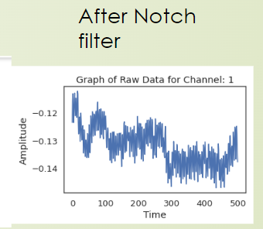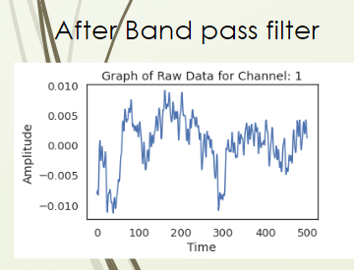

…………………………………………………………………………………………………………………………………………………………

4.1.6 DATA EPOCHING

1. using events.txt and trials.txt files, for each session of each subject we fitered out the electrical brain signals corresponding to the time when blue, green or red color was shown.

2. each second 256 recordings were recorded.

3.splitted the 5 second data into 5 one seconds data when a particular color was shown.

4. removed the last 5 recordings of each second, so we are left with 250 recordings in each second.

5. each second data is a particular elements of the training set.

6.therefore there are total 75\*5 = 375 elements in the training set of each session of each subject.

7.there are total 8 channels we used.

8. therefore size of training set is (375,250,8)

……………………………………………………………………………………………….

**.4.1.7** FEATURE EXTRACTION

As the Extracted features are meant to minimize the loss of important information embedded in the signal. In addition, they also simplify the amount of resources needed to describe a huge set of data accurately.

Then the features we extracted for the data for each session of each second of shape (375, 250, 8)-

1.)Statistical Features (mean, standard deviation, skewness, kurtosis)

a. Mean

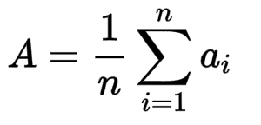 17

In each sample of the dataset of shape (250, 8 ), calculated the mean of amplitudes of all the 250 recordings for each channel and got (1,8) matrix as an output.

b. standard deviation

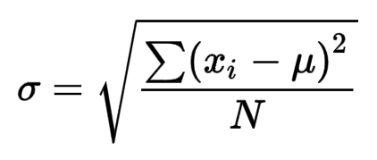

In each sample of the dataset of shape (250, 8 ), calculated the standard deviation of amplitudes of all the 250 recordings for each channel and got (1,8) matrix as an output.

c. skewness

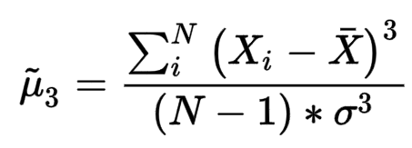

In each sample of the dataset of shape (250, 8 ), calculated the skewness of amplitudes of all the 250 recordings for each channel and got (1,8) matrix as an output.

d. kurtosis

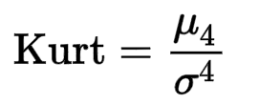

In each sample of the dataset of shape (250, 8 ), calculated the kurtosis of amplitudes of all the 250 recordings for each channel and got (1,8) matrix as an output.

2. DCT features (DCT power)

In each sample of the dataset of shape (250, 8 ), calculated the Discrete cosine transformation power of amplitudes of all the 250 recordings for each channel and got (1,8) matrix as an output.

3. Wavelet Features (cA energy, cD energy)

In each sample of the dataset of shape (250, 8 ), calculated the CA energy and Cd energy of amplitudes of all the 250 recordings for each channel and got (1,16) matrix as an output.(2 values corresponding to each channel as an output which are at a distance of x and x+8 or x-8 in the output matrix).

4. Band Power (delta, theta, alpha, beta, gamma)

Brainwaves is divided into 5 sub frequency bands namely alpha (8 – 13 Hz), beta (13 – 30 Hz), gamma (30 – 100 Hz), theta (4 – 8 Hz) and delta (1 – 4 Hz) and here we computed the average power of a signal in all of these specific frequency range.

In each sample of the dataset of shape (250, 8 ), calculated the average of power of signals on each specific range of amplitudes of all the 250 recordings for each channel and got (1,40) matrix as an output.(5 values corresponding to each channel as an output which are at a distance of x and x+8, x+16,x+24, x+32 in the output matrix).

5.Coefficient of variation

The coefficient of variation is a popular measure for describing the amount of repeat variability present in ECG measurements from recording to recording.

In each sample of the dataset of shape (250, 8 ), calculated the Coefficient of Variation of amplitudes of all the 250 recordings for each channel and got (1,8) matrix as an output.

18

6. secDiffMean

In each sample of the dataset of shape (250, 8 ), calculated the secDiffMean of amplitudes of all the 250 recordings for each channel and got (1,8) matrix as an output.

7. secDiffMax

In each sample of the dataset of shape (250, 8 ), calculated the secDiffMax of amplitudes of all the 250 recordings for each channel and got (1,8) matrix as an output.

8. firstDiffMean

In each sample of the dataset of shape (250, 8 ), calculated the firstDiffMean of amplitudes of all the 250 recordings for each channel and got (1,8) matrix as an output.

9. firstDiffMax

In each sample of the dataset of shape (250, 8 ), calculated the firstDiffMax of amplitudes of all the 250 recordings for each channel and got (1,8) matrix as an output.

10.hjorth (hjorth activity, hjorth mobility, hjorth complexity)

a. Hjorth Activity

The activity parameter represents the signal power, the variance of a time function. This can indicate the surface of power spectrum in the frequency domain. This is represented by the following equation:

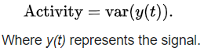

b.Hjorth Mobility

The mobility parameter represents the mean frequency or the proportion of standard deviation of the power spectrum. This is defined as the square root of variance of the first derivative of the signal *y(t)* divided by variance of the signal *y(t).*

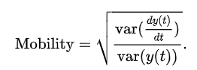

c. The Complexity parameter represents the change in frequency. The parameter compares the signal's similarity to a pure [sine wave](https://en.wikipedia.org/wiki/Sine_wave), where the value converges to 1 if the signal is more similar.

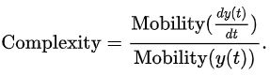

In each sample of the dataset of shape (250, 8 ), calculated the hjorth(activity, mobility, complexity)on each specific range of amplitudes of all the 250 recordings for each channel and got (1,24) matrix as an output.(3 values corresponding to each channel as an output which are at a distance of x and x+8, x+16 in the output matrix).

19

11. MaxPwelch(a1,b1,c1,d1,e1,f1,g1,h1)

computes the maximum power spectrum density of signals of each input channel using welch method.

In each sample of the dataset of shape (250, 8 ), calculated the MaxPwelch of amplitudes of all the 250 recordings for each channel and got (1,8) matrix as an output.

………………………………………………………………………………………………………………………………………………………………………

4.1.8 FEATURE SELECTION

Feature selection is a process where you automatically select those features in your data that contribute most to the prediction variable or output and its accuracy in which you are interested.

Having irrelevant features in your data can decrease the accuracy of many models.

Feature selection was done in two ways

1.Random experimentation of feature combination.

2. built in libraries to do feature selection (SelectKBest)

**1.Manual experimentation of feature combination**

a.  Statistical + DCT + Wavelet + Band Power + secDiffMean + secDiffMax + first\_diff\_mean +  first\_diff\_max + first\_diff\_max + hjorth +  maxPwelch  (All features Combined)

b. Statistical + DCT + Band Power + secDiffMean + secDiffMax + first\_diff\_mean +  first\_diff\_max + first\_diff\_max + hjorth +  maxPwelch (All features Except Wavelet features)

c. only wavelet (only wavelet features)

Only KNN was giving us 72% and all other models were giving us less than 40% so we observed only KNN vs features.

KNN accuracy didn’t changed after removing each of the features from all the features except Wavelet features.

KNN accuracy change from 72 % to 30% when we removed Wavelet features from all the features.

So by feature selection procedure we observed only wavelet features are required.

**2.Build in libraries to do feature selection(SelectKBest)**

- there are 28 features in total extracted.

-used SelectKBest library to do feature selection in python.

- experimented for no. of features vs accuracy for each of the 8 channels

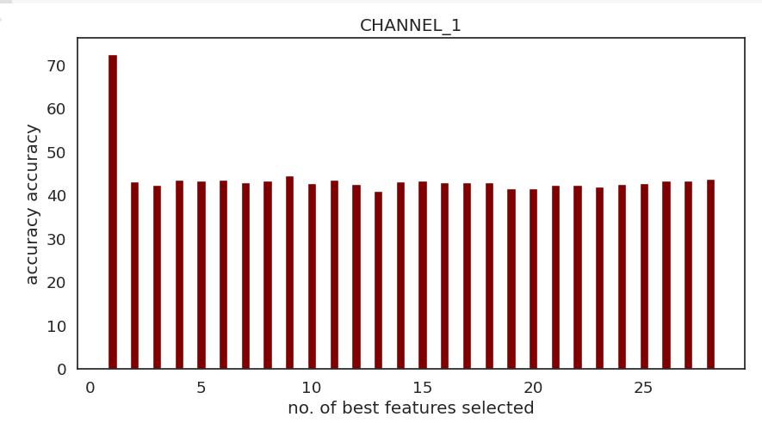

20

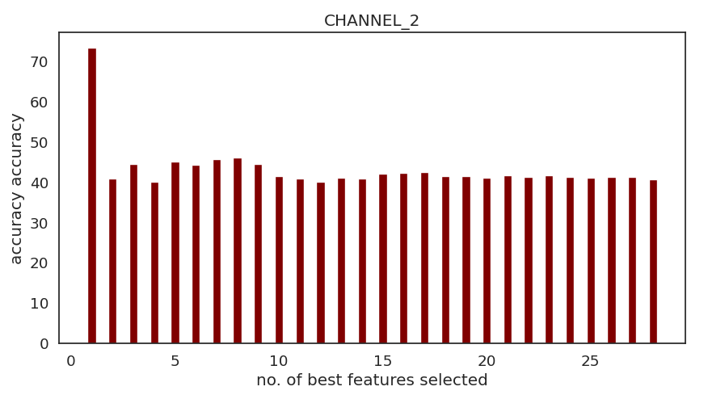

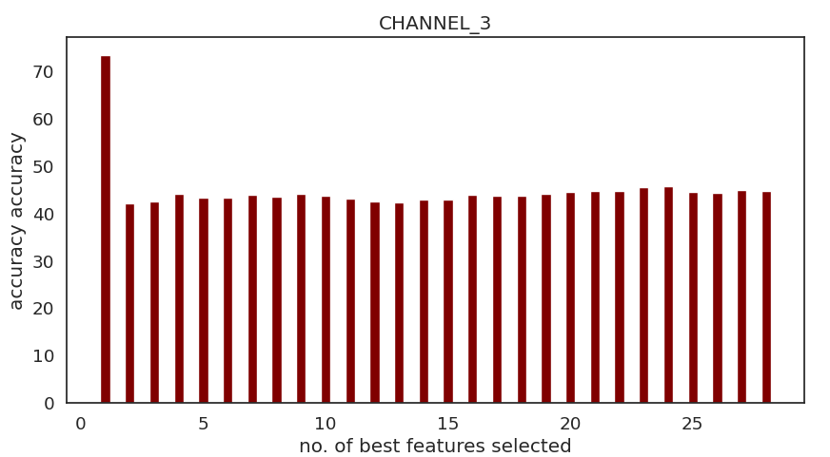

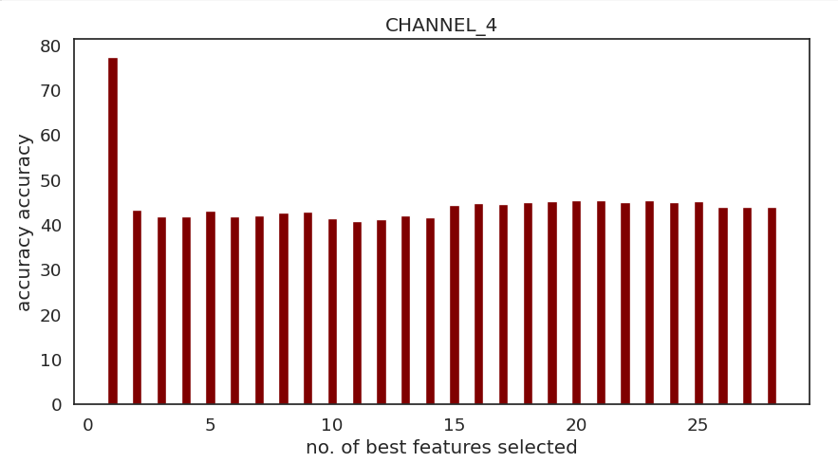

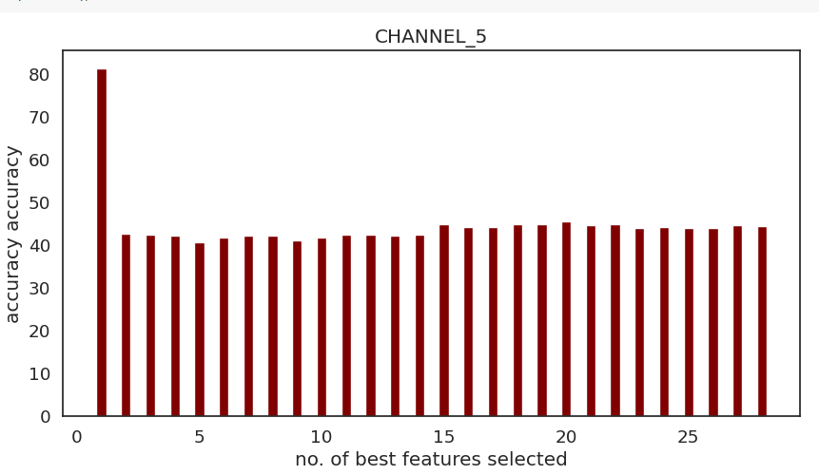

21

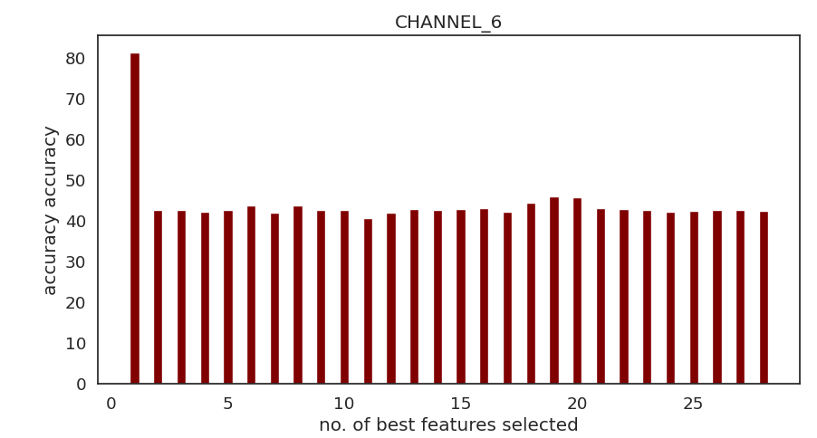

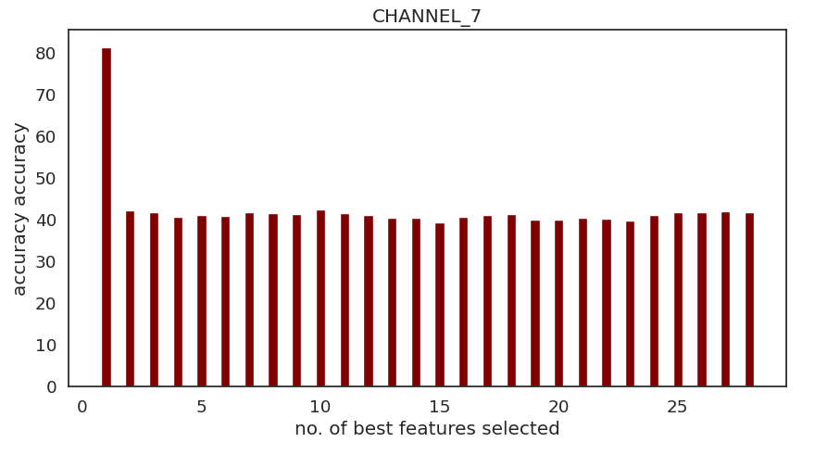

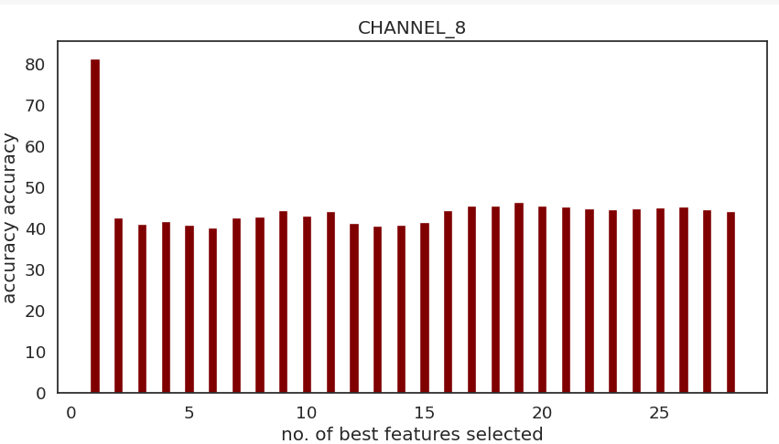

-Accuracy was highest with no. of features= 1(wavelet feature) in all the channels

…………………………………………………………………………………………………………………………………………………………

4.2 Front-end

The GUI refreshes at 255Hz, and reads the contents of the shared memory for any

change in the timestamp. In the case a timestamp change is noticed, it reads the

prediction stored in the shared memory block (red, blue or green color) and makes the

necessary changes to the UI by taking in the prediction as an input.

22

4.3 InTIGRATION

The integration of the system occurs in two parallel threads, one managing data

acquisition, processing and interpreting the signal received (backend) and the other

handling the user interface (frontend). Communication

between them is handled through a shared piece of memory handling the time stamp

and the label associated with the prediction of the data received at that time stamp. Both

the frontend and backend run on a refresh rate of 255Hz. When the prediction confidence

goes past a certain threshold, it writes the timestamp of the prediction and the prediction

itself on the shared block of memory by acquiring a mutex lock first. When the frontend

detects a change in the timestamp in the shared memory, it reads the prediction label in

the shared memory block and changes the UI according to the prediction.

…………………………………………………………………………………………………………………………………………………………

23

**5RESULTS AND DISCUSSION**

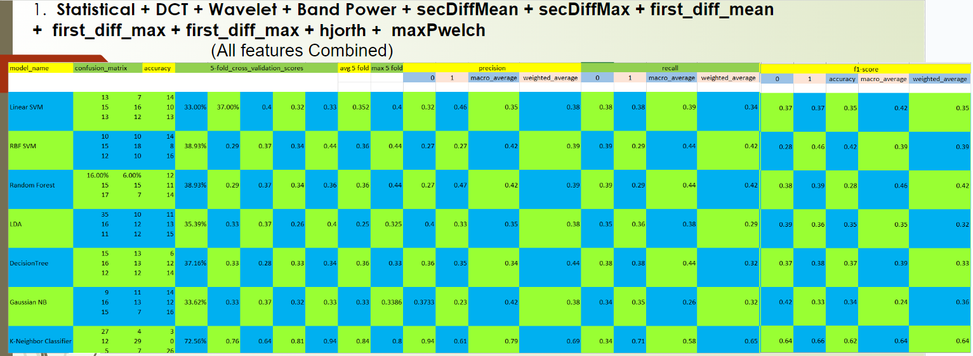

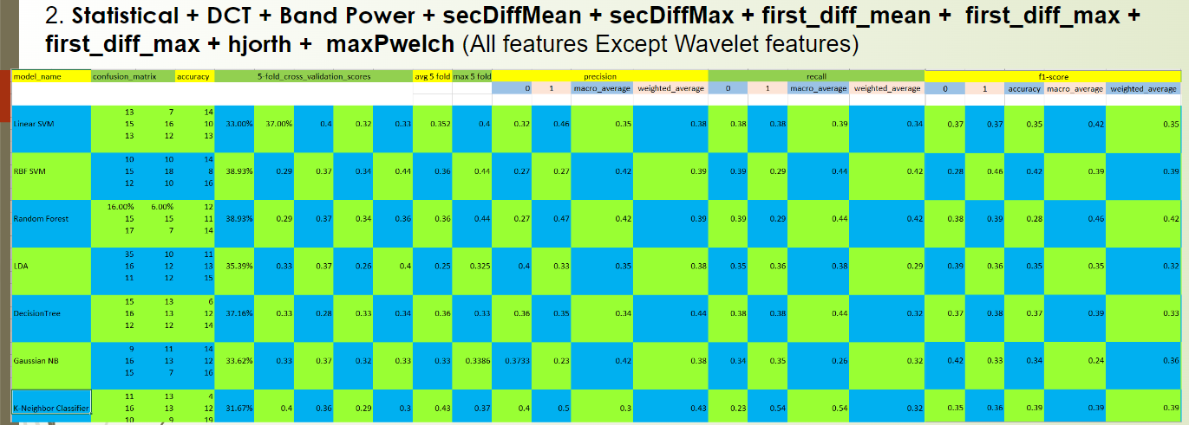

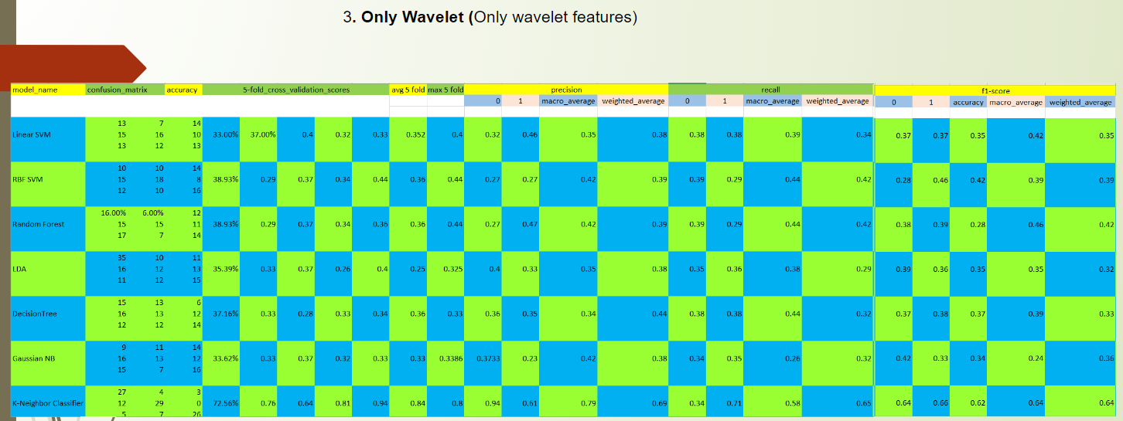

Highest accuracy of Tri-color experiment is 72.56%(when K-neighbour classifier was trained with only Wavelet features)

…………………………………………………………………………………………………………………..

24

**6.CONCLUSION AND FUTURE WORK**

In this paper, we analysed and differeciated the brain signals from red, green and blue color shown to the subject using a supervised learning approach. We conducted various feature selection experiments to come to the conclusion that highest accuracy of the model trained by the data collected by us through experimentation is 72.56%(when K-neighbour classifier was trained with only Wavelet features) . This research work has pretty good application as if we are able to discriminate between brain signals corresponding to three different colors then we can use this as three control commands for controlling any dedicated computer application and this could be a very helpful solution for people suffering for paralysis, coma etc.

Further as a future work we would like to work on

………………………………………………………………………………………………….

Reference-

1. Brain response to color stimuli: an EEG study with nonlinear approach. <https://link.springer.com/article/10.1007/s11571-021-09692-z>

2. Analysis of Visual color perception using EEG spectral features.

<https://www.researchgate.net/publication/259641490_EEG_spectral_analysis_of_visual_evoked_potential_produced_by_RGB_color_stimuli>

3. Analysis of brain activity and response to colour stimuli during learning tasks: an EEG study.

<https://ui.adsabs.harvard.edu/abs/2013SPIE.8652E..0IF/abstract>

4.Classification of color imagination using Emotiv EPOC and event-related potential in electroencephalogram

<https://www.sciencedirect.com/science/article/pii/S0030402616308415>

5. Classification of EEG from Black Color Stimuli to Command a Remote-Controlled Car: Ongoing Study.

<https://www.researchgate.net/publication/332075377_Classification_of_EEG_from_Black_Color_Stimuli_to_Command_a_Remote-Controlled_Car_Ongoing_Study>

6. Decoding visual colour from scalp electroencephalography measurements

<https://www.sciencedirect.com/science/article/pii/S1053811921003074>

7. Discriminating Different Color from EEG Signals using Interval-Type 2 Fuzzy Space Classifier

<https://ieeexplore.ieee.org/document/7853388>

25

8. Effects of colour towards underwear choice based on electroencephalography (EEG)

<https://www.sciencedirect.com/science/article/abs/pii/S1441358216302191#:~:text=They%20give%20more%20favourable%20neural,while%20female%20prefers%20red%20colour>.

9. : ELECTROENCEPHALOGRAM (EEG) STUDIES ON HUMAN PERCEPTION IN COLOURS

<https://jamt.utem.edu.my/jamt/article/view/5685>

10. Environmental Colour Impact upon Human Behaviour: A Review

<https://www.researchgate.net/publication/257715419_Environmental_Colour_Impact_upon_Human_Behaviour_A_Review>

11. TOWARDS EEG-BASED SIGNALS CLASSIFICATION OF RGB COLOR-BASED STIMULI

<https://www.researchgate.net/publication/333488946_TOWARDS_EEG-BASED_SIGNALS_CLASSIFICATION_OF_RGB_COLOR-BASED_STIMULI>

………………………………………………………………………………………………

26