**Requirement Analysis**

**Data Flow Diagrams & User Stories**

|  |  |
| --- | --- |
| Date | 16 April 2025 |
| Team ID | SWTID1745000177 |
| Project Name | ShopEZ: E-commerce Application |
| Maximum Marks | 4 marks |

**Data Flow Diagrams:**

A Data Flow Diagram (DFD) is a traditional visual representation of the information flows within a system. A neat and clear DFD can depict the right amount of the system requirement graphically. It shows how data enters and leaves the system, what changes the information, and where data is stored.

ShopEZ: E-commerce Application DFDs:

**Level-0 Description:**

User: The end-user who interacts with the product shopping web app.

Process Purchase: Handles trade requests from the user, processes them, and updates the product data and user account data.

Fetch Product Data: Requests and retrieves real-time product data from the Product Catalog API and updates the product data in the database.

Notify Buyer: Sends notifications to the user regarding their orders or product updates.

Stock Data: Database storing product information.

User Data: Database storing user information.

Product Catalog API: External service providing real-time product market data.

Email Notification Service: External service used to send notifications to the user.

**Level-1 Description and Processes:**

User: The end-user who interacts with the product shopping web app.

Stock Data: Database storing product information.

User Data: Database storing user information.

Product Catalog API: External service providing real-time product market data.

Email Notification Service: External service used to send notifications to the user.

**Processes:**

User Interface (UI): Manages user requests and interactions with the web app.

User Authentication (Signup/Login): Handles login and signup processes, updates user account data.

Purchase Processor: Manages trade requests, updates product data, and communicates with the portfolio manager and notifier.

Cart Manager: Updates user portfolios based on trade activities.

Product Fetcher: Requests real-time product data from the Product Catalog API and updates the product data.

Order Notifier: Sends notifications to users through the Email Notification Service.

**Level – 0 DFD**

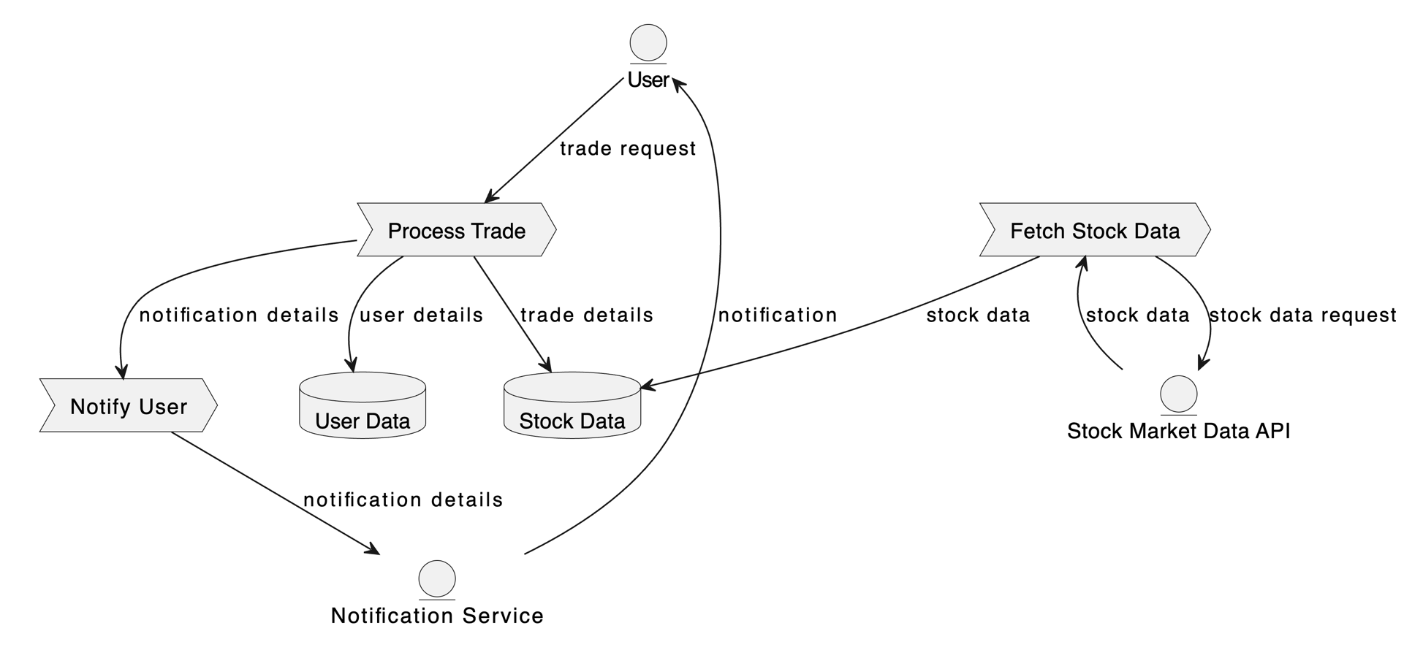

**Level – 1 DFD**

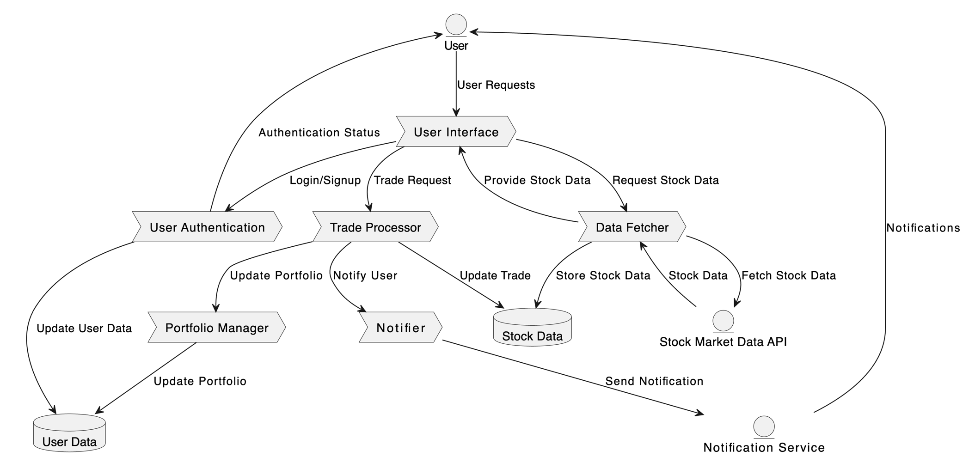

**User Stories**

Use the below template to list all the user stories for the product.

| **User Type** | **Functional Requirement (Epic)** | **User Story Number** | **User Story / Task** | **Acceptance Criteria** | **Priority** | **Release** |
| --- | --- | --- | --- | --- | --- | --- |
| Customer (Web user) | Account Management | USM-1 | As a user, I want to create an account to start shopping. | I can provide personal information, set a username and password, and agree to terms of service. | High | Sprint 1 |
| Customer (Web user) | Account Management | USM-2 | As a user, I want to log in to my existing account. | I can enter my credentials (username/email and password) and access my account dashboard. | High | Sprint 1 |
| Customer (Web user) | Account Management | USM-3 | As a user, I want to securely reset my password. | I can request a password reset link via email and successfully change my password. | Medium | Sprint 2 |
| Customer (Web user) | Market Data | USM-4 | As a user, I want to view real-time product quotes and market data. | I can see up-to-date product prices, shopping volume, and market indices. | High | Sprint 1 |
| Customer (Web user) | Market Data | USM-5 | As a user, I want to search for products by product name or category. | I can quickly find relevant products and view their details. | Medium | Sprint 1 |
| Customer (Web user) | Trading | USM-6 | As a user, I want to place buy and sell orders for products. | I can specify the product, quantity, price, and quantity, size, and other preferences. | High | Sprint 2 |
| Customer (Web user) | Trading | USM-7 | As a user, I want to view my order history and purchase confirmations. | I can see a detailed history of my past orders and their execution status. | Medium | Sprint 2 |
| Customer (Web user) | Portfolio Management | USM-8 | As a user, I want to track my product portfolio and its performance. | I can see a list of my owned products, their current value, and overall portfolio gain/loss. | High | Sprint 2 |
| Customer (Web user) | Portfolio Management | USM-9 | As a user, I want to set up watchlists to monitor specific products. | I can create custom watchlists and add/remove products as needed. | Medium | Sprint 3 |
| Customer (Web user) | Research | USM-10 | As a user, I want to access product research and analysis. | I can view customer reviews, product specifications, and news articles related to products. | Medium | Sprint 3 |
| Customer (Web user) | Customer Support | USM-11 | As a user, I want to contact customer support for assistance. | I can submit a support ticket or access a knowledge base for troubleshooting. | Low | Sprint 4 |
| User Type | Functional Requirement (Epic) | User Story Number | User Story / Task | Acceptance Criteria | Priority | Release |