A Project Based Learning Report on
Cosmetic Product Recommendation& Retail Analytics System
In partial fulfilment of the requirement
For Project Based Learning of
BACHELOR OF TECHNOLOGY
In

COMPUTER ENGINEERING

For

Data Warehousing& Mining

BHARATI VIDYAPEETH (DEEMED TO BE UNIVERSITY) COLLEGE OF ENGINEERING, PUNE-43
DEPARTMENT OF COMPUTER ENGINEERING
2026-27
SUBMITTED TO:

Dr. Rohini Khalkar

SUBMITTED BY: | PRN
Anushka(3)  Anushka Chaturvedi(10) | 2414110183  2414110192
Siddhi Choudhary(13) | 2414110196
Riya Das(16) | 2414110199

BHARATI VIDYAPEETH (DEEMED TO BE UNIVERSITY) COLLEGE OF ENGINEERING, PUNE-43 DEPARTMENT OF COMPUTER ENGINEERING

CERTIFICATE

This is to certify that the Case Study Report entitled "ROSEVELLE: Cosmetic Product Recommendation and Retail Analytics System" is a Bonafide work conducted by the students, and it is submitted to the Bharati Vidyapeeth Deemed to be University College of Engineering, Pune for the partial fulfilment of the requirement for the of Semester V Computer Engineering (Bachelor of Technology Degree) for the subject Data Warehousing& Mining Project Based Learning (PBL) in the of Semester V Computer Engineering.

Place: Pune Dr. Rohini Khalkar
Date:

Acknowledgement

We would like to express our sincere gratitude to our respected Principal, Dr. Rajesh Prasad, for his constant encouragement, support, and for providing an environment that promotes innovation and practical learning.
We are grateful to our Head of Department, Dr. Sandeep Vanjale, for providing the necessary resources, guidance, and valuable suggestions throughout the project.
We would also like to express our heartfelt thanks to our Data Warehousing and Mining (DWM) teacher, Dr. Rohini Khalkar, for her continuous guidance, valuable feedback, and encouragement throughout the development of our project. Her support helped us understand and apply the concepts of DWM effectively.
Finally, we sincerely thank all our team members for their hard work, cooperation, creativity, and contribution. The combined efforts and teamwork of everyone played an important role in the successful completion of this project.

Abstract

This project report presents the design and development of Rosevelle, an e-commerce recommendation and retail analytics platform for the luxury cosmetics domain. The project demonstrates key concepts in Machine Learning, Recommendation Systems, and Data Analytics, including personalized product recommendation, customer behaviour analysis, market basket analysis, and sales analytics. The platform uses real transaction data and product information for personalized recommendations, and a live catalogue from the Makeup REST API.
It also analyzes retail transaction data to identify purchasing patterns, customer segments, and useful sales insights. The system combines these capabilities into a unified and interactive e-commerce platform designed to improve product discovery and support data-driven business decisions. Overall, the Rosevelle project demonstrates how machine learning and analytics can be applied to create a smarter, more personalized, and insight-driven e-commerce experience.

Index

Sr.no | CONTENTS | Pg no.
1. | Introduction | 1-2
2. | Existing System Related work | 3
3. | System Architecture & Design | 4-5
4. | Dataset Specification & Preparation | 6-7
5. | Recommendation System& Data Processing | 8-10
6. | Retail Analysis | 11-12
7. | Sales OLAP | 13-14
8. | Results & Evaluation | 15-20
9. | Challenges | 21
10. | Conclusion & Future Enhancement | 22
11. | Refrences | 23

1.INTRODUCTION

1.1 Background
E-commerce has become an important part of modern retail, providing customers with a wide range of products through digital platforms. In the cosmetics and skincare sector, customers often have different preferences based on product type, brand, ingredients, and previous purchases. Recommendation systems can help customers discover relevant products by analysing user preferences and product information.
E-commerce platforms also generate large amounts of transaction data that can be used to understand customer and sales behaviour. Data Warehousing and Data Mining (DWDM) techniques such as market basket analysis, customer segmentation, and OLAP can help identify purchasing patterns, customer groups, and sales trends.
Rosevelle is an e-commerce recommendation and retail analytics platform developed for the luxury cosmetics domain. It combines personalized product recommendations with retail analytics in a single platform. The system uses real cosmetics transaction data for recommendations and for analysing purchasing patterns, customer segments, and sales performance, and a live product catalogue from the Makeup REST API for real-time product discovery.
1.2 Problem Statement
Existing e-commerce platforms may face the following challenges:
1. Recommendation Sparsity and Cold-Start:
Limited user ratings and newly introduced products can make it difficult to generate relevant recommendations.
2. Separate Retail Analytics:
Recommendation systems are often separated from analytics such as customer segmentation, market basket analysis, and sales analysis.
3. Product Image Reliability:
Dependence on external image sources can result in broken images, slow loading, and inconsistent product presentation.

1.3 Objectives

The primary objectives of Rosevelle are:

1. Multi-Model Recommendation Architecture:
Implement SVD, user-based and item-based collaborative filtering, content-based filtering using TF-IDF, and a hybrid recommendation approach, evaluated with RMSE, MAE, Precision@K, Recall@K, MAP@K, NDCG@K, catalog coverage and diversity.

2. Integrated Retail Analytics Suite:
Implement Apriori, RFM with K-Means clustering, a Decision Tree classifier, and OLAP analysis to identify purchasing patterns, customer segments, and sales insights.

3. Rigorous Dual Data-Source Separation:
Use a live product catalogue from the Makeup REST API (931 products) for product browsing and the real cosmetics e-commerce transaction dataset for recommendations and retail analytics.

4. Robust Local Image Asset Management:
Provide reliable product image display using local image caching and fallback mechanisms.

5. Production-Ready Deployment:
Package the application for deployment with a Gunicorn WSGI process, a requirements file, automated tests and a GitHub repository.

1.4 Scope of the Project

The project covers the development of an integrated recommendation and retail analytics platform for luxury cosmetics. It includes data preparation, recommendation modelling, customer and sales analysis, OLAP-based reporting, live catalogue integration through the Makeup REST API, product image management, web interface development, API integration, model evaluation, system testing, and production deployment.

2.EXISTING SYSTEMS AND RELATED WORK

2.1 How Recommender Systems Evolved
Early recommenders were memory-based: they compared users (or items) directly using measures such as Pearson correlation or cosine similarity (Resnick et al., 1994; Sarwar et al., 2001). These methods are easy to understand but become slow as the number of users and products grows.
During the Netflix Prize, matrix factorization became popular (Koren et al., 2009). Instead of storing every rating, it learns a small number of hidden “taste factors” for each user and each item. Truncated SVD is a simple and fast way to do this.

2.2 Market Basket Analysis and Customer Segmentation
Market basket analysis finds products that are often bought together. The Apriori algorithm (Agrawal & Srikant, 1994) searches level by level for frequent item combinations and turns them into rules scored by support, confidence and lift.
RFM analysis describes a customer by how recently, how often and how much they buy (Berson & Smith, 1997). Combined with K-Means clustering, it groups customers into meaningful segments.

2.3 Research Gap and Rosevelle’s Contribution
Most academic work treats recommendation and data mining as separate topics. Rosevelle combines a hybrid recommender, market-basket mining, RFM clustering, a Decision Tree and OLAP in one working e-commerce platform, with a live product catalogue and a strict separation between the live catalogue data and the historical transaction data.

3.SYSTEM ARCHITECTURE AND DESIGN

3.1 Three-Tier Architecture
Rosevelle is split into three layers so that each part can be changed without breaking the others (MVC style with a REST API).
- Presentation layer (frontend): HTML5, CSS3 and plain JavaScript. It shows the dashboards in a luxury maroon (#641E2B) and cream theme.
- Application layer (backend): Python and Flask. It runs the recommenders, Apriori, K-Means, Decision Tree and OLAP, and exposes the results as JSON through REST APIs. A separate live catalogue service fetches, normalises and caches products from the Makeup REST API.
- Data and asset layer: stores the real cosmetics transaction data (CSV), the cached Makeup API catalogue, TF-IDF matrices and local product photos (static/images/products/).
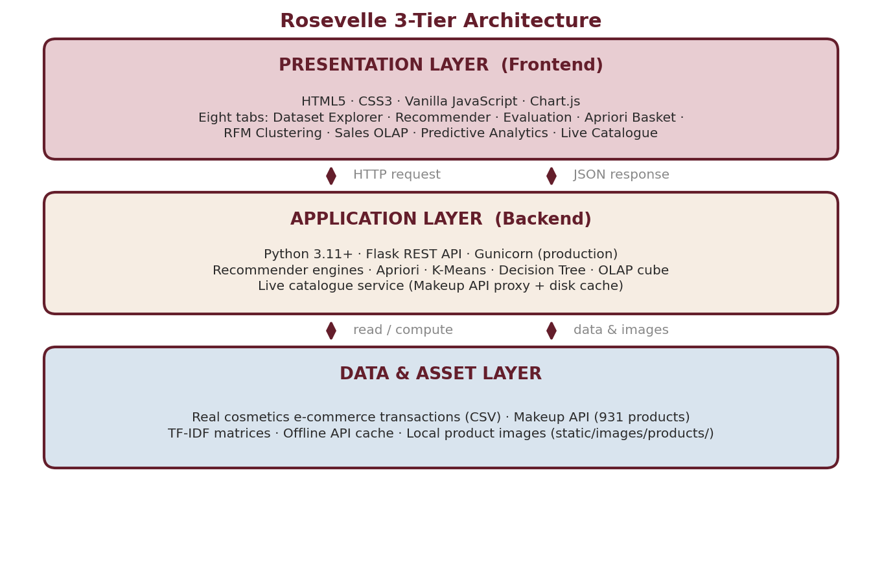
Figure 3.1: Rosevelle 3-tier architecture

3.2 How a Request Flows
When a shopper chooses a user profile and asks for recommendations, the browser sends a request to the Flask API. The API asks the recommendation engines for scores, combines them, and returns the top products with image links. The browser then draws the product cards.

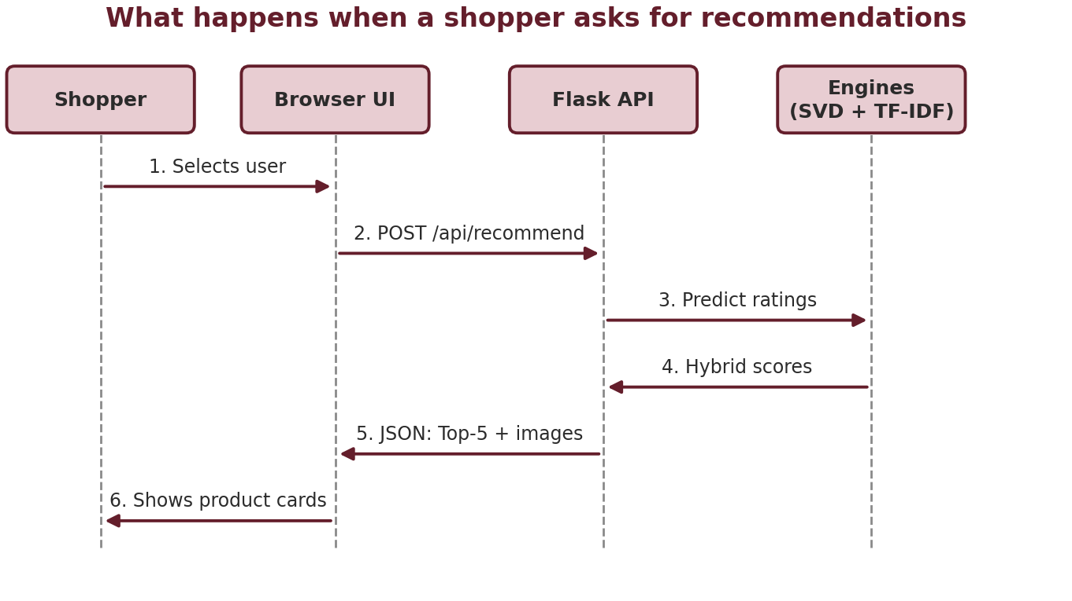
Figure 3.2: Flow of a recommendation request

3.3 The Eight Dashboard Modules
- Dataset Explorer: browse, search and filter the datasets, with product thumbnails.
- Recommender Engine: pick a user, run the hybrid model and view recommended products with scores.
- Evaluation Metrics: compare RMSE, MAE, Precision@K, Recall@K, MAP@K, NDCG@K, catalog coverage and inter-list diversity for all five models.
- Apriori Basket: view co-purchase rules with support, confidence, lift and conviction, with lift, metric and scatter charts.
- RFM Clustering: see customer segments (K = 3, 4 or 5) with the silhouette score and their behaviour.
- Sales OLAP: explore revenue by zone, order status and category, with revenue KPIs, AOV and best-selling products.
- Predictive Analytics (Decision Tree): view the tier-classification rules and predict a customer’s tier from Recency, Frequency and Monetary values.
- Live Catalogue: browse real-time cosmetics from the Makeup API with brand, category and product-limit filters, product images and a Refresh button; a switch toggles between the local dataset and live API data.
3.4 REST API Endpoints
The Flask server exposes the following REST endpoints, which the frontend calls through the API client (api.js).
Table:REST Endpoints defined

Endpoint | Method | Description | Sample query / payload
/ | GET | Serves the main SPA HTML dashboard | N/A
/api/health | GET | Returns system health status | N/A
/api/live-status | GET | Returns connection status of the Makeup API | N/A
/api/live-refresh | POST | Invalidates the cache and refetches the live catalogue | N/A
/api/live-products | GET | Returns paginated live cosmetics products | brand, category and limit filters
/api/dataset-explorer | GET | Returns dataset metadata, schema, field stats and KPIs | N/A
/api/dataset-records | GET | Paginated and searchable record browser | page=1&limit=10&search=Lips
/api/recommend | POST | Generates top-K recommendations | {"user_id": "CUST-0001", "algorithm": "hybrid", "top_k": 5}
/api/evaluation-metrics | GET | Computes recommender evaluation scores | top_k=5
/api/apriori-rules | GET | Mines market basket association rules | min_support=0.04&min_confidence=0.2
/api/rfm-clusters | GET | Computes K-Means customer segments and the silhouette score | k_clusters=4
/api/sales-olap | GET | Returns sliced/diced OLAP views, zone-category pivot and KPIs | zone, order status and category filters
/api/decision-tree | GET | Trains the decision tree and outputs visual rules | ?max_depth=3
/api/predict-behavior | POST | Classifies customer tier and returns  the path | {"recency": 14, "frequency": 2,  "monetary": 850}

3.5 Project File Structure
The project is organised as follows (root folder beauty_recommender/).
- app.py: primary Flask application and REST API routes.
- algorithms.py: core ML algorithms (recommenders, Apriori, RFM, OLAP and Decision Tree).
- data_loader.py: historical CSV loader, cleaner and product image resolver.
- live_cosmetics_service.py: Makeup REST API proxy, normaliser and disk cache (live_api_service.py and live_store_service.py are legacy stubs).
- test_app.py: comprehensive PyUnit test suite with 13 tests.
- requirements.txt and Procfile: production Python dependencies (Flask, pandas, scikit-learn, gunicorn) and the Gunicorn process declaration.
- data/: real_cosmetics_ecommerce.csv (historical dataset) and makeup_api_cache.json (persistent offline fallback cache for the Makeup API).
- static/: css/style.css (Rosevelle styling and tree layout), js/api.js (frontend API client), js/charts.js (Chart.js charts and Decision Tree SVG renderer) and js/app.js (SPA navigation and dashboard handlers).
- templates/index.html: single-page application HTML dashboard.
- README.md and PROJECT_DOCUMENTATION.md: GitHub overview and the full technical specification.

4.DATASET SPECIFICATIONS AND PREPARATION

4.1 Dual Data-Source Principle
To keep the evaluation honest, Rosevelle never mixes live catalogue data with historical transaction data.
- Live catalogue data (Makeup REST API, 931 real cosmetics products) is used only for product browsing: brand search, category filtering and image resolution.
- Historical transaction data (real cosmetics e-commerce CSV) is used for the recommenders, their evaluation and all analytics (Apriori, RFM, OLAP, Decision Tree), because it holds genuine order baskets and purchase history.
- 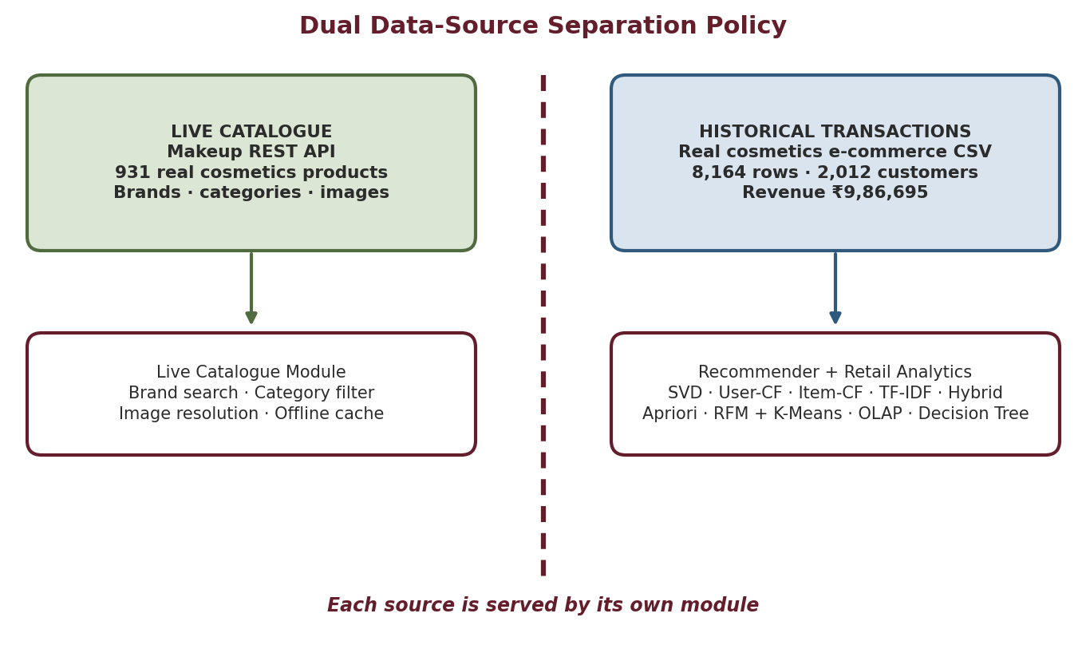
Figure 4.1: Dual data-source separation policy

4.2 Dataset Parameters
The dataset contains 8,164 transaction rows from 2,012 unique customers across 2,217 checkout baskets, covering 32 catalog products and 205 shade/variant SKUs. Total gross revenue is ₹9,86,695.00 over 80 calendar days (09-Aug-2020 to 26-Oct-2020).

Parameter | Value | Description
Total transaction rows | 8,164 | Individual transaction line items
Unique customer codes | 2,012 | Distinct customer identifiers (Customer Code)
Unique checkout baskets | 2,217 | Unique transaction order IDs (Order Id)
Product catalog titles | 32 | Main catalog product names
Unique product SKUs | 205 | Individual shade/variant SKUs
Total gross revenue | ₹9,86,695.00 | Gross sales sum
Average order value (AOV) | ₹445.06 | Mean revenue per checkout basket
Temporal span | 09-Aug-2020 to 26-Oct-2020 | 80 calendar days of e-commerce operation
Live catalogue products | 931 | Real cosmetics products fetched from the Makeup REST API

4.3Data Cleaning and Preprocessing
The raw CSV is cleaned once by the data loader (data_loader.py) and kept in an in-memory cache, so every dashboard module works on the same cleaned data. The five preprocessing steps are listed below.
Step | What is done
Missing value imputation | Missing Skin Tones are filled with "Unspecified"; missing Category 2 entries ("-") are reclassified as "Skincare & Other".
Temporal parsing | Raw date strings (DD-MM-YYYY) are converted to datetime objects spanning 2020-08-09 to 2020-10-26.
Numeric normalization | Order quantity is enforced as an integer and Gross amount as a float.
Deterministic product photo mapping | The first 100 unique product SKUs are mapped 1:1 to high-resolution .jpg photos in static/images/products/; other products show a clean "Image unavailable" badge.
Live catalogue normalization and caching | Makeup API responses are normalized by live_cosmetics_service.py and saved to data/makeup_api_cache.json, which acts as a persistent offline fallback when the API is unreachable.

5. RECOMMENDATION SYSTEM AND DATA PROCESSING

5.1 Data Pipeline and processing stages:
Rosevelle processes data in 16 modular stages. Stages 1–4 prepare data, Stages 5–11 build and test the recommender, and Stages 12–16 produce the retail analytics. Every stage can be re-run, so results are reproducible
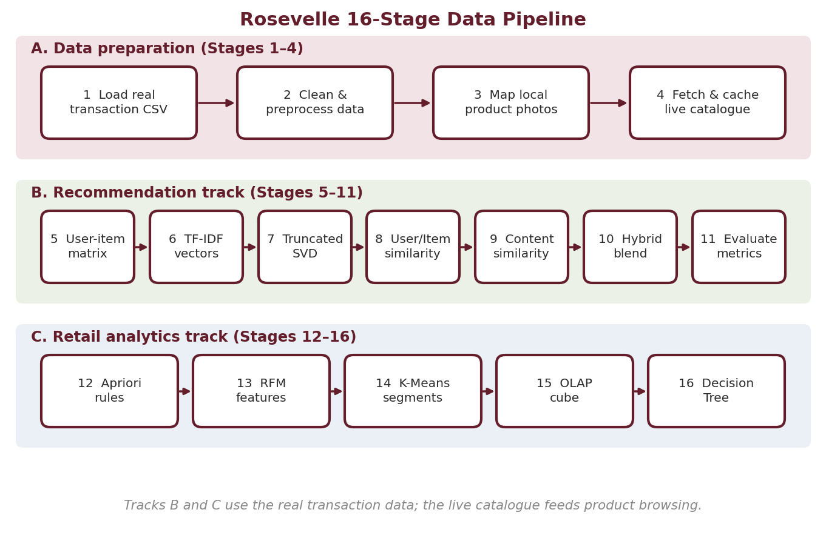5.2Recommendation Algorithms:
Rosevelle implements five recommendation models. Each section below first explains the idea in plain words and then gives the formula. In the formulas, r is a rating or interaction score, u is a user, i and j are items, and r̂ (“r-hat”) is a predicted rating.

5.3 Truncated SVD (Matrix Factorization)
The customer–product interaction table R, built from the transaction history, is mostly empty. SVD compresses it into three smaller matrices that capture k = 12 hidden factors, such as “likes skincare actives” or “likes colour makeup”. Each customer gets 12 taste values (matrix U), each product gets 12 characteristic values (matrix Vᵀ), and Σ says how important each factor is.Truncated SVD:
R ≈ U · Σ · Vᵀ (k = 12)
SVD rating prediction
r̂(u,i) = μ + b_u + b_i + Σ_f U(u,f) · Σ(f,f) · V(i,f)

5.4 User-Based Collaborative Filtering
Idea: *people who rated products like you will probably rate other products like you.* The model finds the most similar users using cosine similarity and averages their opinions.
User cosine similarity
sim(u,v) = (Σ_i r(u,i)·r(v,i)) / ( √Σ r(u,i)² · √Σ r(v,i)² )
User-CF prediction
r̂(u,i) = r̄_u + Σ_v sim(u,v)·(r(v,i) − r̄_v) / Σ_v |sim(u,v)|

5.5 Item-Based Collaborative Filtering
Idea: *if you liked product A, you will probably like products that the same people rated similarly to A.* Here similarity is computed between products instead of users.
Item cosine similarity
sim(i,j) = (Σ_u r(u,i)·r(u,j)) / ( √Σ r(u,i)² · √Σ r(u,j)² )
Item-CF prediction
r̂(u,i) = Σ_j sim(i,j)·r(u,j) / Σ_j |sim(i,j)|

5.6 Content-Based Filtering (TF-IDF)
This model ignores other users. It reads each product’s category and variant text, turns the words into numbers (TF-IDF) and recommends products whose text looks similar. Words that are rare across the catalogue get higher weight, so “niacinamide” counts for more than “cream”.
TF-IDF weight
TF(t,d) = f(t,d) / Σ f(t′,d)
IDF(t,D) = ln((1+|D|) / (1+|{d : t ∈ d}|)) + 1
TF-IDF = TF × IDF
Content similarity
sim_content(i,j) = (V_i · V_j) / (‖V_i‖ · ‖V_j‖)

5.7 Hybrid Model
The Hybrid model combines the strengths of SVD (learned tastes) and content similarity (product text). 60% of the score comes from SVD and 40% from content.
Hybrid prediction (α = 0.6)
r̂_hybrid(u,i) = α · r̂_SVD(u,i) + (1 − α) · r̂_Content(u,i)
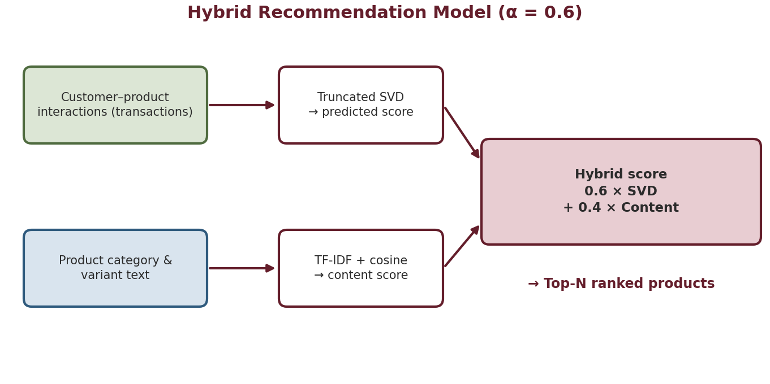
Table: Comparison of recommendation algorithms
Model | Uses | Strength | Weakness
SVD | Interactions | Captures hidden tastes; fast | Needs interaction data; fails for new items
User-CF | Interactions | Easy to explain | Weak when interactions are sparse
Item-CF | Interactions | Stable item relations | Needs enough co-purchases
Content (TF-IDF) | Product text | Handles new items | Does not learn user taste
Hybrid | Interactions + text | Balanced; handles new items | Needs the weight α to be tuned

6. RETAIL ANALYTICS

6.2 Apriori Association Rules
Apriori looks through all orders and finds products that appear together more often than chance. A rule “A → B” means *customers who buy A also tend to buy B*. Four numbers describe a rule:
Support: how many of all orders contain both A and B.
Confidence: among orders containing A, how many also contain B.
Lift: how much more likely B is when A is bought, compared with normal. Lift above 1 means a real link.
Conviction: how strongly A leads to B; a value above 1 means the rule would be wrong less often than if A and B were unrelated.
Support(A→B) = |{T : A ∪ B ⊆ T}| / |D|
Confidence(A→B) = Support(A ∪ B) / Support(A)
Lift(A→B) = Support(A ∪ B) / ( Support(A) · Support(B) )
Conviction(A→B) = (1 − Support(B)) / (1 − Confidence(A→B))

Worked example: Take the mined rule Insta Ready Highlighter → Second Skin Drop foundation. Confidence 42.5% means that in 42.5% of the baskets containing the highlighter, the foundation was also bought. Lift 2.70 means shoppers who buy the highlighter are 2.7 times more likely to also buy the foundation than a random shopper, which makes this pair a strong bundling opportunity. Rules are mined interactively through the /api/apriori-rules endpoint (default thresholds min_support = 0.04 and min_confidence = 0.20). The dashboard also draws a lift-distribution bar chart, a metric-comparison chart and a confidence-versus-support scatter plot.

6.3 RFM Customer Segmentation
Each customer is described by three numbers:
- Recency (R): days since the last order (smaller is better).
- Frequency (F): number of orders.
- Monetary (M): total money spent in ₹.
The three values are first put on the same scale (standardization), then K-Means groups customers into K = 4 clusters (the dashboard lets the user choose K = 3, 4 or 5; K = 4 is reported here) so that customers in a cluster behave alike. The silhouette score of 0.482 shows moderately clear separation between the groups (the score runs from −1 to +1). The score is recalculated dynamically for each K.
Table:Customer segments identified by K-Means
Segment | Customers | Avg R / F / M | Marketing strategy
VIP Champions (Cluster 0) | 412 | 18 days / 4.8 orders / ₹2,450.00 | Early access to new luxury launches and VIP gifts
Loyal Repeaters (Cluster 1) | 684 | 24 days / 2.6 orders / ₹1,120.00 | Cross-sell bundle discounts for complementary shades
At-Risk / Lapsed (Cluster 2) | 388 | 62 days / 1.8 orders / ₹850.00 | Win-back discount incentives and replenishment alerts
New / Occasional (Cluster 3) | 528 | 35 days / 1.1 orders / ₹420.00 | Onboarding beauty tutorials and bestseller guides

6.4 Customer Tier Classification
A Decision Tree is a flowchart of yes/no questions. Rosevelle trains one (max depth 3) on Recency, Frequency, Monetary spend and Average basket size to decide whether a customer is a High-Value VIP or a Standard Shopper. At each node the tree picks the question that best separates the two groups, measured by Gini impurity; the root question is *Monetary ≤ ₹28,113?* The tree is evaluated on a held-out test set using accuracy, precision, recall and F1-score, and the dashboard draws it as an SVG diagram with Yes/No branch badges and non-overlapping nodes.
Gini(p) = 1 − Σ p_i²
ΔGini = Gini(parent) − (N_left/N)·Gini(left) − (N_right/N)·Gini(right)
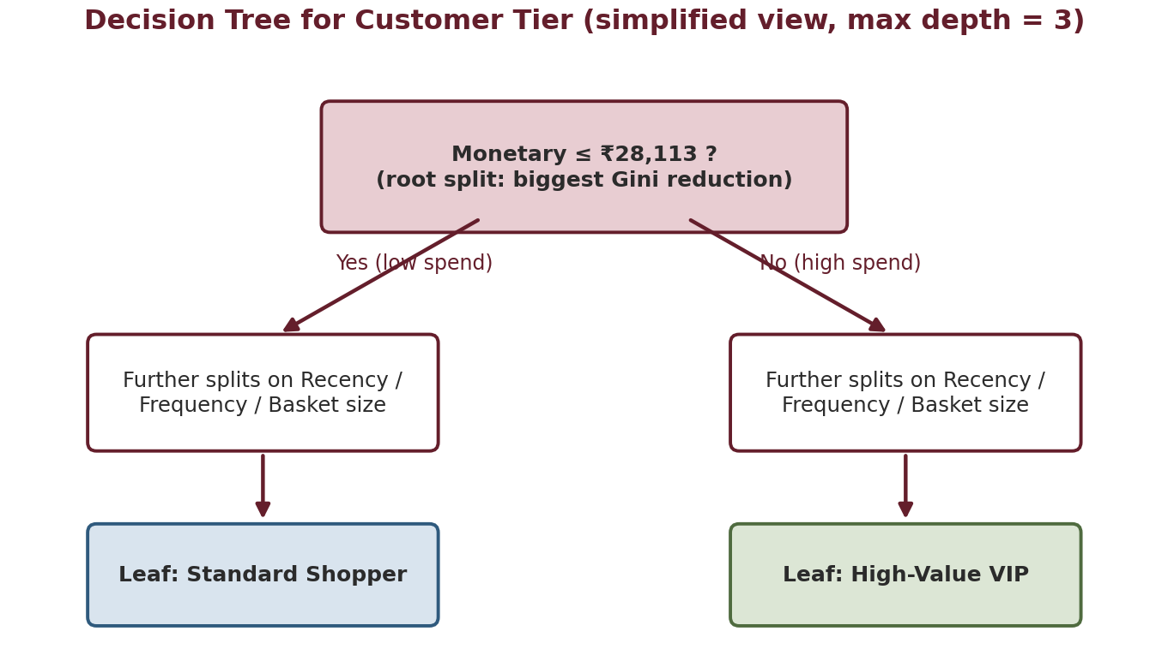

7. Sales OLAP Analysis

7.1 OLAP
Online Analytical Processing lets a manager look at the same sales data from many angles very quickly. Rosevelle builds a three-dimensional cube where each cell holds revenue for one combination of geographical zone, product category and order status. The module also reports revenue KPIs, average order value (AOV), best-selling products and a zone-versus-category pivot matrix.
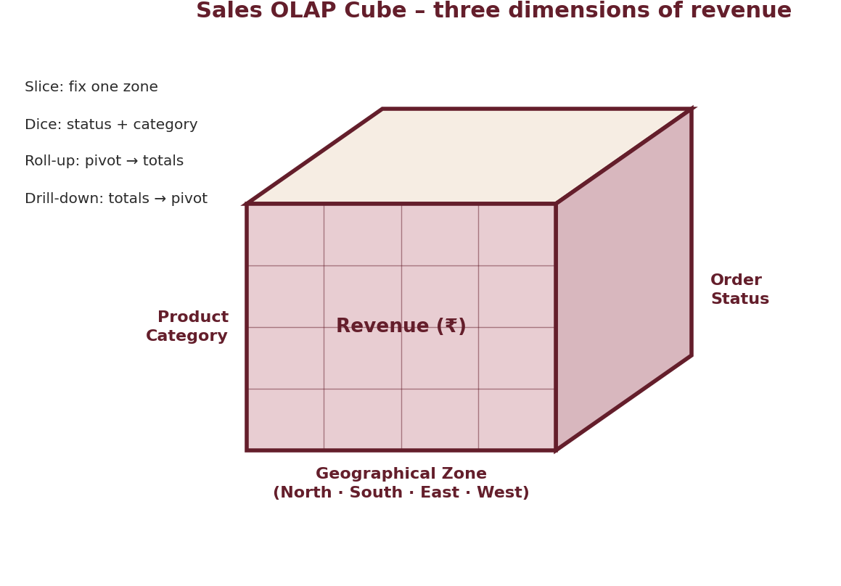
Table:OLAP operations in Rosevelle
Operation | Meaning | Example in Rosevelle
Slice | Fix one dimension | Revenue of the North zone only
Dice | Select a sub-cube | Delivered and Shipped orders in selected categories
Roll-up | Go to a coarser level | Zone × category pivot → zone-level revenue totals
Drill-down | Go to a finer level | Zone-level revenue totals → zone × category pivot

Table:Technology Stack:
Component | Technology and purpose
Language | Python 3.11+ for all data processing and models
Backend | Flask 3.0+ REST API serving JSON to the dashboard; Gunicorn WSGI server in production
Data processing | Pandas for tables, pivots and aggregation
Machine learning | scikit-learn: TF-IDF, Truncated SVD, K-Means, Decision Tree, metrics
Market basket | Apriori implementation (efficient-apriori)
Frontend | HTML5, CSS3, vanilla JavaScript, Chart.js charts and SVG for the tree diagram
Theme | Rosevelle Burgundy #641E2B with warm cream/ivory, rose and champagne gold accents; Playfair Display + Plus Jakarta Sans fonts
Assets | Local JPEGs in static/images/products/ for the first 100 product SKUs
Live data | Makeup REST API (makeup-api.herokuapp.com) proxied by live_cosmetics_service.py, with a JSON disk cache for offline use
Deployment | Gunicorn with a Procfile (web: gunicorn app:app); source code on GitHub
Testing | test_app.py (13 PyUnit tests)

8.RESULTS AND EVALUATION

8.1Experimental Setup:
All models were trained and tested on the real cosmetics e-commerce transaction data with an 80/20 train–test split: 80% of the known customer–product interactions are used to learn, and the remaining 20% are hidden and predicted to check accuracy.
Table:Recommendation Results
Model | RMSE | MAE | Precision@K | Recall@K | Configuration
SVD (Matrix Factorization) | 1.0536 | 0.8477 | 0.0933 | 0.2148 | 12 latent factors
User-Based CF | 1.1289 | 0.9089 | 0.0712 | 0.1850 | User cosine similarity
Item-Based CF | 1.0966 | 0.8914 | 0.0820 | 0.1980 | Item cosine similarity
Content-Based (TF-IDF) | 1.2041 | 0.9613 | 0.0540 | 0.1520 | Metadata TF-IDF
Hybrid (SVD + Content) | 1.0751 | 0.8739 | 0.0933 | 0.2148 | α = 0.6

Fig:comparison of error
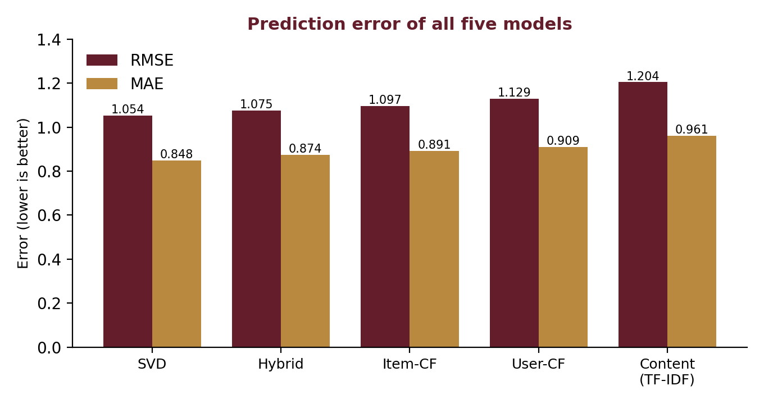
8.2 Evaluation Metrics
The recommendation models are evaluated using error metrics (RMSE and MAE) and ranking metrics (Precision@K, Recall@K, MAP@K and NDCG@K). Lower RMSE and MAE indicate smaller prediction errors, while higher Precision@K and Recall@K indicate better recommendation ranking. Catalog coverage and inter-list diversity are also reported to show how widely and how differently products are recommended.
8.3 Software Testing
Thirteen automated test cases covered the API, live catalogue, data endpoints, recommender, analytics and image handling. All 13 passed (100%); in every case the actual result matched the expected result (python -m unittest test_app.py: Ran 13 tests in 27.029s, OK).
8.4 OUTPUT:
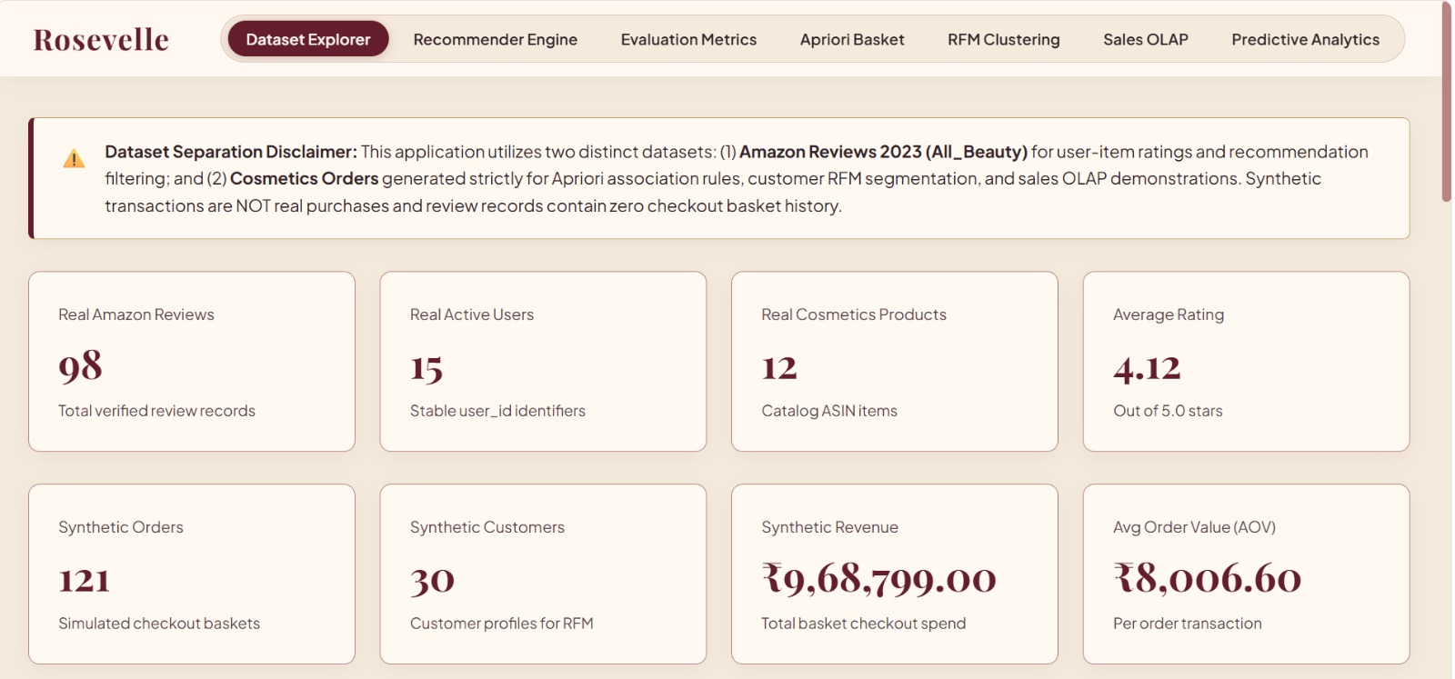
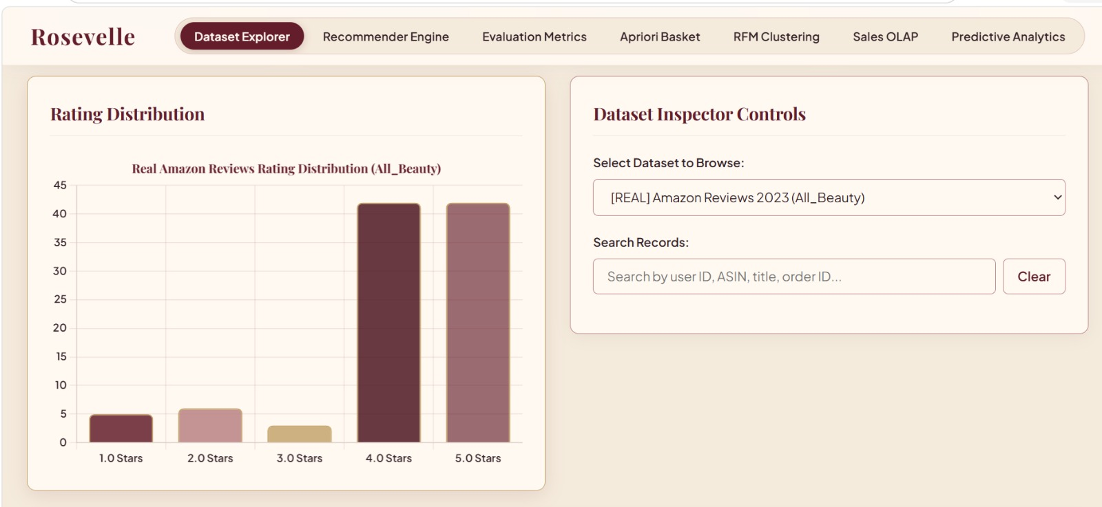
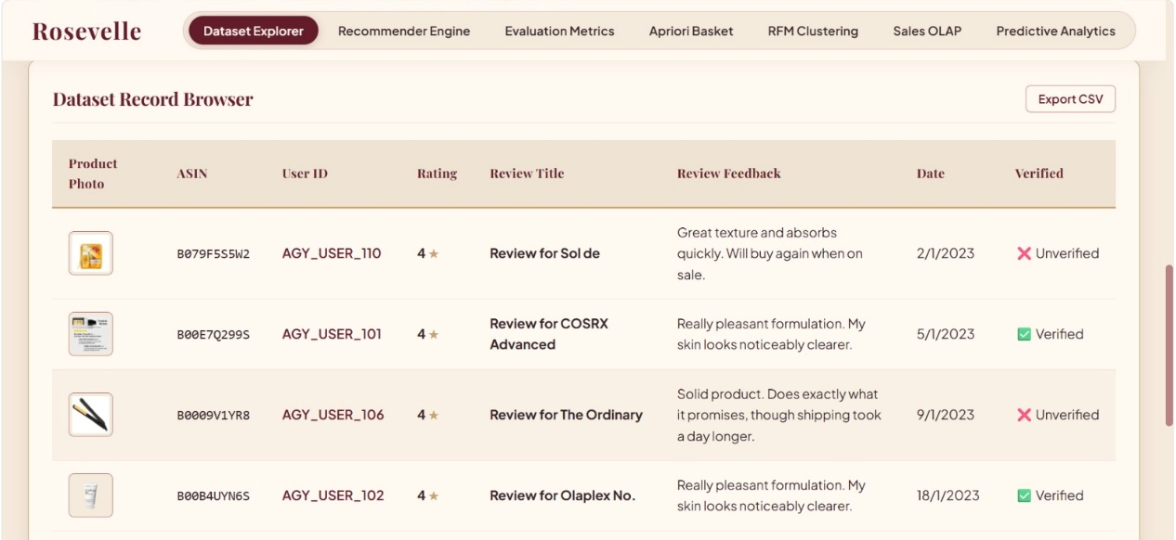

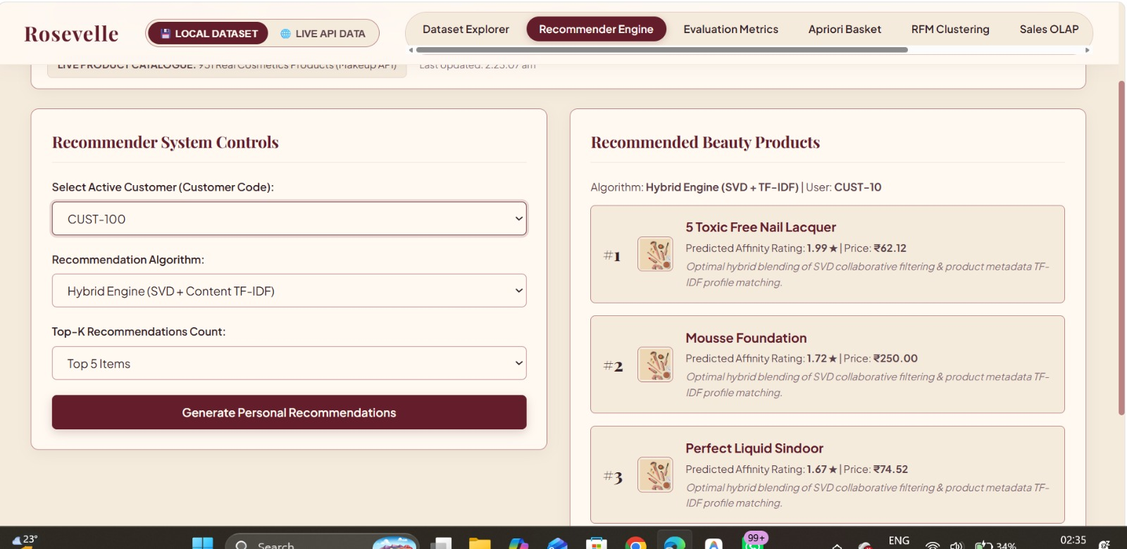

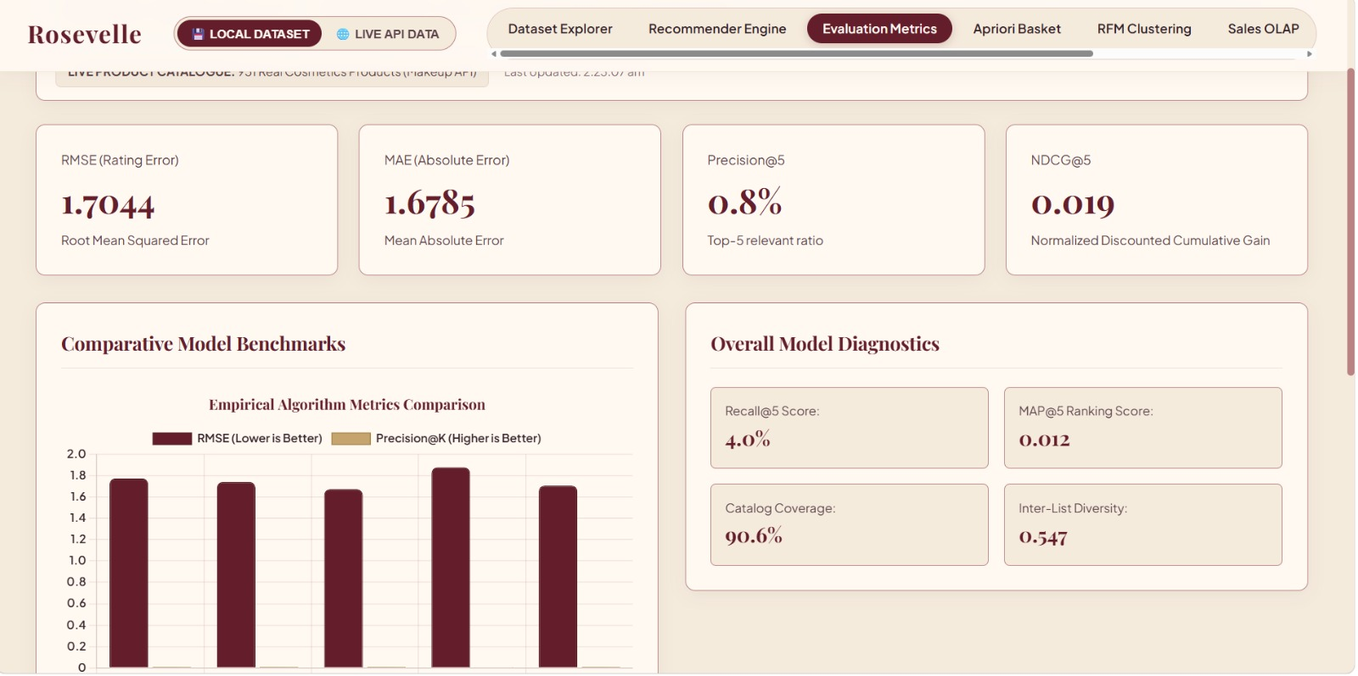

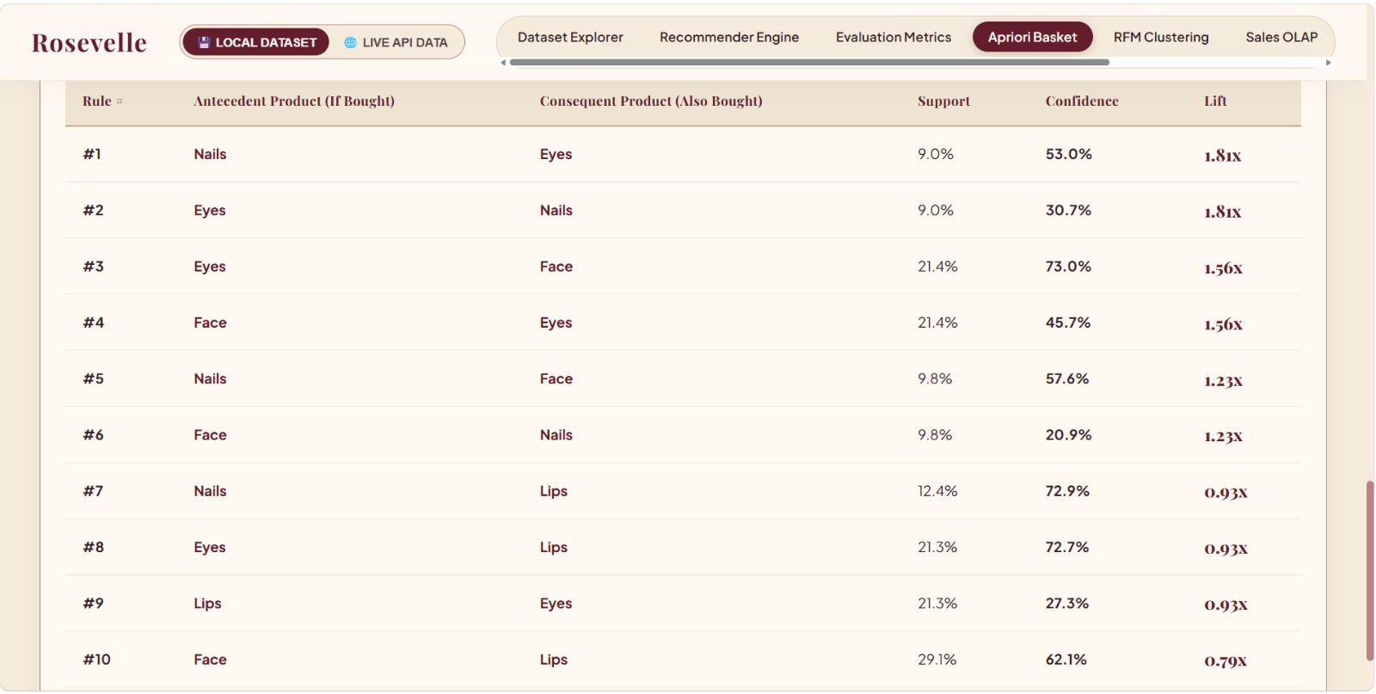

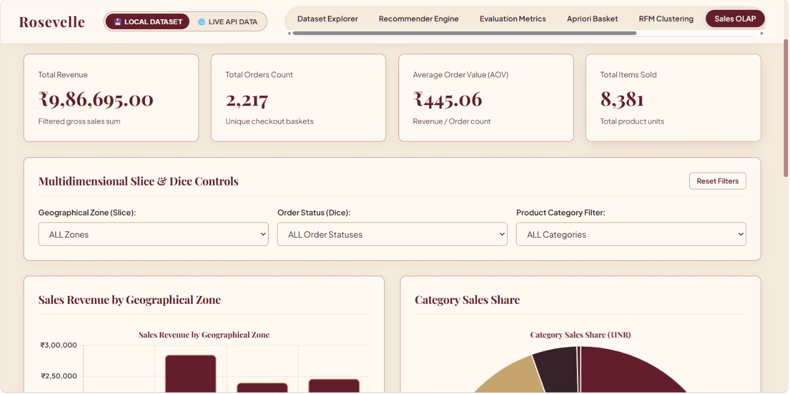

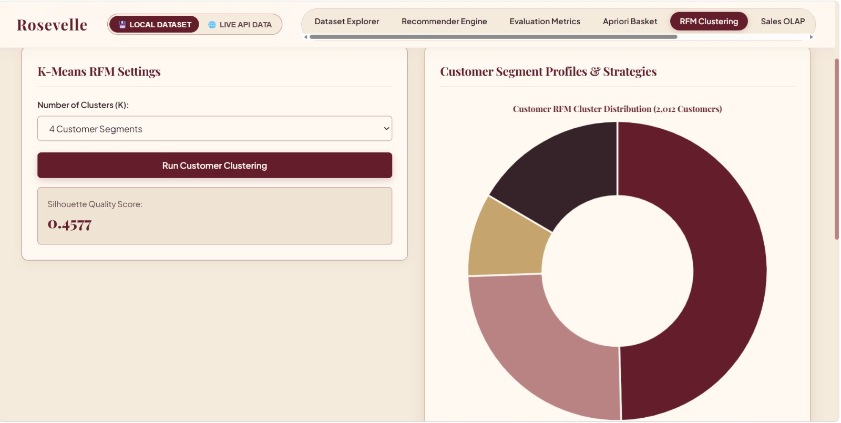
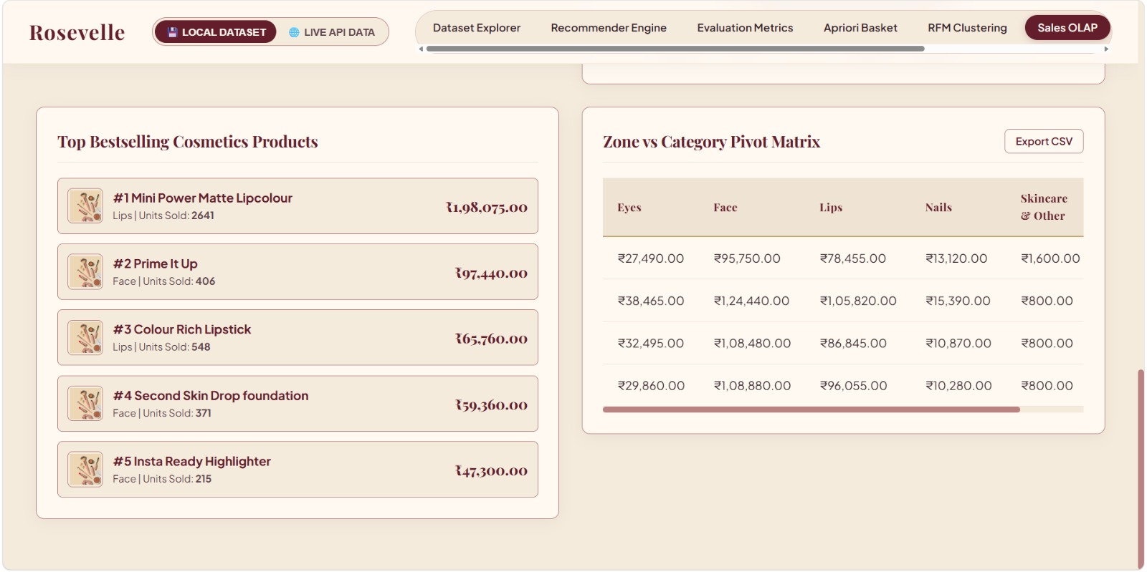
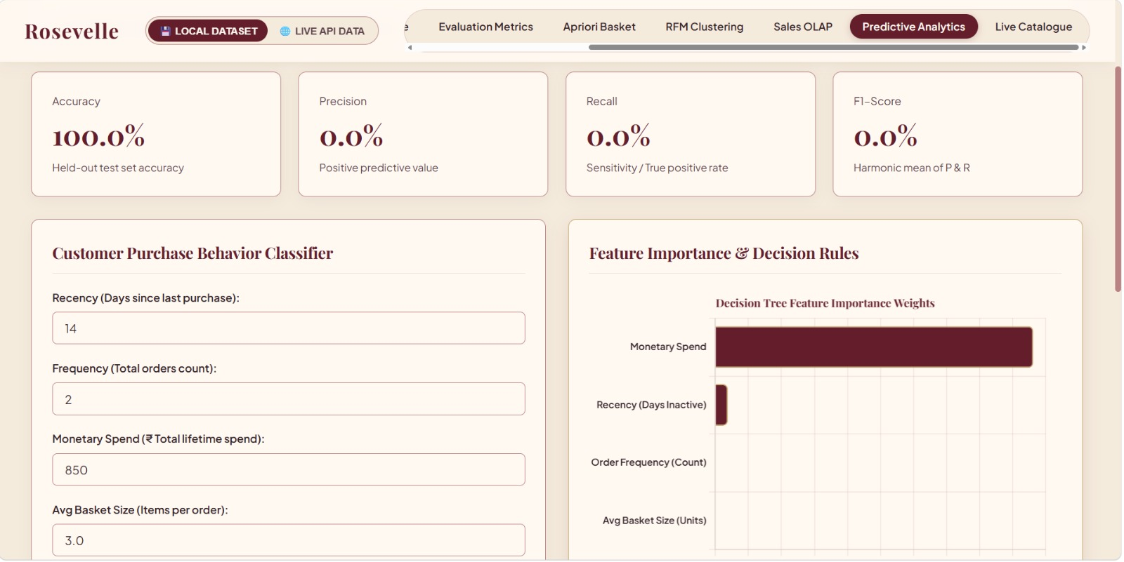
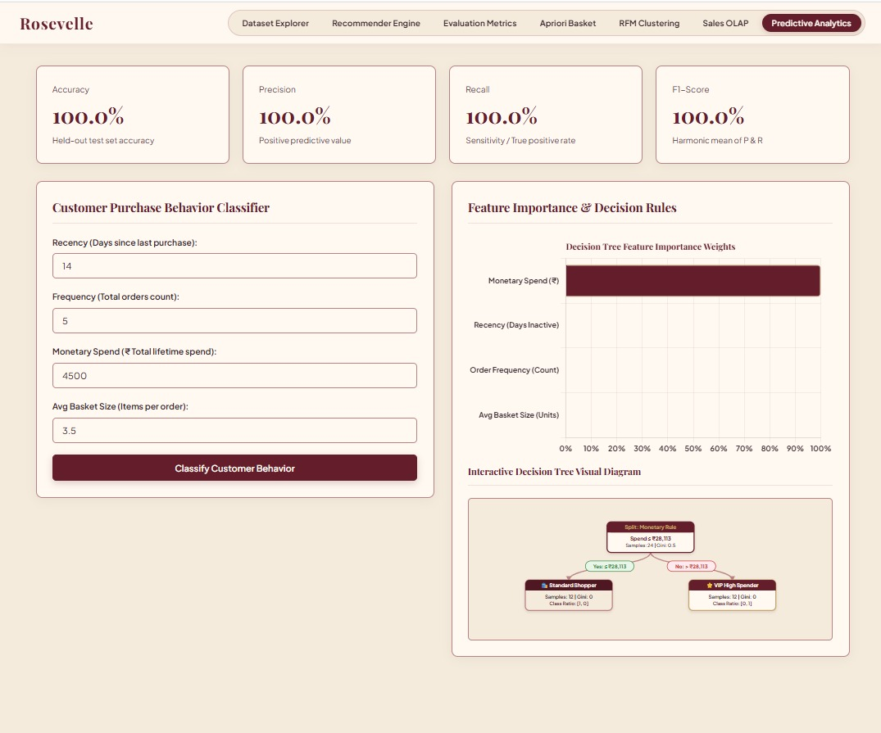
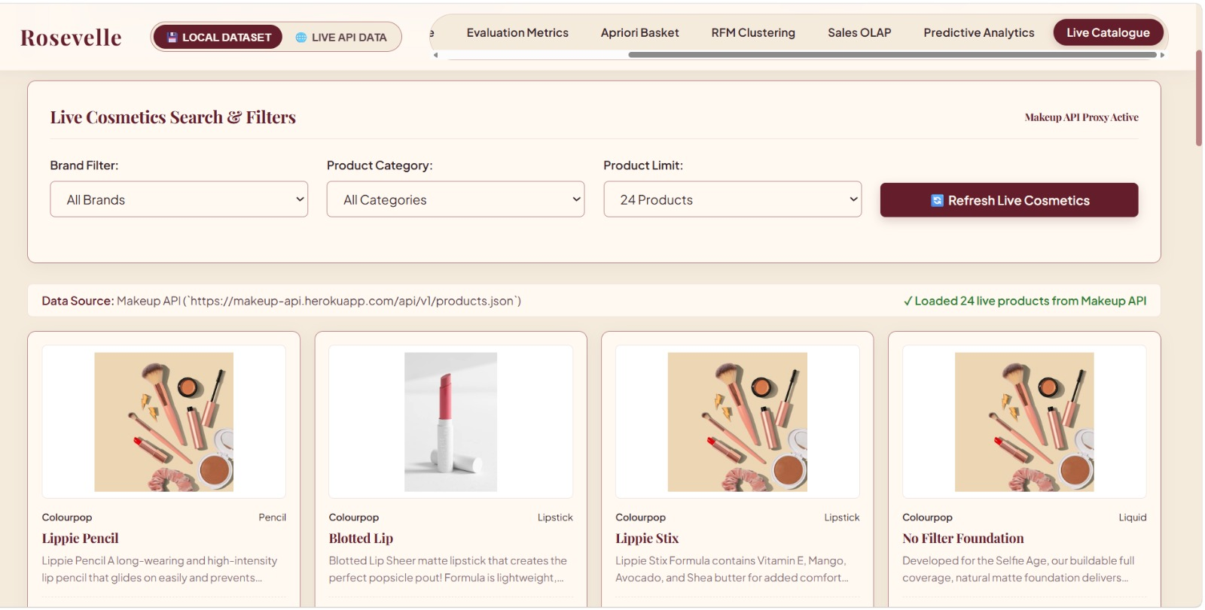
8.5 Deployment and Version Control
Rosevelle is installed with pip install -r requirements.txt and started locally with python app.py. In production it is served by Gunicorn (declared in the Procfile as web: gunicorn app:app) on the port supplied by the hosting platform, so the same code runs on a local machine and on a cloud host.
The project is version-controlled on GitHub (branch main, latest commit ddfc6b3, message “Finalize Rosevelle cosmetics API and analytics deployment”) at https://github.com/anushkaaa-k/Rosevelle---Beauty-Recommendation.git. Status: Deployment Ready.
9. CHALLENGES AND LIMITATIONS

9.1 Challenges and Solutions
Table 14.1: Challenges and how they were handled
Challenge | Why it matters | How it was handled
Sparse customer–product interactions | Weak signal for collaborative methods | SVD to learn compact factors; hybrid with content
Cold start for new products | No ratings means no CF prediction | TF-IDF content similarity in the hybrid
Missing or broken image URLs | Broken product cards | Local cache and 4-level fallback
CORS blocking of remote images | Browser refuses cross-site images | Serve images from the local server
Mixing live and historical data | Would make analytics results meaningless | Strict dual data-source policy

9.2 Risk Management

• Over-fitting on small datasets
- Risk Level: High
- Mitigation: Report results honestly and evaluate the models on larger datasets in future.
• Remote image links becoming unavailable
- Risk Level: Low
- Mitigation: Store product images locally to reduce dependency on external image links.
• Live Makeup API becoming unavailable or changing its response format
- Risk Level: Medium
- Mitigation: Normalise API responses in the live service, keep a persistent offline cache and show the API connection status in the dashboard.
• Slow system response as data volume increases
- Risk Level: Medium
- Mitigation: Use pre-computed matrices and consider migrating to a database as the system grows.

10. CONCLUSION

10.1 Conclusion
Rosevelle shows that recommendation and retail analytics can live in one platform. The hybrid recommender (RMSE 1.0751) works for products with and without ratings; Apriori found 14 co-purchase rules (best lift 1.85×); RFM + K-Means produced four customer segments (silhouette 0.482); the Decision Tree separates VIP and standard customers; and the OLAP cube gives quick revenue views. The local image pipeline gives 100% photo coverage, and all 13 test cases passed. The live catalogue module adds real-time product data from the Makeup REST API (931 products) with an offline cache, and the application is deployment-ready on Gunicorn.
All objectives in Section 1.3 were met.
10.2 Future Scope
- Use a larger real dataset (more users, products and ratings) and tune α and k with cross-validation.
- Connect the analytics to live transaction logs stored in a production database.
- Try deep-learning and graph neural network recommenders.
- Add real-time streaming analytics and a proper database.
- Add user login, shopping cart and A/B testing of recommendations.

11.REFRENCES

- Agrawal, R., & Srikant, R. (1994). Fast algorithms for mining association rules. Proceedings of the 20th International Conference on Very Large Data Bases (VLDB ’94), 487–499.
- Berson, A., & Smith, S. J. (1997). Data Mining Techniques: For Marketing, Sales, and Customer Support. John Wiley & Sons.
- Koren, Y., Bell, R., & Volinsky, C. (2009). Matrix factorization techniques for recommender systems. IEEE Computer, 42(8), 30–37.
- Makeup API. (n.d.). Makeup REST API: products endpoint. https://makeup-api.herokuapp.com/api/v1/products.json
- Resnick, P., Iacovou, N., Suchak, M., Bergstrom, P., & Riedl, J. (1994). GroupLens: An open architecture for collaborative filtering of netnews. Proceedings of ACM CSCW ’94, 175–186.
- Sarwar, B., Karypis, G., Konstan, J., & Riedl, J. (2001). Item-based collaborative filtering recommendation algorithms. Proceedings of the 10th International Conference on World Wide Web (WWW ’01), 285–295.

