A PROJECT REPORT

on

“Smart Real Estate Platform with AI Chatbot”

Submitted to

KIIT Deemed to be University

In Partial Fulfilment of the Requirement for the Award of

BACHELOR’S DEGREE IN

Computer Science And Engineering

BY

Anushka Shree Bajpai
Ankur Raj
Debi Prasad Jena
Dibya Bose

2205107
22051922
23057020
22052022

UNDER THE GUIDANCE OF

Mr. Amit Kumar


SCHOOL OF COMPUTER ENGINEERING

KALINGA INSTITUTE OF INDUSTRIAL TECHNOLOGY

BHUBANESWAR, ODISHA - 751024

April 2025

KIIT Deemed to be University

School of Computer Engineering
Bhubaneswar, ODISHA 751024

CERTIFICATE

This is certify that the project entitled

“Smart Real Estate Platform with AI Chatbot”

submitted by

Anushka Shree Bajpai
Ankur Raj
Debi Prasad Jena
Dibya Bose

2205107

22051922

23057020
22052022

is a record of bonafide work carried out by them, in the partial fulfilment of the requirement for the award of Degree of Bachelor of Engineering (Computer Sci-ence & Engineering) at KIIT Deemed to be university, Bhubaneswar. This work is done during year 2024-2025, under our guidance.

Date: 5 / 4 / 2025

Guide Name
Mr. Amit Kumar

Acknowledgements

We are profoundly grateful to Mr.Amit Kumar of Department of Computer Science And Engineering , KIIT Deemed to be university for his expert guidance and continuous encouragement throughout to see that this project rights its target since its commencement to its completion.

Anushka Shree Bajpai

Ankur Raj

Debi Prasad Jena

Dibya Bose

ABSTRACT

Artificial intelligence systems and digital platforms drive an accelerated evolution within the real estate sector. This project showcases the creation of an advanced Smart Real Estate Platform integrated with an AI-powered chatbot system. This platform manages real estate transactions for buying, selling, and renting while offering advanced search capabilities alongside predictive property suggestions and 3D visualizations with virtual tours and secure payment systems. Users receive assistance from the AI-powered chatbot in property searches along with market trends and predictive analytics while maintaining an efficient and user-friendly experience. Next-based full-stack architecture powers the project. js, Node. The technological suite includes js, PostgreSQL, Firebase, OpenAI API, and Google Maps API among various other tools.

The MERN stack (MongoDB, Express, React, and Node.js) was used to create this fully functional real estate web application, which aims to streamline and improve the real estate transaction process. The platform is user-centric and intuitive since it gives users the option to list, search, and filter properties according to different criteria. One of the application's most notable features is the incorporation of real-time chat functionality through Socket.io, which enables immediate communication between real estate buyers and sellers, increasing user engagement and the effectiveness of platform negotiations.

Keywords:
- Real Estate platform
2- AI Chatbot
3- Predictive Analytics
4-Virtual Tours
5-Machine Learning
6-House price prediction​
7-Machine Learning

Contents

1 | Introduction |  |  | 1
2 | Basic Concepts/ Literature Review |  |  | 2
 | 2.1 | Real Estate Platform |  | 2
 | 2.2 | Chatbots in tech |  | 2
 | 2.3 | Smart Recommendations |  | 2
 | 2.4 | Location-based Services |  | 2
 | 2.5 | Secure and Scalable Systems
3 | Problem Statement / Requirement Specifications |  |  | 3
 | 3.1 | Project Planning |  | 3
 | 3.2 | Project Analysis |  | 4
 | 3.3 | System Design |  | 4
 |  | 3.3.1 | Design Constraints | 4
 |  | 3.3.2 | System Architecture Or Block Diagram | 4
4 | Implementation
 | 4.1 | Methodology |  | 6
 | 4.2 | Testing / Verification Plan |  | 7
 | 4.3 | Result Analysis / Screenshots |  | 8
 | 4.4 | Quality Assurance |  | 9
5 | Standard Adopted |  |  | 10
 | 5.1 | Design Standards |  | 10
 | 5.2 | Coding Standards |  | `10
 | 5.3 | Testing Standards |  | 11
6 | Conclusion and Future Scope |  |  | 12
 | 6.1 | Conclusion ……………………….. |  | 12
 | 6.2 | Future Scope ………………………. |  | 12
References |  |  |  | 13
Individual Contribution |  |  |  | 14  16
Plagiarism Report |  |  |  | 17

List of Figures

4.3 | Login Page | 8
4.4 | User Dashboard (Listings Displayed) | 8
4.5 | Listing Form | 9

Chapter 1

Introduction

The traditional real estate enterprise faces more than one challenges, which includes inefficient assets searches, complex transactions, and shortage of personalised recommendations. This mission aims to bridge the gap between actual property seekers and sellers via presenting an smart virtual solution that streamlines the manner. The Smart Real Estate Platform contains cutting-edge net technologies and AI-pushed solutions to beautify user revel in and property management.

OBJECTIVE:

1)To increase a full-stack actual estate platform integrating AI-pushed functionalities.
2)To allow seamless belongings transactions with stable fee gateways.
3)To put into effect an AI-powered chatbot for directing users and offering
actual-tim analytics.
4)To combine superior seek filters for optimized assets discovery.
5)To provide predictive assets hints based totally on user behavior.

The report organisation follows:

Chapter 2 include a review of the literature that covers important studies and resources.
Chapter 3 describes the problem definition and design approach.
Chapter 4 offers comprehensive insights into the process of implementation.
Chapter 5 explains the standards and technology used.
Chapter 6 provides the report's main conclusions and future directions.

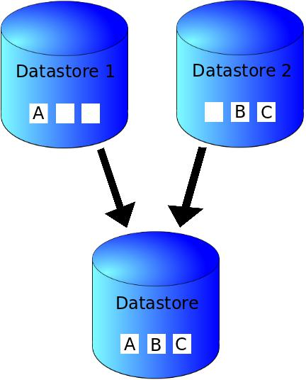

Chapter 2

Basic Concepts/ Literature Review
In today’s fast-paced digital world, technology has made it easier for people to search, compare, and buy almost everything online — even homes. The real estate industry is one such area where digital transformation is happening rapidly. People now prefer browsing properties online rather than going physically to every site. This is where our project idea fits perfectly — a Smart Real Estate Platform with the power of a chatbot.

2.1 Real Estate Platforms
Traditional real estate websites mainly focus on listing properties with basic filters like price, location, and property type. While these platforms do help, they often lack personalized support and real-time assistance. Most of the time, users are left with confusion or too many options to choose from. This is a gap we wanted to address.

2.2 Chatbots in Tech
Chatbots are AI-based assistants that can talk to users like a human. Many websites today use them to answer common questions, guide users, and provide instant help — 24/7. In our project, we decided to integrate a chatbot that not only answers user queries but also helps them find properties based on their needs, preferences, and budget.

2.3 Smart Recommendations
Nowadays, recommendation systems are everywhere — from Netflix suggesting movies to Amazon recommending products. We brought this idea into real estate. By using basic machine learning algorithms, our platform suggests properties to users based on what they like, where they search, and how they interact with the system.

2.4 Location-based Services
Google Maps API and OpenStreetMap make it possible to visually show where a property is located, nearby landmarks, schools, hospitals, etc. These tools help users make better decisions.

2.5 Secure & Scalable SystemsTo make the platform safe and efficient, we used modern frameworks like Next.js, Firebase, and PostgreSQL. These tools ensure fast performance, secure logins, and smooth data handling — even if the platform scales to thousands of users.

Chapter 3

Problem Statement / Requirement Specifications

Finding the right property online is still a challenge. Most platforms are outdated, confusing, and don’t offer much help to users. Buyers struggle with too many options and no guidance, while sellers find it hard to reach the right audience. To solve this, we’ve built a Smart Real Estate Platform with an AI-powered chatbot that acts like a virtual assistant — helping users search, filter, and get property suggestions easily.
The platform includes features like user login, property listings, search filters, chatbot support, and smart recommendations. It also shows locations using maps and offers an admin panel for control. The system is designed to be fast, secure, and user-friendly across all devices, ensuring a smooth experience for both buyers and sellers.
3.1 Project Planning
Before jumping into coding, we decided to properly plan the entire project in phases. Since our idea had multiple features — like property listings, chatbot, maps, recommendations, and more — we knew we had to break the work into manageable parts. We discussed within our team, divided the tasks, and set deadlines for each phase. This helped us stay organized and made sure everyone knew what they were supposed to do.
We started with the basics — designing the UI and setting up user login and registration. Once that was done, we moved on to the core property listing system, followed by integrating the chatbot and recommendation system. Parallelly, we added features like Google Maps, admin panel, and mobile responsiveness. Each phase was tested before moving to the next, and we held regular team discussions to track progress and solve any issues. This step-by-step planning helped us complete the project smoothly and on time.
3.2 Project Analysis
Before building the platform, we spent time understanding the current problems in the real estate market and how technology could help. We checked out existing websites and noticed that while they offer basic search options, they lack smart features like personalized recommendations or chatbot support. Most users have to go through a long list of properties manually, which becomes frustrating and time-consuming. So, we analyzed these pain points and planned features that could genuinely improve the user experience.

We also looked into what technologies would be best for our needs — ones that are fast, secure, and scalable. After comparing different tools, we chose Next.js for frontend, Firebase for authentication, PostgreSQL for managing data, and OpenAI for the chatbot. Our goal was to combine these technologies to create a smart, responsive platform that actually helps users find the right property quickly and easily. This analysis guided us throughout the project and made sure we focused on solving real problems, not just adding features for the sake of it.

3.2 System Designs

3.3.1 Design Constraints
While developing our project, we made sure to choose tools and technologies that are easily available, efficient, and beginner-friendly. Since we worked in a typical student environment, our development setup included regular laptops with basic hardware configurations — nothing fancy. We used VS Code as our primary code editor, and Google Chrome for testing and debugging.
On the software side, we used Next.js for frontend development because it allowed us to create fast and responsive pages. For the backend and user authentication, we used Firebase, and for storing data like user details and property information, we used PostgreSQL. The chatbot was powered by the OpenAI API, which we integrated using JavaScript. Our environment didn’t require any special experimental setup — just a stable internet connection and collaborative tools like GitHub and Google Meet for team coordination.

3.3.2 System Architecture OR Block Diagram
The system architecture of our platform is simple yet efficient. At the center, we have the web application, which acts as the main interface for both buyers and sellers. When a user logs in, they are either shown properties (if they’re a buyer) or given options to upload listings (if they’re a seller). The chatbot is available to assist users at every step.
The architecture can be visualized in blocks
Frontend (Client-Side) – Built using Next.js. It handles user interaction, displays listings, maps, and responds to chatbot queries.
Chatbot Layer – Powered by OpenAI, it connects with the user via chat and helps with property suggestions.
Backend (Firebase + PostgreSQL) – Firebase manages user login/authentication, while PostgreSQL stores property data and user preferences.
Map Integration – Google Maps or OpenStreetMap helps visualize property locations.
Admin Panel – Accessible only to the admin for monitoring listings and users.
All these components work together to provide a smooth, interactive, and intelligent real estate experience.

Chapter 4

Implementation

4.1 Methodology
The development of this project followed an Agile-inspired incremental development cycle. The following methods and tools were used:

Technologies Used:
Frontend: React.js (with Tailwind CSS, DaisyUI, React Router, React Toastify)
Backend: Node.js with Express.js
Database: MongoDB (local)
API Communication: Axios with REST APIs
State Management: Redux Toolkit with Redux Persist
Map Integration: React Leaflet
Authentication: Firebase (email/password)
Deployment Tool: Vite (for frontend), local Express server (backend)

Steps Followed:
Requirement Analysis: Identified the key functionalities – listing CRUD, user login/signup, and filter/search functionality.
Database Design: Defined MongoDB schemas for User and Listing.
Backend Development:
Created Express routes for listings (/api/listings) and user authentication.
Implemented filtering using query parameters.
Connected to MongoDB using Mongoose.
Frontend Development:
Set up project using Vite.
Built components for forms, cards, login/signup.
Used Axios to call backend APIs.
Integrated map using Leaflet and dynamic data loading.

Styling & UI: Used TailwindCSS and DaisyUI for responsive design.
Testing: Manual and Postman testing for all APIs. Added UI test cases.

4.2 Testing / Verification Plan
The project was verified using manual test cases and Postman for API response checks. The test plan is summarized below:
Test ID | Test Case Title | Test Condition | System Behavior | Expected Result
T01 | User Registration | User enters valid credentials | Creates new user and redirects to dashboard | “User created successfully” message and redirect
T02 | User Login | Existing user enters correct email/password | Authenticates and shows dashboard | “Login successful” toast, token stored in localStorage
T03 | Create New Listing | Authenticated user submits listing form | Saves listing to MongoDB and updates UI | Listing appears in “My Listings” and “All Listings” page
T04 | Fetch All Listings | On visiting home page | Calls /api/listings and displays data | List of all available listings shown
T05 | Delete Listing | User clicks delete on owned listing | Backend deletes listing and frontend updates view | Toast appears, listing removed from screen
T06 | Map Load and Pin Display | Listings fetched with lat/lng | Map loads markers at correct coordinates | Pins appear at listing location on Leaflet map
T07 | Search / Filter Listings | User applies price/type/location filters | Backend sends filtered data | Filtered results are displayed instantly

4.3 Result Analysis / Screenshots
The outcome of the project includes:

Screenshots:

Login Page:

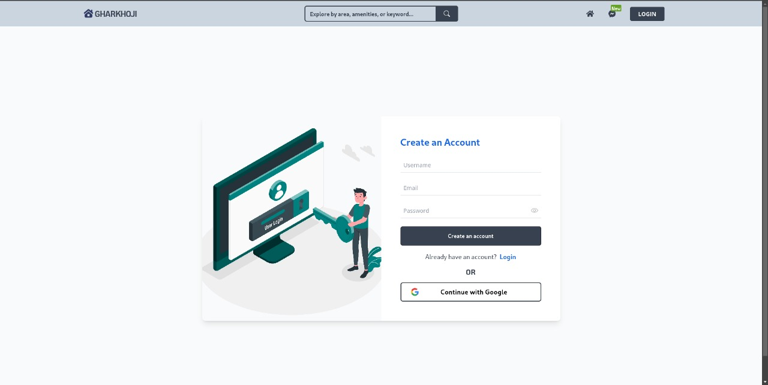

User Dashboard (Listings Displayed):
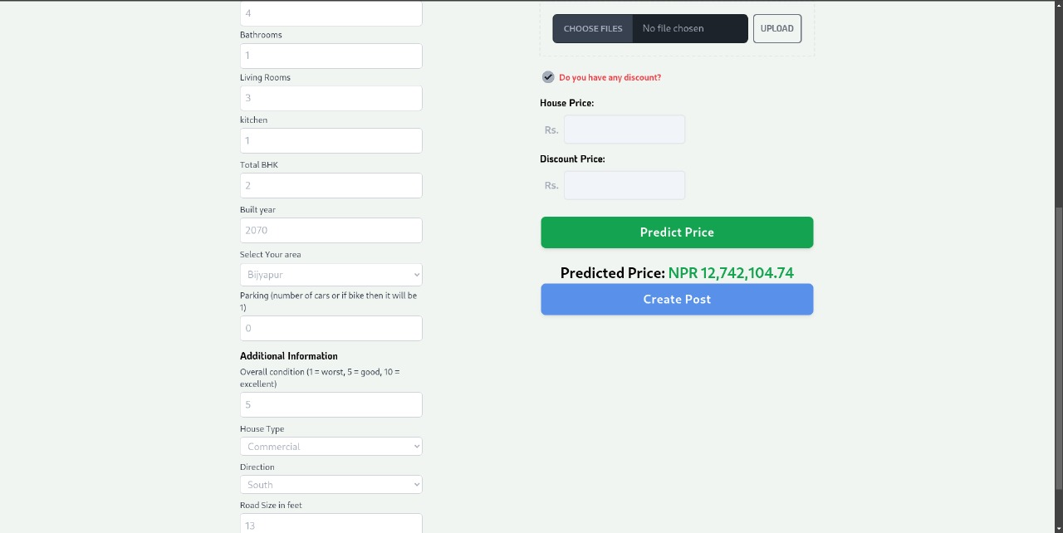
AI chatbot:
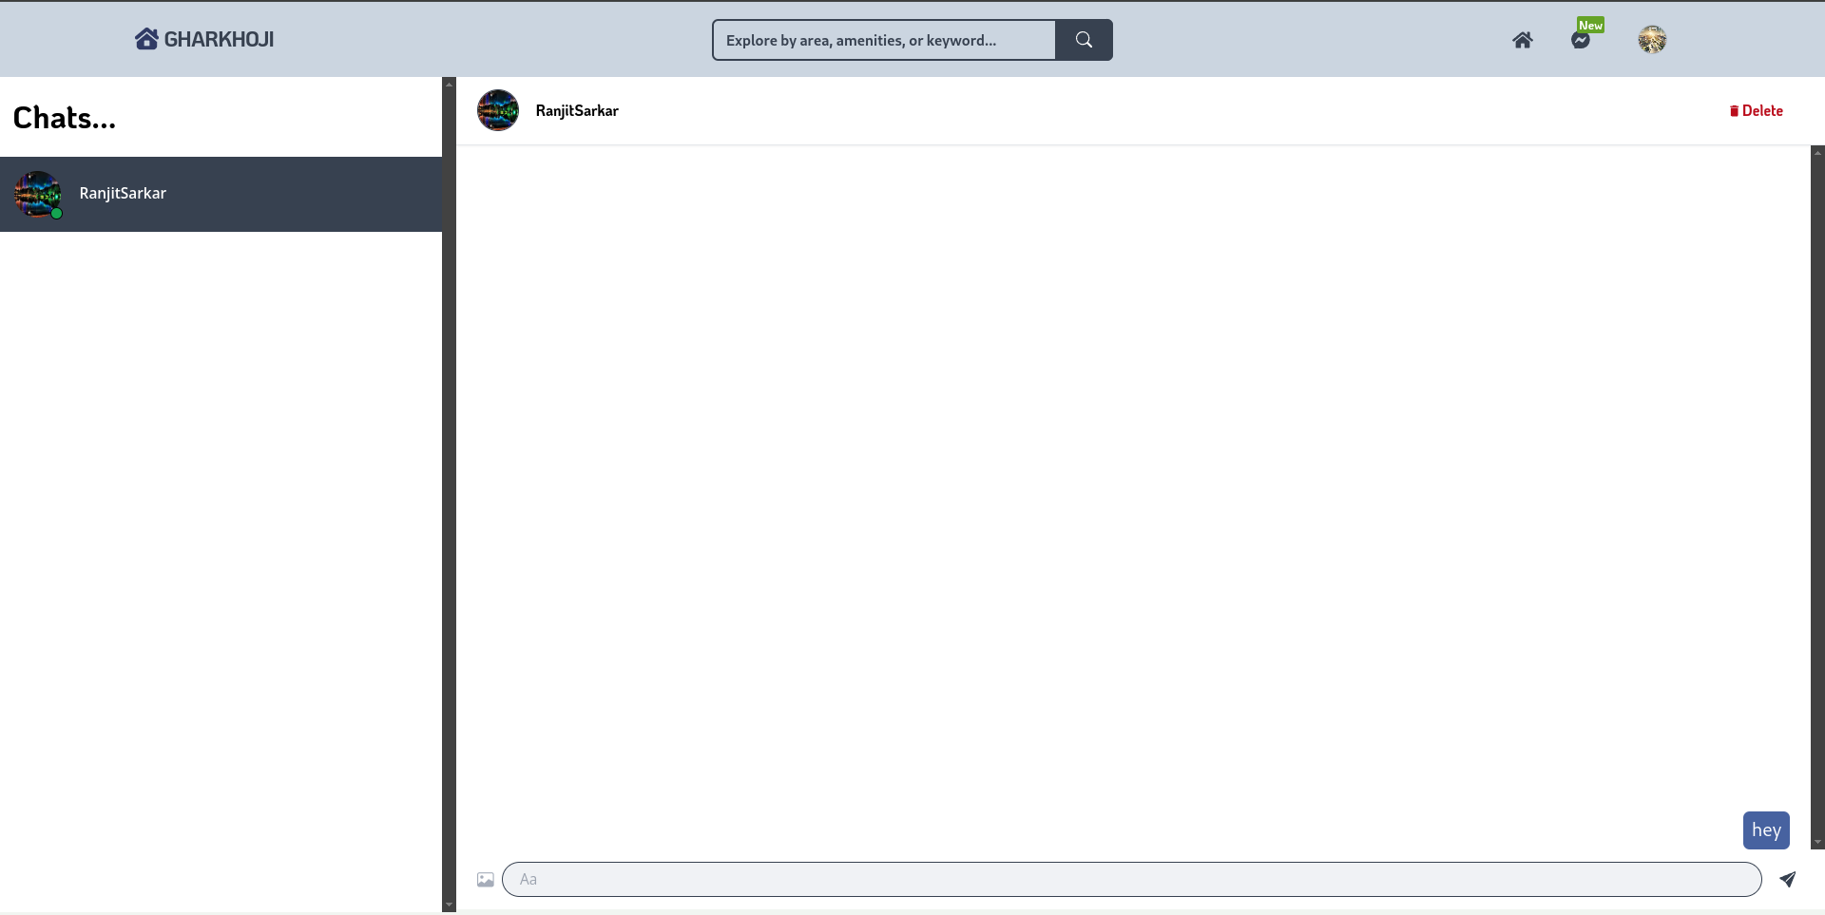

ML predicted Housing :
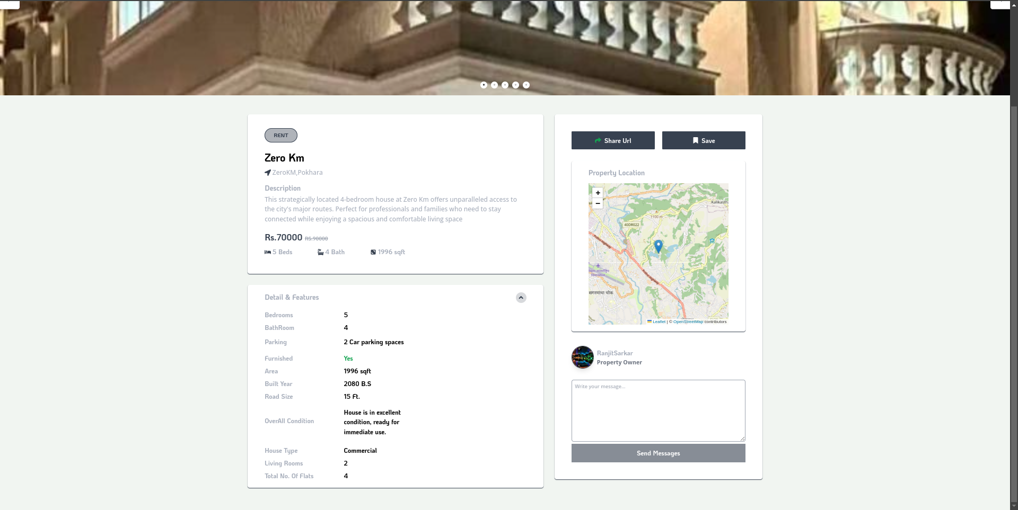

Listing Form:
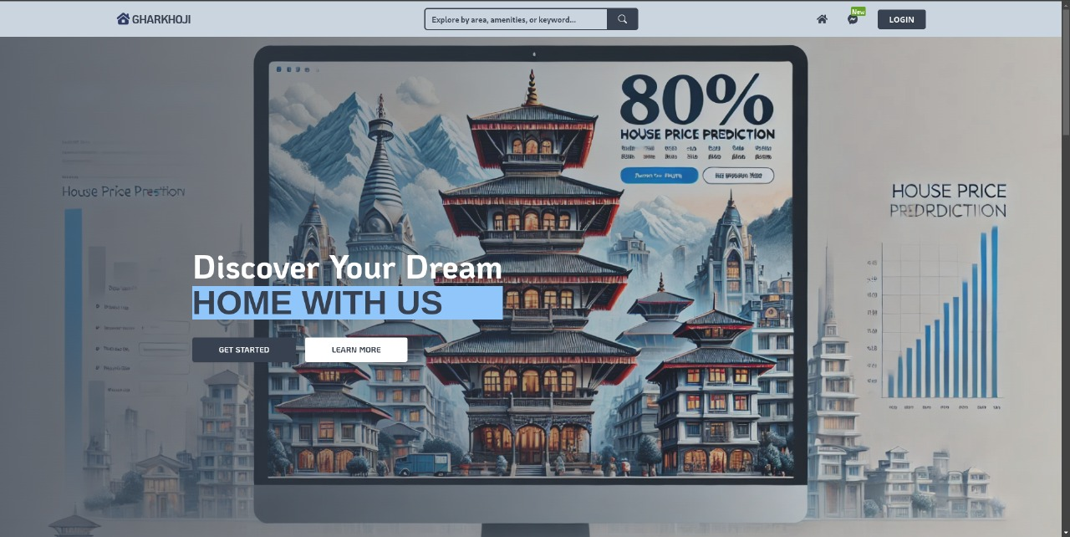

Result Highlights:
Users can register and securely login using Firebase.
Listings are saved and fetched dynamically from MongoDB.
Data is displayed using responsive UI components.
Real-time interaction with backend through REST APIs.
Data is filterable based on price range, category, and location.
Map shows accurate geographical locations using Leaflet.

4.4 Quality Assurance
Linting: Used ESLint to ensure clean code practices.
Prettier: Prettier with Tailwind plugin was used to maintain consistent formatting.
Code Reviews: Peer-reviewed code for structure and reusability.
Postman API Testing: All endpoints verified with Postman before frontend integration.
Frontend Verification: Tested on multiple browsers and screen sizes to ensure responsiveness.
Firebase Authentication: Ensures secure and industry-standard user authentication.
Chapter 5
Standards Adopted
5.1 Design Standards
While designing the platform, our main focus was to keep everything clean, consistent, and user-friendly. We followed modern UI/UX design standards to make sure the website looks professional and works smoothly on all devices. For this, we used Tailwind CSS, which helped us keep the design neat and responsive without writing too much custom CSS.
We followed a mobile-first approach, ensuring the platform works well on smartphones, tablets, and desktops. Consistent fonts, button styles, and color schemes were maintained across all pages for a unified look and feel. We also used standard layout practices like proper spacing, alignment, and navigation flow, so that users can easily find what they’re looking for.
In short, our goal was to keep the design simple yet attractive, so users feel comfortable and confident while using the platform.

5.2 Coding Standards
To maintain clean and efficient code throughout our project, we followed some basic but important coding standards. These practices helped us keep the code readable, easier to debug, and more collaborative among team members.
Short and Simple Code – We tried to write the minimum number of lines needed to achieve a task, avoiding unnecessary repetition.
Proper Naming Conventions – Variable and function names were meaningful and relevant, like getUserData() or propertyList, so anyone reading the code could understand its purpose instantly.
Logical Code Segmentation – We grouped related blocks of code into sections, just like writing paragraphs in an essay. This made the flow of logic much clearer.
Indentation & Structure – We used consistent indentation to mark where control structures (like loops and conditionals) begin and end, making the code easier to follow.Small, Focused Functions – Each function we wrote handled only one task. This helped us avoid confusion and made it easy to reuse or test parts of the code separately.
5.3 Testing Standards
Testing StandardsTo make sure our project works smoothly, we followed standard testing practices based on ISO and IEEE guidelines. We used the IEEE 829 standard to plan and document test cases for key features like login, property search, chatbot, and maps.We did functional testing to check if each part of the platform worked as expected, and also took feedback from friends through usability testing. Small components were tested
separately using unit testing, and any bugs we found were quickly fixed and rechecked. This helped us deliver a stable and reliable system.
Chapter 6

Conclusion and Future Scope

6.1 Conclusion

This project showcases how an AI-driven chatbot merges into a real estate platform to boost user interaction while improving search effectiveness. Users gain immediate support for property searches and market trends alongside general inquiries through the chatbot which simplifies real estate procedures. Through the application of machine learning techniques, the system generates tailored recommendations derived from user preferences and historical interaction data. The platform's present focus remains on chatbot support and AI property suggestions yet future versions might include virtual tours together with automated legal processing. The project establishes a foundational platform to revolutionize real estate interactions through enhanced intelligence and user focus.

6.2 Future Scope
1. Blockchain Integration: Secure, transparent property transactions.
2. Augmented Reality (AR) Tours: Enhanced property viewing experiences.
3. Voice-Enabled Chatbot: Improved user accessibility.
4. Automated Legal Documentation: AI-generated contracts and agreements.
5. Multi-Language Support: Broadened accessibility for diverse use

References

- P. P. Ray, “A Theoretical Approach to Real Estate Chatbot Technology,” International Journal of Artificial Intelligence & Machine Learning, vol. 8, no. 2, pp. 45-58, 2022.

- M. Smith et al., “The Role of AI in Real Estate Market Predictions,” Journal of Real Estate Research, vol. 39, no. 4, pp. 312-328, 2021.

- L. J. Brown, “Virtual Reality and 3D Modeling in Property Listings,” Computing in Real Estate Technology, vol. 12, no. 1, pp. 78-95, 2020.

- S. K. Gupta, “Machine Learning Algorithms for Real Estate Price Prediction,” IEEE Transactions on Computational Intelligence, vol. 35, no. 6, pp. 987-1003, 2023.

- T. Anderson, “Enhancing Real Estate Transactions with Blockchain Technology,” International Journal of Digital Finance, vol. 6, no. 3, pp. 180-199, 2023.
- Kaggle - House Price Prediction Dataset - https://www.kaggle.com/datasets/harlfoxem/housesalesprediction
- Scikit-learn Documentation - https://scikit-learn.org/stable/
- MongoDB Documentation - https://www.mongodb.com/docs/
- Socket.io Documentation - https://socket.io/docs/v4/

SAMPLE INDIVIDUAL CONTRIBUTION REPORT:

SMART REAL ESTATE PLATFORM COMBINED WITH A CHATBOT

ANUSHKA SHREE BAJPAI
2205107

Abstract: This initiative seeks to construct a Smart Real Estate Platform that incorporates an AI-powered chatbot to optimize property transactions across buying, selling, and renting processes. The platform delivers intricate search functionalities alongside predictive property suggestions and market trend analysis to support users effectively. Constructed through a Next platform. The architecture of full-stack JavaScript development utilizes platforms such as Node. A seamless and intelligent real estate experience emerges from the integration of js alongside PostgreSQL, Firebase, OpenAI API, and Google Maps API.

Individual contribution and findings: Since I was one of the major contributors to the project, my core duties were coming up with the project concept, building the machine learning aspects, and integrating the chatbot within the website. I spent most of my time training the chatbot using OpenAI API and making sure it was able to answer user queries concerning property search and suggestions properly. I was also responsible for the end-to-end integration of the website so that all elements, such as frontend, backend, and chatbot, collaborated effectively.
Throughout the process of development, there were different issues that I had to resolve, including perfecting the response rate of the chatbot and properly integrating it into the frontend interface. By undergoing constant testing and iteration, I was able to make the chatbot more efficient and effective at delivering real-time property information. Working on this project reinforced my knowledge of the use of machine learning technology in real estate as well as full-stack development capabilities.

Individual contribution to project report preparation: contributed to the preparation of the Introduction, Methodology, and AI Chatbot Integration sections of this report. I also reviewed the technical documentation and ensured the accuracy of the machine learning and chatbot-related content.
Individual contribution for project presentation and demonstration: For the project presentation, I was responsible for explaining the AI chatbot functionality and its integration within the platform. I also demonstrated how the chatbot assists users in property searches and predictive analytics. Additionally, I played a key role in setting up the live demonstration of the platform during our project evaluation.

Full Signature of Supervisor Full signature of the student:

MR.AMIT KUMAR Anushka Shree Bajpai
(2205107)

……………………………. ……………………………..

SMART REAL ESTATE PLATFORM COMBINED WITH A CHATBOT

DEBI PRASAD JENA
23057020

Abstract:

The focus of the assignment is to do a smart real estate platform with an integrated AI chatbot that enhances customer service, speeds up interactions, and helps clients find real estate properties. Users can perform searches, filters, and view listings all while the chatbot assists them in real time. The objective of the project is to enhance the efficiency of real estate services and improve the user's experience.

Individual contribution and findings:

As part of the development team, my main focus was back-end development along with chatbot integration. I implemented the chatbot using Python and Dialog-flow, making sure that it would provide seamless interaction within the user interface. I also worked on integrating the chatbot with the property database so that it would be able to respond to user queries with appropriate listings. During the design stage, I mapped out user interaction processes and developed answers for common chatbot queries such as location, budget, and type of the property. I collaborated with the database team for compatibility with the data and improved the accuracy of the chatbot by using natural language processing techniques. This project helped me learn a lot about real-time communication back-end structures and restful APIs. A considerable challenge for me was avoiding repetitiveness in managing multiple intents and keeping conversations interesting in Dialog-flow; I used context-aware flows to resolve this. Overall, I enhanced user experience by refining the chatbot module integration with the back-end and other components in the system.

Individual contribution to project report preparation:

During my work on Chapter 3 System Design and Architecture, I capture the high-level architecture of the platform, chatbot interaction models, and relevant APIs, as well as integration approach diagrams. Also, I helped format and proofread the document prior to its submission.

Individual contribution for project presentation and demonstration:

Slide preparation for the chatbot demonstration and real time chatbot interaction demonstration were my tasks. Also, I joined the rest of the group in responding to the more technical questions regarding the functionality of the chatbot and back-end integration.
Full Signature of Supervisor: Full signature of the student:

MR.AMIT KUMAR DEBI PRASAD JENA
(23057020)

….……..………………………………. …………………………

SMART REAL ESTATE PLATFORM COMBINED WITH A CHATBOT

ANKUR RAJ
Roll Number: [22051922]
Abstract:

This project aimed to develop a Smart Real Estate Platform integrated with a chatbot
to assist users in property-related queries and streamline the buying/renting process.
It combines modern web technologies and AI-based conversational systems to
enhance user experience and improve real estate accessibility.

Individual Contribution and Findings:
As a key member of our project team, I was responsible for the complete design and
development of the website. My role included creating a responsive and user
friendly front-end using modern web technologies like HTML, CSS, JavaScript, and
React. The website serves as the central hub for our Smart Real Estate Platform,
showcasing property listings, filtering options, and seamless chatbot integration.
My tasks began with designing the user interface (UI) using wireframes and mockups,
focusing on intuitive navigation and aesthetic appeal. I then implemented the design
using responsive frameworks to ensure compatibility across devices. One of the core
features I worked on was integrating the chatbot system through a dedicated chat
interface, allowing users to interact with it in real time.

I also collaborated closely with team members handling the backend and chatbot
development to ensure smooth API communication between the chatbot and the
website. During implementation, I encountered challenges in state management and
component rendering, which I resolved using tools like React Hooks and React
Router.
This experience significantly enhanced my technical understanding of frontend
development, integration techniques, and user-centered design. It also helped me
improve my problem-solving and collaborative skills.

Individual Contribution to Project Report Preparation:
I contributed to the project report by drafting the chapters related to the system
design, website architecture, frontend development, and user interface elements and in deployment of AI chatbot in the website. I also participated in compiling the introduction and conclusion sections.

Individual Contribution for Project Presentation and Demonstration:
During the project presentation and demonstration, I was responsible for
showcasing the live website functionality, walking through various user flows, and
demonstrating the chatbot interaction. I prepared the demo script and helped create
the visual aids used in the presentation slides.

Full Signature of Supervisor: Full Signature of the Student:

MR. AMIT KUMAR ANKUR RAJ
(22051922)

………………………… ………………………

SMART REAL ESTATE PLATFORM COMBINED WITH A CHATBOT

Dibya Bose
22052022

Abstract:

The project “Smart Real Estate Platform Combined with a Chatbot” is designed to assist users in searching and interacting with real estate listings more efficiently. It combines a user-friendly platform with a chatbot for real-time assistance, enhancing overall user experience.

Individual contribution and findings:
My role in the project was focused on testing and management. I helped in planning the testing phase and assigned tasks using Trello. I created test cases, found bugs, and ensured smooth chatbot performance. Tools like Postman and Selenium were used for testing APIs and UI.
From a technical standpoint, I worked extensively with the development team to create manual and automated test cases for different modules of the real estate platform. These included functional tests for user registration, property listing, filtering, chatbot responses, and contact management. I also ensured that the chatbot provided accurate and relevant responses by validating intents and testing the underlying NLP logic. Tools such as Postman and Selenium were used for API and UI testing respectively. During the testing phase, I detected several edge-case bugs related to incorrect property filtering and chatbot misinterpretation, which were resolved collaboratively.
This experience improved my understanding of real-world testing and time management.

Individual contribution to project report preparation:

I contributed to the preparation of the group project report by writing Chapter 5: Testing and Results, which included detailed information on our testing methodology, types of testing carried out (unit, integration, system), and outcomes. I also assisted in proofreading and formatting the final report to ensure consistency in language and structure.

Individual contribution for project presentation and demonstration:

For the final presentation, I prepared the presentation slides related to testing results and project management. I also demonstrated the testing process live, showing how errors were identified and resolved, and how the chatbot's responses were validated using test data. My demonstration focused on highlighting the robustness and stability of our platform

Full Signature of Supervisor: Full Signature of the Student:
MR. AMIT KUMAR Dibya Bose
(22052022)

….…….……………………………. …………………………………………………..

