COMPUTER NETWORKS
Jackfruit Mini Project

SDN-Socket Programming
Packet Loss Detection and Recovery
A UDP application that detects packet loss with sequence numbers and works with an SDN controller to switch traffic to an alternate path (Mininet + Ryu)
Submitted by
No. | Name | SRN
1 | Anushka Acharya | PES2UG25CS631
2 | Adarsh Shankar Chanapannavar | PES2UG25CS626
3 | Gowtam M | PES2UG25CS646

Project repository
https://github.com/anushkaacharya35/sdn-packet-loss
October 2026

1. Introduction and Problem Statement
Modern networks must keep applications running when links degrade or fail. In a traditional network, the application only sees the symptom (missing packets) and can do little more than retransmit over the same broken path. In a Software-Defined Network (SDN), a central controller can change the forwarding path at run time, so the application and the network can cooperate to recover from the fault.
Project 7, Packet Loss Detection and Recovery, asks for a UDP application that detects packet loss using sequence numbers and works with an SDN controller to switch traffic to an alternate path. The project uses low-level UDP sockets, a Mininet topology with two paths between the hosts, and an OpenFlow 1.3 controller (Ryu).

1.1 Objectives
- Implement a reliable-delivery layer on top of UDP: sequence numbers, acknowledgements and retransmission.
- Detect missing packets and measure the loss rate at the receiver.
- Monitor the network paths and create an alternate path in Mininet.
- Trigger dynamic rerouting from the application (socket) to the SDN controller.
- Measure recovery time and compare packet loss before and after recovery, against a static baseline with no rerouting.

1.2 Mandatory requirements and how they are met
Requirement (from the project brief) | How this project meets it
Implemented with TCP or UDP sockets as specified | UDP datagram sockets (Python socket module), no framework
Client, server, worker, broker or peer components | Sender (client) on h1, receiver (server) on h2, Ryu controller
Deployed and tested in a Mininet topology | Four-switch diamond topology with two paths (topo.py)
Interaction between socket app and SDN network | Receiver alerts the controller, which rewrites flow rules
Complete system: Mininet + controller + sockets | Single command runs the whole experiment (topo.py)
Topology, source code, configuration, test cases, reproduction steps | All in the GitHub repository with a README
Final demo code shared on GitHub with documentation | https://github.com/anushkaacharya35/sdn-packet-loss

2. System Architecture
Two hosts are connected through a diamond of four OpenFlow switches. Traffic from h1 to h2 normally follows the primary path through s2. A second path through s3 is available but unused until the controller moves traffic onto it. The Ryu controller programs all switches over OpenFlow, and receives loss alerts from the receiver application.
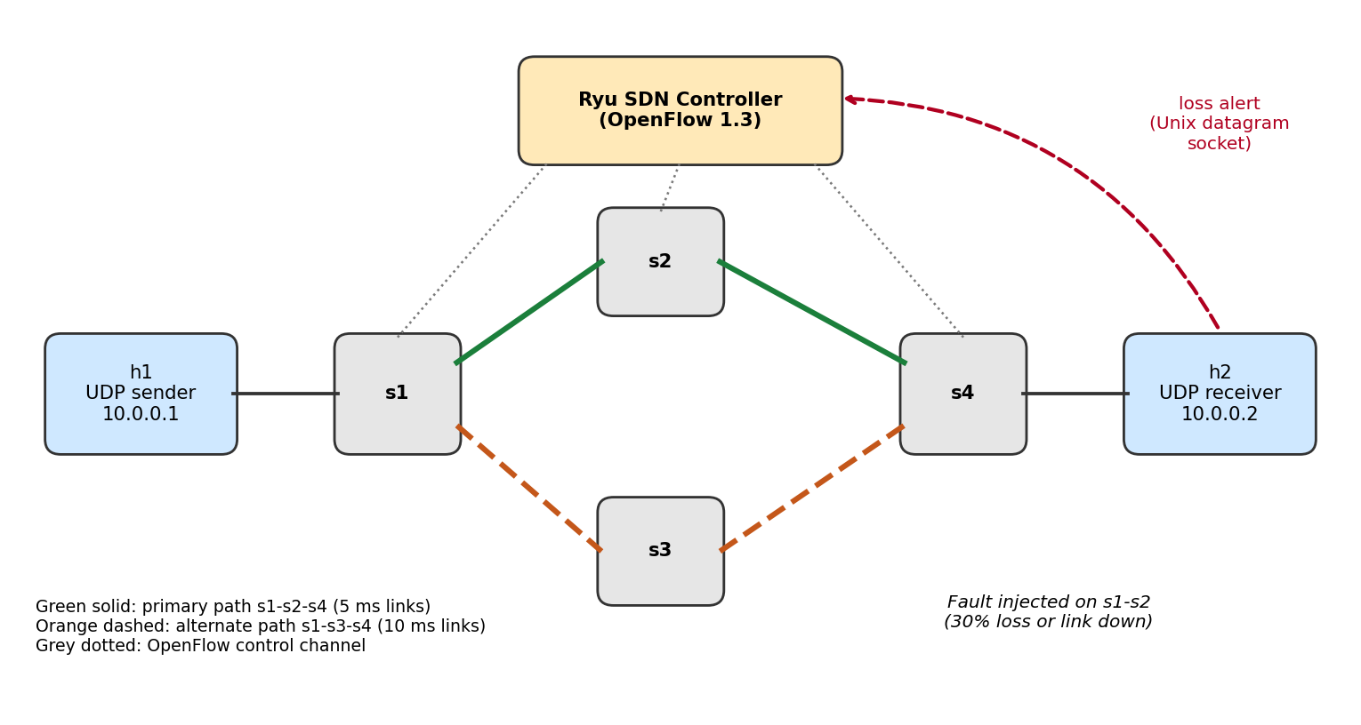
Figure 1: System architecture. Solid green = primary path, dashed orange = alternate path, dashed red = application-to-controller alert.

2.1 Components
Component | File | Role
UDP sender | sender.py | Sends numbered packets at a fixed rate, tracks ACKs, retransmits after a timeout, records latency
UDP receiver | receiver.py | ACKs every packet, finds missing sequence numbers, computes loss per window, alerts the controller, measures detection and recovery time
SDN controller | controller.py | Installs the primary path, polls port counters, listens for alerts, reroutes to the alternate path
Topology and runner | topo.py | Builds the Mininet network, injects faults, runs the dynamic and static experiments
Analysis | plot.py | Compares static and dynamic results (table and graph)
Shared protocol | proto.py | Packet header format and constants

2.2 Topology and port map
Each link is 10 Mbit/s. Primary-path links have 5 ms delay and alternate-path links 10 ms, so the alternate path is slower but healthy. The ports are numbered explicitly so the controller can use fixed output ports.
Switch | Port 1 | Port 2 | Port 3
s1 | h1 | s2 (primary) | s3 (alternate)
s2 | s1 | s4 | -
s3 | s1 | s4 | -
s4 | s2 (primary) | s3 (alternate) | h2

The design is loop-free by construction: static ARP entries are installed on the hosts and every switch gets explicit forwarding rules, so no flooding or spanning tree is needed.

3. Implementation

3.1 UDP application protocol
Every packet starts with a fixed 14-byte header followed by a 100-byte payload. ACKs reuse the same header and echo the sequence number and original timestamp.
Field | Size | Purpose
type | 1 byte | DATA (1), ACK (2) or FIN (3)
retransmit flag | 1 byte | Set on retransmissions so loss is measured only on first transmissions
sequence number | 4 bytes | Identifies the packet and exposes gaps at the receiver
send timestamp | 8 bytes | Used for latency measurement; carried unchanged on retransmissions

Sender. The sender transmits 750 packets at 50 packets per second (about 15 s). Each packet stays in an unacknowledged table until its ACK arrives. If no ACK arrives within the retransmission timeout (250 ms), the packet is sent again with the retransmit flag set, up to 10 attempts, after which it is counted as failed. When everything is acknowledged the sender sends FIN five times and writes its statistics: retransmissions, failed packets, mean and 95th-percentile latency, total time and goodput.
Receiver. The receiver ACKs every DATA packet, including duplicates, so a lost ACK never causes a permanent stall. It stores which sequence numbers have arrived as original (non-retransmitted) packets and tracks duplicates and one-way delay.

3.2 Loss detection
Loss is evaluated over consecutive windows of 20 sequence numbers. A window is closed once a packet at least three positions beyond it has arrived, which tolerates small reordering. The loss rate of the window is the fraction of its sequence numbers that never arrived as first transmissions. Using first transmissions only means that retransmissions cannot hide the loss on the path.
- Loss trigger: a window with loss of at least 15% sends one alert to the controller.
- Stall trigger: if nothing arrives for 1.0 s, the receiver assumes a path failure (total loss) and sends the same alert. This handles a dead link, where no later packet exists to reveal a gap.
- Detection time is the time from the first missing packet to the alert. Recovery time is the time from the first missing packet until 10 consecutive original packets arrive in order after the alert.

3.3 SDN controller
The controller is a Ryu application using OpenFlow 1.3. When a switch connects, it proactively installs IPv4 forwarding rules (priority 10, matching on destination IP) for the primary path. Transit switches s2 and s3 always have rules for both directions. Only two switches change on a reroute:
Switch / match | Primary path | Alternate path | Direction
s1, dst 10.0.0.2 | output port 2 (to s2) | output port 3 (to s3) | h1 to h2 (data)
s4, dst 10.0.0.1 | output port 1 (to s2) | output port 2 (to s3) | h2 to h1 (ACKs)

To reroute, the controller sends a new FlowMod with the same match and priority but a different output port. OpenFlow replaces an existing entry with an identical match and priority, so the change is atomic per switch and needs no explicit delete. Both directions are moved so data and ACKs use the same healthy path.
Path monitoring. Every 2 s the controller requests port statistics and logs the packet counts transmitted by s1 and received by s2 and s3. This shows which path currently carries traffic. All events (switch connected, alert received, reroute) are written with timestamps to results/controller_events.log.

3.4 Socket to SDN integration
The receiver reports loss to the controller through a Unix datagram socket (/tmp/sdn_ctrl.sock) carrying a small JSON message with the event name, the measured loss and the sequence number. The controller runs a listener on this socket in a Ryu green thread and calls its reroute routine when an alert arrives.
A Unix socket is used because Mininet hosts run in separate network namespaces but share the machine file system, and the controller runs in the root namespace. A Unix socket therefore reaches the controller without extra management links or NAT, while keeping the application-to-controller path independent of the data path that may be failing.

3.5 Mininet topology and fault injection
topo.py builds the network with TCLink links and OVS switches speaking OpenFlow 1.3 to the remote Ryu controller. Faults are injected on the s1-s2 link, four seconds after the sender starts:
- Packet loss: 30% random loss on both ends of the link using the Linux traffic control netem queue.
- Link failure: the link is brought down completely (configLinkStatus).
Each scenario is run twice: dynamic (receiver alerts the controller) and static (the receiver is started with --no-alert, so the path never changes). The static run is the baseline for comparison.

4. Experimental Setup
Parameter | Value
Environment | Ubuntu VM, Mininet with Open vSwitch, Ryu 4.34 in a Python 3.9 virtual environment
Protocol and message size | UDP, 14-byte header + 100-byte payload
Send rate and count | 50 packets/s, 750 packets (about 15 s); 1500 packets in the live demo
Retransmission timeout / max tries | 250 ms / 10
Loss window / threshold / reorder tolerance | 20 packets / 15% / 3 packets
Stall timeout | 1.0 s of silence
Links | 10 Mbit/s; primary 5 ms, alternate 10 ms delay
Fault time | 4 s after the sender starts, on link s1-s2

4.1 Test cases
ID | Test | Expected result | Outcome
T1 | Connectivity h1 <-> h2 through primary path | 0% ping loss | Pass
T2 | Transfer before any fault | 0% loss in all windows | Pass
T3 | 30% loss on s1-s2, dynamic | Loss detected, rerouted, loss returns to 0% | Pass
T4 | 30% loss on s1-s2, static baseline | Loss persists, many retransmissions | Pass
T5 | Link s1-s2 down, dynamic | Stall detected, rerouted, all packets delivered | Pass
T6 | Link s1-s2 down, static baseline | No delivery after failure | Pass
T7 | Live demo: link down during a 1500-packet transfer | Flow rule moves from s1-eth2 to s1-eth3 | Pass

5. Results

5.1 Scenario A: 30% packet loss on the primary link
The fault begins at t = 4 s. In the dynamic run the first missing packet is seen at 4.18 s and the receiver alerts the controller at 4.46 s, a detection time of 0.28 s. The controller log shows the reroute applied about 1 ms after the alert. After that, loss stays at 0%.
Metric | Static (no reroute) | Dynamic (SDN reroute)
Loss while degraded (% of windows after first loss, before reroute) | 31.2 | 17.5
Loss after recovery (%) | not recovered | 0.0
First-transmission loss over whole run (%) | 23.5 | 0.93
Detection time (s) | none | 0.28
Recovery time (s) | none | 0.49
Retransmissions | 579 | 14
Duplicate packets at receiver | 229 | 6
Packets that failed after 10 tries | 1 | 0
Mean delivery latency (ms) | 213.54 | 39.91
95th-percentile latency (ms) | 1030.72 | 41.70
Total transfer time (s) | 16.52 | 15.02
Goodput (packets/s) | 45.34 | 49.93

Without rerouting, every window keeps losing about a third of its packets until the end, so the sender needs 579 retransmissions (77% extra traffic) and the average delivery takes more than five times as long. With rerouting, only the windows around the fault are affected, retransmissions fall to 14 (about 2%), and mean latency is about 40 ms, the delay of the 10 ms alternate path plus the ACK return.
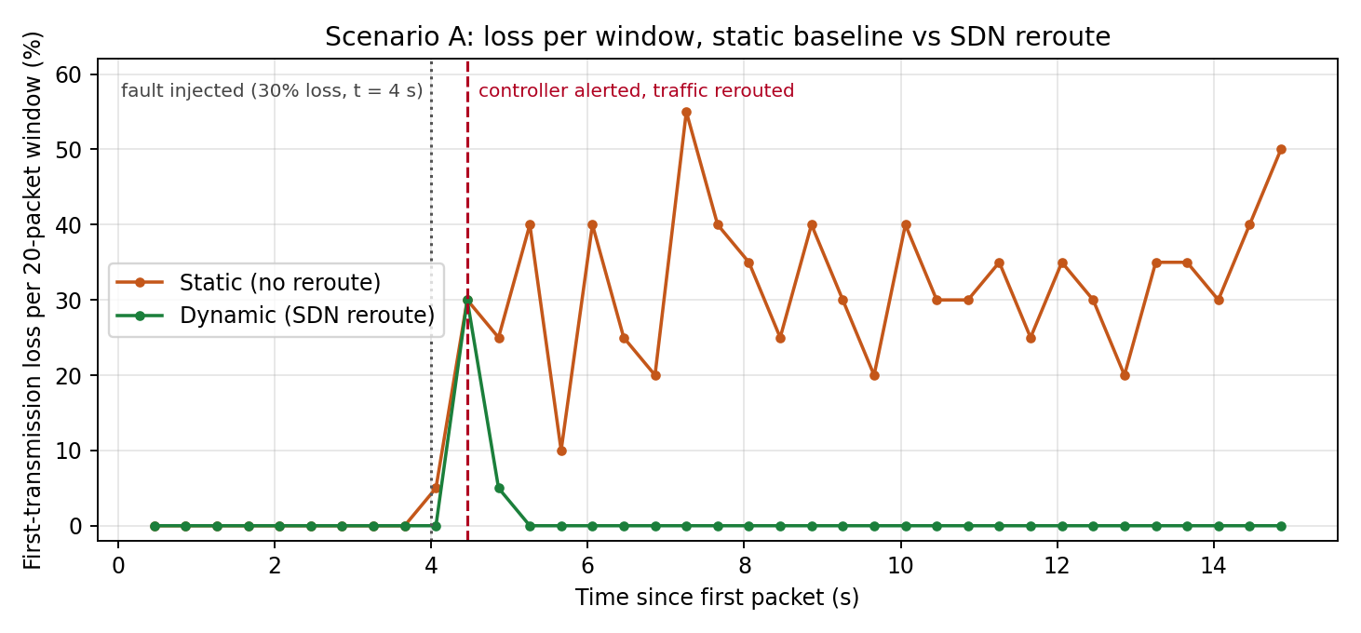
Figure 2: First-transmission loss per 20-packet window. Values are taken from the receiver console logs of the two runs.

5.2 Scenario B: link failure
When the link goes down nothing arrives, so there are no gaps to observe. Detection relies on the 1.0 s stall timeout. The first loss is seen at about 4 s, the receiver alerts the controller after one second of silence, and traffic is moving again about 1.2 s after the failure.
Metric | Static (no reroute) | Dynamic (SDN reroute)
Packets never delivered (of 750) | 552 | 0
Retransmissions | 4968 | 129
Detection time (s) | none | 1.001
Recovery time (s) | none | 1.209
Loss while degraded (%) | 0.0 * | 52.5
Loss after recovery (%) | not recovered | 5.6 **
Mean delivery latency (ms) | 20.94 * | 79.18
95th-percentile latency (ms) | 21.52 * | 540.89 ***
Total transfer time (s) | 17.54 | 15.02

* Static: only packets sent before the failure were ever delivered (198 of 750), and the receiver sees no gaps when nothing arrives, so these figures do not describe the outage. The failed-packet count is the meaningful number.
** The sender keeps transmitting during the one-second detection delay, and those packets are lost on the dead link. This reflects the detection delay, not loss on the alternate path.
*** The slowest 5% of packets waited through the outage and were then retransmitted over the alternate path.
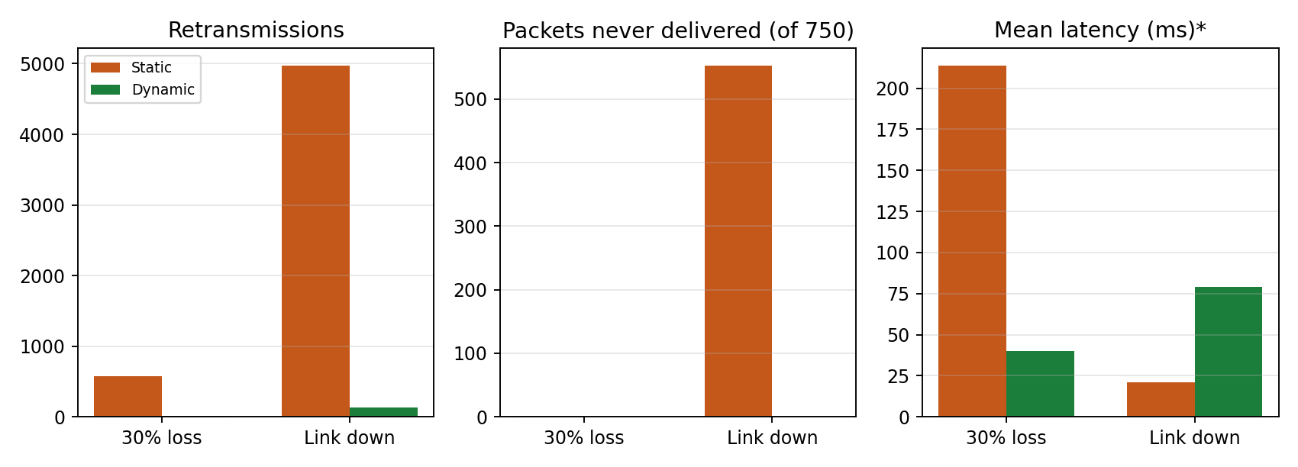
Figure 3: Static baseline versus dynamic reroute. *Static link-down latency covers only packets delivered before the failure.
The result of the failure scenario is the most striking. The static system loses 74% of the transfer (552 of 750 packets exhausted all retries). The dynamic system delivers every packet, at the cost of a one-second pause and a higher latency tail.

5.3 Live demo and flow-table evidence
In the live demo a 1500-packet transfer was started, and the link s1-s2 was brought down about six seconds in. The receiver reported a stall, the controller received the alert and rerouted, and all 1500 packets were delivered (1 duplicate). First loss was at 5.96 s, the alert at 6.96 s (detection 1.00 s), and recovery completed 1.25 s after the first loss.
The flow table of s1 shows the controller action directly. Before the failure the rule for destination 10.0.0.2 sends packets out of s1-eth2 (the s2 branch). After the reroute the same rule sends them out of s1-eth3 (the s3 branch) and has already forwarded 4654 packets.
Before the failure (sudo ovs-ofctl -O OpenFlow13 dump-flows s1):
cookie=0x0, duration=62.328s, table=0, n_packets=0, n_bytes=0, priority=10,ip,nw_dst=10.0.0.1 actions=output:"s1-eth1"
cookie=0x0, duration=62.328s, table=0, n_packets=0, n_bytes=0, priority=10,ip,nw_dst=10.0.0.2 actions=output:"s1-eth2"
After the reroute (same command):
cookie=0x0, duration=5126.172s, table=0, n_packets=4500, n_bytes=252000, priority=10,ip,nw_dst=10.0.0.1 actions=output:"s1-eth1"
cookie=0x0, duration=175.573s, table=0, n_packets=4654, n_bytes=724524, priority=10,ip,nw_dst=10.0.0.2 actions=output:"s1-eth3"
Figure 4: Flow table of s1 before and after the reroute (text transcribed from the terminal; the original screenshots are in the screenshots folder of the repository).
s1 rule (nw_dst = 10.0.0.2) | Before failure | After reroute
Output port | s1-eth2 (toward s2) | s1-eth3 (toward s3)
Path used | s1 - s2 - s4 (primary) | s1 - s3 - s4 (alternate)
Packets forwarded | 0 (idle) | 4654

5.4 Notes on measurement
- The controller monitor reports 0% loss on the lossy link because netem drops packets after Open vSwitch has counted them as transmitted. The monitor therefore shows which path carries traffic, while loss itself is measured by the receiver from sequence numbers.
- Sender and receiver run on the same machine, so they share a clock and one-way delay can be computed from the embedded timestamp.
- Each scenario was run once per mode. Packet loss is random, so individual window values vary between runs, but the detection and recovery behaviour was consistent in the loss run and the two failure runs.

6. Analysis and Discussion
- Detection speed depends on the fault type. Random loss is visible as gaps within one or two windows, giving 0.28 s detection. A dead link produces silence, so detection is bounded by the stall timeout (1.0 s). A shorter stall timeout would detect failures faster but risks false alarms on a slow link.
- The SDN part of the recovery is almost free. The reroute itself took about 1 ms (alert to FlowMod). Almost all the recovery time is the application noticing the problem, which is why the application-to-controller signal is the key design element.
- Retransmission alone does not fix a bad path. The static baseline delivers nearly everything by retransmitting, but it spends 579 retransmissions in the loss case and cannot recover at all when the link is down. Rerouting removes the cause instead of repeating the symptom.
- The alternate path is slower. Its links have twice the delay, so latency after recovery is higher than the original path would have been, but much lower than with 30% loss.
- Threshold choices. The 15% threshold and 20-packet window were chosen so that clean runs produced no false alerts (all pre-fault windows were 0%) while 30% loss was caught within two windows.

6.1 Limitations and future work
- Failover is one-way: after the primary link recovers, traffic stays on the alternate path. Automatic fail-back would need a probe of the primary path.
- The design handles one flow between two hosts. A larger version would key rules on flows and use OpenFlow group tables with fast-failover.
- The alert channel is a Unix socket on the same machine. A real deployment would use a controller REST API or a UDP/TCP control message.
- The controller could also detect failures itself from port status events or LLDP probes, and combine that with the application signal.

7. Conclusion
The project implements a complete loss detection and recovery system: a UDP application with sequence numbers, ACKs and retransmission; a Mininet diamond topology with a primary and an alternate path; and a Ryu controller that reroutes both directions of the flow when the receiver reports loss or a stall. Experiments with 30% loss and with a full link failure show that the dynamic system recovers in about half a second to just over a second and then runs loss-free, while the static baseline keeps losing packets or, on a dead link, loses most of the transfer. The live demo confirms the reroute directly in the switch flow table.

7.1 Mapping to evaluation criteria
Component | Where it is addressed
Problem understanding and architecture | Sections 1 and 2, Figure 1
TCP/UDP socket implementation | Section 3.1 (sender.py, receiver.py)
Mininet + SDN implementation | Sections 2.2, 3.3, 3.5 (topo.py, controller.py)
Socket-SDN integration | Section 3.4 (loss alert over Unix socket)
Initial testing and demo | Section 4.1 test cases, Section 5.1
Complete application functionality | Section 3.1 and 5: all packets delivered with ACK and retransmission
Dynamic SDN functionality | Sections 3.3 and 5.3 (FlowMod reroute, flow table evidence)
Challenging scenario / robustness | Section 5.2 (link failure) and 5.1 (30% loss)
Performance evaluation and comparison | Sections 5.1 and 5.2 (static baseline versus dynamic)
Documentation, final demo and viva | This report, README and repository

8. How to Reproduce
The full source, results and screenshots are in the repository: https://github.com/anushkaacharya35/sdn-packet-loss

8.1 Prerequisites
sudo apt install -y mininet openvswitch-switch python3-matplotlib
# Ryu in its own Python 3.9 environment
pip install "setuptools<58" wheel pbr
pip install eventlet==0.30.2 dnspython==1.16.0
pip install --no-build-isolation ryu==4.34

8.2 Run order
- Clean up any old Mininet state first: sudo mn -c. This also kills a running controller, so do it before starting the controller.
- Terminal 1, start the controller: ryu-manager controller.py and wait for the line saying it is listening for loss alerts.
- Terminal 2, run both experiments: sudo python3 topo.py --mode both (add --fault down for the link-failure scenario).
- Generate the comparison table and graph: python3 plot.py. Results are written to the results folder.
- For the live demo: sudo python3 topo.py --mode cli, then at the mininet prompt source demo.cmds. Inspect the flow table with sudo ovs-ofctl -O OpenFlow13 dump-flows s1 before and after.

8.3 Repository contents
Item | Description
proto.py, sender.py, receiver.py | UDP application
controller.py | Ryu OpenFlow 1.3 controller
topo.py, demo.cmds | Mininet topology, experiment runner and live demo script
plot.py | Static versus dynamic comparison
results_loss, results_down, results_demo | Raw logs, per-window CSV files and summary JSON for each scenario
screenshots | Flow-table and terminal evidence
README.md | Setup and usage instructions

