Sales Dashboard Report

1. Project Overview
This project presents an end-to-end sales analysis using Excel and Power BI. The goal is to understand sales trends, product performance, and customer behavior to support decision-making.

2. Objectives
- Analyze sales performance across different regions and products.
- Identify top-selling products and trends over time.
- Provide interactive dashboards for stakeholders.
- Gain insights using KPIs and visual storytelling.

3. Dataset Summary
The dataset includes transactional sales data with the following fields:
- Order Date
- Region
- Product Category
- Sub-Category
- Sales
- Quantity
- Discount
- Profit
- Customer Name

4. Tools Used
- Microsoft Excel (Pivot Tables, Pivot Charts, Slicers, Conditional Formatting)
- Microsoft Power BI (Data Modeling, DAX, KPIs, Interactive Charts)

5. Excel Dashboard
The Excel Dashboard was created using Pivot Tables and Charts. Key features:
- Monthly Sales Trend
- Top 5 Products by Sales
- Sales by Region
- Profit Margin Analysis
- Filters to slice by Region and Product Category
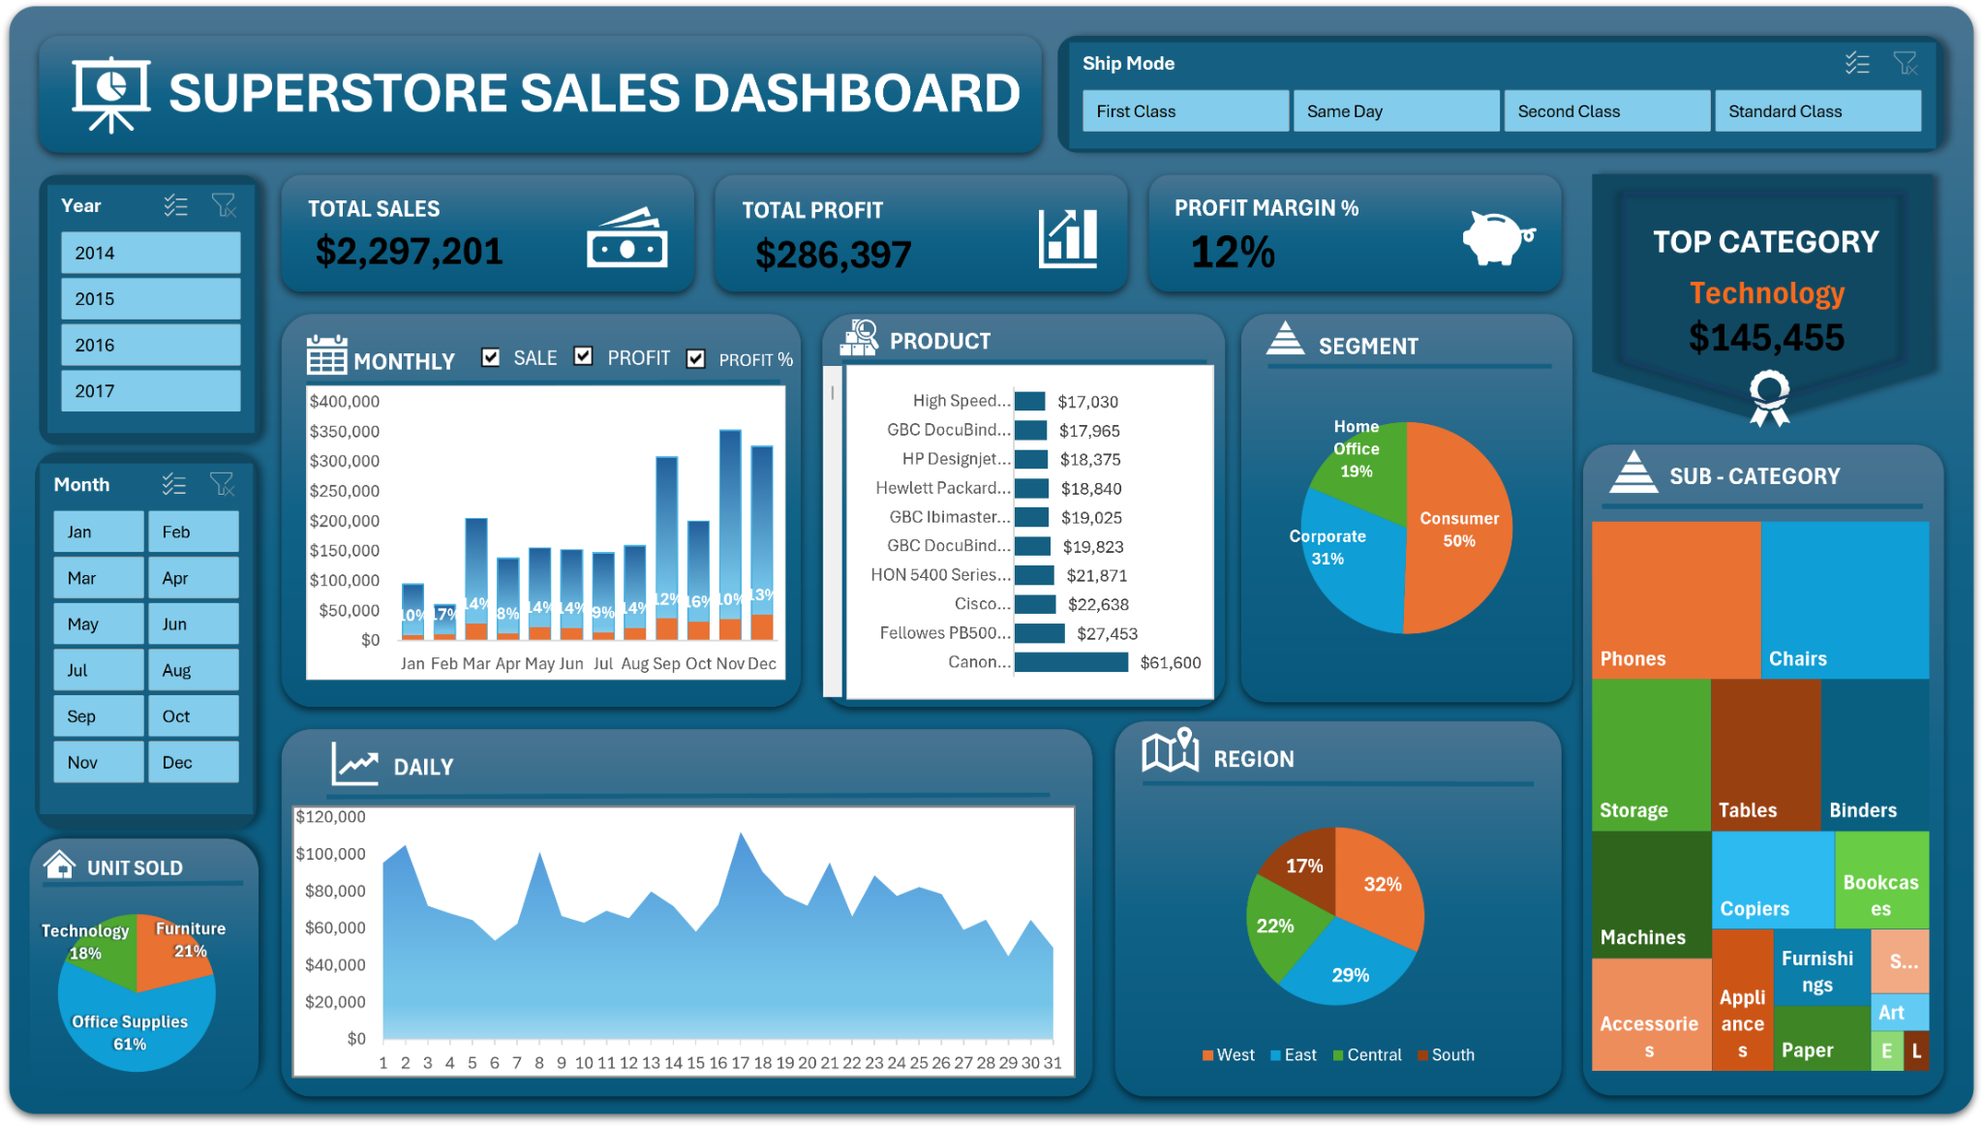

6. Power BI Dashboard
Power BI was used to create an interactive and dynamic dashboard. Key features:
- Sales KPIs (Total Sales, Total Profit, Average Discount, Quantity Sold)
- Monthly Sales Trend by Product Category
- Region-wise Sales Comparison
- Top Products Visualization
- Customer Segmentation
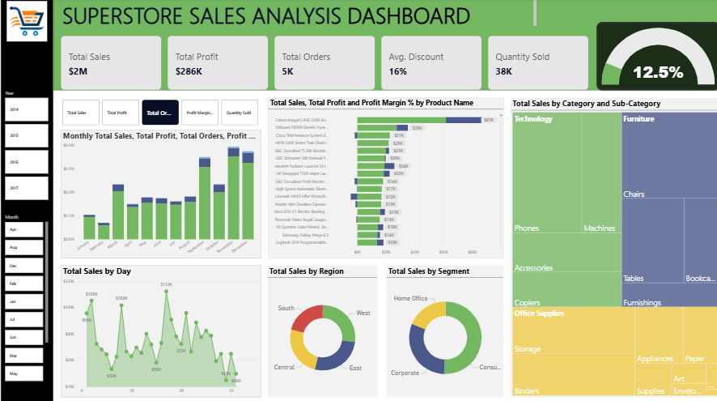

7. DAX Formulas Used in Power BI
- Total Sales = SUM(SalesData[Sales])
- Total Profit = SUM(SalesData[Profit])
- Average Discount = AVERAGE(SalesData[Discount])
- Quantity Sold = SUM(SalesData[Quantity])
- Profit Margin = DIVIDE(SUM(SalesData[Profit]), SUM(SalesData[Sales]))

8. Key KPIs
- Total Sales: ₹X (based on actual data)
- Total Profit: ₹Y
- Top Selling Product: Product A
- Best Performing Region: Region X

9. Key Insights & Visualizations
- Sales peaked in the festive season (Oct-Dec).
- Region A contributes to 40% of total sales.
- Product Sub-category B had the highest growth rate.
- Discounts above 20% led to a dip in profits.

10. Conclusion & Recommendations
This sales dashboard allows stakeholders to make informed decisions. It provides an overview of performance, helps monitor KPIs, and highlights areas of improvement.
Recommendations:
- Focus marketing on high-profit regions and products.
- Control discounts to maintain profitability.
- Use Power BI to automate weekly/monthly reports.

