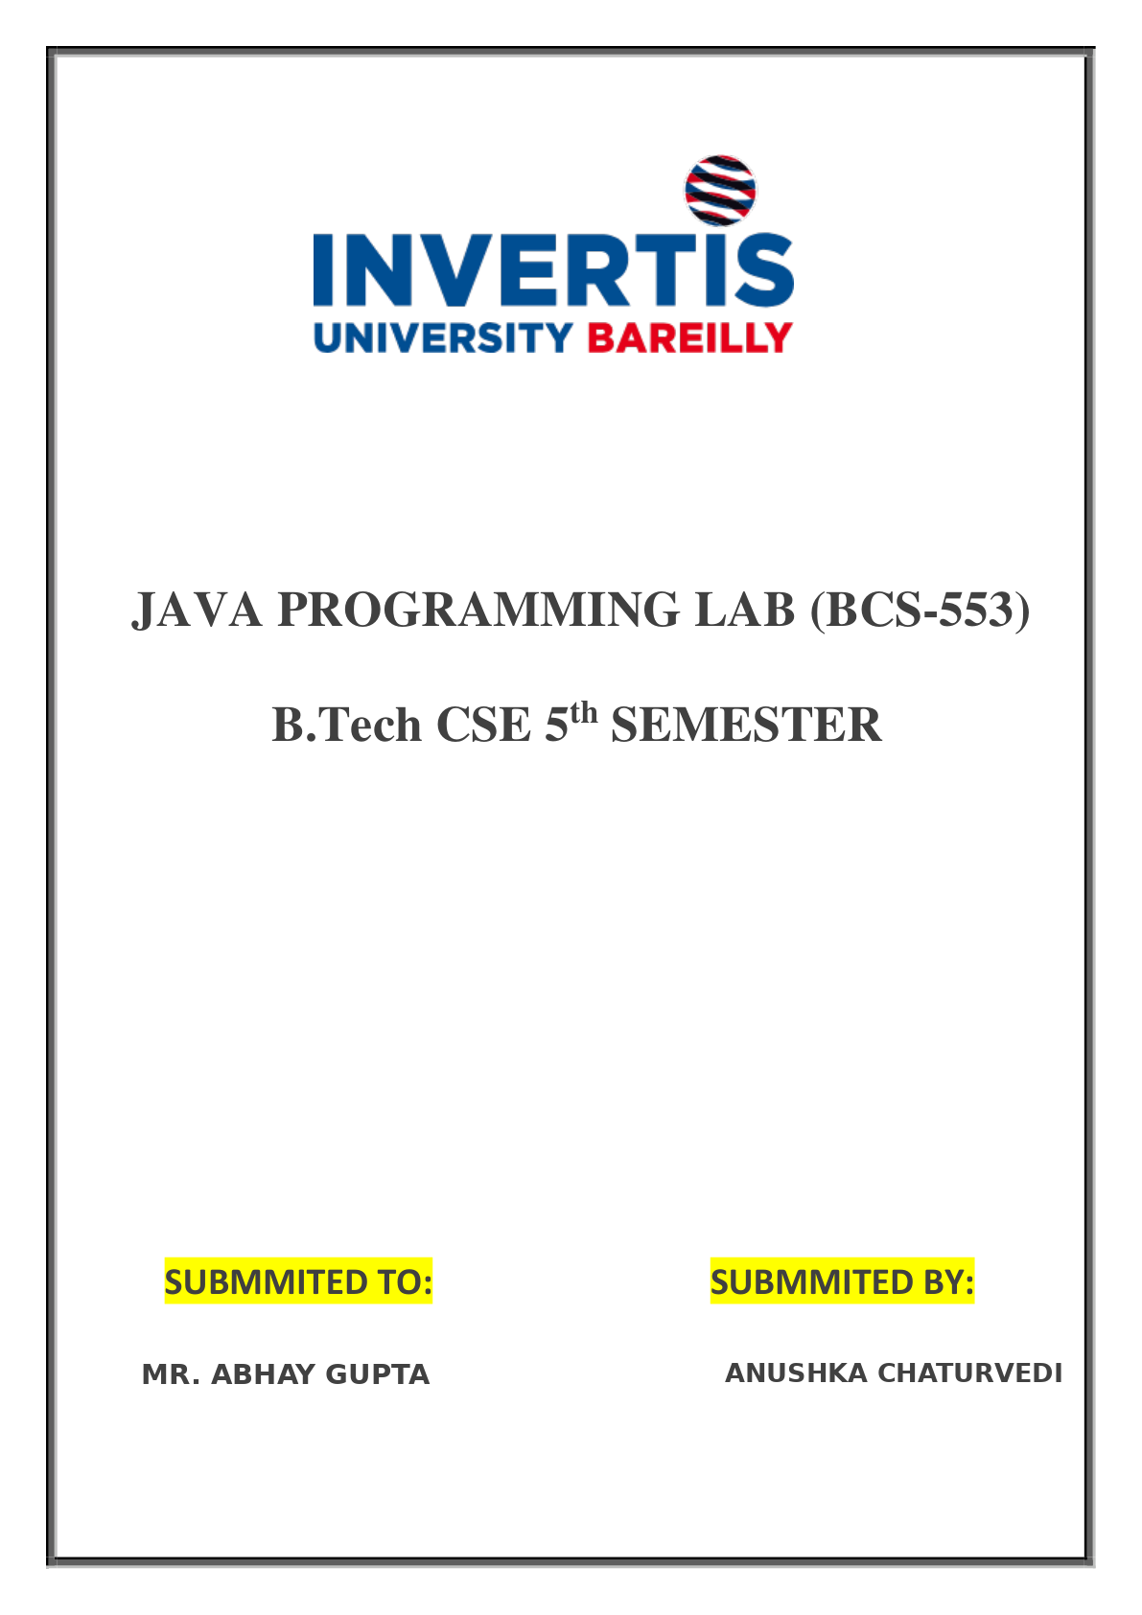

INDEX
SN. | PROGRAM NAME / EXPERIMENT AIM | PAGE | DATE | SIGNATURE
1 | Hello World, Variables and Arithmetic  Aim: Print text, store values in variables and perform calculations using arithmetic operators. | 3 | 26/10/2026
2 | Decisions and Loops with Numbers  Aim: Use if-else, else-if and loops to make decisions and perform repeated calculations. | 5 | 26/10/2026
3 | Star and Number Patterns  Aim: Use nested loops to print square, triangular and inverted patterns of stars and numbers. | 7 | 26/10/2026
4 | Writing Functions  Aim: Create and call user-defined functions with parameters and return values to calculate factorial, combinations, permutations and maximum values. | 9 | 28/10/2026
5 | Arrays: Traversal and Counting  Aim: Create arrays, traverse their elements, calculate their sum and largest value, and count elements satisfying a condition. | 11 | 28/10/2026
6 | Arrays: Reverse and Duplicates  Aim: Print array elements in reverse order, find the smallest value and its index, and detect duplicate values. | 13 | 28/10/2026
7 | Counting Steps and Complexity  Aim: Count loop iterations and understand the time complexity of single loops, nested loops and repeated halving. | 15 | 30/10/2026
8 | Matrices: Transpose and Row Sums  Aim: Create and traverse two-dimensional arrays, calculate a matrix transpose and find the sum of each row. | 17 | 30/10/2026
9 | Matrices: Rows and Columns  Aim: Access specific matrix rows, calculate column sums and count matrix values satisfying a condition. | 19 | 30/10/2026
10 | Switch and ArrayList  Aim: Use a switch statement to select a day and perform basic operations on an ArrayList. | 21 | 02/11/2026
11 | Bubble Sort and Selection Sort  Aim: Sort arrays in increasing order using bubble sort and selection sort, and count swaps performed by bubble sort. | 23 | 02/11/2026
12 | Insertion Sort  Aim: Sort arrays in increasing order using insertion sort and count the number of shifts. | 25 | 02/11/2026
13 | Strings: Methods and Palindromes  Aim: Use String methods, reverse a word, check whether a word is a palindrome and print substrings. | 27 | 04/11/2026
14 | Characters: Counting and Positions  Aim: Use charAt() to count vowels, count occurrences of a character and print each character with its index. | 29 | 04/11/2026
15 | StringBuilder Methods  Aim: Use StringBuilder to append, insert and delete characters from a mutable sequence of text. | 31 | 04/11/2026



