1. Business Problem (Use crime dataset)
  - What is the business objective?
  - Are there any constraints?
- Objective:
Identify clusters in the crime data i.e, In the context of crime data, each data point could represent a location, a type of crime, or a time period, and the features might include variables like crime rate, population density, types of crimes, etc.
The goal is to find natural groupings in the data, where each cluster represents a set of observations (e.g., locations) that are more similar to each other than to those in other clusters.
And Once the clusters are identifieddraw meaningful inferences from these clusters.

- Constraints:
Consider any constraints that might affect your analysis, such as data limitations or specific requirements from stakeholders.

- Work on each feature of the dataset to create a data dictionary as displayed in the below table:
Name of Feature | Description | Type | Possible Values/Range | Missing Values
‘Murder’ | Number of murders | float | 0.8-17.4 | 0
‘Rape’ | Number of Rape | float | 7.3-46.0 | 0
‘UrbanPop’ | Percentage of the population living in urban areas | int | 32-91 | 0
‘Assault’ |  | int | 45-337 | 0

3. Exploratory Data Analysis (EDA):
3.1. Summary.
The summary step involves getting a quick overview of the dataset :
Use describe() to get the summary of dataset:
 | Murder | Assault | UrbanPop | Rape
count | 50.00000 | 50.00000 | 50.00000 | 50.00000
mean | 7.78800 | 170.760000 | 65.540000 | 21.232000
std | 4.35551 | 83.337661 | 14.474763 | 9.366385
min | 0.80000 | 45.000000 | 32.000000 | 7.300000
25% | 4.07500 | 109.000000 | 54.500000 | 15.075000
50% | 7.25000 | 159.000000 | 66.000000 | 20.100000
75% | 11.25000 | 249.000000 | 77.750000 | 26.175000
max | 17.40000 | 337.000000 | 337.000000 | 46.000000

3.2. Univariate analysis.
Univariate analysis focuses on analyzing each individual feature to understand its characteristics.
For that purpose Visualize the Distribution of Numerical Features using histograms or density plots and Analyze Categorical Features (if any) using bar plots.
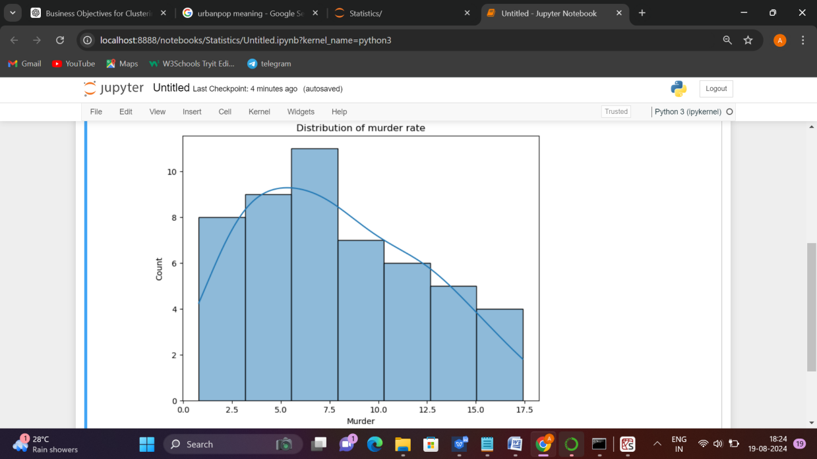
Fig.Histogram for a numerical feature
3.3. Bivariate analysis.
Bivariate analysis involves exploring the relationships between two variables to identify any correlations, patterns, or interactions.
For that use scatter plots to visualize the relationship between two numerical features.Calculate the correlation coefficient (using df.corr()).
Use a heatmap to visualize the correlation matrix.
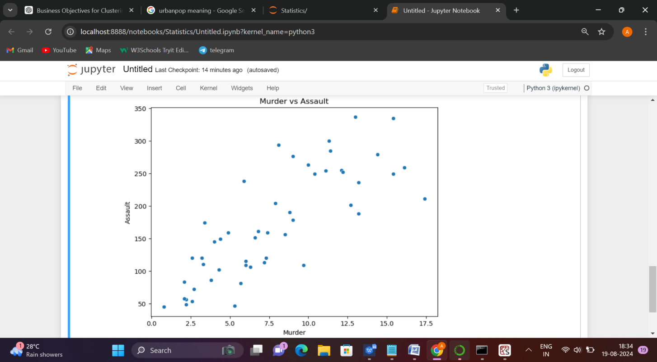
Fig.scatter plot between 2 numbrical features

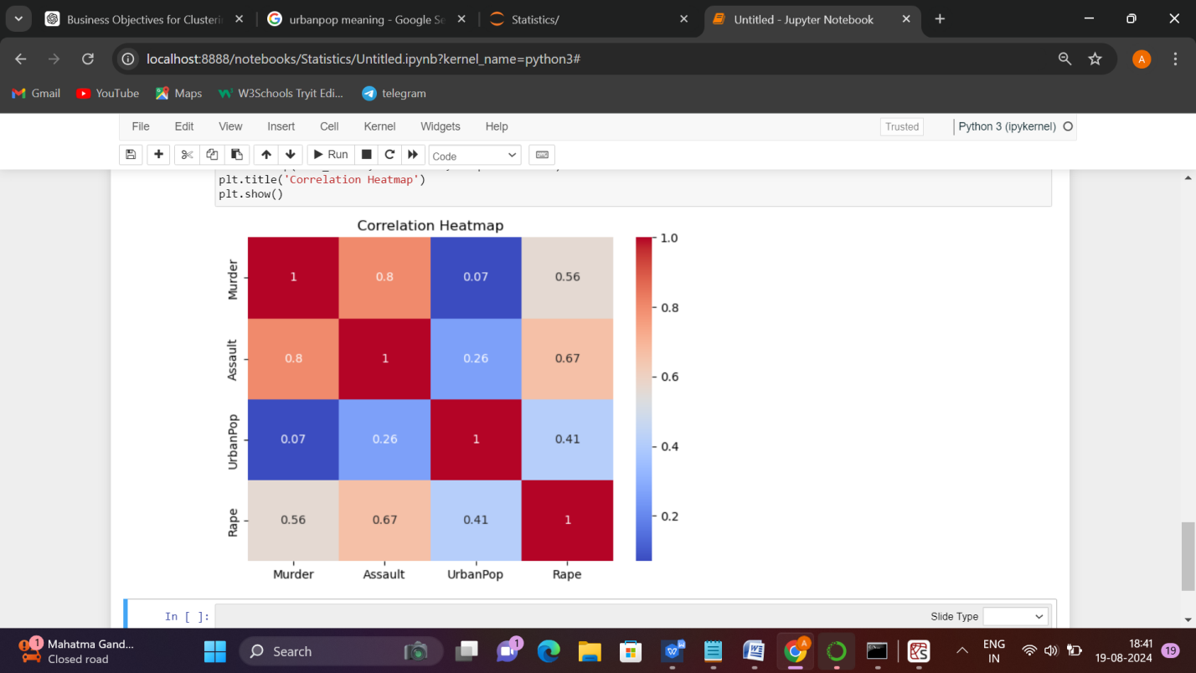
Fig. Correlation matrix and heatmap

4. Data Pre-processing
4.1 Data Cleaning, Feature Engineering, etc.
The goal of data cleaning is to correct or remove any inaccuracies, inconsistencies in dataset.In data cleaning Handling Missing Values (using df.isnull().sum()), dealing with outliers for that use boxplot to detect outliers and transformation, handling duplicates(using duplicated()).
Feature engineering involves creating new features or modifying existing ones.(e.g., creating a "crime rate" feature by dividing the number of crimes by the population).
5. Model Building
5.1 Build the model on the scaled data (try multiple options).
5.2 Perform K- means clustering and obtain optimum number of clusters using scree plot.
5.3 Validate the clusters (try with different number of clusters) – label the clusters and derive insights (compare the results from multiple approaches).
---(Refer code)---
6. Write about the benefits/impact of the solution - in what way does the business (client) benefit from the solution provided?
Enhanced Understanding: By identifying clusters in the crime data, the client can gain a clearer understanding of crime patterns and trends. For example, clusters might reveal
high-crime areas, times, or types of crime.
Resource Allocation: Insights from the clustering analysis can help in optimizing the allocation of resources such as police patrols, emergency response teams, and community safety programs. This can lead to more efficient and targeted interventions.
Strategic Decision-Making: The client can use the clustering results to make data-driven decisions about crime prevention.

