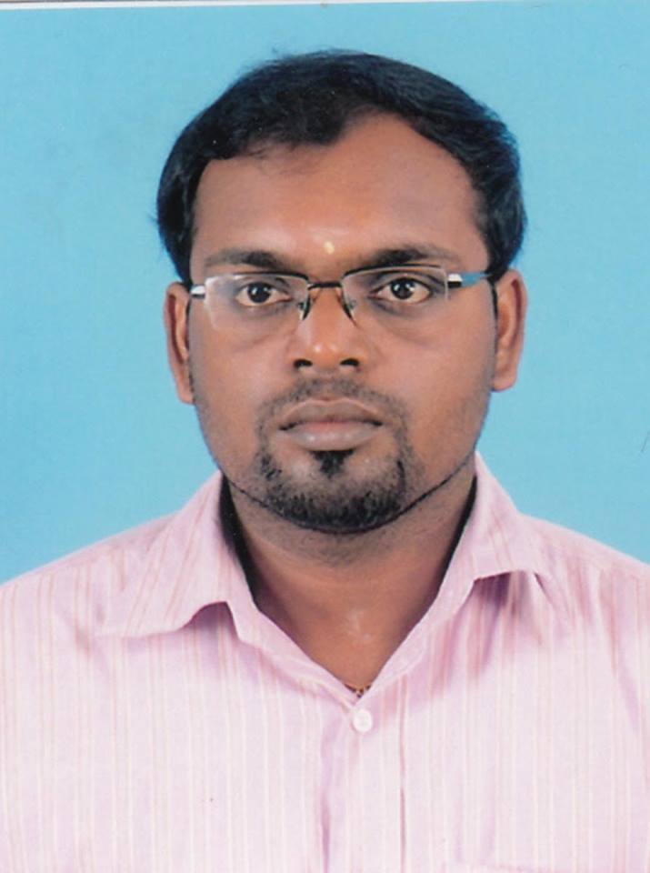
SIVARAJAH HARIKARAN
LUXMY BAVANAM,
SAMARABAHU,
UDUPPIDDY,
JAFFNA.
OBJECTIVE

To obtain the opportunity to become a enthusiastic professional while delivering the skills and abilities to reach the organizational and social goals in a challenging environment as well as improving the knowledge in the work setting, and to become a dedicated valuable personal contributing to the continuous development of the country.
WORK EXPERIANCE

- Possition :Area Cashier and finance assistant
Organization :ACTED Kilinochchi
Duration : from 01/10/2013 to 05/06/2014
- Possition :Temporary lecturer
Organization :Department of Human resource management at University of Jaffna.
Duration : from 16/06/2014 to 20/05/2015
- Possition : Human resource Officer
Organization : Sarah Industries Private limited.
Duration : from 01.06.2015 to 31.07.2017
- Possition : Assistant Manager Human Resource
Organization : Royal International College.
Duration : from 18.09.2017 to 06.11.2017
- Possition : Lecturer in Human Resource Management.
Organization : Department of Economics and Management, Vavuniya Campus.
Duration : from 13.11.2017 to now

EDUCATIONAL QUALIFICATIONS

- G.C.E. (O/L) – at J/ Uduppiddy American Mission College- Year-2003

Tamil Language A

English (2004) B

Tamil Literature A

Mathematics B

Science & Tech C

Social St & His B

Business & Acct C

Hinduism A

Geography C

Music B

- G.C.E. (A/L) – at J/ Uduppiddy American Mission College.
Year : 2007 Index No : 6339506
Economics A
Accounting B
Business Studies B
- Degree: - Bachelor of Business Administration (Specialization in H R M)
University: - University of Jaffna.
Class: - 1st class
- I have complete Post Graduate Diploma in Management at University of Rajarata, Srilanka.
- Reading Master of business administration at University of Rajarata, Srilanka.
Professional Qualification

- AAT (Association of Accounting Technicians) Completed in 2010.
- Marketing diploma completed at All Indian University.

Other Qualification
- Good communication skills in English, and Tamil languages.
- Participated in CIMA Global business challenge 2013.
- Attended “counseling and mentoring workshop” at University of Jaffna.
- Attended “Capacity building on Gender” at University of Jaffna.

LEADERSHIP VALUES

- Member of the school scouts.
- President of the School commerce association.
- Head prefect of School in 2005/2006.
RESEARCH AND PUBLICATIONS

- Name of Author(s): - S.Harikaran & L.Jeevaraj
Article Topic: - “Leadership Style of Principals and Teacher’s Behaviour in Kilinochchi
Zone Schools”
Name of Journal: - European Journal of Business Management

- Name of Author(s): - S.Harikaran & L.Jeevaraj
Article Topic: “Employees’ Stress and Its Impact On Their Performance In District
Secratariat Jaffna.”
Name of Journal: - Journal of Development Country studies.

- Name of Author(s): - S.Harikaran
Article Topic: “Influence of Personal Demographic Variables On Conflict Management
Styles: Study On Teachers in Vadamaradchi Zone, Jaffna, Srilanka”
Name of Journal: - Journal of Research on Humanities and Social Science.

- Name of the Author(S): - Marino Vijitharan, Dr.Y.Nanthagopan,.S.Harikaran
Article Topic: “The Impact of Emotional Intelligence On Job Performance: A Comparative Study Between Primary and Secondary Level School Teachers in Jaffna Zone Sri Lanka”
Name of Journal: - Journal of Management, South Eastern University of Sri Lanka.

- Name of the Author(S): - N. Thevanes,. S.Harikaran
Article Topic: “The Relationships among Work-Life Balance, Organizational Citizenship Behavior and Organizational Performance: A Review of Literature”
Name of Journal: - Journal of Management, South Eastern University of Sri Lanka.

PERSONAL INFORMATION

Name in Full : Sivarajah Harikaran
Date of Birth : 17th September 1987
Gender : Male
Civil Status : Single
Citizenship : Sri Lankan
N. I. C. Number : 872611460V
Contact Number : 0776660601
E.mail : harikaran88@gmail.com

I hereby declare that the particulars given above are true and accurate to the best of my knowledge.

………………………
Sivarajah Harikaran.

