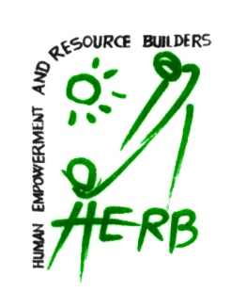

# HUMAN EMPOERMENT AND RESOURCE BUILDERS

# Batticaloa - Sri Lanka

# 

The **HERB** is created by the group of professionals from the different field of discipline in early year of 2000 for the purpose of proper knowledge transmission to fill the information gab among the target community. **HERB** shares the experiences which it had gained with the target group to get the best of its achievement, through Formations, trainings, Facilitations, Conducting feasibility services and researches.

**Vision**

Proper knowledge transmission to fill the information gabs among the community

**Mission**

It is a place where one could obtain psychological assistance to identify hidden talents and to be aware of psychological obstacles to live in reality. Professionals in counseling and psychology provide the needy with individual attention to live actively and to make a better future.

**Contact Person :** Mr.A.Jeyanthan

Director/Resource Management Officer

515/68, Trinco Road - Batticaloa Sri Lanka

Mobile - 0772385923

E mail - jalagaiah@gmail.com

**Our Services**

* With the available Resource pool Contacting Trainings /workshops for the Requested Titles
* Organizing play types of workshops for children
* Project evaluation
* Designing work shops
* Gender inclusive advocacy and Governance
* Preparing Training/Feasibility Reports
* Organizing & Proposing Human Development & Leadership work shops
* Preparing Workshops/Seminars/Trainings Modules
* Facilitation techniques /Skills Development
* Creating Workshops/Seminars/Trainings Exercises
* Conduct & Facilitate Holistic Formation and Leadership, Counseling, Livelihood Workshops all over The Island.
* Enhancing Knowledge on small scale infra structure development
* Providing Facilitators/Resource persons on requests.
* Providing consultancy services for Agriculture/Livestock sectors.
* Designing concept papers for projects on requests.
* Designing Street Drama
* Performing Street Drama
* Career Guidance
* Personal Counseling/Group counseling
* Magazine Preparation

|  |  |  |  |
| --- | --- | --- | --- |
| Training Title | Participants/Target Group | Training Output | Funding Agency |
| Facilitation techniques and  Modern leadership | The Education office Staff from Kilinochi/ Zone office | * Build strong conviction. * Creates willingness to accept community responsibilities among the target group. * Makes a person open to new opportunities and challenges. * Improve performance and increase risk taking ability. * Helps a person give and receive both criticism and complements tactfully and easily. | Project Funded by  World Vision LankaHEA |
|  | Local Authority members ,staff/CBO Members in Nuvaraeliya District | * Improve performance and increase risk taking ability. * Helps a person give and receive both criticism and complements tactfully and easily. * Understand others and to adapt their behaviour accordingly. * Build and nurture strong, lasting, mutually beneficial relationships. * resolve conflict in a positive manner | CARE |
|  | Paddipalai ADP  Youths/CBO Staff/Mobilizes | * Look at individual Facilitation and the communication strengths among the Target Group, * Improving facilitation techniques skills and the values | Paddipalai ADP  World Vision Lanka |
|  | Tsunami Project – Ampara District  Local Authority members/Staff | * Builds optimistic attitude. * Makes a person more sensitive * Develop a caring attitude. * Makes a person self-motivated and ambitious. * Understand others and to adapt their behavior accordingly. * Build and nurture strong, lasting, mutually beneficial relationships. * resolve conflict in a positive manner | Project Funded by – International Organization for Migration |
|  | Tsunami Project – Batticaloa District  IDP Camp Managers/SDOs Ds office | * Build strong conviction. * Creates willingness to accept community responsibilities among the target group. * Makes a person open to new opportunities and challenges. * Improve performance and increase risk taking ability. * Helps a person give and receive both criticism and complements tactfully and easily. | Project Funded by – International Organization for Migration |
|  | Tsunami Project – Batticaloa District  IDP Camp Managers/SDOs Ds office | * Improve performance and increase risk taking ability. * Helps a person give and receive both criticism and complements tactfully and easily | Project Funded by – International Organization for Migration/UNHCR |
| Team building and Leadership | Local Authority Staff Members | * Have a practical understanding of how delegates function as best communicators in their community. * Through communication skills and the skills reforming the relationship.  To facilitate a greater understanding through dialogue and teamwork, | Project Funded by - ASIA Foundation |

|  |  |  |  |
| --- | --- | --- | --- |
| Training Title | Participants/Beneficiaries | Training output | Funding Agency |
| Facilitation techniques and  Effective leadership | The Education office Staff from Batticaloa and Paddiruppu Zone office | * Self-awareness, * Self-confidence, * Positive personal impact, * Outstanding performance, * Communication skills and Interpersonal competence | UNICEF |
|  | CBO Members/Staff in Valaichchenai  Oddamavai DS Division | * A set of behaviours which allow you to communicate effectively and unambiguously in a face-to- face setting * They can also be thought of as behaviours which assist progress | Project Funded By CARE International |
|  | CBO Members/Staff in Paddipalai/Vellavely DS Division | * Better understand others and to adapt their behaviour accordingly. * Build and nurture strong, lasting, mutually beneficial relationships. * resolve conflict in a positive manner | Paddipalai/Vellavely ADP  World Vision Lanka |
|  | Ampara District  Local Authority members/Staff | * Self-awareness, * Self-confidence, * Positive personal impact, * Outstanding performance, * Communication skills and Interpersonal competence | International Organization for Migration |
|  | Teachers from Paddipalai Zone | * To have a practical understanding of how delegates function as leaders. * To raise delegate's personal awareness of who they are? * Create willingness to accept responsibility among the community | World Vision Lanka |
|  | Local Authority Staff/Members  Trincomalee | * A set of behaviors which allow you to communicate effectively and unambiguously in a face-to- face setting * They can also be thought of as behaviors which assist progress towards achieving an objective | The Institute for youth concern |
|  | Local Authority Staff/Members  Mannar | * Build strong conviction. * Creates willingness to accept community responsibilities among the target group. * Makes a person open to new opportunities and challenges. * Improve performance and increase risk taking ability. * Helps a person give and receive both criticism and complements tactfully and easily |  |

|  |  |  |  |
| --- | --- | --- | --- |
| Training Title | Participants/Beneficiaries | Training Content | Funding Agency |
| Gender inclusive advocacy and Governance/ Better Understanding on Gender Values | DS office Staff Eravur Town | To have a practical understanding of how delegates function.  To raise delegate's personal awareness of who they are?  Create willingness to accept the Gender concept | Project Funded by ‘’ DIAKONIA’’ |
|  | Tsunami Project – Batticaloa District | What is Gender?  Definition of Gender  Components of psychosocial wellbeing   1. Human Capacity 2. Social Ecology 3. Economic Environment 4. Cultural and values   Definition of development | Project Funded by – IOM |
|  | Local Government staff / SDOs - Ampara District | What is Gender?  Definition of Gender  Self realizations and evaluation  Knowledge  Attitude  Skill  Practice  Effective Communication Skills and Art of Relationship (TA) | Funded by ‘‘Seva Lanka foundation’’ |
|  | DS Office Staff  IDP Camp Managers/SDOs Ds office | Human Security and Gender  Gender in National Identity  Gender and Armed Conflict  The Role of Religion | Funded by IOM |
|  | Student Leaders Batticaloa Zone | Human Security and Gender  Gender in National Identity  Gender and Armed Conflict  The Role of Religion  Conclusions | The Institute for youth Concern |
|  | Youths from Ampara Youth Service  Council | Human Security and Gender  Gender in National Identity  Gender and Armed Conflict  The Role of Religion  Conclusions | National Youth Service Council |

|  |  |  |  |
| --- | --- | --- | --- |
| Training Title | Participants/Beneficiaries | Training Content | Funding Agency |
| Family Counseling and leadership | Cupules | To have a practical understanding of how delegates function.  To raise delegate's personal awareness of who they are?  Create willingness to accept the Gender concept | World Vision  Ambegamuva ADP |
|  | Fathers | The use of counselling as a way of responding to people in distress has grown rapidly in recent years. While it has proven popular with many people, the rapid growth of counselling has also generated some disquiet and numerous questions. Confusion abounds in many quarters about what counselling is and to what extent it works. The position is complicated by the fact that there is considerable debate about how the effects of counselling should be measured. Nevertheless, robust and consistent evidence about the effectiveness of counselling is now accumulating.. | World vision Lanka  Pottuvil ADP |
|  | Mothers | Self-realizations and evaluation  Knowledge  Attitude  Skill  Practice | World vision Lanka  Pottuvil ADP |
| Psychological Assistance Family rehabilitation project | Family members |  | World vision Lanka  Pottuvil ADP |
| Student Counseling and leadership | Student Leaders | Attitude Change | UNICEF |
| Counseling | Youths from Ampara Youth Service Council | Self realizations and evaluation  Knowledge  Attitude  Skill  Practice | National Youth Service Council |

|  |  |  |  |
| --- | --- | --- | --- |
| Training Title | Participants/Beneficiaries | Training Content | Funding Agency |
| Family Counselling | IDP Camp Managers from  Batticaloa | * Provide support in times of crises. * Promote change when change is needed. * Propose realistic action in the context of different life situations which may bring about difficulty. * Assist individuals to accept information on health and well-being, personally and/or for loved ones, and adapt to its implications.   Counselling is an agreement between the **counsellor** and the **client** (or person being helped) and is based on two-way communicating and talking. | International Organization for Migration |
| Identifying Problems and Barriers during Counselling | Youth Service Council members | Culture  Perceptions  Habits  Education  Family situation  Resources available to the client  Religious persuasion  Primary language ability, mother tongue | Youth Service Council |
| Basic Counselling | Pre- School Teachers | Self-realizations and evaluation  Attitude  Skill  Practice | UNHCR |
| Family Counselling | IDP Family members  Vaharai | Self realizations and evaluation  Attitude  Skill  Practice | IOM |
|  | IDP Family Members  Kaluvanchikudy DS | Self realizations and evaluation  Knowledge  Attitude  Skill  Practice | IOM |
|  | IDP Family Members  Mutur | Self realizations and evaluation  Knowledge  Attitude  Skill  Practice | IOM |
| Effective Conflict resolution skills Development | Sectional Heads  Teaching Hospital Batticaloa | Productivity  Effective Conflict resolution skills Development  Crystal clear communication | world bank |
| Effective Conflict resolution skills Development | Department of Local Government  Eastern Province | Effective Conflict resolution skills Development  Crystal clear communication | Handicap international |

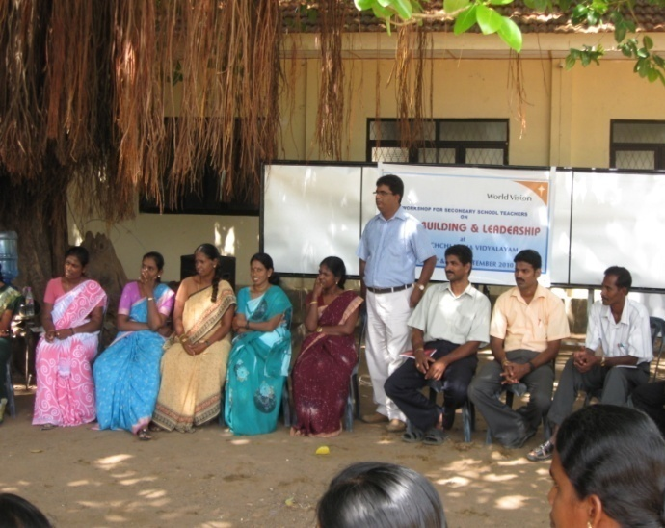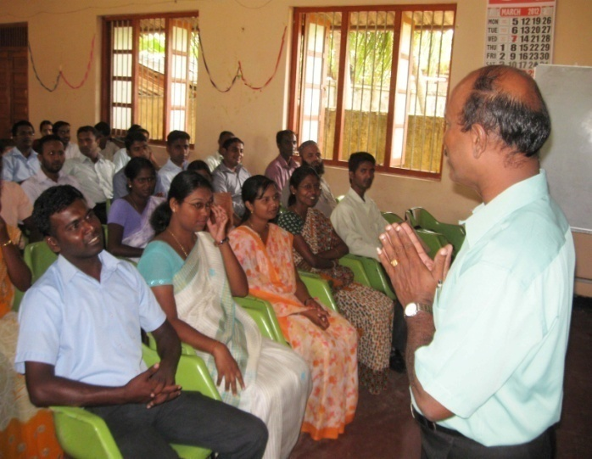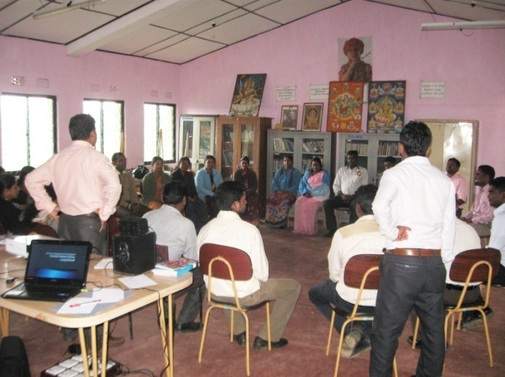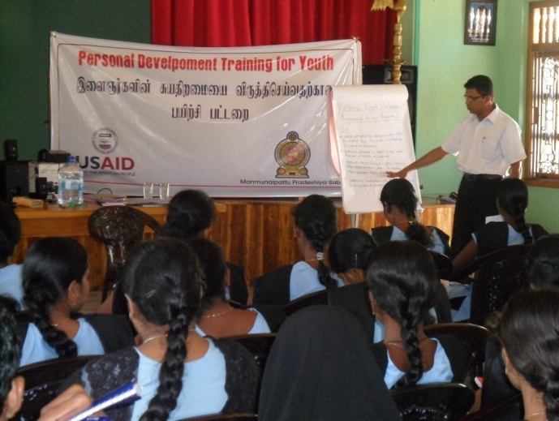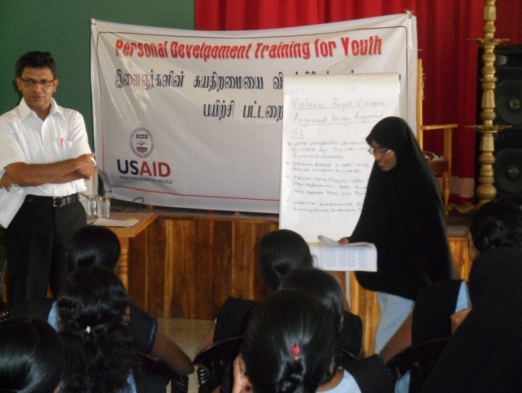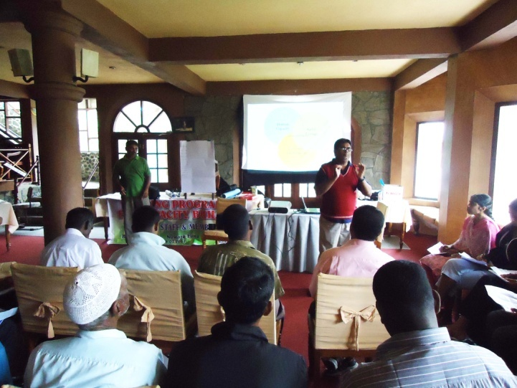

**Batticaloa**

**Batticaloa**

**kilinochi**

**Ambegamuwa**

**Ampara**

**Nuwaraelia**

**Methodology**

⦁ Visualization Exercise

* Indoor outdoor games and evaluations

⦁ Guidance by the Resource person/Facilitators about the various activities related to

⦁ Leadership values, Skills and the strengths.

⦁ Group Discussions/Presentation/

⦁ On Time Inputs.

⦁ Power Point Presentation.

⦁ Psychological Games and Evaluation.

⦁ Individual /Group Presentations

⦁ Self-Evaluations and Reflection.

⦁ Open Forum

⦁ Video clips

⦁ Posters and banners making.

**Learning of the trainings**

⦁ Attentive participation

⦁ Active involvement of the youths.

⦁ Forwardness in sharing

⦁ Sense of group feeling

⦁ Ready to mix up with everyone forgetting their own set up

⦁ A leader should be fearless and humble, committed and vulnerable, outspoken and sensitive, value-based and flexible.

⦁ Leadership is not about managing things but about developing people. You have to act as a liberator and not a limiter of human talent

⦁ Build trust and respect with other neighbor community.

⦁ Quickly they were able to understand and share their ideas without any difficulty.

⦁ You should measure your success not by the extent of your power, but by how many lives you touch and transform.

⦁ Your legacy to the generations that follow will be how much value you have added to your community and how many lives you have improved.

⦁ As an effective youth leader, you need to renew yourself, revitalize your body and energize your spirit.

⦁ In the games activities and group sharing the exposed their hidden abilities and even their happiness and sorrow was exposed.

⦁ Identify the role model

⦁ Working towards to achieve the harmony.

⦁ Effective decision systems and communication among the youths.

⦁ Commitment to common objectives

⦁ Strength -Weakness -Opportunity between the individual members & the villages

# Our organizations available training packages

⦁ Peace Building and Leadership

⦁ Facilitation techniques/Skill Development

⦁ Career Guidance / Development

⦁ Better Understanding on Gender concept / Values

⦁ Non Violent Communication

⦁ Enhancing Knowledge on small scale infra-structure development

* Family Rehabilitation Counseling
* Counseling Skill Development

⦁ Art of Relationship and Transaction Analysis

⦁ Training on Gender inclusive advocacy and Governance

⦁ Conflict Transformation and Mediation

* Youth Counseling

⦁ Conflict Mitigation and Problem Solving

⦁ Personality Development/Self Esteem

⦁ Group Dynamics/Team Building

⦁ Management Skill Development

* Interpersonal Relationship

**Experience/Working Partners**

⦁ Eastern University Sri Lanka

⦁ Department of Education

⦁ National youth service council Batticaloa, Sri Lanka

⦁ International Organization for Migration

⦁ Local Authorities

⦁ Eastern Province Education department

⦁ Zonal office Education Vavuniya

⦁ World Vision Sri Lanka

⦁ Sevalanka

⦁ Handicap International

⦁ RDHS office Batticaloa

⦁ DS offices

⦁ ADT

⦁ Asia Foundation

⦁ The Institute for Youth Concern

**Our Available Resource Pool**

# Mr.Jeyanathan - Special Trained Trainer for Holistic formations

# Career Guidance & Counseling Officer,

# Resource Person for Psychosocial Intervention Program

# Zonal Education Office Batticaloa

# Dip in Counseling/ Dip in Psycho Social Work/ BA Sociology

* **Rev.Fr.A.A.Navaretnam** –
* **Lecturer EUSL/Catholic Chaplin/Gender Facilitator EUSL**

MA

# Mr.S.M.A.Asmias - Lecturer NISD, Colombo

# BA, Dip in Edu MA (Social Work)

# Dip.In.Cuonselling

# Ms. Navaranjini Nadarajah

Gender Consultant / Resource Person.

* **Ms.T.Sivaprasanthini -** Consultant Special Trainer Gender (Colombo)/Psychosocial Work

# MA (Psychology)

* **Ms. S.J. Hillary -** Gender/Women’s’ development

BA – EUSL

# Mr.S.Aritharn - Assi.Centre Manager

# Psychosocial Centre

# Department Of Education

# Eastern Province

* **Ms.S.Shanthy –** Gender and Production Consultant
* **Ms.S.Kirubakaran** – **Assistant Director of Education**

BA, Dip in Edu, MA (Sociology)

# Mr.Manirajah - Career Guidance & Counseling Officer, Resource Person for Psychosocial Intervention Program Zonal Education Office Batticaloa

# BA, Dip in Edu, Dip.In.Cuonselling

* **Rev.Fr.X.I.Rajeeva – Trained Facilitator Teacher/Students’/Youth Counselor**

BA

**Availability –** On Request **/**whenever needed

**If requested we will include more resource people from the relevant sector.**

515/68, Trinco Road - Batticaloa Sri Lanka

Mobile –0772385923, E mail – [jalagaiah@gmail.com](mailto:jalagaiah@gmail.com)