**BEC Progress Up to 20th August 2020**

**BERENDINA EMPLOYMENT CENTER (GUARANTEE) LIMITED**

1. **Geographical coverage**

|  |  |  |
| --- | --- | --- |
| **Province** | **District** | **DSD** |
| Sabaragamuwa | Kegalle | Galigamuwa, Dehiyowitta and Bulathkopitiya |
| Central | Nuwara Eliya | Ginigaththena and Nuwara eliya |
| North Central | Anuradhapura | Manupa,Thirappane and Kahadakasdeliya |
| Eastern | Trincomalee | Town & Gravets ,Thampalakamam,cKinniya,cMutoor |
| Batticoloa | Pattipalai (MSW),Chenkalady,Porathivu Pattu |
| Northern | Mullaitivu | Maritime Paththu,Puthukudiiruppu, Oddusuddan |
| **5 provinces** | **6 districts** | **18 DSDs** |

1. **Skills Development**
2. **Soft Skills**

BEC has already identified 122 youth to follow soft skills development training. Out of them 21 youth in Batticola branch started the training during first week of March.

After lockdown BEC was able to negotiate with training providers specialy in Mulaitivu, Trincomalee and and Kegalle and commence the soft skills development training for altogether 84 youth.

|  |  |
| --- | --- |
| Distrcit | Number of students |
| Batticoloa | 21 |
| Trincomalee | 15 |
| Mullaitivu | 25 |
| Kegalle | 23 |

1. **VT and Professional Skills**

BEC had identified 154 youth to provide scholarships to follow Vocational and Professional trainings during 2020. Out of which, courses for 100 students started before the lockdown. During the period of Lockdown BEC conducted a follow-up over the phone with the students who already started the courses. And the students identified for the courses to be started. From July 2020 onwards after the situation comes to normal with lifting the restrictions from the health department BEC was able to start the some courses. Now the total youth who are following vocational and professional courses are 154.

Among the VT & professional scholarships provided in 2019, 110 were following the courses. BEC is in the process of providing scholarships for them and has been able to successfully re engage them in trainings after lifting the restrictions. Out of 991 financial assisted youths in 2019, There were 42 dropouts also.

1. **Student mentoring and Career Guidance Training**

Since mid-July 2020 BEC has been able to start Career guidance and Coucelling trainings in some districts. With that BEC has been able to identify some youth for directing government vocational trainings and also to identify for BEC’s scholarships program.

|  |  |  |  |  |
| --- | --- | --- | --- | --- |
| Branch | Total number of CG programs conducted after lock down | # of youth identified for finanacial assistance | # of youth identified for Gvt VT program | # of youth identified for Soft Skill program |
| Mullaitivu | 2(23) | 16 | 7 |  |
| Ginigathhena | 1(35) |  |  | 35 |

In this year 02 branches has planned to establish and material supports to CIC units in Kahatagasdigiliya and Nuwara Eliya DS offices. Kahatagasdigiliya CIC unit will be opened in End of September and Materials will be provided to the Nuwara Eliya DS office in September 15th.

1. **Bright Student Scholarships program**
2. **Provision of Monthly Scholarships**

Provision of BSS scholarships was temporally stopped (April, May and June) due to the COVID-19 situation. From July 2020 onwards schools have been gradually opened and started the extra classes subject to the strict health restrictions. Hence BEC started providing scholarships for 2715 youth who have already been enrolled to the program. Out of 1,280 youth are to be stat for the A/L exam to be held from 12th October onwards, hence they will be financially assisted up to end of September 2020.

1. **Bright Student Scholarships Impact Survey (need to get from Madhushanka)**

Impact survey done for the BSS students and Non BSS students who sat on 2019 A/L. This Survey was done to find impact of BSS program and 26,645 non BSS student’s A/L results and 594 BSS students’ results were counted for the survey. Survey overall results generated as follows.

|  |  |  |  |  |  |  |  |  |
| --- | --- | --- | --- | --- | --- | --- | --- | --- |
| **Stream** | **Total BSS students** | **Results counted BSS students** | **Total Non BSS students** | **% AL pass_BSS** | **% AL pass_non BSS** | **Chi-Square** | **p Value** | **Significance** |
| Science | 132 | 115 | 3,013 | 59% | 47% | 5.58 | .018 | Yes |
| Maths | 119 | 108 | 2,339 | 55% | 47% | 2.09 | .148 | No |
| Technology | 60 | 51 | 3,299 | 82% | 59% | 11.58 | .001 | Yes |
| Commerce | 185 | 167 | 5,605 | 86% | 64% | 34.92 | .000 | Yes |
| Arts | 98 | 87 | 12,389 | 91% | 69% | 19.873 | .000 | Yes |

1. **Job Linkages**

Still most of the private companies have not started to work in their full potential. Hence the vacancies in the existing job market seems still poor in Most of the districts. Hence job linking activity will be considered at the end of this year to place the youth who are to be completed the courses in due course.

In this year we were able to place 80 youths in jobs before start lockdown in the country. But after situation comes normal BEC was able to place 10 youths in jobs.

1. **COVID- 19 relief program for BMIC clients and EIP families**
2. **Provision of assistant to BMIC clients**

Due the COVID 19 pandemic situation, the entire economy of the country has been shaken. Prolonged lockdowns have caused negative consequences especially on small hold farmers and micro entrepreneurs. They are currently struggling to recover from the damages caused.

Hence , Berendina decided to assist all BMIC clients in two different approaches. The first approach was assist for feasible livelihood interventions (agricultural/business project interventions) and second approach was Provision of dry food ration in the areas where there was no feasibility to implement such kind of agricultural/ business projects due to various issues prevailing.

1. Supporting agriculture related project –BDS and BEC staff together with BMIC staff involve in supporting clients with suitable agriculture interventions. The staff intend to engage in selection of beneficiaries, provision of agricultural inputs and monitoring and follow up of the projects. Through this project it is expected to reach out 7000 clients.

2. Provision of dry food ration – Clienteles who is not in a position to be supported by the agriculture input provision will be provided with the dry food ration. During the project implementation BDS and BEC staff engaged in procurement of dry ration packs, field level coordination with clientele. Through this approach it is intended to reach 78,000 clients.

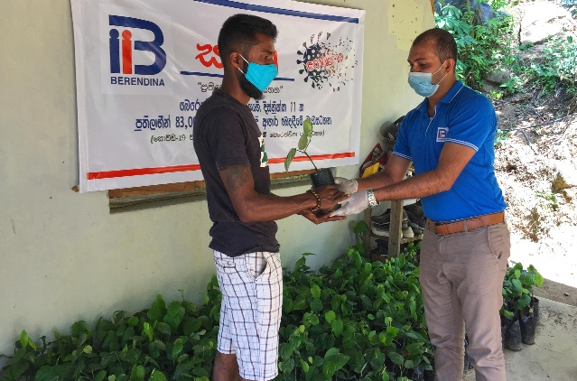 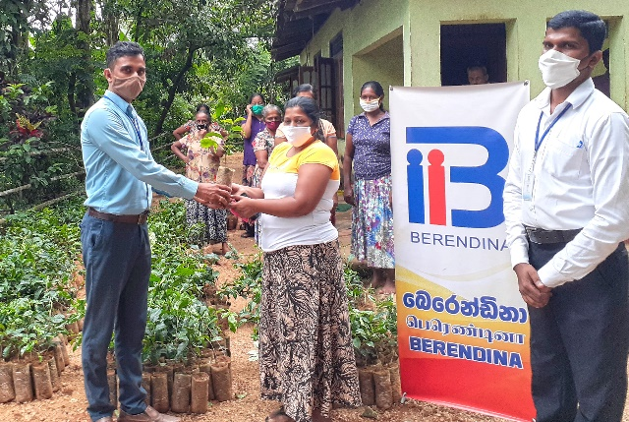

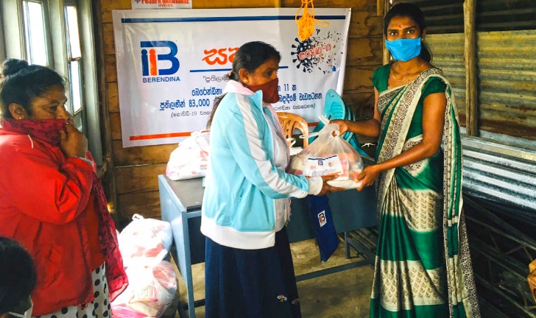 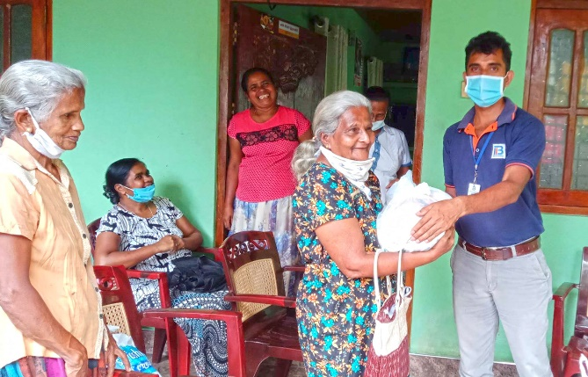

1. **Provision of Dry food ration to EIP families**

Due to the COVID-19 situation, most of the EIPs have been deprived of assistance from their close relatives and neighbors while receiving limited government assistance. Hence, Berendina Development Services submitted a proposal to HSBC for a joint grant project to provide dry food rations for selected EIP families. This will be a provision for a period of 2 consecutive months. Total value of the project is 8.7 million Rupees. This project has been approved by HSBC and their contribution of 5.5 million Rupees **was received.**

Since June 2020 BDS and BEC officers have been engaging in identifying such needy families and distributing dry food rations. So far Berendina has identified 4390 EIPs and distributed the ration packs for the first round.

