**TVEC Facilitation workshop_ Batticaloa and Trincomalee**

Berendina Employment center conducted TVEC Think Tank at Eastern province with the partnership of YouLead project and TVEC.

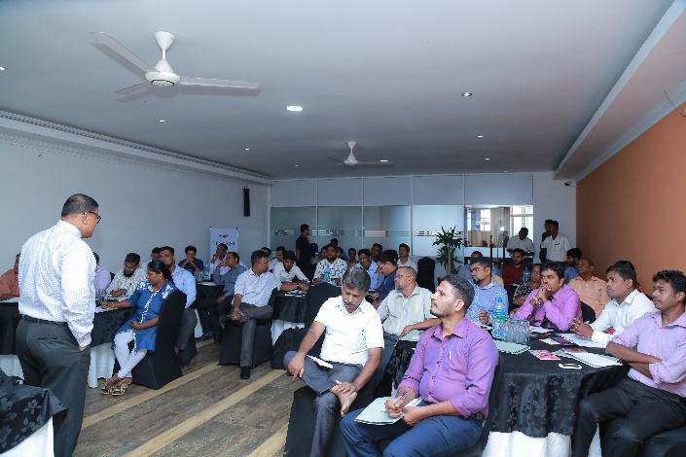Berendina Employment Centre (Guarantee) Ltd is an organization committed towards uplifting the lives of marginalized youth. Since the year 2000, Berendina Employment Centre has linked over 18,861 youth with employment opportunities and provided over 10,343 Professional & Vocational Training Scholarships. The success rate of youth obtaining employment within a year of training after completing the training is also 65%. When carrying out these interventions, Berendina Employment Centre partners with a number of Vocational Training Providers.

TVEC consultation workshop intention is to create awareness among the private training providers about the center registration procedure and process, institutions registration criteria, required standard and renewal process of TVEC and importance of course accreditation with soft skills inclusion with course module for increase the employability. This consultation workshop provides a better understanding about the TVEC expectation and facilitate the training providers to provide quality of services or trainings. And also provides the better understanding about skills gap and demand to be considered. As a result, BEC and YouLead conducted the TVEC Think Tank as pilot program with the support of TVEC at eastern province.

Representative from Private training institutions, who have newly applied for TVEC registration participated this TVEC Think Tank workshop from eastern province. Representatives of TVEC facilitated to this workshop and create awareness among the institutions in terms of registration criteria, skill demand and course accreditation procedure. And also discussed about the soft skills inclusion with course module.

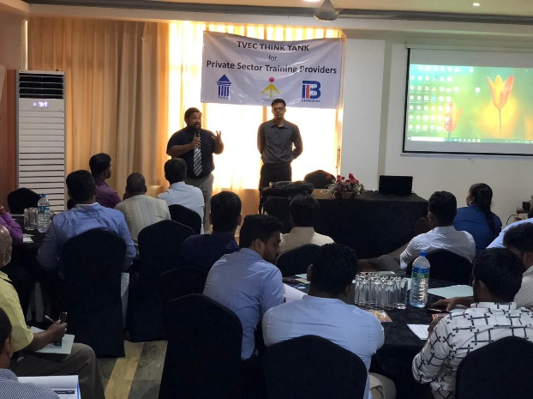However, it has been identified that Private Vocational Training Centers in the Eastern Province often do not follow guidelines and procedures set out by the Tertiary and Vocational Education Commission (TVEC) administered by the government, and continues to provide training courses without proper course accreditations. They are further not aware of the Center Registration process either. This is mainly due to their lack of knowledge on the processes. Subsequently, the students do not receive the best services/ training for the courses they follow, which are further not recognized.

Therefore, in order to create awareness among private training providers on how to follow the Center Registration process, understand the registration criteria, its renewal process and the required standard, 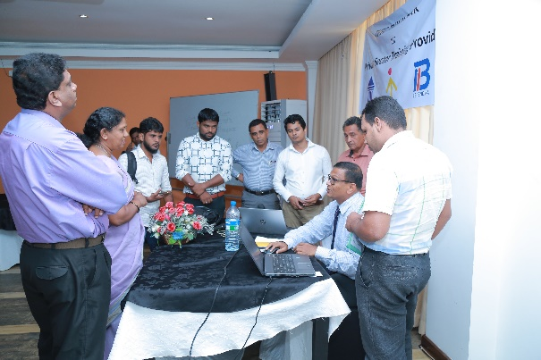a TVEC consultation workshop was conducted on the 23rd of October 2018 at East lagoon Hotel in Batticaloa. The consultation workshop was facilitated by Mr. T. Senthuran, Deputy Director of TVEC. There were participants from 33 Private Vocational Training providers from Trincomalee, Batticaloa and Ampara Districts who have newly applied for the TVEC registration.

Berendina Employment Centre partnered with the YouLead Project to facilitate this consultation workshop. YouLead is a U.S Agency for International Development (USAID) funded 4-year project that aims to establish a skilled workforce and link youth with more productive careers. YouLead improves Technical and Vocational Education and Training, and undertakes activities to support and strengthen students, teachers, institutions and entrepreneurs.

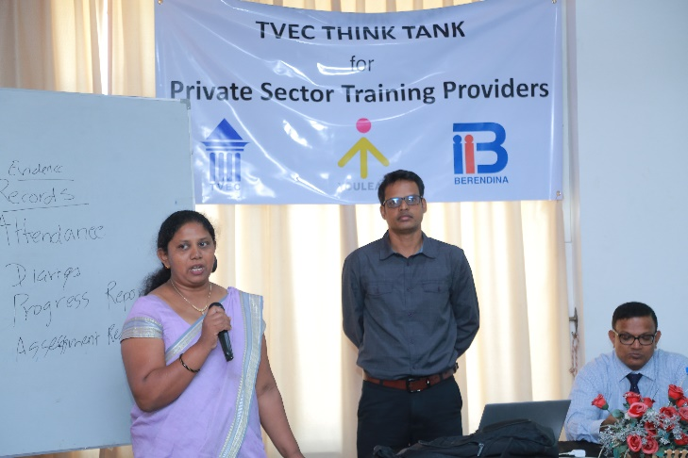The consultation workshop also provided awareness on the importance of course accreditation and the inclusion of soft skills in course modules to increase employability of participants/ students. It also provided a better understanding about expectations of TVEC to the new training providers in order for them to provide quality services/ trainings. They were also made aware about the skills gap and demand in the country, which needs to be considered when offering suitable courses in the Eastern Province that are industry driven. Following the sessions, an open discussion and feedback was also conducted to clarify the participants doubts.

Feedback from the participants also were very positive regarding this consultation workshop and appreciated