**Training on Career Counseling for Government officers**

20  
18

**13th  November, 2018 @ Kulakkodan hall**

**Trincomalee**

**Sathurukondan, Batticaloa**

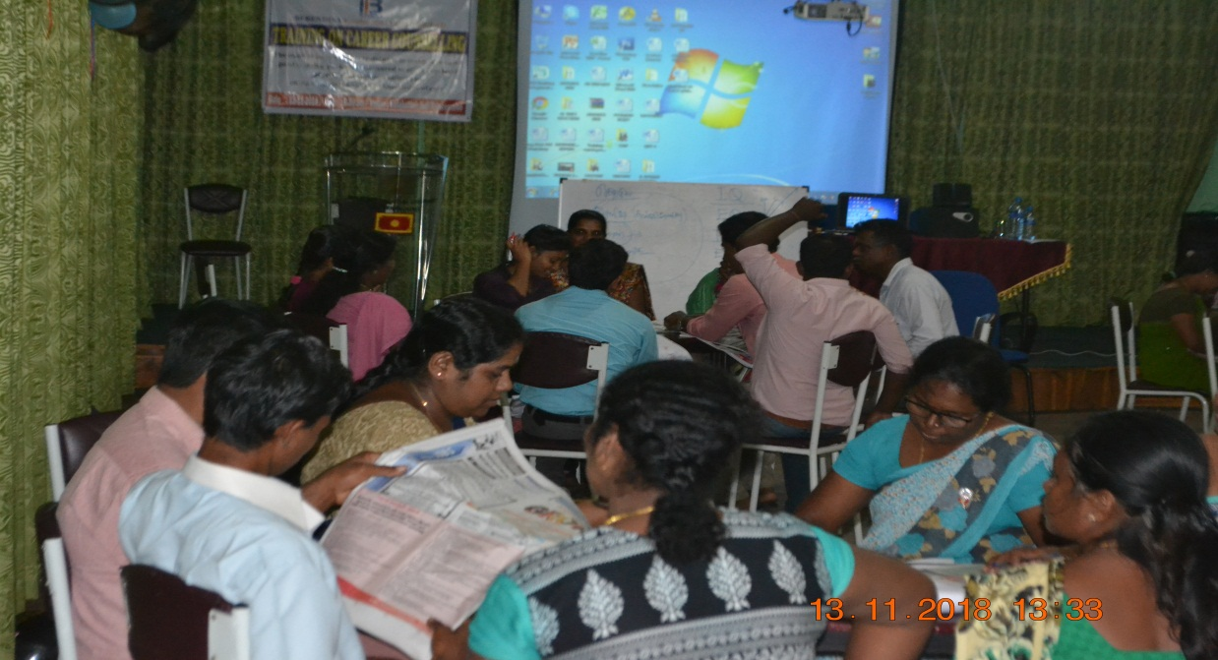

**REPORT Written by: A.Jeyanathan**

Berendina Employment Center (BEC) commenced its activities in the year 2000 with the overall objective of uplifting the lives of marginalized youth. Since inception, BEC has linked over 18,861 youth with employment opportunities and provided over 10,343 professional/ vocational training scholarships with a success rate of 65% of youth obtaining employment/ self-employment within a year of training.

**Introduction**

BEC’s programs for skill development and youth employment have been constantly evolving over the decades responding to the changing environment in which BEC is working and the lessons that BEC learned from its work and the work of others. The strategic planning session reinforced to think and review of BEC’s works in the past, contextual demand, challenges and with the best prediction of the next four years on the Skill development and Employment sector in the country. Through this new Strategic Plan BEC is ensuring its commitment to be relevant to the country’s priority and contribute for the sustainable development.

In order to complete the particular deliverable, BEC seeks qualified resource person in order to provide a one day-training on career counseling for grass root level government staff from the respective divisional secretariat divisions for facilitate the youth at village level.

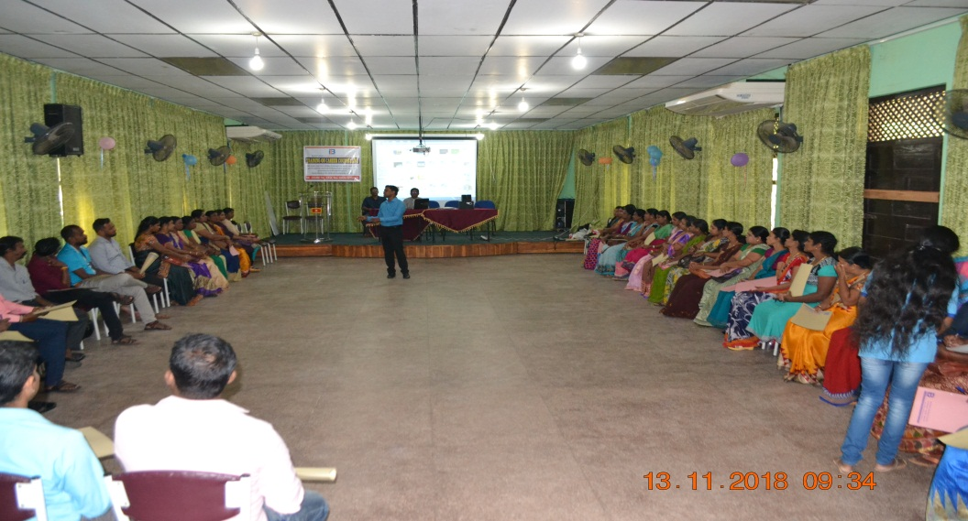

**Participants:** Development officers **50** from (male 18 female 32)

Divisional Secretariat office Town and Gravat Trincomalee

**Objective**

**Objective of the training**

To train and capacitate government officers to achieve the following,

* GND level Government officers enhanced their capacity to conduct career counseling to youth at village level as independently
* Government officers well understood and gained knowledge and sensitized on the career guidance and counseling
* Government officers gained the knowledge and skills to guide the youth
* Government officers ready to change, motivate, guide unemployed youth towards the current job market

**At the end of the training, participants have:**

**•** The understanding the concept of the career guidance and counselling and importance

* Ensure the implementation of career guidance process among the grass root level youths
* Ensure the sustainability of the community and specially youths

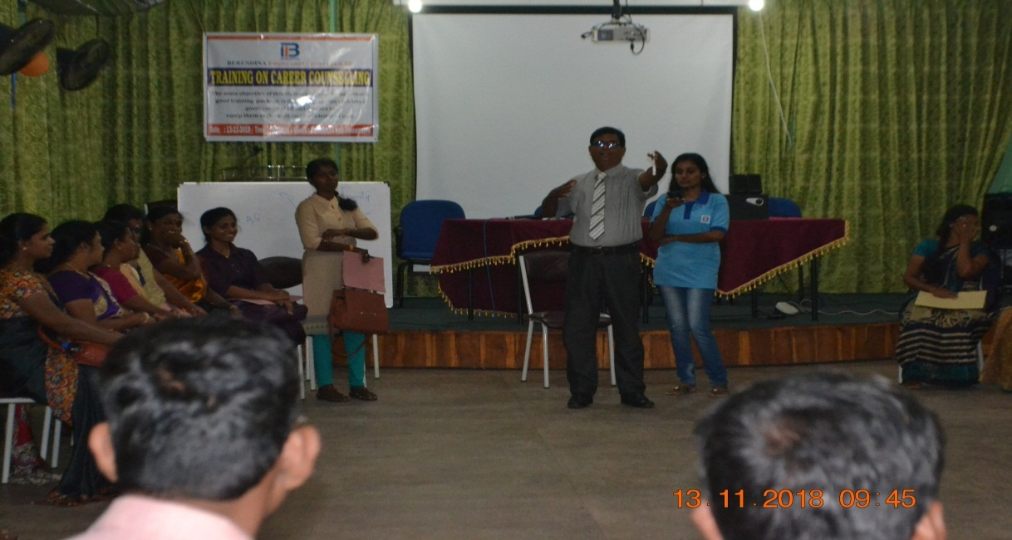

**Description of Training Sessions**

|  |  |  |
| --- | --- | --- |
| **Specific objectives** | **Contents and Sub Contents** | **Activity** |
| Get to know each other’s about / to get brief idea about the training | Brief introduction of the workshop / Self-introduction | * Explained purpose of this Training * Self-introduction with participatory method. |
| To have clear understanding on career guidance and counseling | What is career guidance?  What is career counseling?  Guidance and counseling are Different | * Presentation * Discussion * Role play * Common group evaluation |
| To have clear understanding on  Career planning steps and psychometric test | Interest  Career key (psychometric test)  Values  Personality  hard skills and soft skills | * Presentation * Individual work (test) * Discussion * Group work |
| To have clear understanding on NVQ level certificate courses | What is NVQ level Courses  How to select course and institutions | * Presentation * Discussion |
| To have clear understanding on career research and choosing a career | How to research a career  Choosing a career | * Presentation * Discussion * Group work |
| Evaluation of workshop | * Question and answer | * Concluded the Training |

**Actual Training: D**ay was begun with the welcome speech by Mr.Chanrakumar project manager of the Berendina Employment Center (BEC) Trincomalee district He introduced first the Berendina Employment Center (BEC) its vision, mission, core values, workshop objectives and Trainer to the participants, following that self-introduction was done in a participatory method. Trainer started the session based on the session plan. Then the training went on for one day with the above topics through the role play, group works, presentations, video clips and posters. It was held recapturing the day by the participants on beginning of the day.

**Questionnaire & Analysis**

**Energizers activities also applied depend on the energy level of the participants**.

**Pre and Post Test analysis:**

**One day workshop to empower government officers to engage in career counseling for rural level youths**

**Pretest/Post Test**

**Read the following statements and indicate ( / ) if correct and ( X ) if incorrect**

**Questions:**

1. State employment is more in srilanka
2. Educational qualification and professional qualification are different
3. While offering career counseling ,skills development of the youth to be considered
4. It is not necessary to be specific while setting the goal
5. NVQ 5 level is equal to diploma
6. There are 6 levels in NVQ certificate courses.
7. Career interest of a person can be ascertained thorough test
8. Training in empathy is not required for a person engaged in career counseling
9. Hard skills alone are sufficient for a person to remain in a career
10. Law of attraction is a maxim that helps to attain one’s goal with ease

|  |  |  |  |  |  |  |  |  |  |  |
| --- | --- | --- | --- | --- | --- | --- | --- | --- | --- | --- |
| **Questions:** | 1 | 2 | 3 | 4 | 5 | 6 | 7 | 8 | 9 | 10 |
| **Correct pre- test** | 15 | 38 | 34 | 18 | 24 | 25 | 25 | 20 | 27 | 30 |
| **Correct post- test** | 50 | 50 | 49 | 50 | 49 | 50 | 50 | 49 | 48 | 49 |
| **change** | 35 | 12 | 15 | 32 | 25 | 25 | 25 | 29 | 21 | 19 |

**Comments & Feedback**

**Comments on over all Sessions:**

*(By individual interaction with participants)*

|  |  |
| --- | --- |
| Selection | Qnty |
| Excellent | **47** |
| http://upload.wikimedia.org/wikipedia/commons/thumb/8/85/Smiley.svg/800px-Smiley.svg.pngVery good | **03** |
| Good | **--** |
| Bad | **--** |

**Feedback from Participants:**

* The contribution of the participants was greater. Mostly, they were energetic and motivated. Most of the concepts of different subjects were vastly accepted and received valid comments
* The participants were able to realize their current challenges on the society and they have got very good knowledge to overcome and they have got ready to full fill their gaps through the session interventions.
* Most of the participants have interested to participate in this training program and requested to have follow-up trainings to them in the future.
* Participants agreed to engaged on career counseling in terms of youth based activities in village level

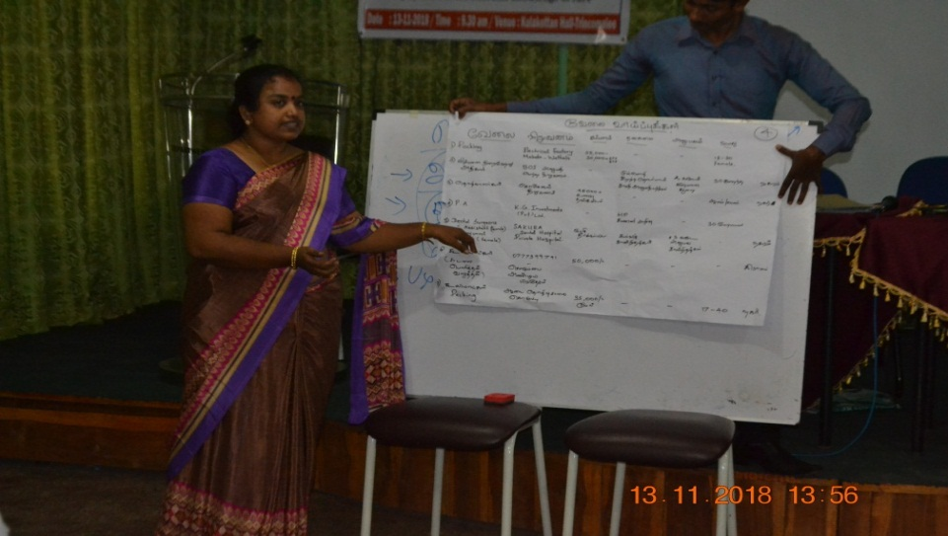**Thank you**