**OUTPUT**

**1 SEARCH BAR**

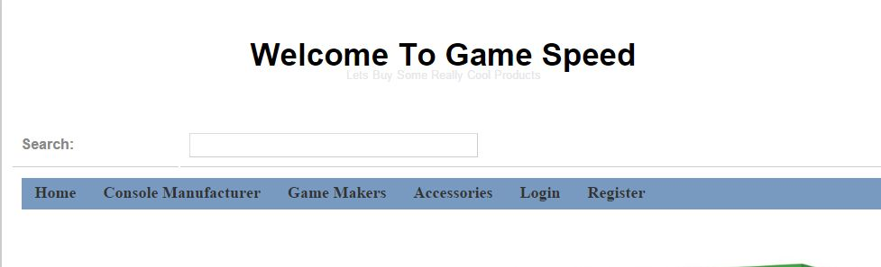

2 When you type “p” then all products having “p” will come in dropdown

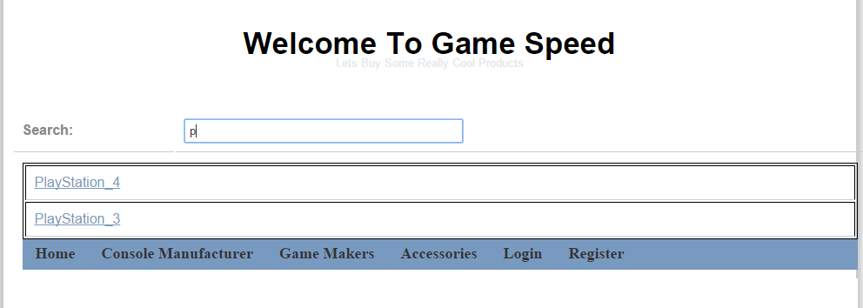

3 Whenyou type “xbox” then all products having “xbox” will be displayed

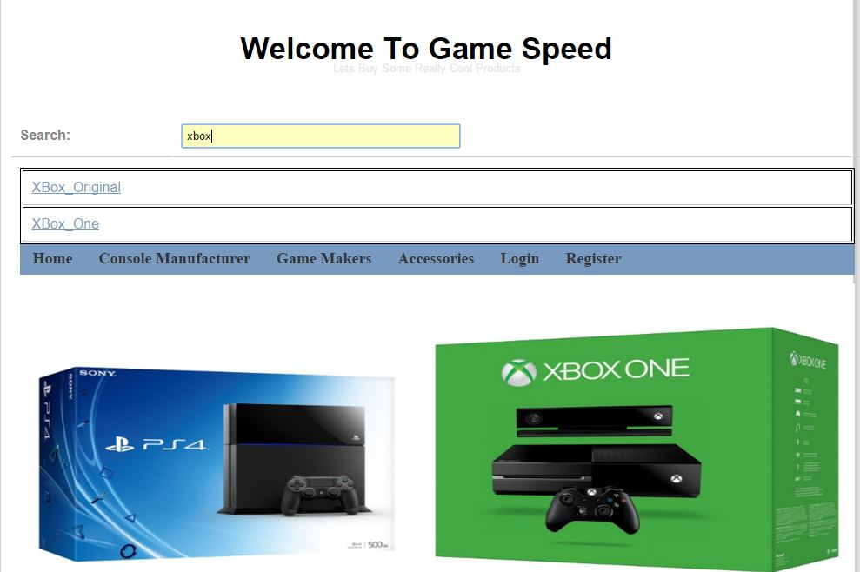

4 When you type **w** then all the products with “w” in it will be displayed

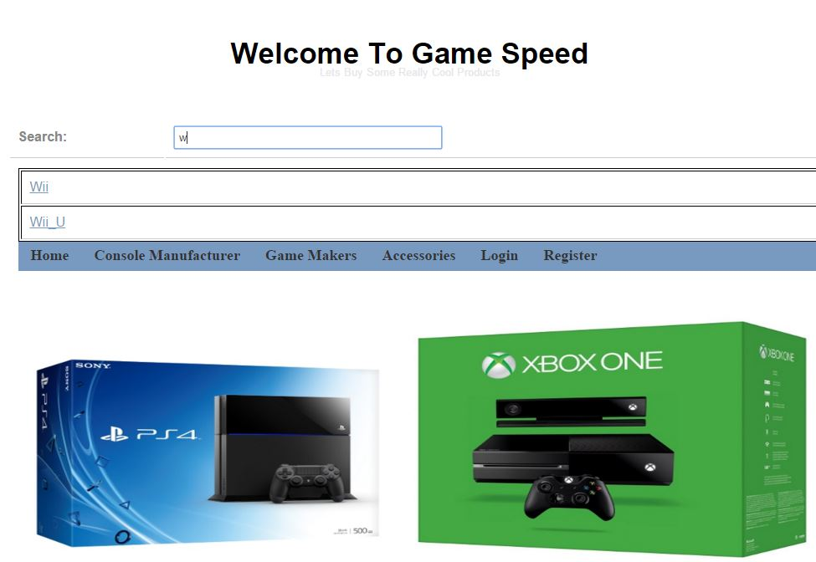

5 When you type **“headphone”** then all the products with “headphone” in it will be displayed

