# **Supermarkets in Baltimore Neighborhoods**

**Description:**

Supermarkets are a necessity and a basic feature a person considers when buying a house. He/ She would want a store nearby. In this project, we will display the available options of supermarkets in the given neighborhood, its ratings, address. This is beneficial for real estate markets, as when advertising a house they can mention that a particular house of interest is in vicinity to a supermarket. Further, we will cluster them based on their ratings. The higher the rating, the more popular the store is.

**Data Set Used:**

The dataset used to solve the above problem is Neighborhoods dataset from <https://data.imap.maryland.gov/datasets/fc5d183b20a145009eae8f8b171eeb0d_0>. This dataset contains the neighborhoods information for Baltimore city and the size of the neighborhood in acres. The data can be downloaded in the form of a CSV file, a shapefile.

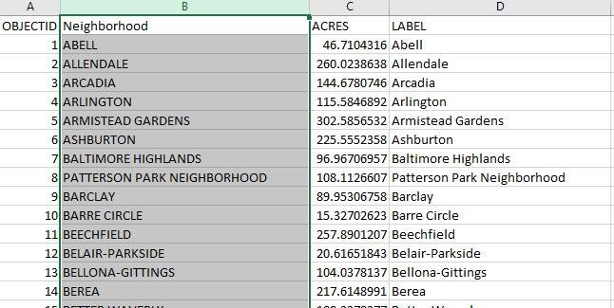

The CSV file contains neighborhoods name which will be used to extract latitude and longitude information using Geopy package in Python.

The file has 4 attributes : OBJECTID, Neighborhood, ACRES, LABEL.

OBJECTID : GIS id

Neighborhood : various neighborhoods name in Baltimore City

ACRES : size of the entire neighborhood

LABEL : a general name for the neighborhood

Once the shapefile is ready, a search API will be used for Supermarket as the category on Foursquare.com. This will return all the supermarkets in a given neighborhood in Baltimore city.

Further, the result returned for supermarkets will be used to cluster them based on their ratings.