PROJECT 1 · DELIVERABLE 3 OF 13
JLR Profile and Incident Timeline
Who JLR is, what happened between August and November 2025, and what it cost
At a glance
- JLR was profitable and cash-positive before the attack: £29.0bn revenue, an 8.5% EBIT margin and £278m net cash in the year to March 2025 [20].
- Production stopped for about five weeks, and it took until mid-November to return to normal levels: roughly eleven weeks from the attack to full output (my arithmetic) [27][19].
- JLR booked £260m of exceptional cyber costs, but the damage was far larger: full-year revenue fell 21%, profit before tax and exceptional items fell from £2.5bn to £14m, and £278m of net cash became £2.6bn of net debt [26]. Tariffs and the Jaguar wind-down also contributed, so not all of that is the attack.

Who JLR is
Jaguar Land Rover (JLR) is a British premium car maker owned by Tata Motors [2]. It sells four brands: Range Rover, Defender, Discovery and Jaguar [21]. It runs four UK manufacturing sites and one in Slovakia, and runs further operations in Austria, India and, through a joint venture, China [21].
Measure | Detail | Source
Revenue, year to March 2025 | £29.0bn, flat on the year before | [20]
Profit before tax | £2.5bn before exceptional items, up 15% | [20]
EBIT margin | 8.5% | [20]
Balance sheet | Net cash £278m; gross debt £4.4bn; liquidity £6.3bn including a £1.7bn undrawn credit line | [20]
Volumes | 400,898 wholesale and 428,854 retail units; Range Rover, Range Rover Sport and Defender made 67.8% of volume | [22]
UK and Slovakia sites | Solihull (Range Rover, Range Rover Sport), Halewood (Evoque, Discovery Sport), Castle Bromwich (body panels), Wolverhampton (engines and batteries), Nitra in Slovakia | [21]
Strategy and investment | “Reimagine” strategy since 2021; £18bn investment planned over five years | [20][21]

The business was in good health when it was attacked. That matters for the analysis: the loss came from the event, not from an already weak business, although tariffs and the Jaguar model changeover also hit the same year [2][26].

What the profile suggests about exposure (my analysis)
- Concentrated volume. Two-thirds of volume comes from three models [22], so a stoppage hits the core of the business.
- A tightly linked supply chain. About 5,000 organisations felt the event [9], and JLR is often the largest client of its suppliers [17]. This is why the government and JLR both stepped in with finance [18][19].
- Separate plant functions, one network. Engines and batteries, stamping, body shops, paint and parts logistics sit at different sites [19], yet the whole group was stopped. The sources do not explain how the systems were connected, so this project does not assume it.

Incident timeline
Dates are from news reports and JLR’s own announcements. Where the sources differ, the Source Log (Deliverable 1) says which value is used.
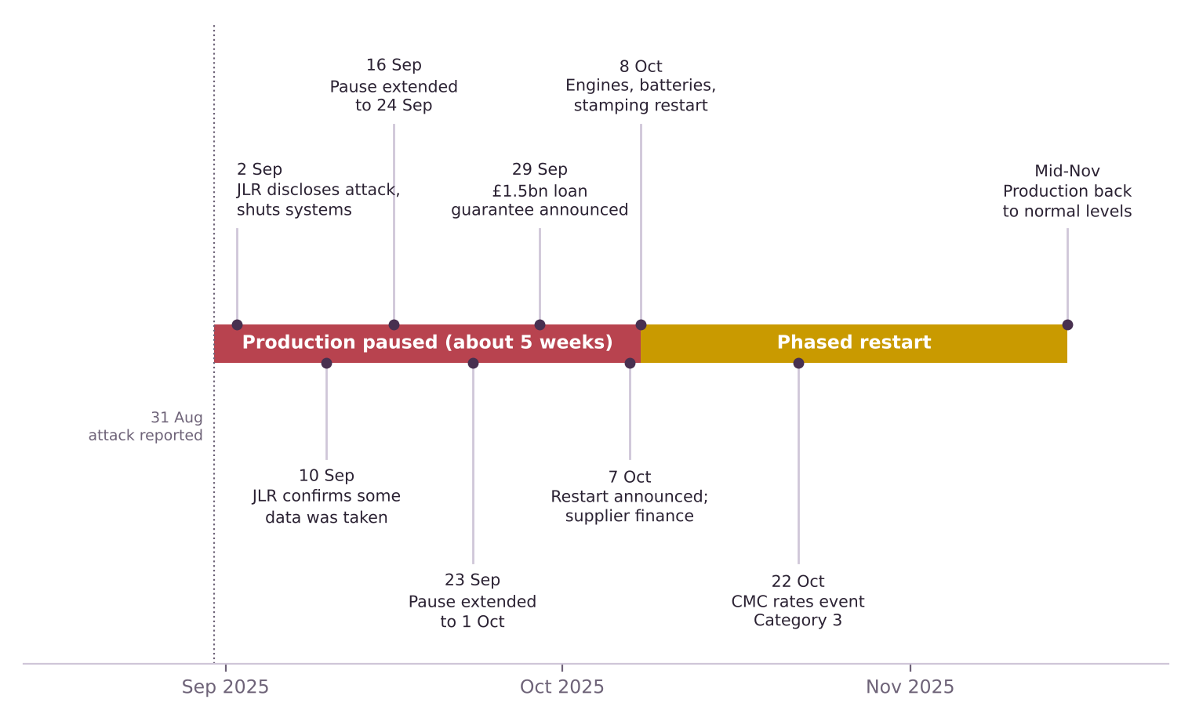
Figure 1. The incident from 31 August to mid-November 2025. Red is a full production pause; amber is the phased restart.
Date (2025) | Event | Source
31 Aug | Attack reported as discovered; JLR shuts its network | [1]
2 Sep | JLR discloses a significant cyber attack. It says there is no evidence any customer data has been stolen. The NCSC begins helping and the ICO says it is assessing the disclosure | [16][18]
Early Sep | Date not given: a group calling itself “Scattered Lapsus$ Hunters” claims responsibility and posts screenshots of internal systems on Telegram. The way in is unconfirmed | [16][17]
10 Sep | JLR revises its first statement and confirms that some company data was taken | [16]
16 Sep | Production pause extended to 24 September; JLR says it is considering a controlled, staged restart | [16]
23 Sep | Pause extended to at least 1 October. Plants at Solihull, Halewood and Wolverhampton remain closed | [15][17]
29 Sep | UK government announces a £1.5bn loan guarantee: a five-year commercial bank loan, guaranteed under UK Export Finance’s Export Development Guarantee. JLR signs the facility in October; it is still undrawn at 31 March 2026 | [1][18][26]
1 to 7 Oct | Pause continues past 1 October. The exact later extension dates were not found in sources read | [19]
7 Oct | JLR announces restart from the next day, plus a supplier financing facility of up to £500m | [19][27]
8 Oct | Phase 1 of restart: engines and batteries, stamping at Castle Bromwich, Halewood and Solihull, and Solihull body, paint and logistics. Nitra and the Solihull Range Rover lines follow that week; Halewood has no date yet | [19]
22 Oct | Cyber Monitoring Centre rates the event Category 3, about £1.9bn | [14][8]
Mid-Nov | Production back to normal levels | [27]

How the restart was sequenced
JLR’s own account says customer-facing systems came back first, so that deliveries and servicing were affected as little as possible, followed by wholesale systems and the Global Parts Logistics Centre [27]. On the factory floor, engines and batteries restarted first, then stamping and support areas, then final assembly sites [19]. The restart was staged by function, not switched on all at once. Deliverable 4 uses this to break the recovery into stages.

What it cost
Measure | Figure | Source
Exceptional cyber costs, full year | £260m (of which £196m booked by September). Lost production and recurring security spend are not included; JLR treats them as underlying | [26][2]
Revenue | £22.9bn, down 20.9% on £29.0bn | [26]
Wholesale volumes (ex China JV) | 307,915 against 400,898 (down 23%, my arithmetic) | [26]
Adjusted EBIT | £0.2bn (0.7% margin) against £2.5bn (8.5%) | [26]
Profit before tax and exceptional items | £14m against £2.5bn | [26]
Profit after tax | Loss of £0.2bn against a profit of £1.8bn | [26]
Free cash flow | Minus £2.2bn against plus £1.5bn | [26]
Net cash or debt, 31 March | Net debt of £2.6bn against net cash of £278m: a swing of about £2.9bn (my arithmetic) | [26]
Liquidity, 31 March 2026 | £6.9bn, including a £1.7bn undrawn credit line and the undrawn £1.5bn UKEF facility | [26]
Quarter to September | Revenue £4.9bn, down 24%; loss before tax excluding exceptional items £485m; margin guidance cut to 0% to 2% | [2][7]

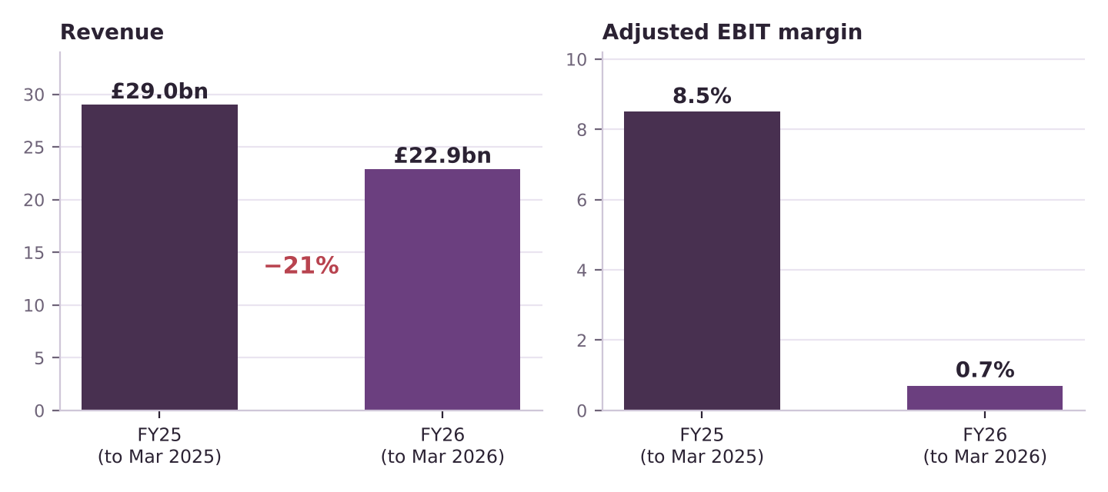
Figure 2. JLR full-year revenue and adjusted EBIT margin, before and after the attack. Sources [26] and [20].

Reading the numbers with care
- The booked cost is a small part of the damage. £260m is the exceptional cyber cost [26]. But revenue fell by £6.1bn (my arithmetic: £29.0bn to £22.9bn) and profit before tax and exceptional items fell by about £2.5bn, from £2.5bn to £14m [26]. JLR states that lost production is not in the £260m [26].
- Not all of the fall is the attack. JLR names the cyber incident, US tariffs and the planned Jaguar wind-down as causes and does not split them [26][27]. The Jaguar brand alone sold 55% fewer cars (21,597 against 48,445) [26]. The project will not claim the whole decline as cyber loss.
- Cash matters as much as profit. Free cash flow swung by £3.7bn and net cash of £278m became net debt of £2.6bn [26][20]. Cash and deposits fell by about £1.9bn and debt rose by about £1.0bn (my arithmetic from [26][20]).
- Quarterly numbers still rest on summaries. The figures for the quarter to September [2][7] come from news and summary pages, not JLR’s release. Full-year figures are from JLR’s own report [26].

Who else was affected
Group | What the sources say | Source
Suppliers | About 5,000 organisations felt the event, most in the West Midlands. JLR told government some suppliers would need support | [9][15]
Supply-chain jobs | Reported as about 120,000 or about 200,000, depending on the source | [1][15][17]
JLR’s supplier finance | A facility of up to £500m let qualifying suppliers receive up to 90% of an order’s value in advance, with JLR covering the cost. At 31 March 2026 only £37m had been advanced; JLR says it was not used extensively and is being wound down because the restart was fast | [19][27]
Government | £1.5bn UKEF-backed facility, a five-year commercial bank loan most of which the government guarantees. Signed in October 2025 and undrawn at 31 March 2026 | [18][26]
Unions and workers | Unions asked for a government-backed furlough scheme | [15][16]
Regulators | The NCSC supported the response and the ICO assessed the data disclosure | [16]

What the timeline tells us

Findings (my analysis)
- Recovery was long and in stages. About five weeks at a full stop, then a phased restart to normal levels by mid-November [27][19]. The roughly eleven weeks from attack to full output is a better measure of the disruption than the five-week pause alone.
- The restart date kept moving. At least two extensions (16 and 23 September) and a further one past 1 October were needed before the 8 October restart [16][17][19]. Uncertainty about the restart date, not just the length of the stoppage, adds to supplier and cash strain.
- Finance was arranged quickly but mostly not drawn. The government-backed facility came four weeks in [1] and the supplier facility at the restart [19], yet both were barely or not used by March 2026 [26][27]. JLR funded the shortfall from its own cash and bank debt. The backstops still mattered for confidence, but the cash strain fell on JLR’s own balance sheet.
- Recovery speed links to every cost line. Every week saved would have reduced lost output and cash drain. This is the observation Deliverable 4 tests with a loss tree and a recovery-stage breakdown.

Questions for Deliverable 4
- How much of the revenue loss came from the five-week stop, and how much from the slower restart?
- Which stages of the restart were limited by IT systems, and which by parts, suppliers or quality checks?
- What would a two-week shorter stop have been worth?

Limitations
- The sources do not explain how the attack worked or how JLR’s systems were connected. This project makes no claims about either, or about who is to blame.
- Some dates are approximate. The date of the hackers’ claim and of the later extensions are not given precisely in the sources read.
- Quarter-level figures are from summaries. Full-year figures come from JLR’s annual report [26]. JLR does not split lost revenue by cause, so any split in this project is an estimate.

Key terms in plain English
Term | What it means
Exceptional items | One-off costs a company reports separately from its normal results. Here: £196m cyber response and £42m voluntary redundancy.
EBIT margin | Operating profit before interest and tax as a share of revenue. A measure of how profitable the core business is.
Export Development Guarantee | A UK Export Finance scheme under which the government guarantees most of a commercial bank loan to a UK exporter.
Wholesale and retail volumes | Wholesale is cars shipped to dealers; retail is cars sold to customers.
Phased restart | Bringing production back in stages, by plant or function, instead of all at once.

Sources
Numbers in square brackets match this list and the Source Log (Deliverable 1).
Ref | Source (select the title to open it)
[1] | UK government bails out Jaguar Land Rover with £1.5B loan after hack disrupts vehicle production for weeks. TechCrunch via Yahoo Finance, Sep 2025.
[2] | JLR cyber-attack results in Tata loss. Tyre Press, Nov 2025.
[7] | JLR Reports Q2 FY26 Results: Cyber-attack effects, recovery, and the road ahead. Jaguar Enthusiasts’ Club (summary of JLR results), Nov 2025.
[8] | JLR Hack UK’s Costliest Ever, Hitting Economy with £1.9bn Loss. Infosecurity Magazine, Oct 2025.
[9] | JLR attack is the most expensive security breach in UK history. Computing, Oct 2025.
[14] | Cyber Monitoring Centre ranks JLR cyberattack as category three event. The Insurer, 22 Oct 2025.
[15] | JLR staff told to stay at home until October as car giant continues to battle cyber attack. ITV News, 23 Sep 2025.
[16] | Jaguar Land Rover production delay after cyberattack. Cybersecurity Dive, Sep 2025.
[17] | Jaguar Land Rover Extends Production Pause Again. Infosecurity Magazine, 23 Sep 2025.
[18] | Jaguar Land Rover resumes production following significant cyberattack. teiss, 10 Oct 2025.
[19] | JLR restarts manufacturing and introduces new financing solution to pay JLR suppliers early. Automotive World (JLR press release), 7 Oct 2025.
[20] | JLR delivers strong full year performance. Automotive World (JLR press release), May 2025.
[21] | Annual Report 2025. JLR, 2025.
[22] | Tata Motors’ JLR Reports 1.1% Rise in Q4 FY25 Dispatches, Retail Sales Dip 5.1%. Angel One, 8 Apr 2025.
[26] | JLR Annual Report 2025/26 (full report, 122 pages, read 21 Oct 2026). JLR, 21 May 2026.
[27] | JLR Annual Report 2025/26 (full report): incident, risk and governance sections. JLR, 21 May 2026.

