PROJECT 1 · DELIVERABLE 4 OF 13
Loss Tree and Recovery-Time Diagnostic
Where JLR’s loss came from, how much was the length of the stop, and what set the pace of the restart
At a glance
- Of a £6.1bn fall in revenue, up to about £3.5bn looks attack-related (about £1.9bn if the underlying decline had been worse than assumed). The rest is a decline already under way from US tariffs and the Jaguar model wind-down. These are my estimates from public figures.
- About three-quarters of the lost output came from the full stop and about a quarter from the slow restart (the tail ranges from roughly 15% to 40% depending on the baseline). Each week stopped was worth roughly £0.5bn of revenue.
- The hypothesis is partly supported. JLR’s own annual report names both the weeks of lost production and the time to normalise distribution as what hit its results [27]. A faster restart depended on more than IT: security checks, the order of the rebuild and shipping also set the pace. Option B has to be defined more broadly than “rebuild IT faster”.

The question and the method
The working hypothesis says JLR’s loss came mainly from how long production stopped, so cutting restart time could be worth more than trying to stop every attack. This deliverable tests that in four steps, using only public figures:
- Step 1: split the revenue shortfall quarter by quarter.
- Step 2: separate the part caused by the attack from a decline that was already under way.
- Step 3: split the attack-related loss between the full stop and the slower restart.
- Step 4: list what set the length of the restart, and test the hypothesis against the evidence.
Read this first
JLR’s annual report [26][27] gives the full-year totals but does not split its loss by cause, so the split here is my estimate from rounded public figures. Every derived number is marked “my arithmetic” and the steps are shown in the calculation table at the end. Treat results as orders of magnitude, not measurements.

Step 1: where the revenue went
JLR reports quarterly revenue. Three quarters are given directly or by simple subtraction, so I rebuilt all four quarters of each year (method in the calculation table).
Quarter | Prior year £bn | This year £bn | Shortfall £bn | Change
Q1 (Apr to Jun 2025) | 7.24 | 6.60 | 0.64 | −9%
Q2 (Jul to Sep 2025) | 6.45 | 4.90 | 1.55 | −24%
Q3 (Oct to Dec 2025) | 7.61 | 4.50 | 3.11 | −41%
Q4 (Jan to Mar 2026) | 7.70 | 6.90 | 0.80 | −10%
Full year | 29.0 | 22.9 | 6.1 | −21%
Sources: [2][26][7][20]; quarters derived by my arithmetic. Because the inputs are rounded, each derived quarter could be off by about £0.1bn to £0.2bn.

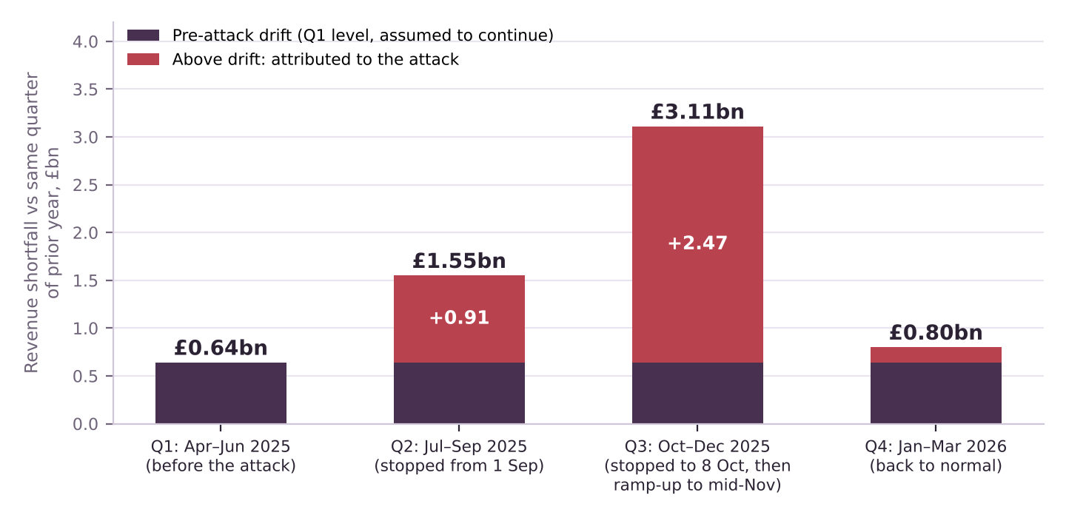
Figure 1. Revenue shortfall by quarter against the same quarter a year earlier. Dark purple is the level already seen before the attack; red is the excess.
The striking result is that the biggest shortfall came not in the quarter when production stopped (Q2) but in the next quarter (Q3), when the stop ended on 8 October and output climbed back to normal by mid-November [19][24]. Q3 revenue was £4.5bn, down 41%. JLR’s annual report says the same thing in words: “the weeks of lost production, and the time it then took to normalise global distribution, had a financial impact on quarters two and three” [27]. It also says the stoppages were partly offset by lower retailer inventory and a larger order book, which helped it recover in Q4 [26].

Step 2: separate the attack from the existing decline
Revenue was already falling before the attack. In Q1 (April to June 2025), before anything happened, revenue was £0.64bn, or 9%, below the year before. JLR names two causes in its volume statements: the planned wind-down of older Jaguar models, and US tariffs on exports [23][24]. It does not say how much each contributed [25][26][27]. The Jaguar brand’s retail sales fell 55% over the full year (21,597 against 48,445) [26].
To isolate the attack, I assume that decline, which I call drift, continued at the Q1 level of £0.64bn a quarter, and treat anything above it as attack-related. Because I cannot know the true drift, I test other levels:
Drift per quarter | Q2 excess £bn | Q3 excess £bn | Q4 excess £bn | Attack-related total £bn | Share in Q3
£0.64bn (Q1 level, flat) | 0.90 | 2.47 | 0.16 | 3.5 | 70%
£0.90bn | 0.65 | 2.21 | 0.00 | 2.9 | 77%
£1.15bn | 0.40 | 1.96 | 0.00 | 2.4 | 83%
£1.40bn (more than double) | 0.15 | 1.71 | 0.00 | 1.9 | 92%

What the sensitivity shows
- The attack-related shortfall is between about £1.9bn and £3.5bn. The flat-drift case is probably the upper end, because the Jaguar wind-down and tariffs likely deepened over the year.
- The drift probably grew. With Jaguar retail down 55% for the year [26], the wind-down was clearly material, so the higher-drift rows are as plausible as the flat one.
- In every case, Q3 holds most of it (70% to 92%). The conclusion that the recovery quarter lost more than the shutdown quarter does not depend on the drift assumption.
- This is not the same measure as the £1.9bn from the Cyber Monitoring Centre [8]. That figure is a cost to about 5,000 organisations, estimated by a different method. Mine is JLR revenue only. The numbers happen to overlap, but they are not comparable.

Step 3: the full stop versus the slow restart
Revenue mixes price, model mix and volume, so I repeat the test with cars shipped to dealers (wholesale volumes), which JLR reports precisely. The idea: how many weeks of normal output were lost in total, and how many of those weeks does the stop alone explain?
Measure | Units | Weeks of output lost | Source
Q1 FY26 wholesale (pre-attack run rate) | 87,235 | n/a | [23][24] derived
Q2 wholesale (stopped from 1 Sep) | 66,165 | 3.1 | [23]
Q3 wholesale (stopped to 8 Oct, ramp to mid-Nov) | 59,200 | 4.2 | [24]
Total shortfall against the Q1 run rate | 49,105 | 7.3 | my arithmetic
Full stop alone: 31 Aug to 8 Oct = 38 days | 36,428 | 5.4 | my arithmetic
Restart tail: the difference | 12,677 | 1.9 (26%) | my arithmetic

A week of normal output is 87,235 ÷ 13 = about 6,710 cars. Adding both quarters together avoids having to decide which quarter a late delivery belongs to.

Test the baseline
If the pre-attack run rate were… | Total weeks lost | Stop weeks | Tail weeks | Tail share
5% lower (82,900 a quarter) | 6.3 | 5.4 | 0.9 | 14%
Q1 level (87,200) | 7.3 | 5.4 | 1.9 | 26%
5% higher (91,600) | 8.2 | 5.4 | 2.8 | 34%
Q4 level (95,300) | 8.9 | 5.4 | 3.5 | 39%

The Q4 row uses fourth-quarter wholesale volume of 95,315 (my arithmetic: full-year 307,915 [26] minus 212,600 for the first three quarters [24]). Q4 was a rebound quarter helped by the order book, so it is an upper bound for normal output. In all four cases the stop explains the larger part, from about 60% to over 85%. The tail is real but smaller.

A cross-check on the tail
The three core models (Range Rover, Range Rover Sport and Defender) were the least affected by the Jaguar wind-down. Their wholesale volumes, rebuilt from the model shares JLR reports, fell about 13% year on year in Q2 and about 40% in Q3 (my arithmetic from [23][24]). The sharper fall in the quarter containing the restart is consistent with the damage continuing after the stop ended. It also reflects tariffs: North America wholesale fell 64.4% in Q3 [24].

The loss tree
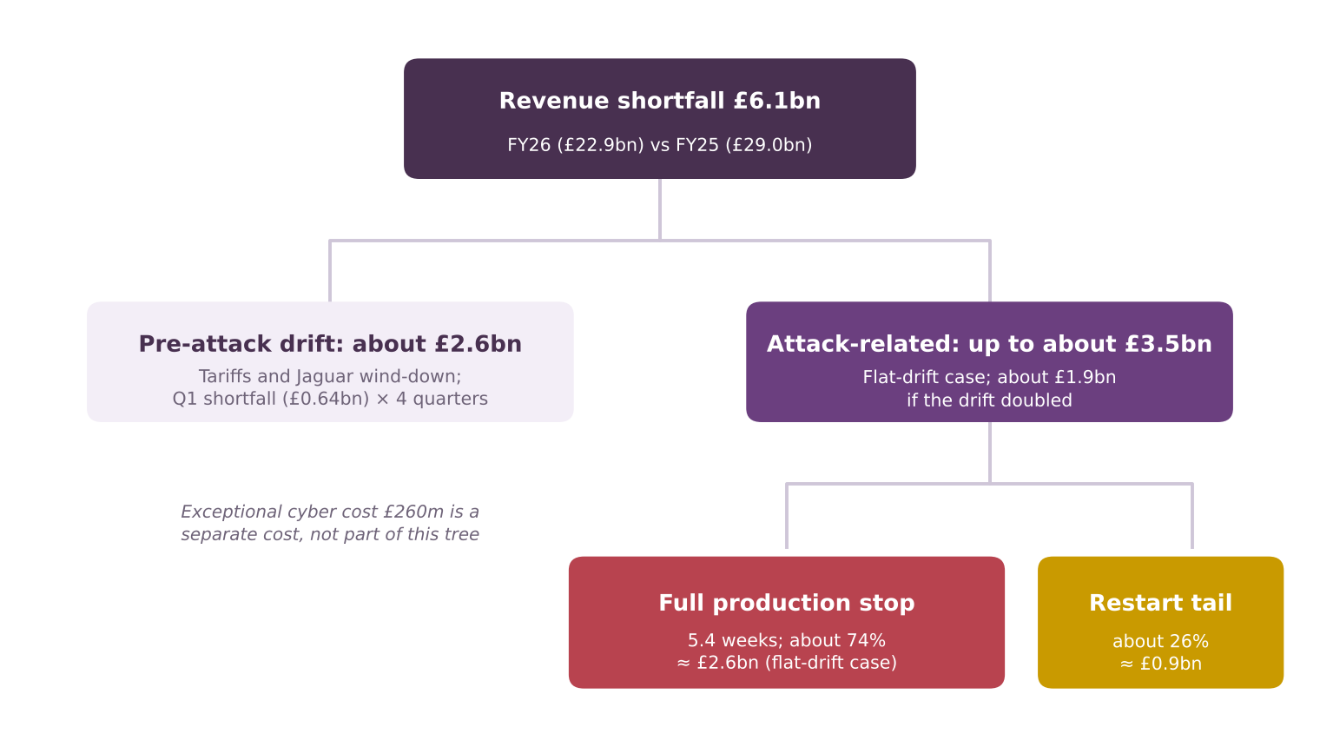
Figure 2. Loss tree for JLR’s FY26 revenue shortfall. The attack-related branch is shown for the flat-drift case; the split between stop and tail comes from the unit method.
Branch | £bn | Basis
Total revenue shortfall | 6.1 | £29.0bn to £22.9bn [26][20]
Pre-attack drift | about 2.6 | Q1 shortfall of £0.64bn × 4 quarters; tariffs and Jaguar wind-down [23][24]
Attack-related, flat-drift case | up to 3.5 | Excess over drift in Q2 to Q4; £1.9bn to £3.5bn across the sensitivity
of which the full stop | about 2.6 | 74% of attack-related loss; 5.4 weeks
of which the restart tail | about 0.9 | 26% of attack-related loss; 1.9 weeks-equivalent
Exceptional cyber cost | 0.26 | Separate cost, not revenue; about 7% of the attack-related revenue shortfall in the flat-drift case [26]

- One week of lost output was worth about £0.5bn of revenue, or about £73m a day (my arithmetic: Q1 revenue of £6.6bn ÷ 13 weeks). Two weeks off the stop would have saved roughly £1bn of revenue. Profit would be less than that, which Deliverable 6 will estimate.
- Profit swung hard. In the first quarter of the stop, loss before tax and exceptional items was £485m against a £398m profit a year earlier [25], a swing of £883m (my arithmetic). Over the full year, profit before tax and exceptional items fell from £2.5bn to £14m [26].

Step 4: what set the length of the restart?
If recovery time is to be shortened, it matters what held it up. JLR has not published a breakdown, but the sources show four factors in play:
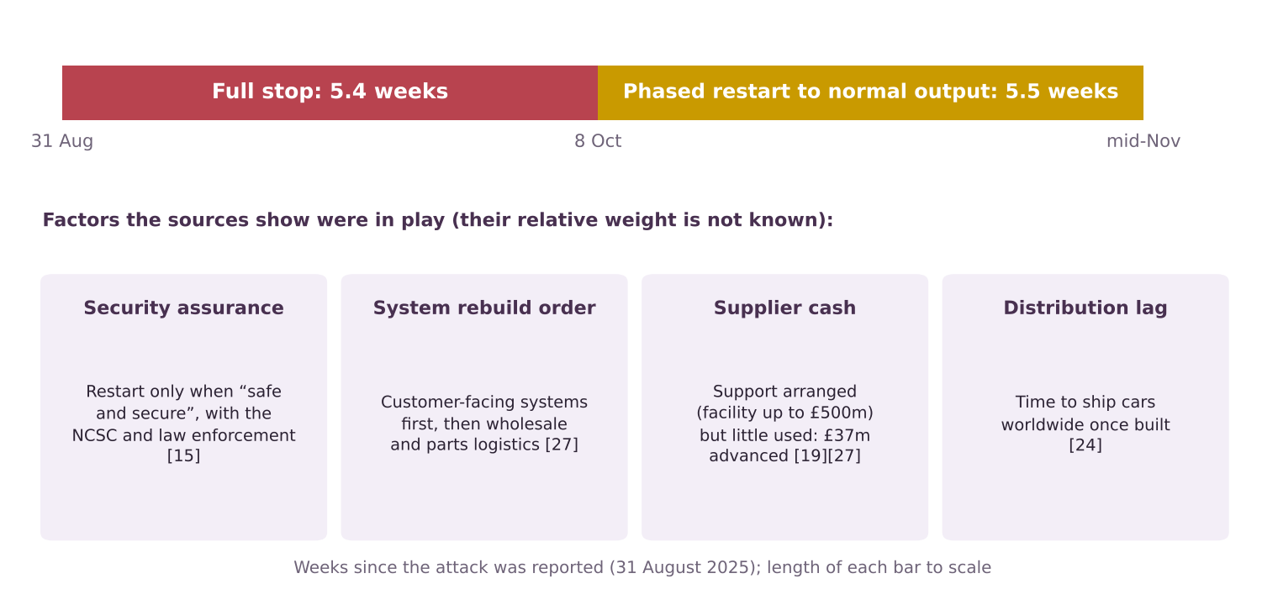
Figure 3. The five-week stop and the roughly five-week restart, with the factors the sources show were in play. Their relative weight is not public.
Factor | Evidence | What would help (my analysis) | Source
Security assurance | JLR said it would restart only “in a safe and secure manner”, working with cyber specialists, the NCSC and law enforcement | Pre-agreed restart assurance; ability to rebuild on clean systems quickly | [15]
System rebuild order | Customer-facing systems came back first, then wholesale and parts logistics. Factory restart was staged by function | Tiered recovery plan, so the most valuable functions return first | [27][19]
Supplier cash | JLR told government suppliers needed support and set up a help desk and manual invoicing. A facility of up to £500m was arranged, but only £37m was advanced and JLR says it was not used extensively; the £1.5bn government-backed facility was undrawn at year end | Supplier payment fall-back ready in advance. Evidence that cash was the binding constraint is weak | [15][19][27][26]
Distribution lag | JLR cites the time needed to distribute vehicles worldwide once built | Limited lever; mainly planning and stock | [24]
Stock buffer | Lower retailer inventory and a larger order book partly offset the loss, helping recovery in later periods | Not a recovery lever, but explains why Q2 hurt less than Q3 | [26]

What we cannot tell from public information
- Which factor held up the restart longest. Without that, the saving from a faster IT rebuild cannot be sized.
- How much of the five weeks was IT recovery and how much was waiting for security clearance.
- Whether suppliers or parts, rather than systems, were the bottleneck for specific plants.

Testing the hypothesis
Claim | Evidence | Verdict
Most of the loss came from how long production stopped | Attack-related revenue shortfall of £1.9bn to £3.5bn against a £260m exceptional cyber cost [26]. The full stop explains 61% to 86% of lost output (the 74% central case) | Supported (strong)
Cutting restart time is worth more than preventing every attack | One week is worth about £0.5bn of revenue, but the comparison needs attack probabilities and costs | Not yet testable; Deliverable 6
A faster restart was achievable | Four factors set the pace, each with an identifiable lever. Their weights are unknown | Open
Disproof test: restart time was set by something other than IT | Security assurance, rebuild order and shipping all played a part; supplier cash support was arranged but little used | Partly true: the hypothesis must widen

Verdict
The hypothesis is partly supported. Downtime was the main driver of loss, so recovery is the right place to look. But recovery is not only IT. Option B should cover assured restart, tiered rebuild and supplier payment continuity, not only “rebuild IT faster”.

What this means for the options (my analysis)
Option | Updated reading
A: Prevention-first | Still valuable, because a successful intrusion started the stop. But it cannot remove the event, and the loss it avoids depends on how likely attacks are, which no public data gives.
B: Recovery-first | Strengthened, with a wider definition: (1) tiered recovery with the most valuable functions first, (2) a clean rebuild and a pre-agreed assured restart, (3) manual or degraded modes including supplier payments, (4) rehearsal of all of it.
C: Risk transfer and ecosystem | Addresses the supplier cash strain and cost sharing, but does not shorten the stop. JLR reportedly had no cover [1] and its annual report mentions no insurance recovery [27], so the stop was funded mainly by JLR’s own cash and bank debt [26].

Inputs this gives Deliverable 6
- Base-case outage in the model: about 38 days of full stop plus about 13 days of restart tail (1.9 weeks), with ranges.
- Revenue per day at the pre-attack run rate: about £73m, to be converted to profit using an assumed margin and labelled illustrative.
- Exceptional cyber cost of £260m as the cost of recovery, treated separately from lost revenue.

Limitations
- Derived, not reported. Quarterly revenue and the stop-versus-tail split are my estimates from rounded numbers. JLR’s annual report does not split lost revenue by cause [26][27].
- The baseline is an assumption. Both the drift and the pre-attack run rate are my choices, and both are tested above.
- Wholesale is not production. Shipments can lag output, and stock buffers soften the first quarter. Adding two quarters reduces but does not remove the problem.
- Revenue is not profit. Lost revenue is not lost profit, because some costs fall when output stops and others do not. The model in Deliverable 6 addresses this.
- Q3 volumes are provisional [24], and the quarterly revenue inputs come partly from news summaries (see the Source Log). Full-year totals are from JLR’s annual report [26].

Calculation notes
Step | Formula | Result
Q2 and H1 prior-year revenue | Q2: 4.9 ÷ (1 − 0.24). H1: 11.5 ÷ (1 − 0.16) | £6.45bn; £13.7bn
Q1 revenue, both years | H1 minus Q2, each year | £6.60bn; £7.24bn
Q3 revenue, both years | Full year minus H1 minus Q4 | £4.5bn; £7.6bn
Q1 wholesale | 212,600 year to date − 66,165 − 59,200 | 87,235
Q4 wholesale | 307,915 full year − 212,600 | 95,315
Weeks of output lost | (87,235 − 66,165) + (87,235 − 59,200) = 49,105; ÷ 6,710 a week | 7.3 weeks
Full stop | 31 Aug to 8 Oct = 38 days ÷ 7 | 5.4 weeks
Tail | 7.3 − 5.4 = 1.9 weeks; 1.9 ÷ 7.3 | 26%
Revenue per week | Q1 FY26 revenue £6.6bn ÷ 13 | £0.51bn

Key terms in plain English
Term | What it means
Drift | The decline that was already under way before the attack, here from US tariffs and the Jaguar model wind-down.
Run rate | The normal pace of output or revenue, here taken from the quarter before the attack.
Loss tree | A diagram that breaks a total loss into its causes, branch by branch.
Wholesale volume | Cars shipped to dealers and importers, as opposed to cars sold to customers.
Counterfactual | An estimate of what would have happened without the event.

Sources
Numbers in square brackets match this list and the Source Log (Deliverable 1).
Ref | Source (select the title to open it)
[1] | UK government bails out Jaguar Land Rover with £1.5B loan after hack disrupts vehicle production for weeks. TechCrunch via Yahoo Finance, Sep 2025.
[2] | JLR cyber-attack results in Tata loss. Tyre Press, Nov 2025.
[7] | JLR Reports Q2 FY26 Results: Cyber-attack effects, recovery, and the road ahead. Jaguar Enthusiasts’ Club (summary of JLR results), Nov 2025.
[8] | JLR Hack UK’s Costliest Ever, Hitting Economy with £1.9bn Loss. Infosecurity Magazine, Oct 2025.
[15] | JLR staff told to stay at home until October as car giant continues to battle cyber attack. ITV News, 23 Sep 2025.
[18] | Jaguar Land Rover resumes production following significant cyberattack. teiss, 10 Oct 2025.
[19] | JLR restarts manufacturing and introduces new financing solution to pay JLR suppliers early. Automotive World (JLR press release), 7 Oct 2025.
[20] | JLR delivers strong full year performance. Automotive World (JLR press release), May 2025.
[23] | JLR volumes down in challenging quarter. Automotive World (JLR press release), Oct 2025.
[24] | JLR Q3 sales impacted by cyber incident as previously indicated. JLR, Jan 2026.
[25] | JLR cites cyberattack, US tariffs for 24% drop in Q2 revenue. Yahoo Finance, Nov 2025.
[26] | JLR Annual Report 2025/26 (full report, 122 pages, read 21 Oct 2026). JLR, 21 May 2026.
[27] | JLR Annual Report 2025/26 (full report): incident, risk and governance sections. JLR, 21 May 2026.

