PROJECT 1 · DELIVERABLE 5 OF 13
Options Analysis and Recommendation
Three ways to spend a resilience budget, and why a recovery-led blend scores best
At a glance
- Recommendation: a recovery-led programme (Option D). It puts recovery first, adds prevention only on the paths into the most valuable functions, and adds an insurance backstop sized to what is left. It scores 3.65 out of 5, ahead of recovery-first alone (3.45), risk transfer (3.10) and prevention-first (2.65).
- The lead is real but narrow. The blend ranks first under five of six weight sets I tried. It is only 0.20 ahead of recovery-first, and a one-point change in one of its scores would hand the lead to recovery-first. So the recommendation is built on recovery-first as the core, with the extras earning their place in Deliverable 6.
- Risk transfer alone would not have helped JLR. JLR had no cyber policy in force and recovered none of its £260m exceptional cost from an insurer [28]; insurance pays money after the event but does not restart a plant. Norsk Hydro’s first cyber payout covered about 6% of its losses [29].
- What would change the answer: a board that puts more than about 38% of its weight on three-year cost, or evidence that a prepared restart could save less than about one week. Both are tested in Deliverable 6.

The decision and the method
Deliverable 4 found that most of JLR’s attack-related loss came from how long production stopped, not from the intrusion itself. That points to a choice: where should a limited resilience budget go? This deliverable compares four options and picks one.
- Step 1: define three options plus a blend, and say what JLR’s own evidence suggests about each.
- Step 2: score each option against six criteria, with the evidence for every score written down.
- Step 3: weight the criteria, calculate a total, and then test the result with five other sets of weights and one-point changes to individual scores.
- Step 4: check what each option would need to repay its cost, review what the main stakeholders would do, and state what would prove the recommendation wrong.
Read this first
The scores and weights are my judgement, not measurements, and public information cannot show JLR’s actual defences or costs. Scores for expected loss and cost are provisional until Deliverable 6 puts numbers on them. The point of this deliverable is to show how the ranking behaves when the judgement changes, not to claim one exact answer.

The options
Options A to C are deliberately pure, so each can be judged on its own. Option D is the blend that the evidence suggests.
Option | What it means | What the public evidence says
A: Prevention-first | Spend mainly on stopping intrusions: stronger access controls, separation of plant and office systems, supplier access, monitoring. | The NCSC handled 204 nationally significant incidents in the year to August 2025, up from 89 [10]. JLR’s annual report says cyber risk “remains elevated” even after third-party experts were engaged to strengthen controls [27]. Prevention lowers the odds; it cannot remove them.
B: Recovery-first | Assume a breach will happen. Build a tiered recovery plan, a clean rebuild and pre-agreed assured restart, manual or degraded modes (including supplier payments and parts logistics), and rehearse them. | JLR restarted in phases, customer-facing systems first, then wholesale and parts logistics, with about five weeks at a stop and about five more to reach normal output [27]. Maersk reinstalled over 4,000 servers and 45,000 PCs in 10 days [30]; Norsk Hydro ran many sites manually [29].
C: Risk transfer and ecosystem | Buy cyber insurance, arrange supplier financing in advance, and rely on lenders and government as a backstop. | JLR had no policy in force and recovered none of the £260m from an insurer [28]. The £1.5bn government-backed facility was signed but undrawn at year end [26][18], and the £500m supplier facility was little used [27].
D: Recovery-led blend | Option B as the core; the A controls that protect the most valuable functions; and an insurance backstop sized to the loss that remains after B. | Follows from Deliverable 4: the main loss driver is duration, but a successful intrusion started the stop and money was still needed to ride it out.

Criteria and weights
Criterion | Weight | Why it matters
1. Reduction in expected loss | 30% | The purpose of the spend. Judged against Deliverable 4: attack-related revenue loss of about £1.9bn to £3.5bn, plus £260m of exceptional cost.
2. Three-year cost (5 = cheapest) | 20% | JLR’s free cash flow was negative £2.2bn in FY26 and net debt was £2.6bn [26], so cost counts. Heavier weights are tested below.
3. Resilience beyond cyber | 15% | A plan that also works for a fire, a supplier failure or a system failure is worth more than one that only answers a cyber attack.
4. Speed to reduce risk | 15% | Attackers are not waiting for a programme to finish. Faster protection counts for more.
5. Confidence of suppliers, government, investors | 10% | JLR depended on a £1.5bn government-backed loan and on suppliers staying solvent [18][8].
6. Low programme disruption (5 = least) | 10% | Rehearsals and access changes take time on live plants.

Scoring and the evidence behind each score
Scores run from 1 (weak) to 5 (strong). Each cell shows the score, then the reason. Where the reason is a public fact, the source is given.
Criterion | A: Prevention | B: Recovery | C: Risk transfer | D: Blend
1. Expected loss | 3 Lowers the odds but cannot remove them [10][27] | 4 Targets the duration that drove about 74% of attack-related lost output (Deliverable 4) | 2 Pays after the event, capped; M&S could claim up to £100m against a £300m hit [28]. Does not shorten the stop | 5 Lowers odds and duration, and funds the tail
2. Cost (5 = cheapest) | 2 Broad programme across IT, plants and suppliers | 3 Focused on critical functions; rehearsals add running cost | 4 Premiums are the main cost; price after a large loss is unknown | 2 B plus targeted prevention plus premiums
3. Beyond cyber | 2 Mostly cyber-specific | 5 A tested restart plan helps for any outage | 2 Covers named perils only | 4 Mostly B, plus some cyber-only spend
4. Speed | 3 Quick wins in months, wide overhaul slower | 2 Design, build and rehearsal across sites takes longest | 4 Cover can be placed in months, though JLR’s own purchase was unfinished when it was attacked [28] | 3 Quick wins and insurance first, rebuild capability after
5. Confidence | 3 Valued, but invisible to suppliers | 4 Assured restart and supplier payment continuity answer suppliers’ main exposure [19][27] | 3 Reassures lenders more than suppliers | 5 Visible restart plan plus lender-facing cover
6. Low disruption | 3 Access changes touch staff and suppliers | 2 Drills on live plants take time | 5 Little operational change | 2 As B, plus prevention changes

Result
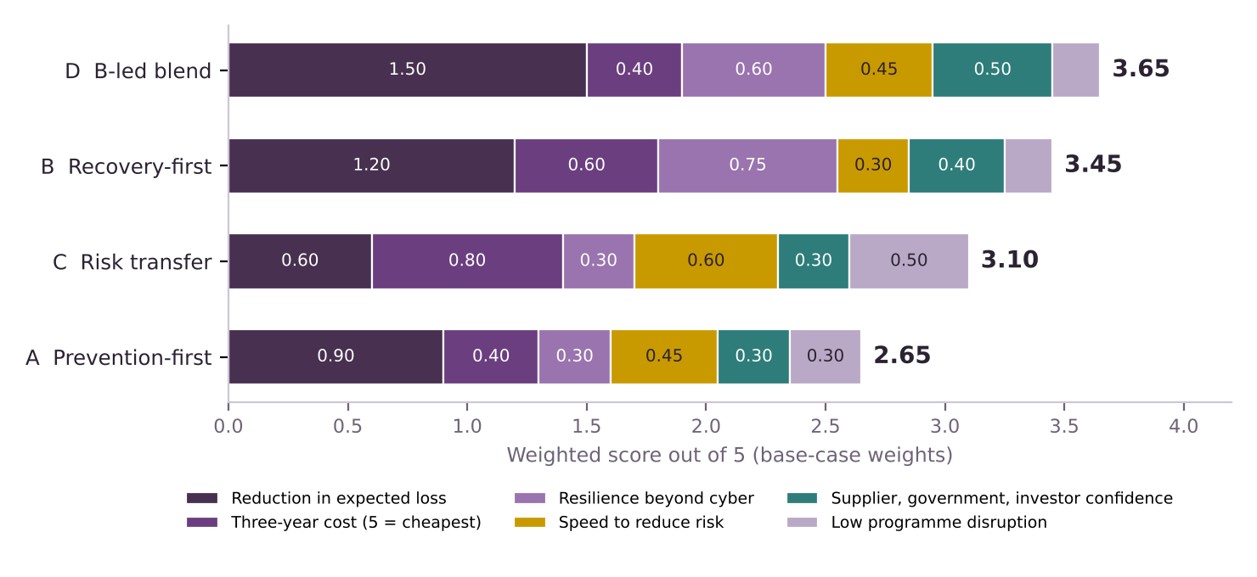
Figure 1. Weighted scores at the base-case weights (30, 20, 15, 15, 10, 10). Each segment is a criterion’s contribution to the total.
- Option D leads at 3.65. Its edge comes mainly from criterion 1: it scores 5 on expected loss, which at a 30% weight is worth 1.50 points.
- Option B follows at 3.45. It beats the blend on cost and is stronger beyond cyber, but scores lower on loss reduction and confidence.
- Option C scores 3.10. It wins on cost, speed and low disruption but is weak where the money was lost, in the length of the stop.
- Option A scores 2.65. Prevention alone is slow, broad and does not reduce what happens after a breach.

How robust is the result?
A ranking that flips when a weight moves slightly is not a finding. I tested it two ways: other weight sets, and one-point changes to individual scores.
Weight set | Weights (criteria 1 to 6) | A | B | C | D | Ranking
Base case | 30/20/15/15/10/10 | 2.65 | 3.45 | 3.10 | 3.65 | D, B, C, A
Equal weights | 17 each | 2.67 | 3.33 | 3.33 | 3.50 | D, then B = C, A
Loss-first | 40/10/10/15/15/10 | 2.80 | 3.50 | 2.95 | 4.00 | D, B, C, A
Cash-constrained | 25/35/10/15/5/10 | 2.55 | 3.25 | 3.35 | 3.25 | C, then B = D, A
Confidence-led | 25/15/15/10/25/10 | 2.70 | 3.60 | 3.05 | 3.90 | D, B, C, A
Speed-led | 25/15/10/30/10/10 | 2.75 | 3.15 | 3.30 | 3.55 | D, C, B, A

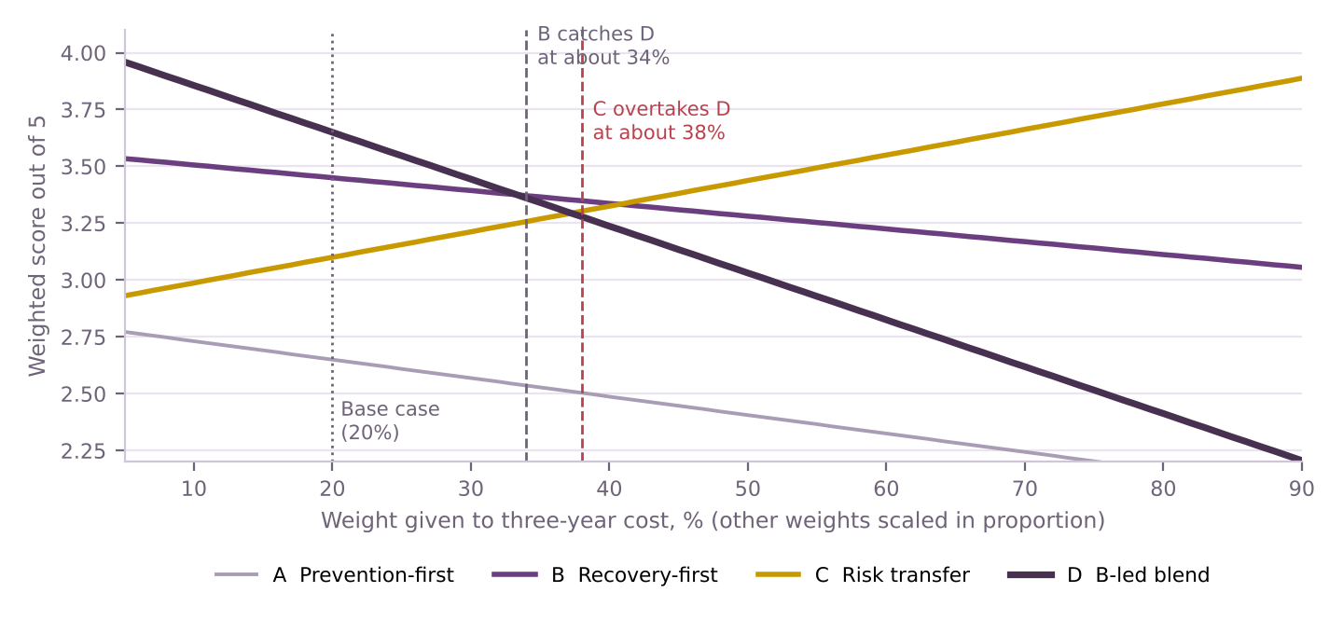
Figure 2. Weighted score as the weight on three-year cost changes (other weights scaled in proportion). Base case is 20%.

What the tests show
- D ranks first under five of six weight sets. Risk transfer (C) wins only under the cash-constrained set, where cost carries 35%, and then by 0.10 with B and D tied.
- The cost weight is the pivot. B catches D when cost is weighted above about 34%; C overtakes D above about 38% and B above about 41%. The base case is 20%, so the result holds unless the board is clearly cost-led.
- The speed weight matters less. C overtakes D only if speed carries more than about 46%, three times the base weight.
- The narrow lead over B is the main weakness. I tried every one-point change to every score. Four stop D coming out clearly on top: lowering D’s expected-loss score from 5 to 4, or raising B’s from 4 to 5, makes B first; lowering D’s cost score from 2 to 1, or raising B’s from 3 to 4, makes them tie. This is why the recommendation keeps B as the core.
- A is never competitive. It stays last under every weight set, so I do not recommend a prevention-led programme.

What other breaches suggest
Case | What happened | What it implies for the options
Maersk, 2017 (NotPetya) | Reinstalled over 4,000 servers, 45,000 PCs and 2,500 applications in 10 days; the chairman said this would normally take at least six months. Cost reported at $250m to $300m [30]. | A fast rebuild is possible when the work is organised. Whether JLR’s estate could match it is unknown. Supports B.
Norsk Hydro, 2019 (ransomware) | Plants were isolated and many sites ran on manual procedures. The first cyber insurance payout was about $3.6m, roughly 6% of losses at that point [29]. | Manual and degraded modes kept production going; insurance covered only a small part. Supports B and limits C.
JLR, 2025 | Five weeks stopped, then a phased restart [27]. No cyber policy; none of the £260m recovered from an insurer [28]. Supplier facility little used [27]. | The cost fell on JLR’s own balance sheet and on government-guaranteed borrowing. Shows what C alone would have left to be funded.

Three cases are an illustration, not a statistical sample. They fit the pattern in Deliverable 4 but do not prove it.

What would an option need to repay its cost?
Deliverable 6 will build the full model. This is a simple version to see how much recovery time a programme must save. One week of output is worth about £0.51bn of revenue (Deliverable 4). I assume, for illustration only, that 20% of lost revenue is lost profit, which is about £102m a week. The table shows the chance of a JLR-scale attack within three years at which the programme just pays for itself.
Illustrative three-year cost | If it saves 1 week | If it saves 2 weeks | If it saves 3 weeks
£50m | 49% | 25% | 16%
£100m | 98% | 49% | 33%
£200m | Above 100% | 98% | 66%
Table: break-even probability = programme cost ÷ (weeks saved × £102m). My arithmetic on assumed inputs; the margin and costs are illustrative, not JLR figures.
- A programme that saves only one week is hard to justify on profit alone. At £100m it needs an almost certain attack.
- Saving two or three weeks changes the picture. At £50m to £100m, break-even falls to 16% to 49%.
- The table leaves out the wider benefits. It does not count the £260m of exceptional cost, the strain on suppliers (the CMC estimates about 5,000 organisations were affected [8][9]) or the reliance on government support. All of these argue for a bigger saving.

Stakeholders
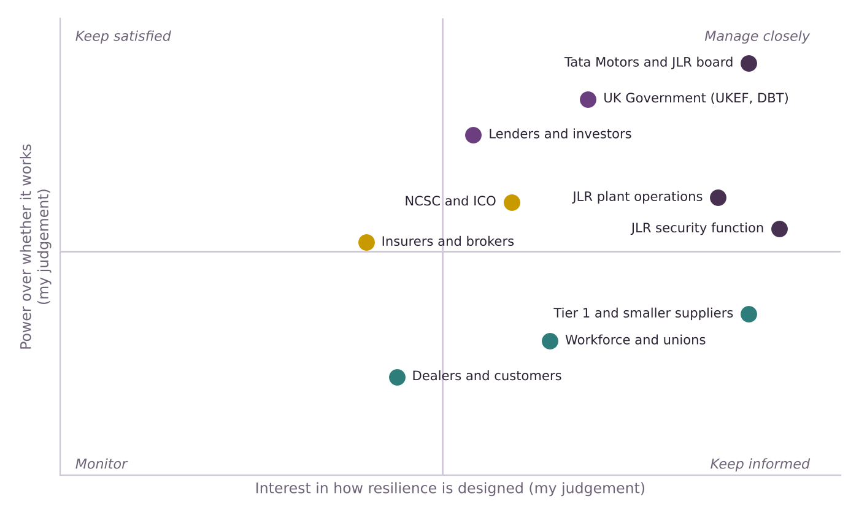
Figure 3. Stakeholder map. Positions are my judgement from public evidence, not measured.
Stakeholder | What they want and what the evidence shows | Effect on the choice
Tata Motors and JLR board | Protect cash and the investment plan. The annual report says information security is board-governed and the incident was an audit matter [27]. | Owns the decision. Sets the cost weight, which is the pivot in the sensitivity test.
UK Government | Keep the supply chain intact. It backed a £1.5bn loan [18]. The CMC’s technical committee chair called the bailout “an unfortunate precedent” [28]. | Cannot be relied on as a standing backstop, which weakens the case for C.
Lenders and investors | Liquidity and covenant headroom: a £1bn minimum quarter-end liquidity covenant sits behind the £1.5bn facility [26]. | Favour cover and visible control. Support the insurance layer in D.
Suppliers | Payment continuity. JLR set up supplier financing and a manual invoice system [19], though little of the facility was used [27]. | Their cash is a restart constraint. Supports payment continuity inside B.
Plant operations and security | Operations bear drills and manual modes; security owns controls. Both are central to B and A. | Delivery risk: B’s rehearsals need plant time. Needs agreement on timing.
NCSC, ICO and Parliament | NCSC and ICO were assisting and assessing during the incident [16]. The proposed Bill would require notification within 24 hours and a full report within 72 hours [12]. | Raises the cost of a slow or disorderly response. Supports B.
Insurers and brokers | JLR’s cover was still being arranged when the attack came [28]. Pool Re has said the protection gap for losses of this size can reach 90% (paraphrased in [28]). | Determine whether the insurance layer in D is available and affordable. A key unknown for Deliverable 6.
Workforce and unions | Job security. MPs said the supply chain involves around 200,000 workers and unions called for a furlough scheme [15]. | Lower power over design, high stake in outcome. Keep informed.

Recommendation
Recommendation
Adopt Option D, built around Option B. Treat recovery as the main investment: restore the most valuable functions first, rebuild from a clean state to a pre-agreed restart plan, keep the business running in degraded mode, and rehearse. Add prevention only where it protects those functions, and buy insurance only for the loss that remains.

Layer | What it contains | Why it earns its place
1. Core: recovery (B) | Tiered recovery order; clean rebuild and assured restart plan agreed with regulators and key suppliers in advance; manual or degraded modes for shipping, parts logistics and supplier payments; scheduled rehearsal. | Deals with duration, the main loss driver, and works for non-cyber outages too.
2. Targeted prevention (A) | Controls on the routes into the tier-1 functions: privileged access, separation of plant and office systems, third-party access. My design assumption; public information cannot show which JLR controls are weak. | Lowers the odds of the event that starts the clock, at lower cost than a broad programme.
3. Insurance backstop (C) | Cover sized to the residual tail after layers 1 and 2, with the supplier-finance arrangement agreed in advance. | JLR had none and recovered nothing [28]; even good cover repays only part of a large loss [28][29].

Layers 2 and 3 are conditional. They go ahead only if Deliverable 6 shows they pay back, since the blend’s lead over B is narrow. If they do not, the answer reduces to Option B.

What would prove this wrong
If we found that… | Then…
The board weights three-year cost above about 38% | Risk transfer (C) scores higher. Recommend a smaller recovery core plus insurance.
A prepared restart saves under about one week | The break-even table says recovery is not worth it on profit alone. Re-examine A and C.
Insurers would not offer meaningful cover at a sensible price | Drop layer 3. The recommendation becomes Option B with targeted prevention.
Most of JLR’s delay came from suppliers or shipping, not systems | Move weight to supplier continuity and distribution inside B, and to the ecosystem part of C.
The chance of a JLR-scale event within three years is below the break-even in the table for the time saved | The programme does not repay itself on profit alone. Narrow the scope of B to the cheapest, highest-saving parts.

Inputs this gives Deliverable 6
- Programme cost ranges for A, B, C and D, each labelled illustrative.
- Weeks of outage saved by B and D: test 1, 2 and 3 weeks, and ranges around them.
- Probability of a JLR-scale event within three years: test a wide range.
- Margin on lost revenue: test 10% to 30% around the 20% used here.
- Insurance recovery: test 0%, about 6% (Hydro [29]) and about a third (M&S’s £100m cover against about £300m [28]).
- Exceptional cyber cost of £260m [26] as the cost of a response, and revenue per week of £0.51bn from Deliverable 4.

Limitations
- Scores and weights are judgements. I wrote down the reasons so you can disagree with them. The sensitivity tests show which disagreements would change the answer.
- Cost and loss scores are provisional. No public source gives programme costs or attack probabilities. Deliverable 6 replaces the scores with ranges.
- Public information cannot show JLR’s controls. Layer 2 is a design assumption, not a finding about JLR.
- Insurance evidence is thin. The JLR insurance facts come from one trade article [28], and the Hydro and Maersk cases are from 2018 and 2019 news reports [29][30]. They are illustrations. The M&S figures (£100m of cover, about £300m profit hit) are also from [28].
- Three breaches are not a sample. They are consistent with the argument but do not prove it.

Calculation notes
Item | Formula | Result
Option A | (3×30 + 2×20 + 2×15 + 3×15 + 3×10 + 3×10) ÷ 100 | 2.65
Option B | (4×30 + 3×20 + 5×15 + 2×15 + 4×10 + 2×10) ÷ 100 | 3.45
Option C | (2×30 + 4×20 + 2×15 + 4×15 + 3×10 + 5×10) ÷ 100 | 3.10
Option D | (5×30 + 2×20 + 4×15 + 3×15 + 5×10 + 2×10) ÷ 100 | 3.65
Profit per week | £0.508bn revenue per week × 20% assumed margin | £102m
Break-even probability | Cost ÷ (weeks saved × £102m); for example £100m ÷ (2 × £102m) | 49%
Weight sweep | One weight set to x%; other five scaled so all six sum to 100% | Figure 2

Key terms in plain English
Term | What it means
Weighted score | Each score multiplied by the importance of its criterion, then added up.
Sensitivity test | Changing an assumption to see whether the answer changes.
Risk transfer | Moving the financial cost of a loss to someone else, usually an insurer.
Degraded mode | Running the business at lower speed with manual steps while systems are down.
Assured restart | A restart order agreed in advance, so that systems come back in a safe, tested sequence.

Sources
Numbers in square brackets match this list and the Source Log (Deliverable 1).
Ref | Source (select the title to open it)
[8] | JLR Hack UK’s Costliest Ever, Hitting Economy with £1.9bn Loss. Infosecurity Magazine, Oct 2025.
[9] | JLR attack is the most expensive security breach in UK history. Computing, Oct 2025.
[10] | NCSC Annual Review 2025: Incident management. National Cyber Security Centre, Oct 2025.
[12] | Cyber Security and Resilience Bill: what will it do?. Penningtons Manches Cooper, 30 Jul 2025.
[15] | JLR staff told to stay at home until October as car giant continues to battle cyber attack. ITV News, 23 Sep 2025.
[16] | Jaguar Land Rover production delay after cyberattack. Cybersecurity Dive, Sep 2025.
[18] | Jaguar Land Rover resumes production following significant cyberattack. teiss, 10 Oct 2025.
[19] | JLR restarts manufacturing and introduces new financing solution to pay JLR suppliers early. Automotive World (JLR press release), 7 Oct 2025.
[26] | JLR Annual Report 2025/26 (full report, 122 pages, read 21 Oct 2026). JLR, 21 May 2026.
[27] | JLR Annual Report 2025/26 (full report): incident, risk and governance sections. JLR, 21 May 2026.
[28] | Did Jaguar Land Rover’s cyber insurance gap help pave the way to 4,000 job losses?. Insurance Business UK, 7 Sep 2026.
[29] | Norsk Hydro receives first cyber insurance payout of $3.6 million for breach-related losses. Computing, 29 Oct 2019.
[30] | Maersk reconstructed entire IT infrastructure in 10 days following NotPetya. Supply Chain Dive, 29 Jan 2018.

