PROJECT 1 · DELIVERABLE 6 OF 13
Financial Model and Explainer
What each option is worth over three years, and what would have to be true for recovery to pay back
At a glance
- At my placeholder assumptions, no option pays back on expected profit alone in the central case. Net expected benefit over three years is −£39m for recovery-first (B), −£22m for risk transfer (C), −£69m for the recovery-led blend (D) and −£100m for prevention-first (A). The loss each avoids is smaller than its cost.
- Recovery pays back under three conditions, and the last is the easiest to act on. The chance of a JLR-scale cyber event within three years would need to be about 34% rather than 15%; or the programme would need to save about four weeks of output rather than two; or it would need to cost about £41m rather than £80m.
- The extra layers in Option D do not pay back on expected profit. D is £30m worse than B in the central case and about level with it in the higher-risk case. Insurance is a choice about risk appetite: JLR’s liquidity (£6.9bn) is about seven times the central event loss (£1.0bn) [26].
- This refines the Deliverable 5 recommendation. Deliverable 5 said the answer reduces to Option B if the extra layers do not pay. The model says so, so I recommend a staged Option B, with each stage released only if the break-even rule below is met.

What the model does
The Excel workbook (Deliverable_06_Financial_Model.xlsx) asks one question: if the company spends £X on a programme, how much expected loss does it avoid over three years? It works in five steps.
- Step 1: estimate the loss if a JLR-scale cyber event happens: weeks of lost output × weekly revenue × margin on lost revenue, plus the exceptional cost.
- Step 2: for each option, change what the programme changes: the chance of the event, the weeks lost, or the part of the loss an insurer pays.
- Step 3: multiply the loss by the probability to get an expected loss over three years, and add an expected loss from a non-cyber outage that recovery capability would also reduce.
- Step 4: subtract the option’s three-year cost from the expected loss it avoids. That is the net expected benefit.
- Step 5: repeat for three scenarios (lower risk, central, higher risk), then test what moves the answer.
Read this first
Only some inputs are facts. The £260m exceptional cost [26], the 7.3 weeks of lost output (Deliverable 4), the £508m of weekly revenue and the insurance cases [28][29] come from public sources. Programme costs, event probabilities, weeks saved and margin are my placeholders, marked as such in the workbook. The value of the model is in showing what must be true, not in the central figure.
Sheet | What it holds
Inputs | Every assumption in its own cell, with its basis. Blue cells are inputs; yellow cells are the ones that matter most. Edit only these.
Model | The calculation, one block for each scenario. All formulas.
Summary | Net benefit, loss avoided, break-even probability and the loss if the event happens, with a chart.
Sensitivity | Five tables: probability against weeks saved, break-even probability, insurance recovery rate, cost multiplier and margin.
Checks, Sources | Six tests that the model reconciles (all pass) and the source of each fixed fact.

The inputs
Input | Lower risk | Central | Higher risk | Status
Chance of a JLR-scale cyber event in 3 years | 5% | 15% | 30% | Assumption. NCSC trend argues against very low values [10]
Chance of a non-cyber outage of similar length | 0% | 5% | 10% | Assumption
Margin on lost revenue | 15% | 20% | 25% | Assumption (Deliverable 4 note)
Weeks of output lost with no programme | 6.3 | 7.3 | 8.9 | Derived from [23][24][26] (Deliverable 4)
Weeks saved by recovery capability (B, D) | 1 | 2 | 3 | Assumption. Maersk rebuilt in 10 days [30]
Weekly revenue | £508m | £508m | £508m | Derived: £6.6bn ÷ 13 [7][25][26]
Exceptional cost per event | £260m | £260m | £260m | Fact [26]; none recovered from an insurer [28]
Insurance recovery rate | 33% | 33% | 33% | M&S: £100m cover against about £300m [28]; Hydro about 6% [29]

Option inputs (all assumptions) | A | B | C | D
Three-year cost | £150m | £80m | £45m | £135m
Cut in cyber event probability | 30% | 0% | 0% | 10%
Share of weeks-saved achieved | 25% | 100% | 0% | 100%
Insurance limit | none | none | £150m | £100m
Option D’s £135m is B (£80m) plus £25m of targeted prevention plus about £30m of insurance premium. These are placeholders for the board to replace.

Results
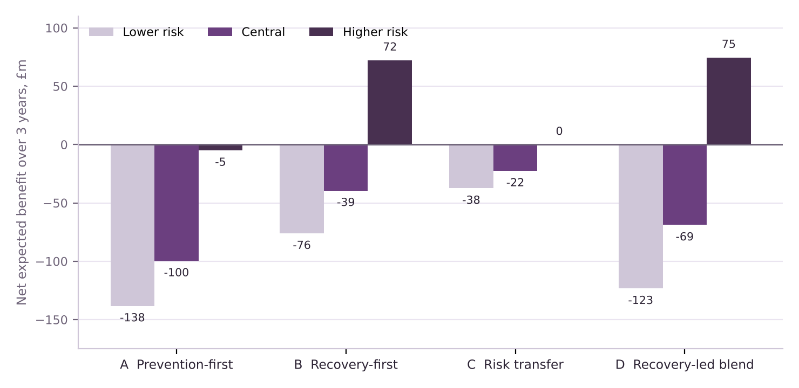
Figure 1. Net expected benefit over three years (loss avoided minus cost), by option and scenario. Illustrative assumptions. Option C is exactly break-even in the higher-risk case, a coincidence of the inputs.
Net expected benefit, £m | Lower risk | Central | Higher risk | Break-even chance of cyber event (central)
A: Prevention-first | −138 | −100 | −5 | 45%
B: Recovery-first | −76 | −39 | +72 | 34%
C: Risk transfer | −38 | −22 | 0 | 30%
D: Recovery-led blend | −123 | −69 | +75 | 33%

- In the central case nothing pays back on expected profit. B avoids about £41m of expected loss for an £80m programme.
- In the higher-risk case recovery pays back. B returns +£72m and D +£75m. Prevention-first (A) stays at about break-even even there.
- D beats B only in the higher-risk case, and then by about £2m. Its extra layers cost more than they return in the other two scenarios.
- C (insurance alone) is the cheapest way to lose money on expected value. Insurers price above expected payout, so cover is a purchase of safety, not of profit.

What would have to be true for recovery to pay back
The break-even view is more reliable than the central figure, because it does not depend on guessing which scenario is right. For option B at central inputs:
Change one input to… | Break-even value | Compared with central
Chance of a JLR-scale cyber event within 3 years | about 34% | 15% assumed; the Sensitivity sheet shows the full grid
Weeks of output saved | about 3.9 weeks | 2 weeks assumed. Deliverable 5 break-even table gave the same logic
Three-year programme cost | about £41m | £80m assumed. This equals the expected loss avoided

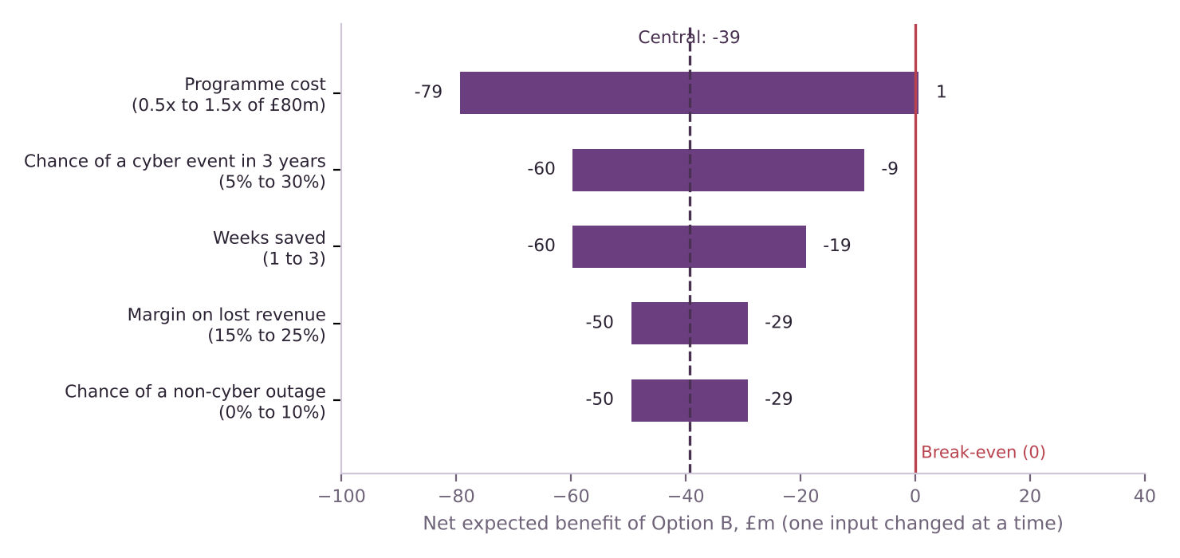
Figure 2. Net expected benefit of Option B at central inputs when one input is changed at a time. Only a lower cost brings it to break-even.

Reading the chart
- Cost is the lever the company controls. Halving the programme cost takes B to break-even with nothing else changed, while the other four inputs are things the company can only estimate.
- No single favourable change on probability, weeks saved, margin or non-cyber outages is enough by itself. They would need to combine.
- Every £10m of programme cost needs about half a week of saved output (£10m ÷ £101.5m a week ÷ the 20% combined chance), at central inputs.

Insurance and the size of a bad outcome
Expected value ignores how large a bad outcome is. The central event loss is £1.0bn: about 40% of FY25 profit before tax of £2.5bn [20], but only about 15% of the £6.9bn of liquidity at 31 March 2026 [26].
If the cyber event happens (central), £m | Do nothing | A | B | C | D
Net loss after insurance | 1,001 | 950 | 798 | 851 | 698
Reduction vs doing nothing | n/a | 51 | 203 | 150 | 303
As % of FY25 profit before tax | 40% | 38% | 32% | 34% | 28%

- Recovery cuts the loss more than prevention. B reduces the loss by about £203m if the event happens, against £51m for A, for a lower cost.
- Insurance buys a fixed cut for a fixed price. In D, a £100m limit costs about £30m, while the expected payout is about £14m (13.5% × £100m). The gap of about £17m is the price of that certainty.
- The limit, not the recovery rate, is what binds. At a 33% recovery rate the loss is large enough to hit the limit, so raising the rate to 50% adds nothing. At a 6% rate (Norsk Hydro [29]) C’s net benefit falls from −£22m to −£36m.
- Whether to buy depends on risk appetite. With liquidity about seven times the central loss and a £1.5bn government-backed facility undrawn at year end [26], cover is not what keeps JLR solvent. It could matter to lenders and to the stability of results.

Recommendation after the model
Refined recommendation
Fund Option B in stages, and release each stage only when the break-even rule is met. Hold targeted prevention and insurance as options, to be bought only if the board wants the smaller range of outcomes at a known cost.

Decision | Rule from the model
Release a stage of B | The weeks of output it is expected to save, × £101.5m a week × the combined chance of an outage (20% at central inputs), must be at least its cost. Recheck after each rehearsal.
Buy insurance (layer 3) | Not justified on expected value. Buy only if the board wants to cap the loss for a stated premium. Ask insurers for a quote, because no public price exists.
Add targeted prevention (layer 2) | Not justified at a £25m cost: a 10% cut in probability avoids about £12m at central inputs. Re-open if a specific weakness is found.
Stop or re-scope | If measured savings from rehearsals are under about one week, or costs rise above the expected loss avoided.
Deliverable 9 turns these rules into stage gates, and Deliverable 7 records the risk that the assumptions are wrong.

Limitations
- The largest inputs are assumptions. Programme costs, probability, weeks saved and margin have no public source. The model shows what is needed, not what is likely.
- One event, no timing. The model has a single JLR-scale event in three years, with no discounting and no growth, and ignores events smaller than a JLR-scale stop.
- Only JLR’s own losses count. Supplier losses (the CMC estimate of £1.9bn is for the UK economy and is media-only [8][9]), regulatory fines and brand damage are left out. All would raise the value of avoiding an event.
- Expected value hides risk appetite. A programme can be worth buying even at a negative expected value if the board wants to reduce its worst case. The model reports the loss if the event happens so the board can judge.
- Margin links revenue to profit crudely. Lost revenue is not lost profit. The Sensitivity sheet shows a 10% to 30% range.

Calculation notes
Item (central inputs) | Formula | Result
Weekly profit lost | £6,600m ÷ 13 = £507.7m revenue; × 20% | £101.5m
Event loss, do nothing | 7.3 weeks × £101.5m + £260m | £1,001m
Event loss, B | (7.3 − 2) weeks × £101.5m + £260m | £798m
Expected loss avoided, B | 2 weeks × £101.5m × (15% + 5%) | £40.6m
Net expected benefit, B | £40.6m − £80m | −£39.4m
Break-even probability, B | £80m ÷ (2 × £101.5m) − 5% non-cyber | 34%
Break-even weeks, B | £80m ÷ (£101.5m × 20%) | 3.9
Insurance payout, D | MIN(£100m limit, 33% × £798m) | £100m

Key terms in plain English
Term | What it means
Expected loss | The loss if an event happens, multiplied by the chance that it happens.
Net expected benefit | The expected loss a programme avoids, minus what it costs.
Break-even | The value of an input at which a programme exactly repays its cost.
Scenario | A consistent set of assumptions, here lower risk, central or higher risk.
Risk appetite | How much variation in results a company is willing to accept.

Sources
Numbers in square brackets match this list and the Source Log (Deliverable 1).
Ref | Source (select the title to open it)
[7] | JLR Reports Q2 FY26 Results: Cyber-attack effects, recovery, and the road ahead. Jaguar Enthusiasts’ Club (summary of JLR results), Nov 2025.
[8] | JLR Hack UK’s Costliest Ever, Hitting Economy with £1.9bn Loss. Infosecurity Magazine, Oct 2025.
[9] | JLR attack is the most expensive security breach in UK history. Computing, Oct 2025.
[10] | NCSC Annual Review 2025: Incident management. National Cyber Security Centre, Oct 2025.
[20] | JLR delivers strong full year performance. Automotive World (JLR press release), May 2025.
[23] | JLR volumes down in challenging quarter. Automotive World (JLR press release), Oct 2025.
[24] | JLR Q3 sales impacted by cyber incident as previously indicated. JLR, Jan 2026.
[25] | JLR cites cyberattack, US tariffs for 24% drop in Q2 revenue. Yahoo Finance, Nov 2025.
[26] | JLR Annual Report 2025/26 (full report, 122 pages, read 21 Oct 2026). JLR, 21 May 2026.
[28] | Did Jaguar Land Rover’s cyber insurance gap help pave the way to 4,000 job losses?. Insurance Business UK, 7 Sep 2026.
[29] | Norsk Hydro receives first cyber insurance payout of $3.6 million for breach-related losses. Computing, 29 Oct 2019.
[30] | Maersk reconstructed entire IT infrastructure in 10 days following NotPetya. Supply Chain Dive, 29 Jan 2018.

