PROJECT 1 · DELIVERABLE 7 OF 13
Risk Register
What could go wrong with the cyber event and with the programme to deal with it, scored before and after treatment
At a glance
- 15 risks, two rated High before treatment. They are an intrusion that causes a multi-week stop (R1) and backups or recovery tools compromised by the same attacker (R3). Thirteen more are Medium.
- After treatment, none is High, five stay Medium and ten are Low. R1 stays at 12 because the recommended programme (staged Option B) shortens the stop but does not reduce the chance of the event.
- The risk that the business case itself is wrong (R6) matters most for the decision. Deliverable 6 shows recovery pays back only if savings are large. The stage gates in Deliverable 9 are its treatment.
- All scores are my judgement from public evidence. Public information cannot show JLR’s actual controls, so the register tests the design, not JLR’s current state.

Purpose and scope
This register covers two kinds of risk: those from the cyber event itself, and those that could stop the recommended programme working or paying back. The programme is staged Option B from Deliverable 6: tiered recovery, a clean rebuild and assured restart, degraded modes including supplier payments, and rehearsal, with prevention and insurance held as options.

How the risks were scored
Score | Likelihood within three years | Impact on JLR
5 | More than 50% | Loss above £500m or a stop of more than four weeks
4 | 30% to 50% | £100m to £500m, or a stop of one to four weeks
3 | 10% to 30% | £20m to £100m, or a stop of several days
2 | 3% to 10% | £5m to £20m
1 | Under 3% | Under £5m
Score = likelihood × impact. High is 15 or more, Medium 8 to 14, Low 7 or less. The money bands follow the loss sizes in Deliverable 6, where a JLR-scale event costs about £1.0bn.

Where the risks sit
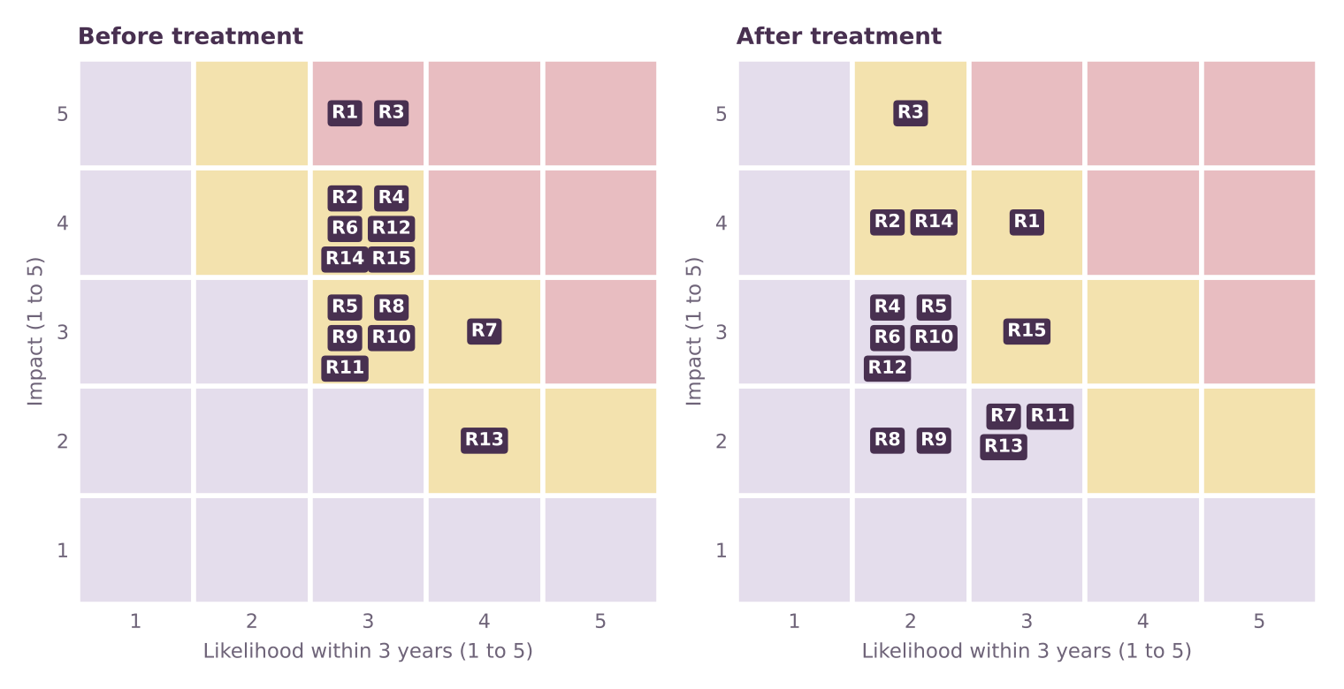
Figure 1. Risk positions before and after treatment. Red cells are High, amber Medium, lilac Low.

The register
Risks are listed from highest to lowest score before treatment. Evidence numbers in brackets match the Source Log (Deliverable 1).
ID | Risk and why it matters | L | I | Score | After (L × I) | Rating after
R1 | Intrusion leads to a multi-week production stop. Criminal groups target UK manufacturers. NCSC handled 204 nationally significant incidents in a year, up from 89 [10]. JLR was stopped for five weeks [27]. | 3 | 5 | 15 | 3 × 4 = 12 | Medium
R3 | Backups or recovery tools are compromised by the same attacker. Attackers who reach the network can look for the means of recovery. Rebuild from a clean state was central to the restart [27]. | 3 | 5 | 15 | 2 × 5 = 10 | Medium
R2 | Recovery plan fails when it is used. Plans that have not been run end to end tend to rest on assumptions. JLR restarted in phases over several weeks [27][19]. | 3 | 4 | 12 | 2 × 4 = 8 | Medium
R4 | Suppliers cannot be paid or fail during a stop. JLR set up supplier financing and a manual invoice system [19]; the facility was little used [27]. The CMC estimated about 5,000 organisations were affected [8][9]. | 3 | 4 | 12 | 2 × 3 = 6 | Low
R6 | Benefit assumptions are wrong (savings smaller than needed). Weeks saved, probability and costs are placeholders (Deliverable 6). Break-even needs about 3.9 weeks at central inputs. | 3 | 4 | 12 | 2 × 3 = 6 | Low
R7 | Plant time is not available for rehearsals. Rehearsals and manual-mode drills take time on live plants. Production teams are measured on output. | 4 | 3 | 12 | 3 × 2 = 6 | Low
R12 | Over-reliance on government support. The government backed a £1.5bn facility [18]; the CMC chair called the bailout “an unfortunate precedent” [28]. | 3 | 4 | 12 | 2 × 3 = 6 | Low
R14 | False confidence: rehearsals pass but a real event differs. Scripted exercises test what was imagined. Real events bring surprises, such as which system the attacker reaches first. | 3 | 4 | 12 | 2 × 4 = 8 | Medium
R15 | Attack arrives through a supplier or managed service provider. Suppliers and managed service providers are being brought into the Bill’s scope [12]. JLR’s supply chain is large and shared. | 3 | 4 | 12 | 3 × 3 = 9 | Medium
R5 | Data theft brings regulatory and legal consequences. JLR confirmed some data was taken [16]. The proposed Bill sets 24-hour notification and 72-hour full report [12]. | 3 | 3 | 9 | 2 × 3 = 6 | Low
R8 | Programme cost exceeds the loss it avoids. Expected loss avoided is about £41m at central inputs against an £80m programme (Deliverable 6). | 3 | 3 | 9 | 2 × 2 = 4 | Low
R9 | Scope grows into a broad prevention programme. Prevention-first scored lowest in Deliverable 5 and is the costliest option in Deliverable 6. | 3 | 3 | 9 | 2 × 2 = 4 | Low
R10 | Skills shortage in recovery engineering and plant security. Recovery and plant-security skills are scarce and shared with suppliers and competitors. (My judgement; no public source.) | 3 | 3 | 9 | 2 × 3 = 6 | Low
R11 | Insurance is unavailable or too expensive after a major loss. JLR’s policy was unfinished when it was attacked [28]. The protection gap for large losses can reach 90% [28]; Hydro recovered about 6% early on [29]. | 3 | 3 | 9 | 3 × 2 = 6 | Low
R13 | New regulation raises obligations or cost. The Cyber Security and Resilience Bill is at Report Stage with 24-hour and 72-hour reporting [11][12]. | 4 | 2 | 8 | 3 × 2 = 6 | Low

Treatment, early warning and ownership
ID | Treatment | Early-warning indicator | Suggested owner (role)
R1 | Option B cuts the length of the stop, not the chance of the event. Targeted prevention only if Deliverable 6 gates allow. | Number of high-severity security incidents on tier 1 and tier 2 systems each quarter | Chief Information Security Officer
R3 | Keep immutable, offline copies and golden images in an isolated recovery enclave with its own identity. | Share of tier 0 to 2 data held in immutable offline copies | Chief Information Security Officer
R2 | Rehearse tier by tier, then plant by plant. Record the measured restore times and fix what fails. | Share of rehearsal findings closed within 90 days | Programme Director
R4 | Agree a manual payment route with the main suppliers in advance, with pre-approved financing terms. | Share of top suppliers (by spend) with an agreed manual payment route | Chief Financial Officer
R6 | Stage gates tied to measured restore times and the break-even rule; stop or re-scope if the rule fails. | Measured weeks saved against the break-even needed at each gate | Chief Financial Officer
R7 | Schedule drills in planned shutdowns; agree a rehearsal calendar with plant directors at the start. | Rehearsals completed against calendar | Manufacturing Director
R12 | Plan for self-funded liquidity; do not count on a repeat of the support in any case. | Liquidity headroom against the £1bn covenant [26] | Chief Financial Officer
R14 | Unscripted exercises and red-team scenarios; rotate the scenario each year. | Share of rehearsals using an unannounced scenario | Chief Operating Officer
R15 | Restrict and monitor third-party access to plant and recovery systems; include key suppliers in rehearsals. | Third-party accounts with standing access to tier 1 and 2 systems | Head of Procurement
R5 | Pre-agreed notification process with legal and the regulators; data-minimisation review for tier 1 systems. | Time from decision to notify to regulator notification, in rehearsal | Legal and Compliance Director
R8 | Fund in stages; cumulative spend capped by the gate rule; track cost per week of saving. | Cumulative spend against gate budget | Programme Director
R9 | Change control: new prevention work needs a named weakness and a cost and saving case. | Number of scope changes approved outside gates | Programme Director
R10 | Mix of in-house leads and framework partners; retain key staff through the programme. | Vacancies in key roles beyond 60 days | Chief Information Security Officer
R11 | Treat insurance as an option, not part of the core. Obtain quotes before any decision. | Quoted premium per £m of limit | Treasurer
R13 | Design the response process to the proposed standard now; track the Bill through to Royal Assent. | Gaps against the Bill’s notification and resilience duties | Legal and Compliance Director
Owners are suggested roles, not named people. JLR’s own governance is not public beyond the board-level oversight of information security described in its annual report [27].

What the register says
- R1 cannot be treated away. A determined attacker may still get in. Recovery cuts the impact from 5 to 4, so the residual score is 12. Targeted prevention is the only lever on likelihood, and Deliverable 6 does not justify it on expected value.
- R3 decides whether recovery works. If the attacker can reach the backups and golden images, a rebuild starts again from nothing. The recovery enclave in Deliverable 8 is the treatment, and R3 is the risk the programme cannot afford to skip.
- R6, R8 and R9 are the programme’s own risks. They are treated by the stage gates and the cost rule in Deliverable 9, which stop spend if measured savings fall short.
- R4, R11 and R12 concern money and the supply chain. JLR’s supplier facility was little used [27], insurance was unfinished at the time of the attack [28], and the government loan was called “an unfortunate precedent” [28]. The mitigation is to agree payment routes and self-funded liquidity in advance.
- R14 is a quiet risk. A rehearsal that passes can create false confidence. Unannounced scenarios are the answer.

Limitations
- Scores are judgement. There are no public attack probabilities or programme costs, so likelihood and impact bands are my estimates. The value is in the ranking and the reasoning, not the decimal.
- Public information cannot show JLR’s controls. The register tests the design of the recommendation, not JLR’s actual defences.
- Not exhaustive. Risks such as physical damage, a second attack during recovery, or a change of owner’s policy are not scored.
- Treatment effects are assumed. The after scores assume the treatment is delivered as described.

Key terms in plain English
Term | What it means
Inherent risk | The score before any treatment (here shown as the first score).
Residual risk | The score after the treatment has been delivered.
Early-warning indicator | A measure that moves before the risk happens, so action can start earlier.
Risk owner | The role accountable for managing a risk, not necessarily the person who fixes it.

Sources
Numbers in square brackets match this list and the Source Log (Deliverable 1).
Ref | Source (select the title to open it)
[8] | JLR Hack UK’s Costliest Ever, Hitting Economy with £1.9bn Loss. Infosecurity Magazine, Oct 2025.
[9] | JLR attack is the most expensive security breach in UK history. Computing, Oct 2025.
[10] | NCSC Annual Review 2025: Incident management. National Cyber Security Centre, Oct 2025.
[11] | Cyber Security and Resilience Bill: what’s the latest and what should businesses do now. Gowling WLG via Mondaq, 21 Sep 2026.
[12] | Cyber Security and Resilience Bill: what will it do?. Penningtons Manches Cooper, 30 Jul 2025.
[16] | Jaguar Land Rover production delay after cyberattack. Cybersecurity Dive, Sep 2025.
[18] | Jaguar Land Rover resumes production following significant cyberattack. teiss, 10 Oct 2025.
[19] | JLR restarts manufacturing and introduces new financing solution to pay JLR suppliers early. Automotive World (JLR press release), 7 Oct 2025.
[26] | JLR Annual Report 2025/26 (full report, 122 pages, read 21 Oct 2026). JLR, 21 May 2026.
[27] | JLR Annual Report 2025/26 (full report): incident, risk and governance sections. JLR, 21 May 2026.
[28] | Did Jaguar Land Rover’s cyber insurance gap help pave the way to 4,000 job losses?. Insurance Business UK, 7 Sep 2026.
[29] | Norsk Hydro receives first cyber insurance payout of $3.6 million for breach-related losses. Computing, 29 Oct 2019.

