PROJECT 1 · DELIVERABLE 8 OF 13
Target Resilience Architecture
A design for recovering a manufacturer in value order: the means of recovery first, then shipping and payment, then production
At a glance
- The design has four tiers and one isolated enclave. The enclave holds the means of recovery (Tier 0). Tier 1 is what lets cars ship and suppliers get paid. Tier 2 restarts production. Tier 3 is everything else.
- The illustrative target saves about 14 days. First production by about day 24 instead of day 38, and normal output by about day 62 instead of about day 76. That matches the two-week saving in the central case of Deliverable 6.
- The order follows what JLR itself disclosed. Customer-facing systems first, then wholesale and parts logistics [27]; engines and batteries, then stamping, body, paint and logistics, then Nitra and the Range Rover lines [19]. The design makes that order pre-agreed and tested.
- This is a design proposal, not JLR’s architecture. Public information shows what JLR did during the restart, not how its systems are built. Target times are my assumptions.

Design principles
Principle | What it means in practice
1. Assume breach | Design for the day a criminal group is already inside. Deliverable 4 showed that the length of the stop, not the intrusion, drove most of the loss.
2. Keep the means of recovery apart | Backups, golden images, identity for recovery staff and communications sit in an enclave that the corporate and plant networks cannot reach.
3. Recover in value order | Restore what lets the business earn and pay first, in a sequence agreed before the incident.
4. Contain by plant | A problem in corporate IT or one site should not stop every site. Separate corporate IT from plant systems, and plants from each other, with controlled gateways.
5. Run degraded, not dark | Pre-build manual or reduced modes for shipping, parts logistics and supplier payments so that the business keeps moving while systems return.
6. Rehearse the whole chain | Test restore times, handovers to regulators and suppliers, and decision-making, not only the technology.

The target architecture
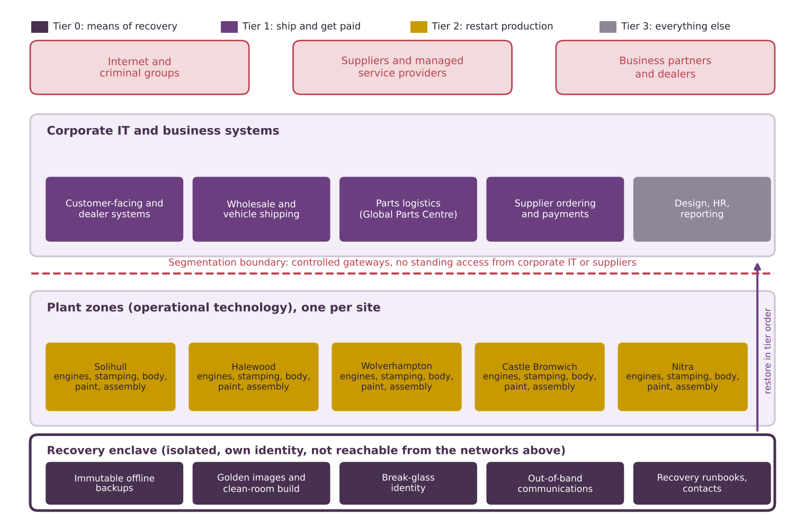
Figure 1. Target architecture. Boxes are coloured by recovery tier. The plant list shows the UK and Slovakian sites named in JLR’s public documents [21]; what runs at each is simplified for illustration.
The picture has three layers. Corporate IT holds the business systems. Plant zones hold the operational technology that runs each factory. A recovery enclave below both holds what is needed to rebuild. Controlled gateways separate the layers, so that standing access does not run from a supplier or from corporate IT into the plants.

Recovery tiers
Tier | Functions | Why this order (evidence) | Target restore (days from incident) | Mode while down
0: Means of recovery | Isolated identity, immutable backups, golden images, clean-room build, out-of-band communications, crisis runbooks. | Nothing else can be rebuilt safely without them. JLR restarted only after security assurance, working with specialists, the NCSC and law enforcement [15][27]. | Day 1 | Break-glass accounts, voice and messaging outside the main network
1: Ship and get paid | Customer-facing and dealer systems; wholesale and vehicle shipping; parts logistics; supplier ordering and payments. | JLR brought customer-facing systems back first, then wholesale and the Global Parts Logistics Centre [27]. Suppliers needed financing and a manual invoice system [19]. | Day 7 | Manual order, shipping and payment routes agreed in advance
2: Restart production | Engines and batteries; stamping; body; paint; logistics; assembly lines, plant by plant. | JLR restarted engines and batteries first, then stamping and Solihull body, paint and logistics, then Nitra and the Range Rover lines [19]. | First output day 24; normal about day 62 | Reduced-rate production on manual or isolated controls where safe
3: Everything else | Design, engineering, HR, finance reporting, analytics. | Valuable, but not needed to earn or pay in the first weeks. | After Tier 2 | Spreadsheets and local copies
Target restore times are illustrative assumptions, not JLR plans. They are set to give a saving of about two weeks (Deliverable 6, central case).

The recovery sequence
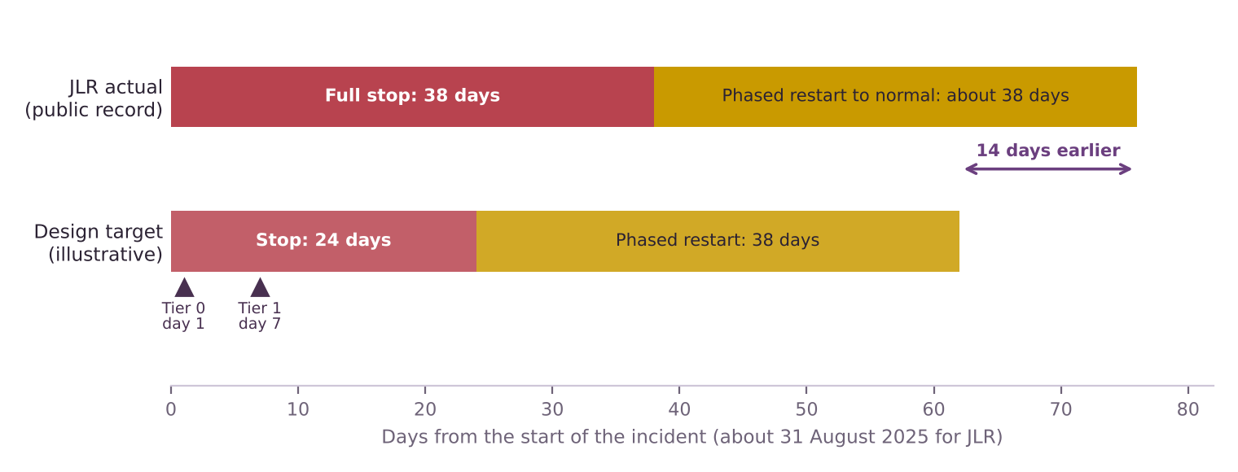
Figure 2. JLR’s actual stop and restart (31 August to 8 October, normal by mid-November [27]) against an illustrative design target. JLR day counts are mine from the dates in the annual report.
- The target shifts both phases earlier by 14 days. The stop shortens from 38 days to 24, and the phased restart (about 38 days in both cases) finishes at about day 62 instead of about day 76.
- Tier 0 and Tier 1 are decided early. Tier 0 by day 1 and Tier 1 by day 7 is the hardest part of the design to prove, and rehearsals will test it first (Deliverable 9).
- Two weeks is the assumption that matters. At central inputs Deliverable 6 shows about 3.9 weeks are needed for the full programme to repay its cost, so the target is a test, not a promise.

What the design changes against JLR’s disclosed approach
What JLR did (public record) | What the design adds | Risk addressed (Deliverable 7)
Restarted in phases, customer-facing systems first [27] | The phase order is agreed and tested before an incident | R2, R14
Worked with cyber specialists, the NCSC and law enforcement before restart [15] | A pre-agreed assurance route and a clean rebuild path | R3, R5
Arranged supplier financing and a manual invoice system during the stop [19]; little of the facility was used [27] | Payment routes and terms agreed with key suppliers in advance | R4
Restarted engines and batteries first, then stamping, body, paint and logistics [19] | Plant-by-plant zones so one site can restart while others wait | R1, R15
No cyber policy; none of the £260m recovered from an insurer [28] | Insurance held as an option, not part of the core | R11

The public record does not show whether JLR already had some of these capabilities. The table shows what the design would make explicit, not what JLR lacked.

What belongs in the funded core
Capability | Layer | Treatment in Deliverable 6
Tiering and recovery order | Core (B) | Funded in Phase 0 and 1; cheapest part of the programme.
Recovery enclave, immutable backups, golden images | Core (B) | Funded in Phase 1, scaled in Phase 2. Treats R3.
Clean rebuild and assured restart plan | Core (B) | Phase 2. Largest cost; released only if gate rules are met.
Degraded modes, supplier payment route | Core (B) | Phase 1 and 2.
Plant segmentation and third-party access limits | Option (A, targeted) | Not justified on expected value at the placeholder cost. Re-open if a specific weakness is found.
Cyber insurance | Option (C) | A choice about risk appetite. Obtain quotes in Phase 0.

Dependencies and assumptions
- Plant cooperation. Live rehearsals need plant time (R7).
- Regulator and supplier agreement. An assured restart plan only saves time if the NCSC, regulators and key suppliers have agreed it beforehand.
- Operational technology limits. Some plant controllers cannot be rebuilt from images quickly. The design assumes these can be isolated and restarted manually.
- Targets are assumptions. Tier 0 by day 1, Tier 1 by day 7 and first output by day 24 are what must be shown in rehearsal.

Limitations
- A design, not a diagnosis. Public sources do not reveal JLR’s network, its backups or its recovery plans.
- Simplified. Real estates have hundreds of systems and dependencies that are not shown.
- Precedents are illustrations. Maersk reinstalled over 4,000 servers and 45,000 PCs in 10 days [30], and Norsk Hydro ran many sites manually [29], but neither proves JLR could match them.

Key terms in plain English
Term | What it means
Recovery enclave | A separate, protected environment that holds the means to rebuild and cannot be reached from normal networks.
Immutable backup | A copy that cannot be changed or deleted for a set period, even by an administrator.
Golden image | A trusted, known-clean copy of a system used to rebuild it.
Operational technology (OT) | The systems that run machines and production lines, as distinct from office IT.
Degraded mode | Running at lower speed or with manual steps while systems are down.

Sources
Numbers in square brackets match this list and the Source Log (Deliverable 1).
Ref | Source (select the title to open it)
[15] | JLR staff told to stay at home until October as car giant continues to battle cyber attack. ITV News, 23 Sep 2025.
[19] | JLR restarts manufacturing and introduces new financing solution to pay JLR suppliers early. Automotive World (JLR press release), 7 Oct 2025.
[21] | Annual Report 2025. JLR, 2025.
[27] | JLR Annual Report 2025/26 (full report): incident, risk and governance sections. JLR, 21 May 2026.
[28] | Did Jaguar Land Rover’s cyber insurance gap help pave the way to 4,000 job losses?. Insurance Business UK, 7 Sep 2026.
[29] | Norsk Hydro receives first cyber insurance payout of $3.6 million for breach-related losses. Computing, 29 Oct 2019.
[30] | Maersk reconstructed entire IT infrastructure in 10 days following NotPetya. Supply Chain Dive, 29 Jan 2018.

