PROJECT 1 · DELIVERABLE 9 OF 13
Phased Roadmap and KPIs
A three-year plan in four phases, with gates that release money only when measured savings justify it
At a glance
- Four phases over 36 months, costed at £80m in total (illustrative). Phase 0 (£3m) decides and baselines, Phase 1 (£15m) builds foundations, Phase 2 (£40m) builds and proves, Phase 3 (£22m) scales and sustains.
- Each phase after the first is released by a gate. At each gate the weeks of output saved, measured in rehearsal, must be at least the cumulative cost ÷ (£101.5m a week × the board’s chance of an outage). At a 20% chance, that means 0.9 weeks at Gate 0, 2.9 at Gate 1 and 3.9 at Gate 2.
- At central inputs the full programme would not clear Gate 1 on the design target of two weeks. That is intended. It means the plan is to spend £18m, measure, and then decide whether Phase 2 is worth £40m.
- Fourteen KPIs track recovery speed, coverage, the supply chain and delivery. Baselines are not public, so Phase 0 measures them. Targets are illustrative.

The plan on a page
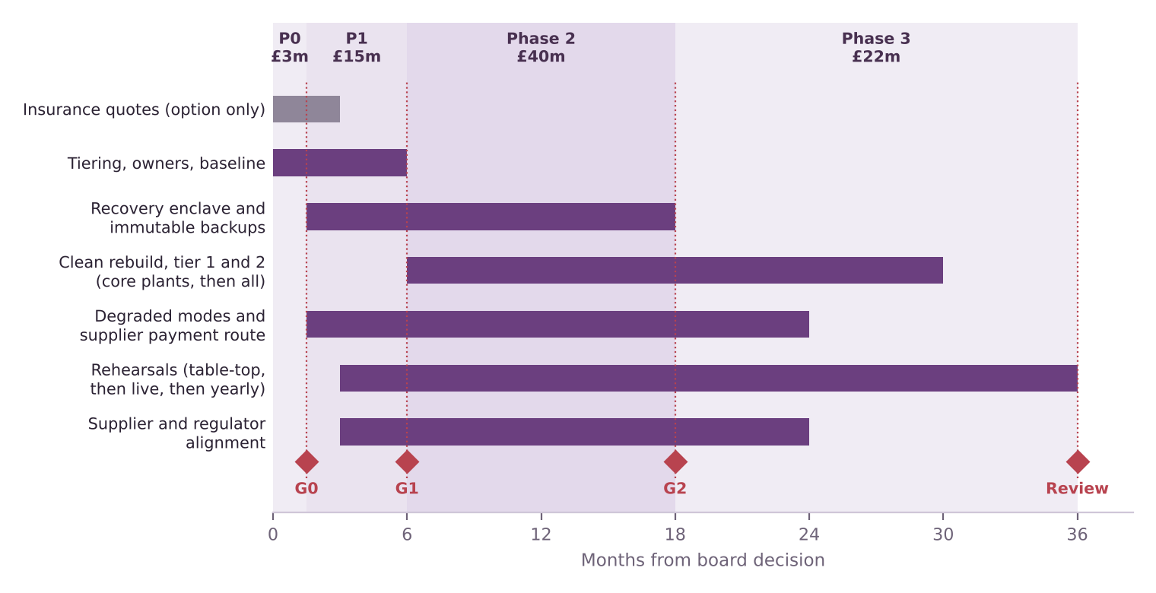
Figure 1. Roadmap by workstream. Diamonds mark gates (G0, G1, G2) and the final review. Phase costs are illustrative and add up to the £80m of Option B in Deliverable 6.
Phase | Months | What happens | Cost (illustrative) | Ends with
0: Decide and baseline | 0 to 1.5 | Board sets its view of the event chance. Owners named. Tier list agreed. Table-top exercise measures today’s restore times. Insurance quotes obtained. | £3m | Gate 0
1: Foundations | 1.5 to 6 | Recovery enclave and immutable backups for Tier 0. Break-glass identity and out-of-band communications. Manual payment route with the top suppliers. Degraded-mode playbooks for shipping and parts. First table-top rehearsal. | £15m | Gate 1
2: Build and prove | 6 to 18 | Clean rebuild for Tier 1 and Tier 2 at two core plants. Assured restart plan agreed with the NCSC, regulators and key suppliers. First live rehearsals. | £40m | Gate 2
3: Scale and sustain | 18 to 36 | Extend to the remaining plants. Yearly live rehearsals with unannounced scenarios. Refresh the tier list and targets. | £22m | Review

The gate rule
Deliverable 6 showed that a programme repays its cost when the weeks of output it saves, multiplied by weekly lost profit (£101.5m at a 20% margin) and the chance that an outage happens, are at least its cost. The gates apply that rule to measured results, not to estimates.
Gate | Releases | Cumulative cost if released | Weeks needed at 10% chance | At 20% (central) | At 35%
G0 | Phase 1 | £18m | 1.8 | 0.9 | 0.5
G1 | Phase 2 | £58m | 5.7 | 2.9 | 1.6
G2 | Phase 3 | £80m | 7.9 | 3.9 | 2.2
Weeks needed = cumulative cost ÷ (£101.5m × chance). The chance is the combined likelihood of a cyber or non-cyber outage that the programme addresses, which the board fixes at Gate 0. My arithmetic on illustrative inputs.
- Weeks saved are measured, not claimed. They are the baseline restore time from the Phase 0 table-top, less the time shown in the latest rehearsal.
- At the central 20%, Gate 1 asks for 2.9 weeks. The design target is 2.0 weeks, so the plan would stop or re-scope there unless rehearsals beat the target, the board’s chance view is above about 29%, or Phase 2 costs less. The company would have spent £18m by then.
- If a gate fails, there are three choices: stop, re-scope to the cheapest parts of the next phase, or re-set the chance view with a written reason. The choice and the reason are recorded.

KPIs
Baselines are not public. Phase 0 measures them, and the targets below are illustrative until then. Linked risks are from the register in Deliverable 7.
KPI | Type | Baseline | Target and date | Risks
Recovery speed
1. Hours to restore Tier 0 from declaring an incident | Leading | Measure in Phase 0 | Within 24 hours by month 6 | R2, R3
2. Days to restore Tier 1 (customer-facing, shipping, parts, supplier payments) | Leading | Measure in Phase 0 | Within 7 days by month 18 | R2
3. Days from declared stop to first output at a core plant, in live rehearsal | Leading | JLR 38 days (actual) | Within 24 days by month 18 | R1
4. Days from incident to normal output | Lagging | JLR about 76 days | Within 62 days by month 36 | R1
Coverage
5. Share of Tier 0 to 2 data held in immutable offline copies | Leading | Measure in Phase 0 | 100% by month 18 | R3
6. Share of Tier 1 and 2 systems with a clean restore tested in the past 12 months | Leading | Measure in Phase 0 | 90% or more by month 24 | R2
7. Plants completed in live rehearsal | Leading | Measure in Phase 0 | 2 by month 18; all 5 by month 36 | R7, R14
8. Share of rehearsals using an unannounced scenario | Leading | Measure in Phase 0 | 50% or more from month 18 | R14
Supply chain and regulators
9. Share of top suppliers (by spend) with an agreed manual payment route | Leading | Measure in Phase 0 | 80% or more by month 18 | R4
10. Time from decision to notify to regulator notification, in rehearsal | Leading | Measure in Phase 0 | Within 24 hours by month 12 (the proposed Bill’s standard [12]) | R5, R13
11. Third-party accounts with standing access to Tier 1 and 2 systems | Leading | Measure in Phase 0 | Falling every quarter | R15
Delivery
12. Cumulative spend against gate budget | Leading | n/a | At or below £3m, £18m, £58m, £80m at each gate | R8, R9
13. Measured weeks saved against the gate requirement | Leading | n/a | At or above the requirement at each gate | R6
14. Rehearsal findings closed within 90 days | Leading | Measure in Phase 0 | 90% or more | R2

- KPIs 3 and 4 are the outcome measures. They compare directly with JLR’s public record (38 days and about 76 days) and feed the weeks-saved figure at each gate.
- Most KPIs are leading. The real test, a live incident, may never come, so the plan relies on rehearsal results.

Governance
Role | Responsibility (suggested)
Board | Sets its view of the event chance at Gate 0; takes each gate decision; decides on insurance.
Chief Financial Officer | Sponsor. Owns the gate rule, liquidity planning and insurance quotes (R6, R8, R12).
Chief Information Security Officer | Owns the recovery enclave, restore targets and technical rehearsals (R1, R3).
Manufacturing Director | Owns plant rehearsals and degraded modes (R7).
Head of Procurement | Owns supplier payment routes and third-party access limits (R4, R15).
Legal and Compliance Director | Owns notification and regulator engagement (R5, R13).
Programme Director | Runs the plan, reports the KPIs and keeps change control (R2, R8, R9).
Roles are suggestions. JLR’s own structure is not public beyond the board-level governance of information security in its annual report [27].

What the board is asked to decide
- Approve Phase 0 and Phase 1 only (£18m in total), with Phases 2 and 3 conditional on the gates.
- Fix the chance view at Gate 0 and write down the reason, since it sets what each gate requires.
- Ask for insurance quotes in Phase 0 and decide on cover as a risk-appetite choice, not as part of the core.

Limitations
- Phase costs and timings are illustrative. They add up to Option B’s placeholder cost and are not JLR figures.
- The gate rule uses expected profit. It does not value the smaller range of outcomes, supplier effects or regulatory standing. A board that values those may choose a lower bar.
- Baselines are unknown. Several targets could be too easy or too hard once Phase 0 measures today’s position.

Key terms in plain English
Term | What it means
Gate | A decision point where money for the next phase is released only if stated tests are met.
Leading KPI | A measure that moves before the outcome, such as rehearsal results.
Lagging KPI | A measure of the outcome itself, such as days to normal output.
Baseline | The starting value of a measure, before the programme.
Table-top exercise | A discussion-based rehearsal where the team walks through a scenario without touching real systems.

Sources
Numbers in square brackets match this list and the Source Log (Deliverable 1).
Ref | Source (select the title to open it)
[12] | Cyber Security and Resilience Bill: what will it do?. Penningtons Manches Cooper, 30 Jul 2025.
[27] | JLR Annual Report 2025/26 (full report): incident, risk and governance sections. JLR, 21 May 2026.

