PROJECT 2 · DELIVERABLE 2 OF 13
Industry Brief
How AI is changing the agency model and the work of turning ideas into finished assets
At a glance
- Almost every agency now uses generative AI, but few make money from it: 87% of US agencies use it, yet 61% call it a “cost of business” and only 6% sell it as a line of business [8].
- The pressure on agencies is structural: media spending has grown faster than holding-company revenue since 2023, platforms are building their own AI ad tools, and Omnicom and IPG have merged [5][13][14].
- The delay moves to review, not away: in one survey, 46% say content gets stuck in review and 41% say it stalls in approvals [9]. Faster generation alone may not make delivery faster, which is the idea this project tests.

Executive summary
Three things matter for this project.
- Agencies are using AI widely but mostly to cut cost. In a Forrester and 4As poll of nearly 200 US agency leaders in April 2026, 87% use generative AI and 50% use agentic AI (software that takes actions with some independence) for execution [8]. But 61% call AI a “cost of business” and only 6% sell it as a line of business [8]. The same poll found that legal risk (62%) and accuracy and bias (63%) are the main barriers [8].
- The agency model is under pressure from three sides. Brands are spending less on agencies and automating execution work; technology platforms are building self-service AI tools; and the holding companies are consolidating [5][13][14]. Analysts argue that agencies must define their value around “insight, orchestration, and high-level problem-solving rather than production scale” [5].
- Faster assets do not guarantee faster delivery. A survey of 388 US marketing and creative professionals found that 46% say content gets stuck in review, 41% say it stalls in approvals, and 70% say these slowdowns affect revenue-generating work [9]. An article on WPP’s new production unit makes a related point: in always-on marketing, “production logistics, not creative ideation, [is] the primary constraint” [11]. If that is right, the gain comes from redesigning the workflow around AI, not from adding AI tools to it.

How agencies use AI today
Finding (Forrester and 4As, April 2026, nearly 200 US agency leaders) | Share | Source
Use generative AI | 87% | [8]
Use agentic AI for marketing execution | 50% | [8]
Use generative AI to improve staff productivity | 81% | [8]
Say AI remains a “cost of business” | 61% | [8]
Define AI as a line of business sold to clients | 6% | [8]
Expect to earn money from AI agents within 24 months | 31% | [8]
Name accuracy and bias as a barrier | 63% | [8]
Name legal risk as a barrier | 62% | [8]

The full report is not public, and I have read it only through a trade-press article [8]. The message is still clear. AI is now ordinary equipment inside agencies. It is used to work faster and cheaper, but it is not yet a product that clients pay extra for. That matters for a production workflow: if clients see AI as a cost saving they expect to share, the price of each finished asset will fall.

Pressure on the agency model
Pressure | Evidence | Source
Brands spending less on agencies | 60% of US senior marketing leaders say they spend less on agencies because of AI (Typeface survey; date not stated). 82% of ANA members have an in-house agency (2023 report) | [13]
Media growth is not reaching agencies | Worldwide media ad spend has grown faster than holding-company revenue since 2023. The Big Six share of US ad spending fell from 44.6% in 2019 to 29.6% in Q1 2024 | [5][13]
Platforms moving into execution | Google, Meta and Amazon offer self-service AI ad tools. Meta is reported to plan, by 2026, to let brands create and target ads from an objective and a price point, while saying it is “not designed to kill off traditional ad agencies” | [5][14]
Consolidation | Omnicom and IPG completed their merger in late 2025 and became the largest holding company, ahead of WPP. About 4,000 roles were cut and $750m of savings are expected within two years | [13]

These are signals, not a forecast. The sources are trade press, and the survey behind the 60% figure does not state its date [13]. The direction is consistent across them: execution work is the part most exposed, because it is the most repeatable.

Where the time goes in content production
The usual story is that AI makes content faster. A survey of US marketing and creative professionals suggests the picture is more mixed. Respondents say AI saves them about 15 hours a week, yet content still stalls after it is made [9].
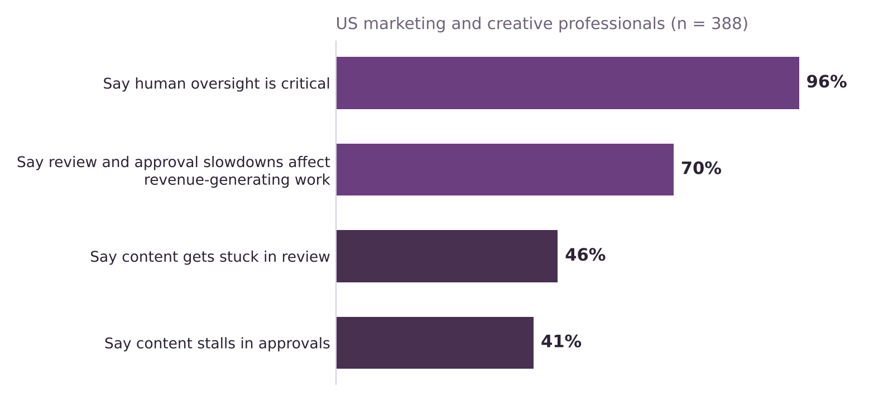
Figure 1. Review, approval and oversight findings from the PhotoShelter survey [9]. A vendor survey, so a signal to test, not proof.
- 46% say content gets stuck in review and 41% say it stalls in approvals [9]. The people who gain hours from AI are still waiting on someone else’s sign-off.
- 70% say these slowdowns hit revenue-generating work, and 96% say human oversight is critical [9]. People do not want review removed. They want it organised.
- Production logistics is the constraint in always-on marketing. Brands must continuously version, localise and optimise assets across platforms, and WPP’s new production unit is described as a response to that demand [11]. Smartly data quoted in the same article shows 37% of marketers name time-consuming creative production as a top challenge, 35% inconsistent quality across platforms and 34% ads not optimised for platform specifications [11].
The survey was published by PhotoShelter, a vendor, and the article names no separate commissioning party [9]. I use it as a signal to test with a model, not as proof.

What it means for this project

Implications (my analysis)
- The right question is about the workflow, not the tool. If AI makes each step faster but review and approval loops stay as they are, the total time barely changes. The project therefore compares ways of changing the workflow, not ways of buying tools.
- Humans are part of the design. With 96% saying human oversight is critical [9] and legal risk the second-biggest barrier [8], a design that removes people from judgement calls will not be accepted. The design question is where people add the most value.
- Price pressure is likely. If clients treat AI as a cost saving, the saving will not stay with the agency. The impact model will therefore show time and cost released, not profit gained.
- The platform route is a real alternative. Self-service tools [14][7] mean a client could do the repeatable work without an agency. One option in this project tests that route.

Open questions for later deliverables
- How many review rounds does a typical global campaign adaptation go through, and how long does each take? No public source gives this, so the model will use assumptions with a sensitivity test.
- Which tasks can AI do reliably without a person checking every item? The task classification framework (Deliverable 5) will score this.
- How much of the saving would clients expect to keep? The impact model will show gross time and cost released and leave the commercial split open.

Limitations
- Mostly trade press and vendor research. All seven sources cited here are grade C. The company facts are in Deliverable 3, where WPP’s own results are used. See the Source Log for grades and conflicts.
- Two surveys, both partly opaque. The Forrester report is not public [8], and the PhotoShelter survey is from a vendor [9]. Neither is treated as proof.
- US-heavy evidence. Both surveys sample US respondents, while WPP works globally.
- Platform plans are reported, not confirmed. The Meta plan comes from a newspaper report relayed by a trade article [14].

Key terms in plain English
Term | What it means
Revenue less pass-through costs | What an agency group actually earns: revenue after deducting costs it passes on to clients, such as media bought on their behalf.
Holding company | A group that owns many agencies and networks, such as WPP, Omnicom and Publicis.
Generative AI | AI that produces new text, images, video or audio from instructions.
Agentic AI | AI that carries out a sequence of tasks with some independence, rather than answering one prompt at a time.
Versioning and localisation | Adapting one approved piece of creative into many versions for different markets, languages and channels.
Pass-through costs | Costs an agency pays on behalf of a client and bills on, which are not part of its own earnings.

Sources
Numbers in square brackets match this list and the Source Log (Deliverable 1).
Ref | Source (select the title to open it)
[5] | WPP’s rocky Q4 underscores AI disruption across agencies. eMarketer, 2026.
[7] | WPP’s AI Tool Lets Brands Skip Agencies for Ad Creation. WebProNews, Undated.
[8] | The State of AI Inside US Marketing Agencies 2026 (reported by MediaPost). MediaPost, 6 Jul 2026.
[9] | AI speeds up content production but sameness a problem (CMOtech UK). CMOtech UK, 18 Mar 2026.
[11] | Why WPP is rebuilding its production model for always-on marketing. eMarketer, 30 Jan 2026.
[13] | FAQ on ad agencies: Consolidation, AI disruption, and what’s changing in 2026. eMarketer, 2026.
[14] | Meta Plans To Automate All Ad Creation By 2026: Report. MediaPost, 2 Jun 2025.

