PROJECT 2 · DELIVERABLE 3 OF 13
WPP Profile and Current State
Where WPP Production sits inside the Elevate28 turnaround, and what WPP has said about AI
At a glance
- WPP is mid-turnaround: revenue less pass-through costs fell 5.6% to £4,745m in the first half of 2026 (4.7% like for like), after a 10.4% fall in 2025. WPP’s plan, Elevate28, targets £500m of annual savings by 2028 [1][10].
- Production is the only growing unit but the smallest: up 1.6% and about 5% of revenue less pass-through costs, with Media down 5.4% and Creative down 4.9% [1].
- WPP is betting on AI-led production: a new unit of close to 10,000 people runs on one AI platform, WPP Open, and WPP says it is not planning layoffs as a result [11][12][10].

Executive summary
- WPP is shrinking and cutting cost. In 2025 revenue less pass-through costs (what the group earns after costs it passes on to clients) fell 10.4% to £10,176m, or 5.4% like for like [10]. In the first half of 2026 it fell a further 4.7% like for like, to £4,745m [1]. Headline operating profit was £398m, a margin of 8.4% [1].
- Elevate28 is a three-year turnaround. Stabilise in 2026, build in 2027, accelerate from 2028, with £500m of gross annual savings by 2028 and about £400m of cash costs to deliver it [10].
- Production is small but growing, and central to the AI story. WPP Production was formed on 23 February 2026 from Hogarth, VML and Ogilvy production teams, on a single platform built around WPP Open [11][12]. It is the only unit with positive growth [1].

Where WPP stands
Measure | First half 2026 | Full year 2025
Revenue less pass-through costs | £4,745m (H1 2025: £5,026m) | £10,176m (2024: £11,359m)
Change, reported | −5.6% | −10.4%
Change, like for like | −4.7% | −5.4%
Headline operating profit | £398m (£412m a year earlier) | £1,321m (£1,707m)
Headline operating margin | 8.4% (8.2%) | 13.0% (15.0%)
Adjusted net debt | £2,935m at 30 June 2026 | £2.2bn at 31 December 2025
Headcount at period end | 97,388 (104,083 a year earlier) | 98,655 (108,044)

Sources: WPP’s 2026 interim results [1] and 2025 preliminary results [10]. “Like for like” removes the effect of currency changes, acquisitions and disposals. WPP’s own guidance for 2026 is a second-half decline of low to mid single digits and a full-year headline operating margin of 12% to 13% [1]. In 2025 the reported operating profit was only £382m after a £641m goodwill impairment [10].
Most of these numbers are bad news, but WPP described the first half as “in line with expectations” [2] and the second quarter improved on the first: Media fell 2.8% after falling 8.3%, and Creative fell 3.5% after falling 6.3% [2].

Elevate28: the plan
Phase | Year | What WPP says it will deliver
1. Stabilise | 2026 | Positive net new business; £250m gross run-rate savings by year end (about £100m in-year); progress on portfolio actions [10][1]
2. Build | 2027 | Return to organic growth during the year; rebuild margins; reduce leverage [10]
3. Accelerate | 2028 on | Faster organic growth, wider margins and strong cash conversion [10]

- Savings: £500m gross annualised by 2028, with total cash costs of about £400m over two years. In 2026, WPP expects about £250m of cash restructuring, of which about £190m relates to Elevate28 [10]. One article reports the same target as “$676m” [4].
- Shape of the group: four operating units (WPP Media, WPP Creative, WPP Production and WPP Enterprise Solutions) across four regions: North America, Latin America, EMEA and APAC [10]. Cindy Rose, the chief executive, says WPP is “no longer a holding company” [4].
- Ambition: a “simpler, lower-cost, AI-enabled business” by 2028, backed by £300m of investment in AI-driven technology in 2025 [10].
- Progress: the chief executive calls WPP “firmly on track” with phase one [2]. Headcount fell 6.4% over twelve months to 97,388 (my arithmetic from [1]), and average headcount is reported 8.4% lower [3].

The four units and the case for Production
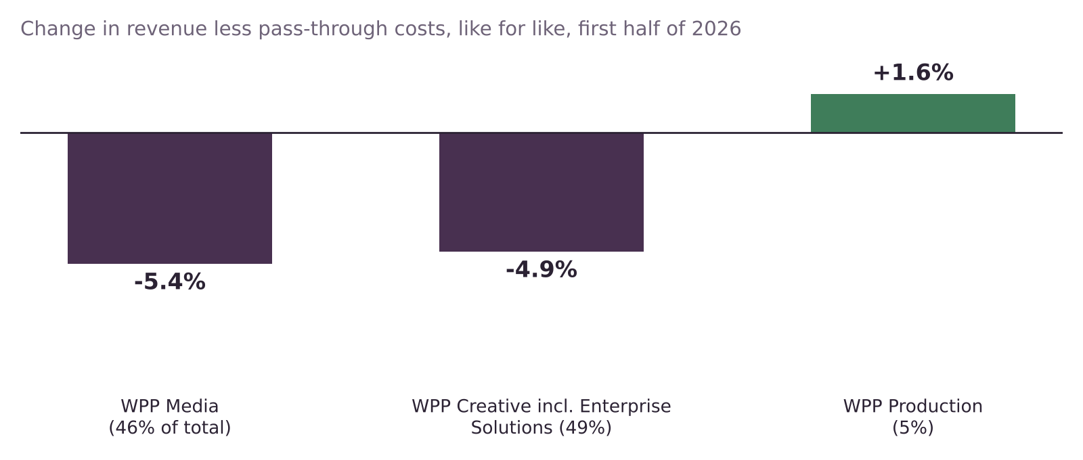
Figure 1. Like-for-like change in revenue less pass-through costs, first half of 2026, with each unit’s share of the total [1].
Unit | H1 2026 change | Share | Note
WPP Media | −5.4% | 46% | The largest drag. Q2 improved to −2.8% from −8.3% in Q1 [1][2]
WPP Creative (including Enterprise Solutions) | −4.9% | 49% | Hit by lower client spending. WPP reports Enterprise Solutions within Creative until 2027 [1][2]
WPP Production | +1.6% | 5% | The only unit growing. Q2: +1.3% [1][2]

Production is a small part of WPP, so it will not change the group’s results on its own. It is still a useful signal: it is where clients are asking for volume, speed and consistency, and where WPP has chosen to place its AI bet. This project therefore treats Production as the setting for a workflow question, not as a financial rescue.

WPP Production and WPP Open

What WPP Production is
- Formed on 23 February 2026 (announced 23 January) by combining Hogarth, VML and Ogilvy production teams into one unit [11][12].
- Led by Richard Glasson, who is also global chief executive of Hogarth [11][12].
- Size: “close to 10,000 people” across 40-plus cities, according to WPP’s announcement as reported [12]; “more than 10,000” in another account [11].
- One platform: all teams run on a single platform powered by WPP Open, with generative AI, virtual and hybrid production and data-led optimisation built into content workflows [12][11]. A high-velocity content studio links production to media for real-time optimisation [12].
- What WPP promises clients: “faster turnaround times, greater cost efficiency”, with no figures [12].
- What WPP says about jobs: the move is “not driven by cost-cutting” and WPP “does not anticipate layoffs” [11].

WPP Open and the AI strategy
- WPP Open is described as a “pioneering agentic marketing platform” and the company’s central operating platform. Over 70,000 people, about 90% of client-facing staff, used it monthly in December 2025. Open Intelligence is its data layer, and Agent Hub launched in January 2026 [10][1].
- HEX, a frontier AI studio of roughly 50 creative technologists, sits within WPP Production [1].
- Partnerships: WPP widened its work with Google, Meta and AWS in the second quarter of 2026 [1]. An earlier $400m Google alliance gives early access to Google’s video and image models [6].
- The production-time claim: one headline says WPP is “claiming to cut content production times by up to 70%” [6]. The visible text does not say who made the claim or how it was measured, so this project treats it as an optimistic scenario, not a fact.
- WPP Open Pro is reported as letting brands plan, create and deploy ads themselves, including smaller brands, which the article says “allows brands to bypass agencies entirely” while WPP presents it as complementary [7]. It is a low-reliability source (undated, no details).
- WPP’s stated principle: “AI augments human creativity rather than replacing it” [1].

What it means for this project

The tension (my analysis)
WPP is building the tools that make AI-led production possible. The same tools, offered directly to brands through WPP Open Pro, could reduce the need for an agency [7][5]. That is the tension at the heart of this case. A redesigned workflow is only worth building if it makes WPP Production more useful to clients, not merely cheaper to run.

Implications for the project
- Production is the right place to look. It is growing, it is where AI is aimed [11][12], and its output is measurable in assets, hours and cycle time.
- The cost context is real. Elevate28 is a cost and efficiency plan [10], so any redesign must show time and cost released. It must also show that quality and brand safety hold, because clients will not trade them away [9].
- No headcount recommendation. WPP says it does not anticipate layoffs from the Production merger [11]. The project redesigns work and shows the people impact openly. It does not recommend staffing levels.
- Use WPP’s own numbers, not the headlines. The project uses figures from WPP’s results announcements [1][10] and treats the 70% claim as a scenario [6].

Open questions for later deliverables
- How much of Production’s work is adaptation and versioning of approved creative, as opposed to originating new content? No public split exists, so the project works from one representative case.
- How many review and approval rounds does that work go through? The current-state map (Deliverable 4) will state this as an assumption.

Limitations
- WPP does not publish its internal workflows, volumes or client data. Everything about how work moves through Production is modelled, not observed, and will be labelled illustrative.
- Production is about 5% of revenue less pass-through costs [1], so its trends are a signal, not the group’s story.
- Several facts come from trade press [2][3][4][11][12]. The results figures come from WPP’s own announcements [1][10]. The full 2025 annual report has not yet been read.

Key terms in plain English
Term | What it means
Revenue less pass-through costs | What the group earns after deducting costs it passes on to clients. WPP’s main measure of size.
Like for like (LFL) | A comparison that strips out currency changes, acquisitions and disposals, so that trends can be compared fairly.
Headline operating profit | WPP’s preferred profit measure, which excludes items such as restructuring costs and impairments.
Elevate28 | WPP’s three-year turnaround plan announced in February 2026.
WPP Open | WPP’s central AI-powered operating platform for planning, creating and running marketing work.
Hogarth | WPP’s large content production agency, whose chief executive leads WPP Production.

Sources
Numbers in square brackets match this list and the Source Log (Deliverable 1).
Ref | Source (select the title to open it)
[1] | WPP 2026 Interim Results. WPP (RNS via Investegate), Aug 2026.
[2] | WPP reports 2.8% revenue drop in Q2. Campaign, 2026.
[3] | WPP Is “On Track” With Turnaround Plan, as Revenue Drops 5.6% in First Half of 2026. Adweek, Aug 2026.
[4] | Cindy Rose Says WPP “No Longer a Holdco” as $676M Annual Savings Drive Begins. Adweek, Feb 2026.
[5] | WPP’s rocky Q4 underscores AI disruption across agencies. eMarketer, 2026.
[6] | WPP bets on $400 million Google AI alliance. Campaign Asia, 2025 (date not shown).
[7] | WPP’s AI Tool Lets Brands Skip Agencies for Ad Creation. WebProNews, Undated.
[9] | AI speeds up content production but sameness a problem (CMOtech UK). CMOtech UK, 18 Mar 2026.
[10] | Strategy Update and 2025 Preliminary Results. WPP (RNS via Investegate), 26 Feb 2026.
[11] | Why WPP is rebuilding its production model for always-on marketing. eMarketer, 30 Jan 2026.
[12] | WPP unifies 10,000 creatives into a single global content factory for the AI era. Mediaweek (Australia), 23 Jan 2026.

