PROJECT 2 · DELIVERABLE 4 OF 13
Current-State Process Map and Root Causes
How one approved campaign becomes hundreds of market and channel versions today, and where the time goes
At a glance
- The case is illustrative: one approved master campaign for a large consumer brand, adapted for 20 markets, 6 channels and 4 versions each, which is 480 assets. WPP does not publish its internal workflows, so every volume, hour and day here is an assumption.
- Most of the time is waiting and rework, not making: in this model a wave takes 28 working days. About 17 are hands-on work and 11 are waiting. About 15 days (54%) sit in review, approval and rework.
- The root cause is how approval works: people approve each finished asset, one after another, instead of approving the rules and patterns that produce the assets once. That points to the redesign in later deliverables.

Executive summary
- What is mapped. The route from an approved master campaign to finished assets in 20 markets, on 6 channels, in 4 versions each (480 assets). This is the kind of work WPP Production describes, where brands must “continuously version, localise, and optimise assets across platforms” [11]. The case is a reasoned model, not WPP’s actual process.
- What the map shows. Eight steps, three review loops and 28 working days in this model. Only about 17 of the 28 days involve hands-on work. Brand and legal review, two rounds of client review, three rework loops and final approval take about 15 days between them.
- Why that is plausible. In a survey of 388 US marketing and creative professionals, 46% said content gets stuck in review, 41% said it stalls in approvals and 70% said these slowdowns affect revenue-generating work [9]. The survey gives no days, so the split here is an assumption built to be consistent with that signal, and it is tested later.
- The root cause. Review is applied to every finished asset, late and in sequence, because nobody agrees the approach before production starts. If that is right, adding AI to the production steps would speed up the smaller part of the timeline.

The case being mapped
WPP Production was formed in February 2026 to deliver content “across channels, formats and geographies” at scale [12]. This project follows one representative piece of work through it. The numbers below are assumptions that later deliverables reuse.
Assumption | Value | Basis
Markets | 20 | Illustrative; a large global brand
Channels | 6 | Illustrative; for example social video, display, search, email, retail and out-of-home
Versions per market and channel | 4 | Illustrative; formats, lengths and offer variants
Assets in one campaign wave | 480 | 20 × 6 × 4
Hands-on hours per asset today | 3.2 | Illustrative; built up task by task in Deliverable 5
Hands-on hours in the wave | 1,536 | 3.2 × 480
Blended cost per hour | £60 | Illustrative rate card; no public source
Cost of hands-on work per wave | £92,160 | 1,536 × £60; about £192 per asset
Assets reworked at least once after a review | about 1 in 3 | Illustrative; averages 0.6 hands-on hours per asset across the wave

Current-state process map
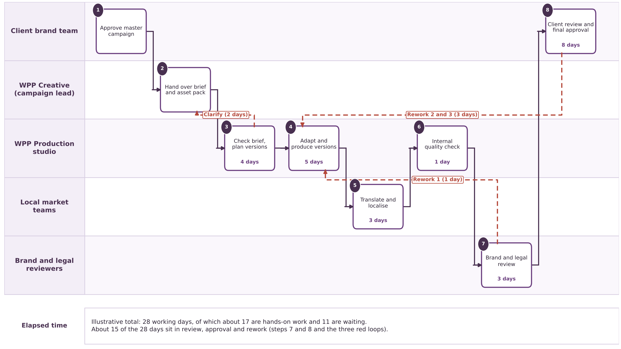
Figure 1. Illustrative current-state workflow. Red dashed lines are rework or clarification loops. Day counts are working days.
Step | Who | What happens | Days elapsed | Of which waiting
1 | Client brand team | Approves the master campaign: the idea, key visuals, script and tone. | before the clock starts | n/a
2 | WPP Creative (campaign lead) | Hands the brief and asset pack to Production. Files are often incomplete or not layered. | 0 | 0
3 | WPP Production studio | Checks the brief, asks questions, and plans the version matrix (markets × channels × versions). | 4 | 2
4 | WPP Production studio | Adapts the master: resizing, copy changes, image and video variants. Individuals may use AI tools, with no shared rules. | 5 | 0
5 | Local market teams | Translate and localise copy and imagery, and check cultural fit. | 3 | 2
6 | WPP Production studio | Internal quality check of every asset against the specification. | 1 | 0
7 | Brand and legal reviewers | Review assets for brand rules, claims, rights and sensitive content. Changes go back to Production (rework 1, one day). | 3 + 1 | 2
8 | Client brand team | Round 1 of review (4 days), rework (2 days), round 2 (2 days), rework (1 day), then final approval and delivery. | 8 + 3 | 5

Days: step 3 includes 2 days waiting for answers to brief questions. Step 7 shows 3 days of review plus 1 day of rework. Step 8 shows 8 days of client review and final approval plus 3 days of rework. The total is 28 days: 4 + 5 + 3 + 1 + 3 + 1 + 8 + 3.

Where the time goes
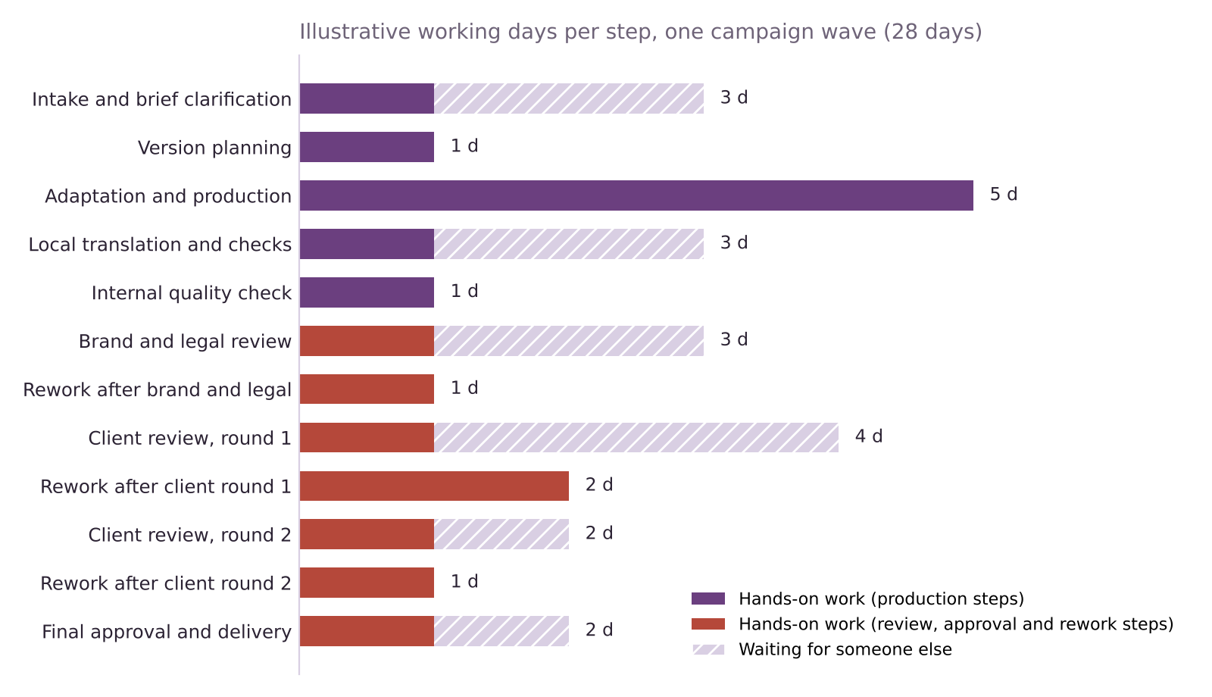
Figure 2. Illustrative working days by step. Red marks steps in review, approval and rework.
- 28 working days in total, about 17 of them hands-on. The other 11 are waiting: for answers, for local teams, for reviewers and for the client.
- Review, approval and rework take about 15 days, or 54%. That is brand and legal review (3 days), rework 1 (1 day), client round 1 (4), rework 2 (2), client round 2 (2), rework 3 (1) and final approval (2). In total: 3 + 1 + 4 + 2 + 2 + 1 + 2 = 15.
- Making the assets takes about 6 days. Version planning and adaptation (1 + 5) are the steps where AI tools are most often added today.
- Waiting is spread across the whole cycle. Only production and the internal check run without waiting time.
A caution on circular reasoning
- The 28-day timeline was built to be consistent with survey signals about review and approval [9][11]. It therefore cannot prove that review is the bottleneck.
- The impact model (Deliverable 8) tests the opposite case, where review is a much smaller share of the timeline, and reports how the conclusion changes.

Bottlenecks, ranked
Rank | Bottleneck | Why it matters (illustrative) | Evidence
1 | Review and approval loops | About 15 of 28 days. Three review stages in sequence and three rework loops. | 46% say content gets stuck in review, 41% in approvals [9]
2 | Unclear or incomplete briefs | 3 days at intake, 2 of them waiting for answers. Also causes late changes. | Assumption; common in agency work but not measured in the sources
3 | Rework after review | 4 days and about 0.6 hands-on hours per asset, which is 19% of the effort. | Follows from the loops above; the size is an assumption
4 | Local adaptation handoffs | 3 days, 2 of them waiting on local teams. | Assumption

Root causes

Fishbone: why content waits in review and approval
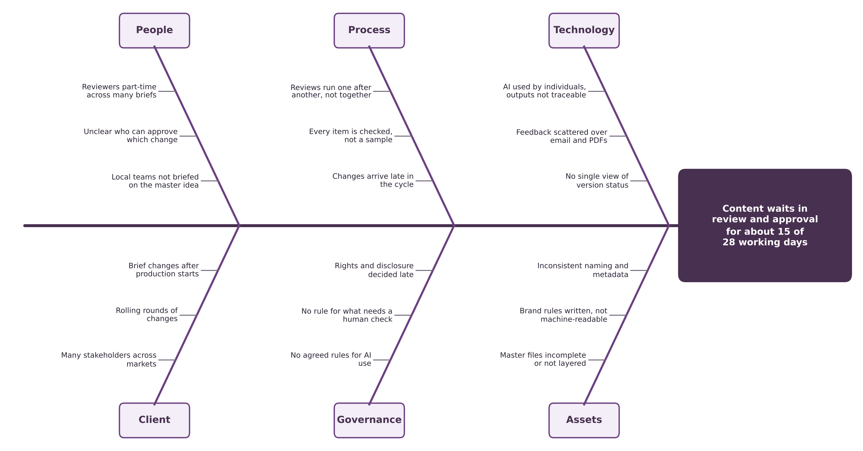
Figure 3. Causes grouped under people, process, technology, client, governance and assets. Illustrative reasoning, not observed findings.

Five whys on the biggest delay
Why | Question | Answer (reasoned from the map)
1 | Why does content wait about 15 of 28 days in review and approval? | Reviewers receive large batches late, one stage after another.
2 | Why do batches arrive late? | The first review happens only after every version has been produced.
3 | Why is nothing reviewed earlier? | Nobody approves the approach (templates, rules, tone) before production starts. Approval is of finished assets.
4 | Why is the approach not approved first? | Brand rules and local adaptations exist as documents and past examples, not as agreed patterns with an owner.
5 | Why is the workflow built that way? | It grew out of single-asset work. Hundreds of versions of one idea were handled by repeating the same checks hundreds of times.

Root cause (working view)
Approval is applied to every finished asset, late and in sequence, rather than to the rules and patterns that produce the assets. If this is right, the largest saving comes from approving patterns once and sampling the rest, which is the idea behind the human gates tested in later deliverables.

What the evidence does and does not support
Claim in the map | What supports it | What is missing
Review and approval are a major source of delay | 46% and 41% say content gets stuck or stalls [9] | Days per stage; the survey is from a vendor and US-based
Production logistics, not ideation, is the constraint | eMarketer’s reading of WPP’s own rationale for WPP Production [11] | WPP gives no volumes, times or savings [12][11]
The case size (480 assets) and the 28 days | Nothing public; reasoned from the work WPP Production describes [11][12] | Everything. Treated as an assumption and tested
About one in three assets is reworked | Nothing public | Everything. Treated as an assumption and tested

What it means for this project

Implications (my analysis)
- Redesign review first. If review and approval are about half the elapsed time, the largest gain is there, not in the making of assets.
- Test the unfavourable case. Because the timeline is built to fit the hypothesis, the model must show what happens if review is only 25% to 30% of the time.
- Keep people where they add value. Three judgement points recur: brand interpretation, claims and cultural sensitivity, and the final sign-off. Deliverable 5 sorts every task by how much judgement and risk it carries.

Open questions for later deliverables
- Which tasks are repeatable enough for AI to do under fixed rules? Deliverable 5 scores this.
- Which approvals can move earlier (before production) and which must stay at the end? Deliverables 6 and 7 design this.
- How much of the elapsed time is waiting that a better workflow could remove, and how much is genuine review? Deliverable 8 tests the range.

Limitations
- The map is a reasoned model. WPP does not publish its workflows, volumes or client data. The steps, days, hours and rework rate are assumptions, labelled illustrative throughout.
- One representative case. Real campaigns vary greatly in markets, channels and complexity. The model is meant to compare designs, not to predict a particular project.
- The evidence is thin. The main support is one vendor survey [9] and one trade-press reading of WPP’s own plans [11]. Neither measures time.

Key terms in plain English
Term | What it means
Swimlane map | A process diagram where each row (lane) shows who does each step, so handoffs between people are visible.
Fishbone diagram | A diagram that groups the possible causes of a problem under headings, so root causes can be tested one by one.
Five whys | Asking “why” repeatedly to move from a symptom to its root cause.
Rework | Work done again after a review or approval asks for changes.
Hands-on work and waiting | Hands-on time is when someone is working on the asset. Waiting is time the asset sits until someone else acts.
Version matrix | The grid of markets, channels and versions that fixes how many assets a campaign needs.

Sources
Numbers in square brackets match this list and the Source Log (Deliverable 1).
Ref | Source (select the title to open it)
[9] | AI speeds up content production but sameness a problem (CMOtech UK). CMOtech UK, 18 Mar 2026.
[11] | Why WPP is rebuilding its production model for always-on marketing. eMarketer, 30 Jan 2026.
[12] | WPP unifies 10,000 creatives into a single global content factory for the AI era. Mediaweek (Australia), 23 Jan 2026.

