PROJECT 2 · DELIVERABLE 5 OF 13
Task Classification Framework
Which tasks AI can do under fixed rules, which need a person to check them, and which stay human-led
At a glance
- 13 tasks scored on four criteria: repeatability, need for creative judgement, brand and legal risk, and data availability. The total decides the lane, with two safety overrides.
- 5 tasks go in Lane 1 (AI-automated), 5 in Lane 2 (AI-assisted, human-checked) and 3 in Lane 3 (human-led). By hands-on hours that is 29%, 43% and 9%, with the remaining 19% being rework after reviews.
- The lanes are not fixed: 3 of 13 tasks would change lane if any single score moved by one point, so the scores need testing with practitioners.

Executive summary
- Why classify tasks. The question for WPP Production is not whether to use AI but where. A task that is repeatable, low-risk and well supported by data can run under fixed rules. A task that needs judgement or carries legal risk needs a person. Sorting tasks first keeps the redesign honest about both.
- Result. Five tasks (29% of hands-on hours) can run under fixed rules with sample checks. Five more (43%) can be drafted by AI but should be checked item by item. Three (9%) stay with people: claims and legal checks, cultural review and final creative sign-off.
- The largest single block is rework. Rework after reviews is 19% of hands-on hours and is not a task a lane can remove. It is an effect of how the workflow is run, which the gates in the next deliverables are designed to reduce.
- Humans stay in the loop by design. The two safety overrides stop anything high-risk from running unchecked, however repeatable it is.

How a task is scored
Each of the 13 tasks in the representative workflow (Deliverable 4) is scored from 1 to 5 on four criteria. I scored them from the nature of the work and the public evidence on where AI is used and where agencies see risk [8][9]. They are judgements, not measurements.
Criterion | 1 means | 5 means
Repeatability (R) | Every item is different | The same steps on every item
Need for creative judgement (J) | Rules decide the answer | A creative or cultural decision is needed
Brand and legal risk (K) | A mistake is cheap and easy to fix | A mistake could breach law, rights or brand trust
Data availability (D) | No examples, rules or specifications to work from | Clear specifications and many approved examples exist

Lane score and rules
Lane score = R + D + (6 − J) + (6 − K). It runs from 4 to 20. A score of 16 or more is Lane 1, 11 to 15 is Lane 2 and 10 or less is Lane 3. Two safety rules override the score: a task with risk 5 can never be Lane 1, and a task with risk 5 and judgement 4 or more is always Lane 3. A task with judgement 5 is always Lane 3.

The three lanes
Lane | How the work runs | How people are involved
Lane 1: AI-automated | AI does the task under fixed, tested rules. | A person checks a sample of the output (for example one in ten, an assumption) and handles exceptions the system flags.
Lane 2: AI-assisted, human-checked | AI drafts or produces a first version. | A specialist reviews every item before it moves on.
Lane 3: human-led | People decide. AI may help with research or options. | People own the result from start to finish.

Results
ID | Task | Hours per asset | R | J | K | D | Score | Lane
T1 | Intake, brief check and version planning | 0.15 | 3 | 3 | 2 | 4 | 14 | Lane 2
T2 | Resize and reformat to channel specifications | 0.35 | 5 | 1 | 1 | 5 | 20 | Lane 1
T3 | Copy adaptation and transcreation (local tone) | 0.40 | 3 | 4 | 3 | 3 | 11 | Lane 2
T4 | First-pass translation and subtitles | 0.20 | 5 | 1 | 2 | 4 | 18 | Lane 1
T5 | Image and video variants (backgrounds, cut-downs) | 0.55 | 3 | 3 | 3 | 3 | 12 | Lane 2
T6 | Local imagery swaps (people, places, products) | 0.10 | 3 | 3 | 4 | 3 | 11 | Lane 2
T7 | Technical quality checks (file specs, safe zones, loudness) | 0.12 | 5 | 1 | 1 | 5 | 20 | Lane 1
T8 | Brand-rule compliance check (logos, colours, fonts) | 0.10 | 5 | 1 | 3 | 4 | 17 | Lane 1
T9 | Claims, rights and legal check | 0.15 | 2 | 4 | 5 | 3 | 8 | Lane 3
T10 | Cultural review for sensitive markets | 0.05 | 2 | 5 | 5 | 2 | 6 | Lane 3
T11 | Review handling and feedback consolidation | 0.18 | 4 | 2 | 2 | 3 | 15 | Lane 2
T12 | Packaging, naming, metadata and delivery | 0.15 | 5 | 1 | 1 | 5 | 20 | Lane 1
T13 | Brand interpretation and final creative sign-off | 0.10 | 1 | 5 | 4 | 2 | 6 | Lane 3

Hours per asset are the illustrative current-state hands-on hours from Deliverable 4. The 13 tasks total 2.60 hours. Rework after review adds 0.60 hours, giving 3.2 hours per asset. Rework is not scored because it is an effect of the process, not a task.
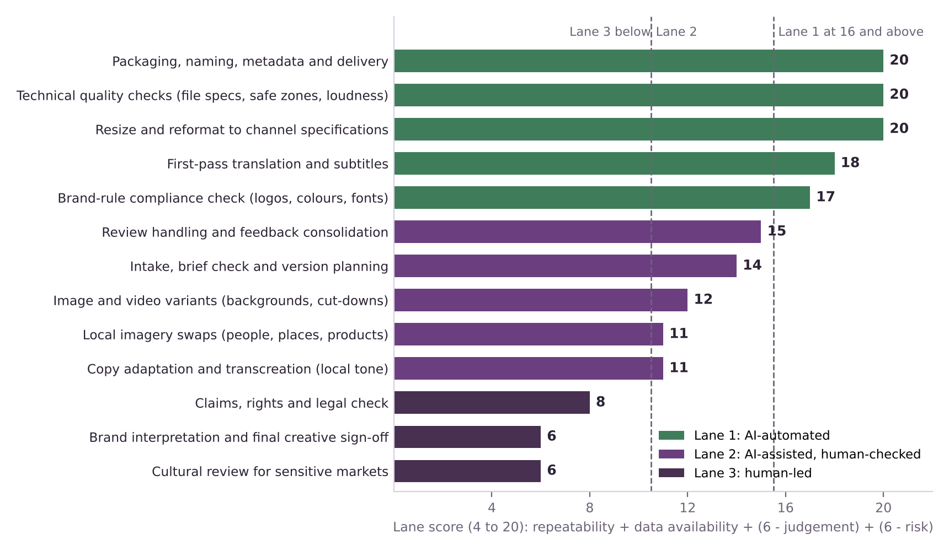
Figure 1. Lane score by task. Dashed lines mark the lane thresholds.
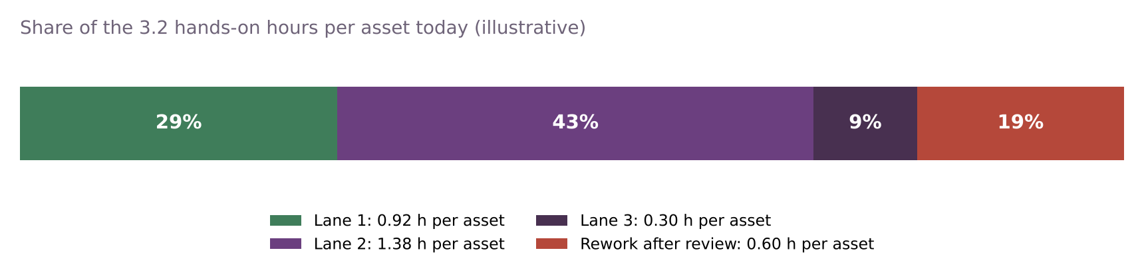
Figure 2. Share of today’s hands-on hours by lane, with rework shown separately (illustrative).

Reading the results
- Lane 1 is mostly “plumbing”. Resizing, technical checks, packaging and rule-based compliance checks are repeatable, low in judgement and well specified. First-pass translation and subtitles also land here because the copy is already approved and the risk is moderate. A sample check is enough, with exceptions flagged.
- Lane 2 is where most of the hours sit. Copy adaptation, image and video variants, local imagery swaps, intake and review handling are partly repeatable but need judgement or carry brand risk. AI can draft; a specialist must check each item.
- Lane 3 is small in hours but large in consequence. Claims and legal checks, cultural review and final creative sign-off carry the risk and judgement. Only 3 of 13 tasks and about 9% of hours, but they are where a mistake does most harm. This is consistent with 96% of professionals saying human oversight is critical [9] and legal risk being the second most-cited barrier to AI in agencies (62%) [8].
- Two starting guesses held, with a caveat. The outline expected first-pass translation to be Lane 1, and it is, but only because subtitles and approved copy keep its risk at 2. It also expected local imagery swaps in Lane 2, and they are, but only just: brand risk of 4 pulls the score down to 11.

How sensitive the lanes are
If any single score moves by one point, 3 of the 13 tasks change lane: T3 (copy adaptation and transcreation), T6 (local imagery swaps), T11 (review handling and feedback consolidation). The other 10 are firmly in their lane.
- Review handling and feedback consolidation (T11) sits one point below the Lane 1 line. Better tooling for collecting and merging feedback would move it up.
- Copy adaptation (T3) and local imagery swaps (T6) sit exactly on the Lane 2 and 3 line. They depend on how risky the market or the brand is. For a regulated product or a sensitive market, treat them as one lane more human.
- What this means: the scores are a starting point for a workshop with producers, brand and legal reviewers, not a final answer. The impact model tests moving work between lanes.

What it means for this project

Implications (my analysis)
- Direct AI savings are limited to about 72% of hours, and only partly. Lane 1 work can shrink a lot, Lane 2 work only somewhat. Lane 3 and rework do not shrink from AI alone.
- Rework is the prize. At 19% of hours and a large share of elapsed time, it is bigger than all of Lane 1. This supports the working hypothesis: the main gain comes from fewer review loops, not faster generation.
- The gates follow from Lane 3. Brand interpretation, claims and cultural sensitivity are where human decisions must stay, so they are where the gates go.

Open questions for later deliverables
- How much faster can Lane 2 work become with AI drafting? The model will use a range, with the unattributed 70% claim [6] as the optimistic case only.
- How large should the Lane 1 sample be? One in ten is an assumption; the governance deliverable will set rules.

Limitations
- The scores are my judgement. They have not been tested with producers or reviewers. The sensitivity test shows which are shaky.
- The hours are illustrative. They follow the representative case in Deliverable 4 and are not WPP data.
- Task lists differ between teams. A real workshop would add or merge tasks.

Key terms in plain English
Term | What it means
Transcreation | Adapting a message to a local market so that it keeps its meaning and feel, rather than translating word for word.
Compliance check | A check that an asset follows rules, such as logo placement, colours and approved wording.
Sample check | Reviewing a small share of the items an automated step produced, instead of every item.
Safe zone | The part of a frame where text and key images must sit so that platforms do not crop them.
Override rule | A rule that moves a task to a more human lane whatever its score.

Sources
Numbers in square brackets match this list and the Source Log (Deliverable 1).
Ref | Source (select the title to open it)
[6] | WPP bets on $400 million Google AI alliance. Campaign Asia, 2025 (date not shown).
[8] | The State of AI Inside US Marketing Agencies 2026 (reported by MediaPost). MediaPost, 6 Jul 2026.
[9] | AI speeds up content production but sameness a problem (CMOtech UK). CMOtech UK, 18 Mar 2026.

