PROJECT 2 · DELIVERABLE 6 OF 13
Options Analysis and Recommendation
Three ways WPP Production could use AI to turn one approved campaign into hundreds of market and channel assets
At a glance
- Three options were scored on six weighted criteria. Option B, a redesigned workflow with three lanes and four human gates, scores 3.70 out of 5. Option C, platform-led self-service, scores 3.20 and option A, bolt-on AI tools, scores 2.85.
- The ranking holds in most tests. B stays first with equal weights and when any single score moves by one point. It loses to C only if speed and cost together carry about 60% of the weight, against 40% in the base case.
- Recommendation: build B in stages. Start with a pilot on one campaign, expand only if the pilot shows a clear time and rework gain, and consider limited self-service later for low-risk asset types.

Executive summary
- The question. How should WPP Production redesign the route from an approved global campaign to market and channel assets, so AI handles repeatable work and people keep the judgement calls?
- The options. A adds AI tools to today’s workflow. B redesigns the workflow around three lanes and four human gates. C moves most production to client self-service on a platform such as WPP Open Pro [7].
- The result. B scores highest at 3.70 out of 5. A scores 2.85 because it speeds up making but leaves about 15 of the 28 working days of review and rework in place (Deliverable 4). C scores 3.20 because it is fastest and cheapest but weakest on brand safety, legal risk and client acceptance.
- How firm this is. The scores are my judgement, not measurements. The lead over C is clear in the base case and disappears if speed and cost are given much more weight than quality and risk. Deliverable 8 tests the numbers behind the speed and cost scores.
- What to do. Run B as a staged pilot on one live campaign wave, with clear stop rules, and keep C as a later, limited extension.

The three options
Option | What it is | What changes | Main trade-off
A. Bolt-on AI tools | Production teams use generative AI for resizing, translation, image variants and checks, inside today’s workflow. Review stays as it is: every finished asset, one stage after another. | Very little. Same steps, same reviewers, same client rounds. | Cheapest to start. Does not touch the 15 review and rework days, so the timeline barely moves.
B. Three lanes, four gates | Work is sorted into three lanes (Deliverable 5). AI does the repeatable work in Lane 1 under agreed rules, AI drafts and people finish in Lane 2, and people decide in Lane 3. Four human gates replace repeated review of every asset. | Review moves earlier and becomes selective: approve the rules and a first sample, check every high-risk item, sample the rest. | Largest potential gain in time and rework. Needs clients to accept sampling and needs new working habits.
C. Platform-led self-service | Clients, or WPP on their behalf, generate market and channel versions through a self-service platform such as WPP Open Pro [7]. People handle exceptions only. | Most of the production workflow. The agency role moves from making assets to running the platform and handling exceptions. | Lowest cost per asset if it works. Brand safety, legal risk and client accountability move to the client or the platform.

All three use AI. The difference is where people stay involved and how review is organised. Option B is the working hypothesis from the start of the project: the main gain comes from fewer review loops, not faster generation. This analysis tests it against two alternatives.

How the options were scored

Criteria and weights
Criterion | Weight | Why it matters here
Quality and brand safety | 25% | Wrong or off-brand work reaches the public. This is the main promise to clients, and 96% of marketers say human oversight is critical [9].
Speed | 20% | Elapsed time from approved master to delivered assets. Speed to market is one of the clearest client benefits.
Cost per asset | 20% | Hands-on cost of making and reviewing one asset. WPP plans £500m of annual savings by 2028 [10].
Legal and IP risk | 15% | Claims, rights, copyright and disclosure. Agency leaders name accuracy and bias (63%) and legal risk (62%) as the main barriers to AI use [8].
Client acceptance and revenue protection | 10% | Whether clients will accept the new way of working, and whether fee income is protected. Analysts see AI tools as a threat to agency revenue [5][13].
Change and people impact | 10% | Disruption to roles, skills and morale. WPP says WPP Production is not driven by cost cutting and does not anticipate layoffs [11].

The weights are my judgement. Quality and risk together carry 40%, speed and cost together 40%, and client and people effects 20%. A reviewer at WPP or a client might weight them differently, which is why the sensitivity tests below matter.

Scores
Each option is scored from 1 (poor) to 5 (strong) on each criterion, where a higher score is always better. For cost, a score of 5 means the lowest cost per asset. For change and people impact, a score of 5 means the least disruption.
Criterion | Weight | A. Bolt-on | B. Three lanes | C. Platform
Quality and brand safety | 25% | 3 | 4 | 2
Speed | 20% | 2 | 4 | 5
Cost per asset | 20% | 3 | 4 | 5
Legal and IP risk | 15% | 2 | 4 | 2
Client acceptance and revenue protection | 10% | 4 | 3 | 2
Change and people impact | 10% | 4 | 2 | 2
Weighted score (out of 5) | 100% | 2.85 | 3.70 | 3.20

Reasons for the scores
Criterion | A. Bolt-on AI tools | B. Three lanes, four gates | C. Platform-led
Quality and brand safety | Unchanged review, but AI used with no shared rules can add inconsistent output. 3 | Rules are agreed first, humans decide the risky items, and checks are logged. 4 | Quality depends on client skill and platform controls, and the risk of sameness rises [9]. 2
Speed | Only the making steps get faster. About 15 of 28 days stay. 2 | Fewer, earlier review loops. Design target 18 days against 28 (Deliverable 7). 4 | Fastest, because most waiting disappears. 5
Cost per asset | Saves part of the Lane 1 and Lane 2 hours, with rework unchanged. 3 | Saves hours in Lanes 1 and 2 and cuts rework, but adds gate and sampling work. 4 | Lowest hours per asset once set up. 5
Legal and IP risk | Individuals choose their own tools and prompts, so exposure is uneven [8]. 2 | Every claim, rights and sensitive-market item is checked by a person at Gate 3. 4 | Provenance and claims checks move to the client. 2
Client acceptance and revenue protection | No change for clients. Fee pressure from AI remains [5]. 4 | Clients must accept pattern approval and sampling, which is a real change. 3 | Fits smaller brands only, may cut agency fees, and WPP presents it as complementary [7]. 2
Change and people impact | Small change to how people work. 4 | New roles for gate owners and a different workload for reviewers. 2 | Largest change to production roles, though WPP expects no layoffs [11]. 2

Evidence is thin on all six criteria. WPP publishes no volumes, times or savings for WPP Production [11][12], and the survey evidence is from US vendors and trade bodies [8][9]. The scores therefore rest on reasoning about how each option changes the map in Deliverable 4.

How sensitive is the ranking?
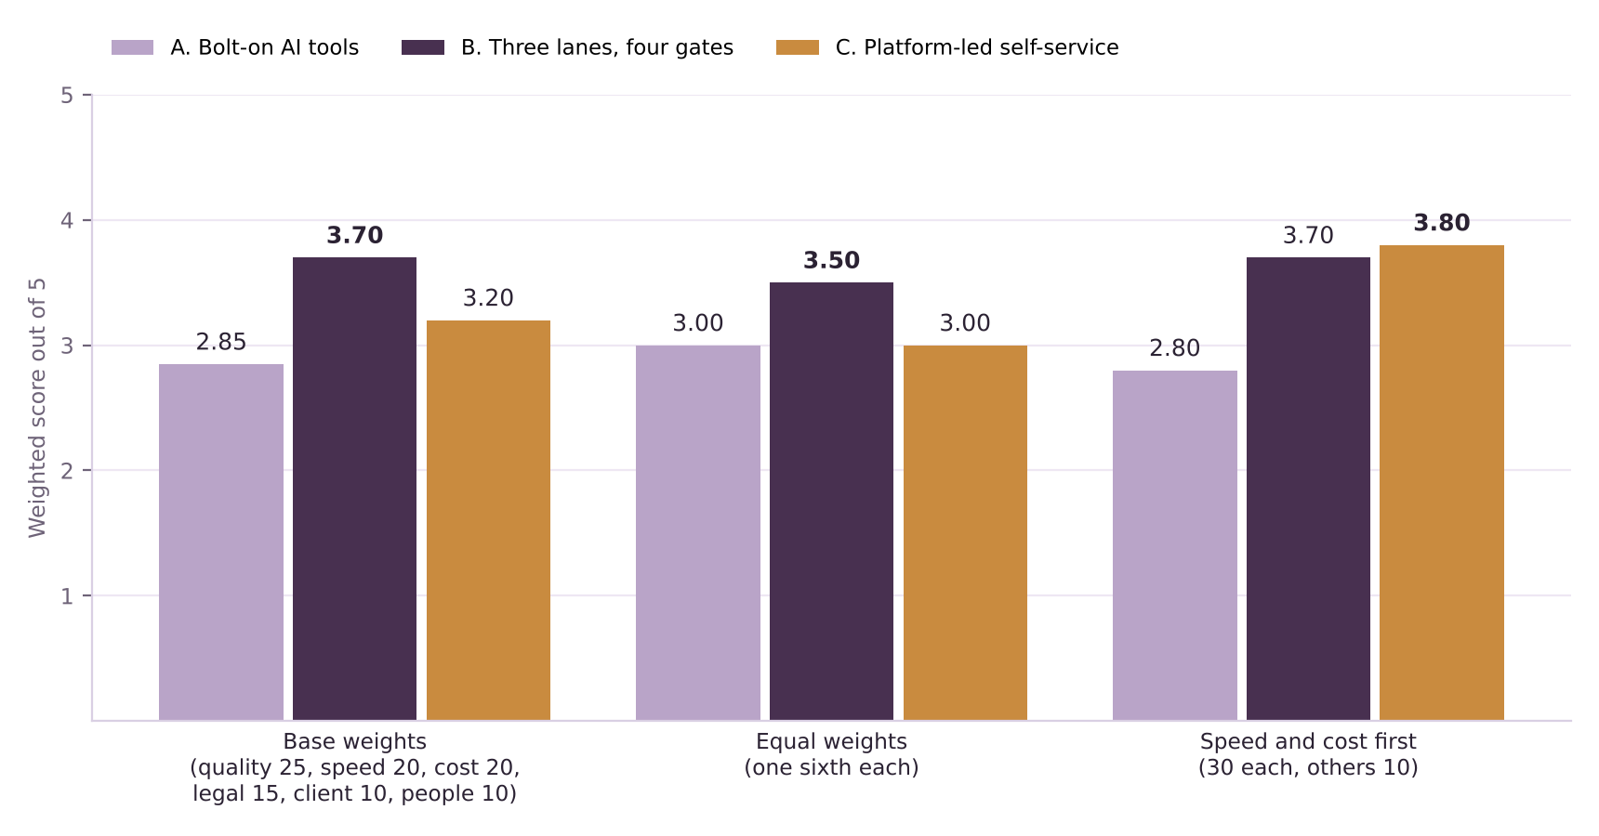
Figure 1. Weighted scores out of 5 under three sets of weights. The highest score in each group is in bold.
Test | A | B | C | Result
Base weights | 2.85 | 3.70 | 3.20 | B first
Equal weights (one sixth each) | 3.00 | 3.50 | 3.00 | B first
Safety first (quality 35, legal 25, others 10) | 2.85 | 3.70 | 2.60 | B first, by a wider margin
Speed and cost first (30 each, others 10) | 2.80 | 3.70 | 3.80 | C narrowly first
Any single score moved up or down by 1 | – | – | – | B stays first in all cases tested
B’s client-acceptance score cut to 2 and people score to 1 | 2.85 | 3.50 | 3.20 | B first
B’s quality and legal scores both cut to 3 | 2.85 | 3.30 | 3.20 | B first, narrowly (3.30 against 3.20)

- B’s lead is robust to the weights, with one exception. If speed and cost together carry about 60% of the weight (40% in the base case), C overtakes B. A board that cares mostly about speed and unit cost would reasonably prefer C.
- A is never first in any test run. It scores only 2 on speed and 2 on legal risk, because it leaves the review structure and the AI rules unchanged.
- B’s weak points are people and clients. Its lowest scores are on change impact and client acceptance. The pilot should test both, not just time saved.
What would change this advice
- If a pilot shows review is a much smaller share of elapsed time than the 54% assumed (Deliverable 4), B’s speed advantage over A shrinks.
- If large clients refuse pattern approval and sampling, B reduces to A with better rules.
- If clients adopt platform tools quickly and accept the quality risk, C becomes more attractive for low-risk asset types.

Stakeholders
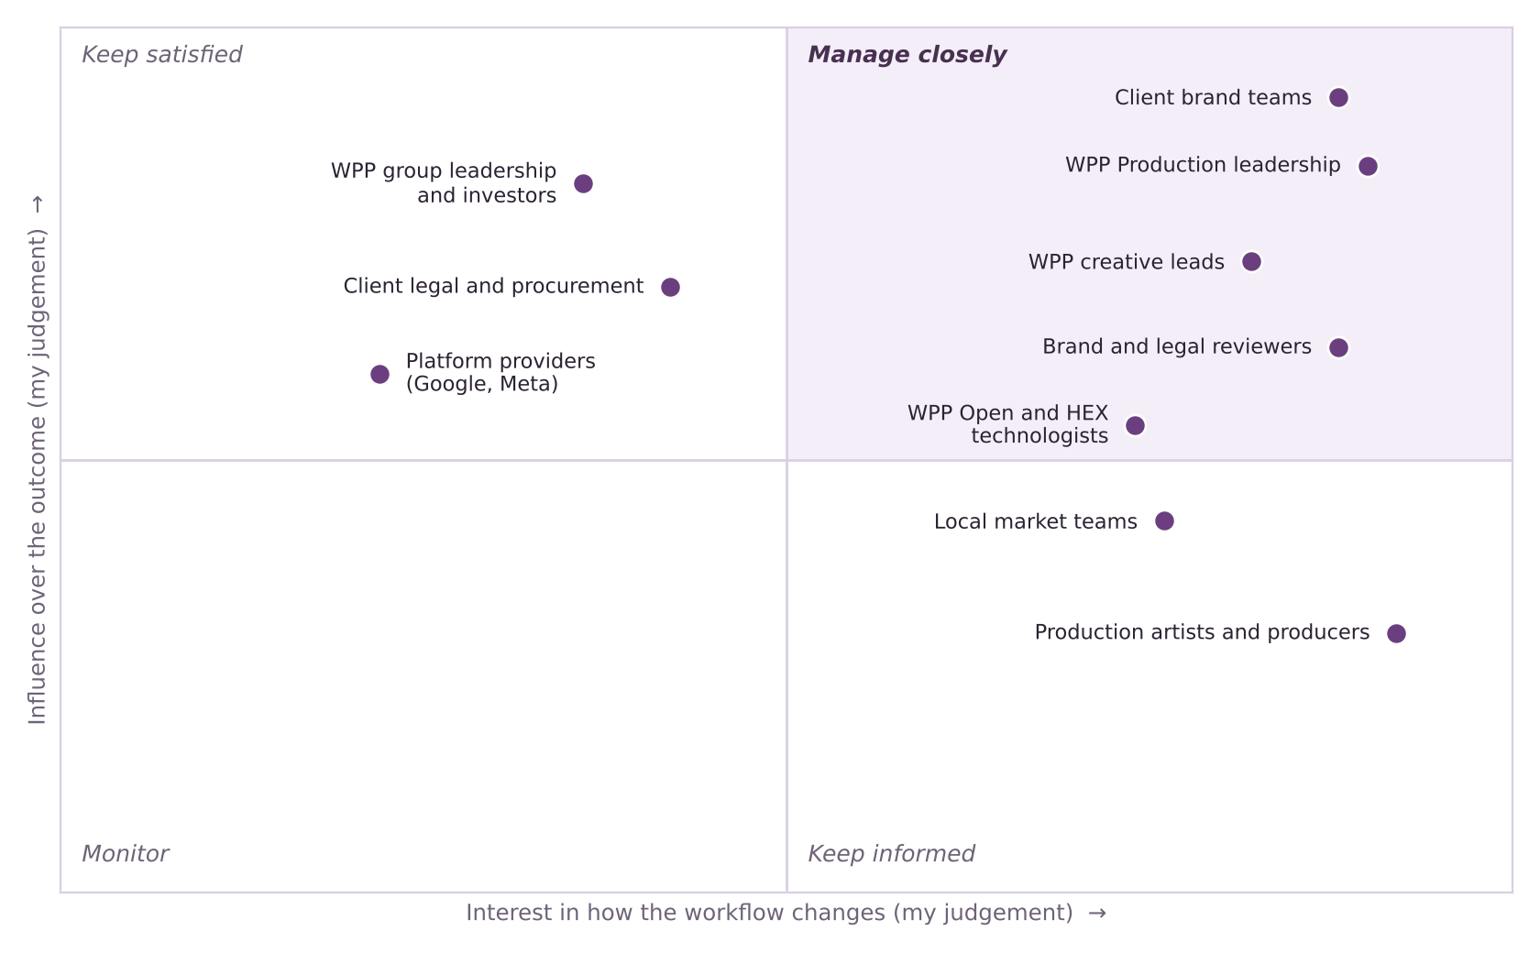
Figure 2. Stakeholders by influence and interest. Positions are my judgement from public information, not survey results.
Stakeholder | Wants | Likely concern | How to engage
Client brand teams | Faster delivery, consistent brand, no surprises | Loss of control if they approve samples rather than every asset | Co-design the rules at Gate 1; show sample results early
Client legal and procurement | Clear accountability for claims and rights; lower cost | AI-made content with unclear origin | Agree the AI-use rules and who signs off claims
WPP Production leadership | Cost and speed gains within Elevate28 [10][11] | Disruption to clients while the unit is still being formed | Sponsor the pilot; own the targets
WPP creative leads | Creative integrity across versions | Idea diluted by automated versions | Own Gate 2; set what can and cannot change
Brand and legal reviewers | Fewer, better-prepared reviews | Being blamed for errors in items they only sampled | Define sample sizes and escalation rules with them
Local market teams | Respect for local judgement | Being bypassed by machine translation | Keep cultural review in Lane 3 with named owners
Production artists and producers | Less repetitive work; skills growth | Job security and deskilling | Involve in pattern design; train on tools and rules
WPP Open and HEX technologists | Real use of the platform and tools [1] | Pressure to deliver tools before rules exist | Build tools to the gate rules, not ahead of them
Platform providers (Google, Meta) | Wider use of their creative tools [5][6][14] | Not a direct party, but shapes what clients expect | Monitor; keep the design able to use their tools
WPP group leadership and investors | Savings and a credible AI story [3][10] | Slow proof; reputational risk from AI errors | Report pilot results against stated targets

Production artists, producers and local teams have the least formal influence but carry the day-to-day change. The pilot design should involve them from the start, because a gate that people do not trust will be bypassed.

Recommendation
Recommended option
Option B: redesign the workflow around three lanes and four human gates, and introduce it in stages with stop rules. Take the quick wins from A inside that design, and consider C only for low-risk asset types once B has proved itself.

Stage | When | What happens
0. Prepare | Weeks 0 to 4 | Choose one pilot campaign wave. Write the brand and AI-use rules as checkable rules. Record today’s time, hours and rework as the baseline.
1. Pilot | Weeks 5 to 16 | Run the three lanes and four gates on that wave. Measure elapsed time, hands-on hours, assets sent back and critical errors.
2. Extend | Months 4 to 8 | Move to three to five clients if the pilot meets its targets. Add gate owners and train reviewers.
3. Scale and review | Months 9 to 12 | Make B the standard route. Test self-service for low-risk Lane 1 asset types, in the spirit of option C.

- Proposed pilot test (my assumption): continue only if elapsed time is at least 25% shorter than the baseline and assets sent back for brand or legal reasons do not rise. Deliverable 9 sets the full stop rules.
- Why not start with C? It carries the most risk on the criteria that clients care about most, rests on the least reliable evidence [7], and needs B’s rules and gates to work safely anyway.
- Why not stop at A? It is a sound first step but leaves the largest delay, review and rework, untouched.

Limitations
- Scores and weights are my judgement. They have not been tested with WPP staff or clients. The sensitivity tests show which conclusions are firm.
- Public evidence is thin. WPP does not publish production volumes, times or savings, and the unattributed claim of “up to 70%” faster content production [6] is used only as an optimistic case in Deliverable 8.
- The options are simplified. A real design would mix elements, and the options would be refined with client input.

Key terms in plain English
Term | What it means
Weighted decision matrix | A table that scores options on several criteria and multiplies each score by how much that criterion matters.
Sensitivity test | Changing an assumption to see whether the conclusion still holds.
Gate | A point in the workflow where a named person must approve before work continues.
Sampling | Checking a small share of items instead of all of them, with a rule for checking more if errors appear.
Self-service platform | A tool that lets the client create and publish assets directly, with little or no agency involvement.
Stop rule | A pre-agreed result that ends or rescopes a pilot.

Sources
Numbers in square brackets match this list and the Source Log (Deliverable 1).
Ref | Source (select the title to open it)
[1] | WPP 2026 Interim Results. WPP (RNS via Investegate), Aug 2026.
[3] | WPP Is “On Track” With Turnaround Plan, as Revenue Drops 5.6% in First Half of 2026. Adweek, Aug 2026.
[5] | WPP’s rocky Q4 underscores AI disruption across agencies. eMarketer, 2026.
[6] | WPP bets on $400 million Google AI alliance. Campaign Asia, 2025 (date not shown).
[7] | WPP’s AI Tool Lets Brands Skip Agencies for Ad Creation. WebProNews, Undated.
[8] | The State of AI Inside US Marketing Agencies 2026 (reported by MediaPost). MediaPost, 6 Jul 2026.
[9] | AI speeds up content production but sameness a problem (CMOtech UK). CMOtech UK, 18 Mar 2026.
[10] | Strategy Update and 2025 Preliminary Results. WPP (RNS via Investegate), 26 Feb 2026.
[11] | Why WPP is rebuilding its production model for always-on marketing. eMarketer, 30 Jan 2026.
[12] | WPP unifies 10,000 creatives into a single global content factory for the AI era. Mediaweek (Australia), 23 Jan 2026.
[13] | FAQ on ad agencies: Consolidation, AI disruption, and what’s changing in 2026. eMarketer, 2026.
[14] | Meta Plans To Automate All Ad Creation By 2026: Report. MediaPost, 2 Jun 2025.

