PROJECT 2 · DELIVERABLE 7 OF 13
Future-State Process Map and RACI
The recommended three-lane workflow with four human gates, who does what, and the design target for elapsed time
At a glance
- The redesign moves review earlier and makes it selective. The client approves the brief and rules (Gate 1) and a first sample (Gate 2). People then check every high-risk item at Gate 3 and sample the rest. The client reviews once at Gate 4.
- AI does repeatable work only under written rules. Lane 1 tasks run automatically and are sampled. In Lane 2, AI drafts and people finish. In Lane 3, people decide and AI does not clear anything.
- Design target: 18 working days against 28 today. That is 36% shorter, and review, approval and rework fall from about 15 days to about 8. This is an illustrative target, tested in Deliverable 8.

Executive summary
- What this is. The future-state design for option B in Deliverable 6, applied to the same 480-asset case used in Deliverable 4: 20 markets, 6 channels and 4 versions each.
- How it works. Five stages and four gates replace eight steps and three rework loops. Work is split into the three lanes scored in Deliverable 5. Brand rules are written as checkable rules before production, so machines can check what they can and people check what they must.
- Where people stay. Brand interpretation, claims and rights, cultural review and client sign-off remain human decisions. This matches WPP’s stated principle that AI “augments human creativity rather than replacing it” [1] and the 96% of marketers who say human oversight is critical [9].
- What it targets. 18 working days instead of 28. The saving comes mainly from review: about 8 days instead of 15. Making and waiting fall from about 13 days to about 10. The target sits inside the 30% to 45% starting hypothesis but is an assumption, not evidence.

Design principles
# | Principle | What it means in practice
1 | Approve the pattern once | The client approves the brief, the brand rules and a first sample. They then do not need to approve every version of the same pattern.
2 | No rules, no AI output | AI only produces work against written, checkable rules. If a rule does not exist for a case, a person handles it.
3 | People decide where judgement or risk is high | Every Lane 3 item gets a human check: claims, rights, sensitive markets and brand interpretation.
4 | Sample the rest, and widen the sample if errors appear | Lane 1 and Lane 2 output is checked by sampling. One critical error in a sample widens the check to the whole batch.
5 | Anyone can stop the line | A producer, reviewer or the AI workflow lead can stop a batch when a quality or legal risk appears. One round of client changes is included.

Future-state process map
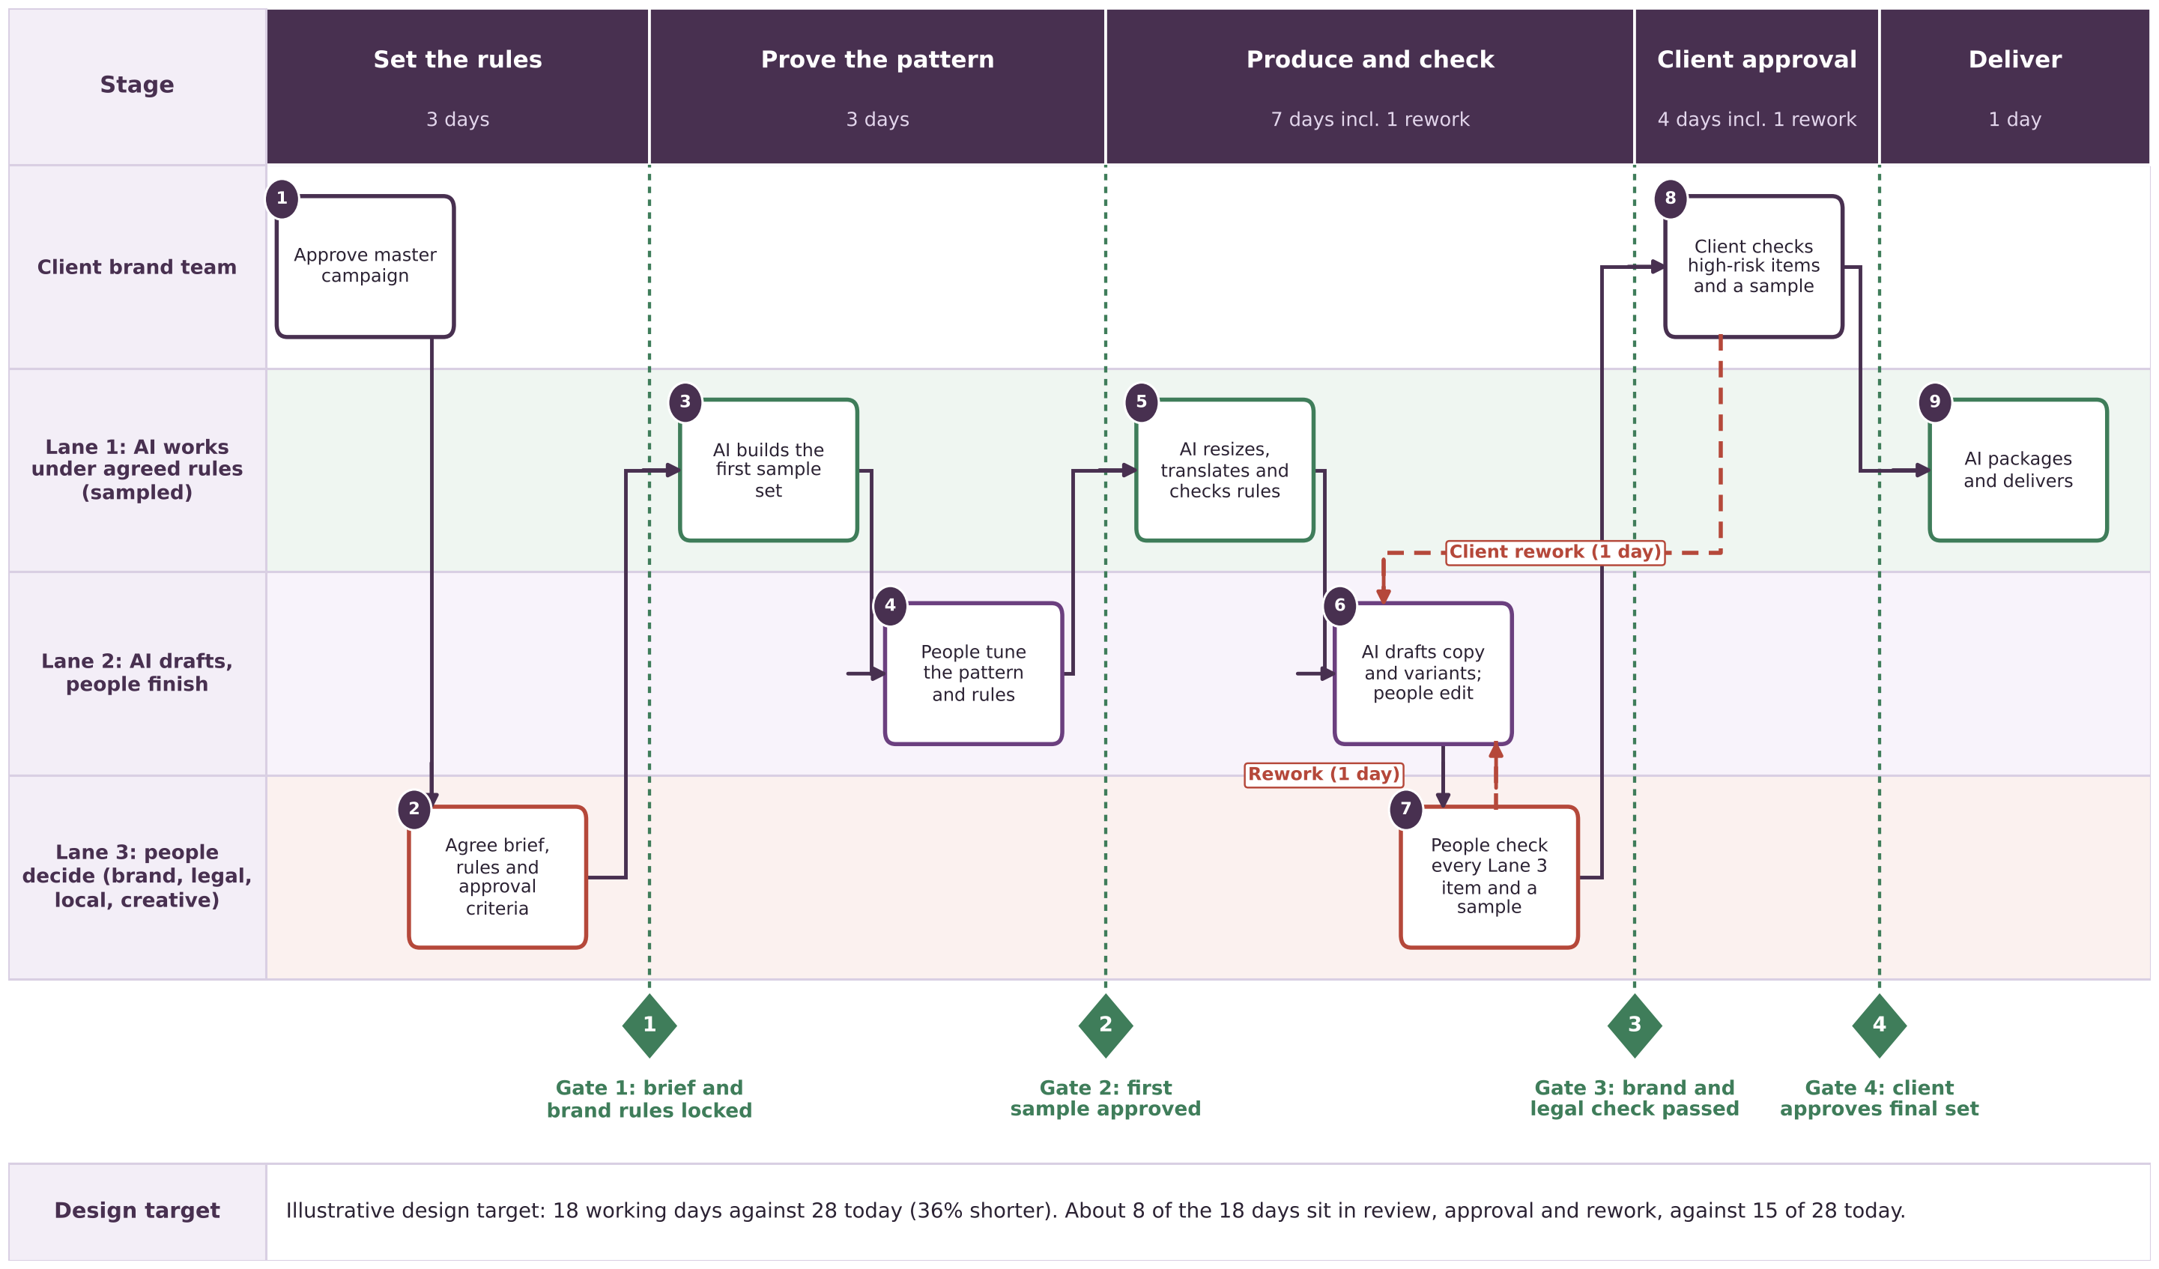
Figure 1. Illustrative future-state workflow. Green dotted lines are the four gates. Red dashed lines are rework loops. Day counts are working days.

The five stages
Stage | What happens | Who | Days | Of which waiting
Set the rules | Client and WPP agree the brief, the brand rules written as checkable rules, the AI-use rules and what each gate needs to see (Gate 1). | Client brand lead, Production lead, brand reviewer | 3 | 1
Prove the pattern | AI builds a first sample set (two or three assets per asset type, in two markets). People tune the pattern and the rules. The client approves the sample (Gate 2). | AI workflow lead, producers and artists, creative lead, client | 3 | 0
Produce and check | Lane 1 and Lane 2 production in all markets (4 days). People check every Lane 3 item and a sample of the rest (2 days). Fixes take 1 day (Gate 3). | Producers and artists, local teams, brand and legal reviewers | 7 | 2
Client approval | The client reviews every high-risk item and a sample of the rest (3 days). One round of fixes (1 day) (Gate 4). | Client brand lead | 4 | 1
Deliver | AI packages, names, adds metadata and delivers. The set is archived with its check log. | Production lead, AI workflow lead | 1 | 0
Total |  |  | 18 | 4

Review, approval and rework days: 1 (Gate 2 decision) + 2 (Gate 3 check) + 1 (rework) + 3 (client review) + 1 (rework) = 8. This uses the same definition as Deliverable 4, which counts the stages after production starts in which someone other than the producer checks, approves or sends back work. Setting the brief and rules at Gate 1 is counted in neither.

Time: today against the design target
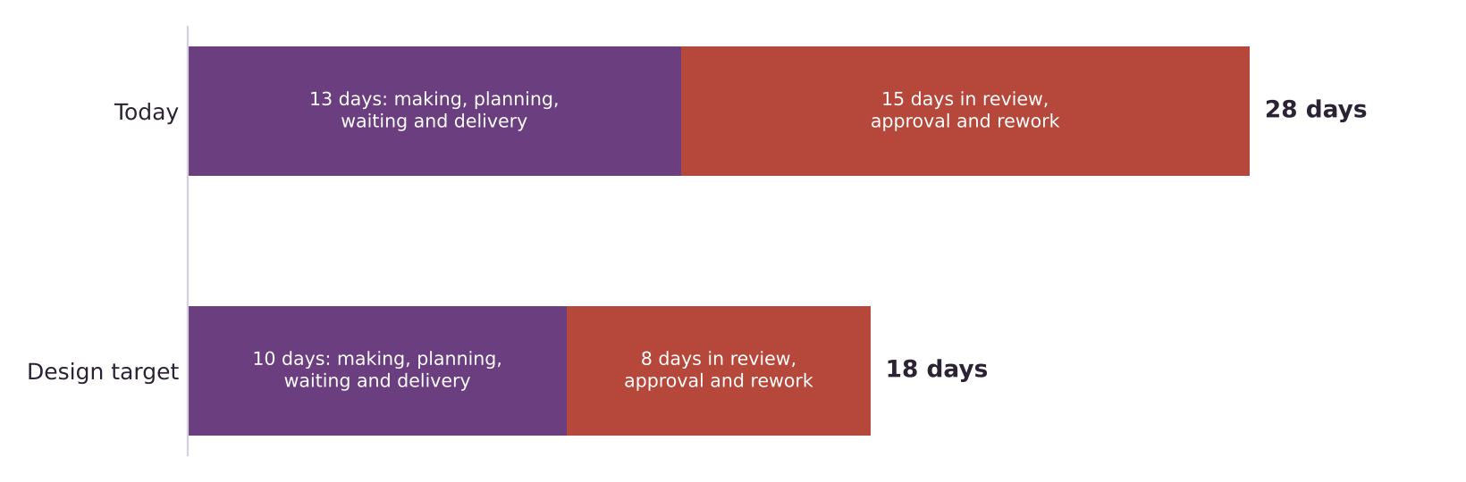
Figure 2. Illustrative working days for one campaign wave. Today’s figures come from Deliverable 4.
Measure | Today | Design target | Change
Elapsed working days | 28 | 18 | 36% shorter
Days in review, approval and rework | 15 | 8 | 47% fewer
Other days (making, planning, waiting, delivery) | 13 | 10 | 23% fewer
Days spent waiting for someone else | 11 | 4 | 7 fewer
Rework days | 4 | 2 | 2 fewer
Rounds of client review | 2 | 1 | 1 fewer

- Most of the saving is in review. Review, approval and rework fall by 7 days. Everything else falls by 3. This is what the working hypothesis predicts.
- The 36% is a design target, not a finding. It was set within the starting range of 30% to 45% and is tested against a low and a high case in Deliverable 8.
- The first wave for a new client will probably take longer. The brand and AI-use rules have to be written at Gate 1. The target assumes some of that work already exists.

The four gates
Gate | Decision | Who decides | What they see | Pass rule | If it fails
Gate 1 | Brief and brand rules locked | Client brand lead | Brief checklist, the brand rules as checkable rules, the market-channel-version matrix, the AI-use rules, the sample sizes | All checklist items complete and the rules signed by the client | No production starts. Back to the brief
Gate 2 | First sample approved | Client brand lead, with the creative lead | Two or three assets per asset type in two markets, with their check results | Client confirms the pattern and rules produce acceptable work. Decision within 1 working day | Change the template or rule and rebuild the sample. Cheap, because few assets exist yet
Gate 3 | Brand and legal check passed | Brand reviewer (brand) and legal reviewer (claims and rights) | Every Lane 3 item, plus a sample (assumed 1 in 10) of Lane 1 and 2 items, at least one per market and channel, with check logs | No critical issue. One critical error in a sample widens the sample to the whole batch | One day of fixes, then recheck of changed items only
Gate 4 | Client approves final set | Client brand lead | Summary of the set, every high-risk item, a sample, the log of changes since Gate 2 | Approval of the set. One round of changes is included | Changes beyond one round are handled as a change request (assumption)

The sample size of 1 in 10, the day limits and the one round of changes are my assumptions. Deliverable 9 turns them into governance rules and review points.

How each task works in the future state
The lanes and hours come from Deliverable 5. The hours shown are today’s hands-on hours per asset. Deliverable 8 estimates how much each lane shrinks.
Task | Name | Lane | Hours today | Who does what in the future state
T1 | Intake, brief check and version planning | Lane 2 | 0.15 | AI checks the brief against a checklist and drafts the version plan. A producer decides (Gate 1).
T2 | Resize and reformat to channel specifications | Lane 1 | 0.35 | Automated. Checked in the sample at Gate 3.
T3 | Copy adaptation and transcreation (local tone) | Lane 2 | 0.40 | AI drafts local copy under the tone rules. A local writer edits and approves.
T4 | First-pass translation and subtitles | Lane 1 | 0.20 | AI translates using an approved glossary. A local reviewer checks the sample and all Lane 3 items.
T5 | Image and video variants (backgrounds, cut-downs) | Lane 2 | 0.55 | AI generates variants under the rules. An artist selects and finishes.
T6 | Local imagery swaps (people, places, products) | Lane 2 | 0.10 | AI proposes swaps. An artist and the local team confirm each one.
T7 | Technical quality checks (file specs, safe zones, loudness) | Lane 1 | 0.12 | Automated checks with a log. Failures go to an artist.
T8 | Brand-rule compliance check (logos, colours, fonts) | Lane 1 | 0.10 | Automated against the Gate 1 rules. Brand reviewer checks the sample.
T9 | Claims, rights and legal check | Lane 3 | 0.15 | A legal reviewer checks every item. AI may flag candidates but does not clear them.
T10 | Cultural review for sensitive markets | Lane 3 | 0.05 | A local reviewer checks every item for sensitive markets.
T11 | Review handling and feedback consolidation | Lane 2 | 0.18 | AI consolidates comments and routes them. A producer decides what to change.
T12 | Packaging, naming, metadata and delivery | Lane 1 | 0.15 | Automated, with the check log attached.
T13 | Brand interpretation and final creative sign-off | Lane 3 | 0.10 | Brand reviewer and client decide. No AI decision.

Who does what: RACI
R = does the work. A = accountable, the one person who answers for the result. C = consulted before the decision. I = informed afterwards. Every activity has exactly one A. Roles are illustrative: WPP’s internal job titles are not public.
Activity | Client brand lead | WPP creative lead | Production lead | Producers and artists | AI workflow lead | Local market team | Brand reviewer | Legal reviewer
Approve the master campaign (before the clock starts) | A | R | I |  |  | I | C | C
Agree brief, brand rules and approval criteria (Gate 1) | A | C | R | I | C | C | R | C
Maintain the rules and pattern library | C | C | A | C | R | C | R | C
Set up AI tools and settings for Lanes 1 and 2 | I | I | A | C | R |  | C | C
Run Lane 1 automated production and technical checks |  |  | A | R | R | I | I
Edit and finish Lane 2 drafts |  | C | A | R | C | C | I
Approve the first sample (Gate 2) | A | C | R | C | C | C | C | C
Cultural and local review (Lane 3) | I | C | I | C |  | A/R | C
Claims, rights and legal check (Gate 3) | C |  | I | I |  | C | C | A/R
Brand interpretation and sign-off (Gate 3) | C | C | I |  |  | C | A/R | C
Sample check of Lane 1 and Lane 2 output (Gate 3) |  |  | A | C | C |  | R | C
Client approval of the final set (Gate 4) | A/R | C | C | I |  | I | C | I
Package, deliver and archive | I |  | A | R | R | I
Stop the line when a quality or legal risk appears | I | I | A | R | R | I | C | C
Report time, rework and quality measures | I | I | A | C | R | I | I | I

What has to be true
- Clients accept pattern approval and sampling. If they insist on approving every asset, the design reduces to option A with better rules.
- Rules can be written down. Brand rules that live only in people’s heads cannot be checked by machines. The effort of writing them is real and falls on Gate 1.
- Reviewers have the authority and time. Gate 3 reviewers must be able to stop a batch, and their workload shifts from many small reviews to fewer, larger decisions.
- The tools exist. WPP says its WPP Open platform is used monthly by 70,000 staff [10], and its HEX studio of about 50 creative technologists sits inside Production [1]. How well they handle checks and logs is not public.
- AI-use rules are agreed. What AI may and may not generate, how outputs are logged and how rights and disclosure are handled must be settled before production, not after.

Limitations
- The design is untested. Day counts, sample sizes and roles come from reasoning about the case in Deliverable 4, not from observed work at WPP [11][12].
- One case, one client type. A smaller or more regulated client would need different gates and sample sizes.
- Roles are illustrative. WPP’s actual structure, and the hand-offs between its creative, production and media units, are not public.

Key terms in plain English
Term | What it means
RACI | A table showing, for each activity, who does the work, who is accountable, who is consulted and who is informed.
Gate | A point where a named person must approve before work continues.
Checkable rule | A brand or legal rule written precisely enough that a tool or a person can say yes or no, such as “logo at least 20 pixels from the edge”.
Pattern | The agreed way of producing one kind of asset, including its template, rules and tone.
Stop the line | Pausing a batch when a problem appears, so that errors are not repeated across hundreds of assets.
Change request | A formal request for work beyond what was agreed, which may carry extra time or cost.

Sources
Numbers in square brackets match this list and the Source Log (Deliverable 1).
Ref | Source (select the title to open it)
[1] | WPP 2026 Interim Results. WPP (RNS via Investegate), Aug 2026.
[9] | AI speeds up content production but sameness a problem (CMOtech UK). CMOtech UK, 18 Mar 2026.
[10] | Strategy Update and 2025 Preliminary Results. WPP (RNS via Investegate), 26 Feb 2026.
[11] | Why WPP is rebuilding its production model for always-on marketing. eMarketer, 30 Jan 2026.
[12] | WPP unifies 10,000 creatives into a single global content factory for the AI era. Mediaweek (Australia), 23 Jan 2026.

