PROJECT 2 · DELIVERABLE 8 OF 13
Impact Model: Time and Cost the Redesign Could Release
What the Excel model assumes, what it shows under three scenarios, and how far the conclusions can be trusted
At a glance
- Central case: cost per asset 27% lower and elapsed time 36% shorter. For the 480-asset wave, that is 18 working days instead of 28 and about £140 per asset instead of £192. The cautious case gives 8% and 21%. The optimistic case gives 50% and 50%.
- Time and cost come from different places. About 70% of the days saved come from fewer and earlier review loops. But about 77% of the net hours saved come from automating repeatable work in Lanes 1 and 2. The working hypothesis is therefore refined, not confirmed in full.
- Scale decides whether it pays. At 60 waves a year the central case pays back a £1.2m one-off cost in about 9.6 months. At 10 waves a year it takes about 57 months. Every number is an illustrative assumption.

Executive summary
- What the model is. An Excel workbook (Deliverable_08_Impact_Model.xlsx) with live formulas. It compares today’s workflow with the recommended three-lane, four-gate workflow (Deliverables 6 and 7) for one campaign wave of 480 assets, under cautious, central and optimistic assumptions.
- What it shows. In the central case hands-on hours per asset fall from 3.20 to 2.24 (30% fewer) and cost per asset from £192 to £140 (27% lower). Elapsed time falls from 28 to 18 working days (36% shorter). The central results sit inside the starting ranges of 20% to 30% for cost and 30% to 45% for time.
- What changed in my thinking. The hypothesis said the main gain comes from fewer review loops, not faster generation. That holds for elapsed time: 70% of the days saved are in review, approval and rework. It does not hold for cost: 77% of net hours saved come from automating Lane 1 and 2 work, and fewer reworked assets add 34%, offset by 11% of added check and set-up hours.
- The unfavourable test. If review is only 27% of today’s 28 days, not 54%, the time saving is still about 29%, but only 43% of it comes from review. The “review first” argument weakens below a review share of about 35%.
- Option A for comparison. Bolt-on tools save only 10% of cost per asset and 7% of elapsed time, which supports the scores given to option A in Deliverable 6.
- Caution. These are modelled results from assumed inputs. WPP publishes no production hours, volumes or savings [11][12]. Hours released are capacity, not cash.

What the model assumes
Today’s figures come from Deliverables 4 and 5: 3.2 hands-on hours per asset (Lane 1 0.92, Lane 2 1.38, Lane 3 0.30, rework 0.60), £60 per hour, 28 working days of which 15 are in review, approval and rework. The scenario inputs below change what the new design achieves. Full inputs and notes are on the Inputs sheet.
Key scenario input | Cautious | Central | Optimistic
Lane 1 hours cut by AI working under rules | 35% | 50% | 70%
Lane 2 hours cut (AI drafts, people finish) | 10% | 20% | 45%
Change in Lane 3 hours | +10% | 0% | −10%
Share of assets reworked (today about 33%) | 25% | 15% | 10%
Share of assets sampled at the gates | 15% | 10% | 5%
Rules set-up hours per wave | 60 | 40 | 24
AI tool cost per asset | £3.00 | £1.00 | £0.50
Elapsed days in review, approval and rework | 10 | 8 | 6
Elapsed days outside review | 12 | 10 | 8

- The 70% claim is not an input. The unattributed claim of up to 70% faster content production [6] equals the optimistic Lane 1 cut only. As a reference, 70% shorter elapsed time would mean 8.4 days, below the optimistic case of 14.
- New work is counted. The design adds rules set-up, sample checks, AI tool costs and platform costs. They reduce the saving by about 0.11 hours per asset in the central case, plus £5 per asset of tool and platform cost.
- Sampling needs evidence. A one-in-ten sample is an assumption (Deliverable 7). The results barely move if it changes, as the sensitivity test shows.

Results by scenario
Per campaign wave of 480 assets | Today | Cautious | Central | Optimistic | Option A
Hands-on hours per asset | 3.20 | 2.79 | 2.24 | 1.54 | 2.79
Cost per asset | £192 | £177 | £140 | £95 | £172
Cost per asset: change | – | −8% | −27% | −50% | −10%
Elapsed working days per wave | 28 | 22 | 18 | 14 | 26
Elapsed days: change | – | −21% | −36% | −50% | −7%
Days in review, approval and rework | 15 | 10 | 8 | 6 | 15

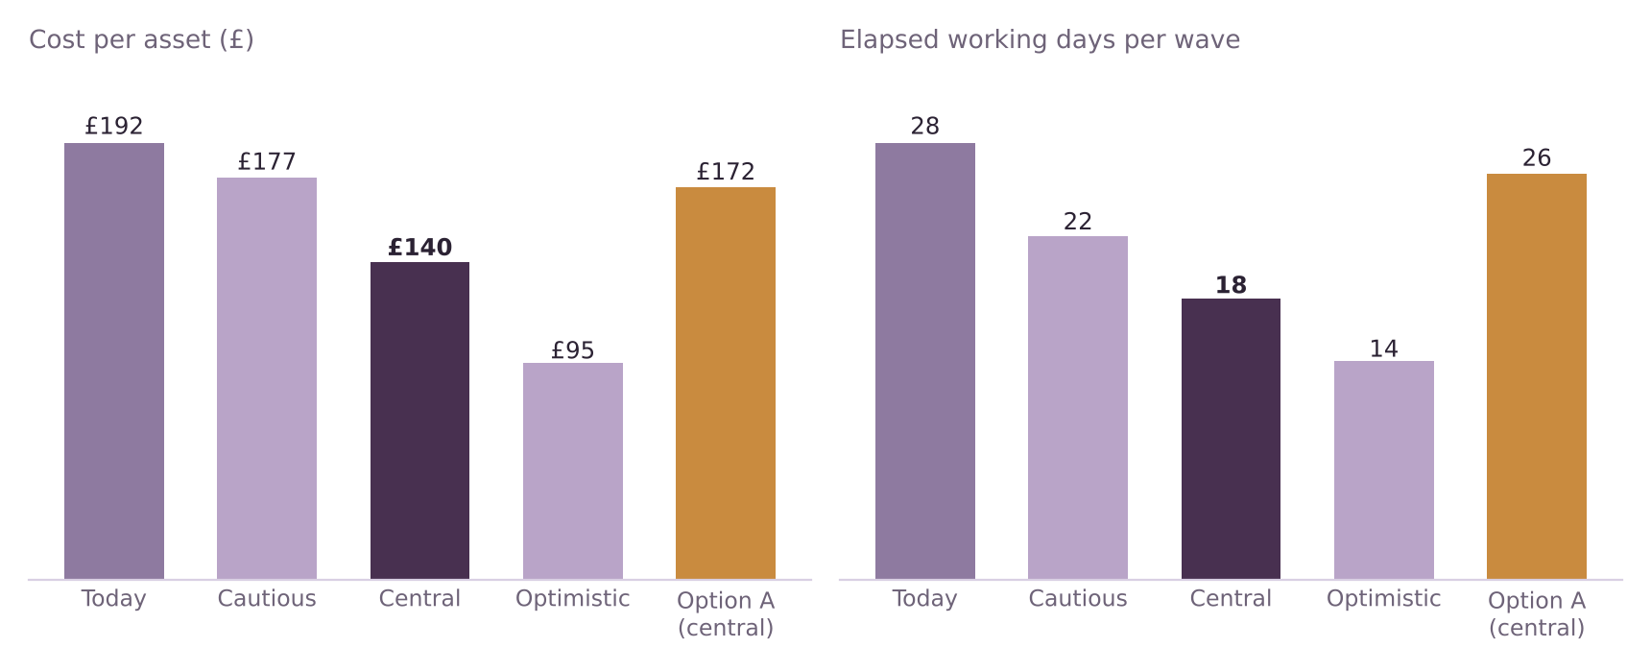
Figure 1. Illustrative cost per asset and elapsed days. Option A is bolt-on AI tools in today’s workflow, central assumptions.
- The spread is wide. Cost per asset falls by 8% to 50% depending on how much time AI really saves in Lanes 1 and 2. Nothing public narrows that range, so the pilot must measure it.
- Time is less uncertain than cost. Even the cautious case shortens a wave by 21%, because earlier approval and one round of client review change the structure of the work, whatever the tools do.
- Bolt-on tools alone are weak. Option A cuts hours a little but leaves review untouched, so it saves almost no elapsed time.

Where the savings come from
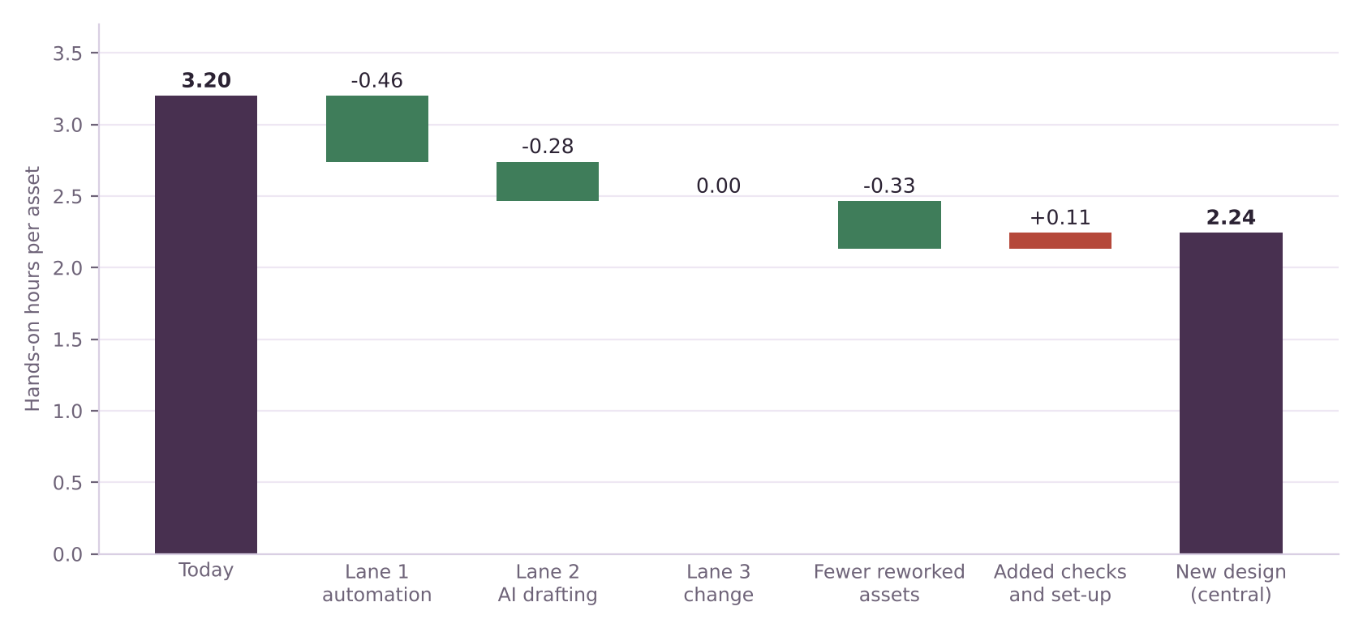
Figure 2. Central case: change in hands-on hours per asset, from today’s 3.20 to the new design.
Source of net hours saved (share of net saving) | Cautious | Central | Optimistic
Lane 1 and Lane 2 work done faster | 112% | 77% | 76%
Fewer reworked assets | 37% | 34% | 25%
Share of elapsed days saved in review, approval and rework | 83% | 70% | 64%

The first two rows can add to more than 100% because added check and set-up hours, and in the cautious case extra Lane 3 hours, reduce the net saving.
A refined hypothesis
- For elapsed time, the main gain comes from fewer and earlier review loops. This matters to clients because it brings campaigns to market sooner.
- For cost, the main gain comes from automating repeatable Lane 1 and Lane 2 work under written rules, with fewer reworked assets as a second source.
- So the redesign is not “review instead of AI”. It is AI work inside rules that people approve once, and fewer late loops. That is a stronger claim than the original and it is the one the pilot should test.

The unfavourable test: what if review is a smaller share of the delay?
Deliverable 4 warned that the 28-day timeline was built to fit the hypothesis. This test lowers the review share of today’s 28 days and keeps the central cut rates (review days cut by 47%, other days by 23%).
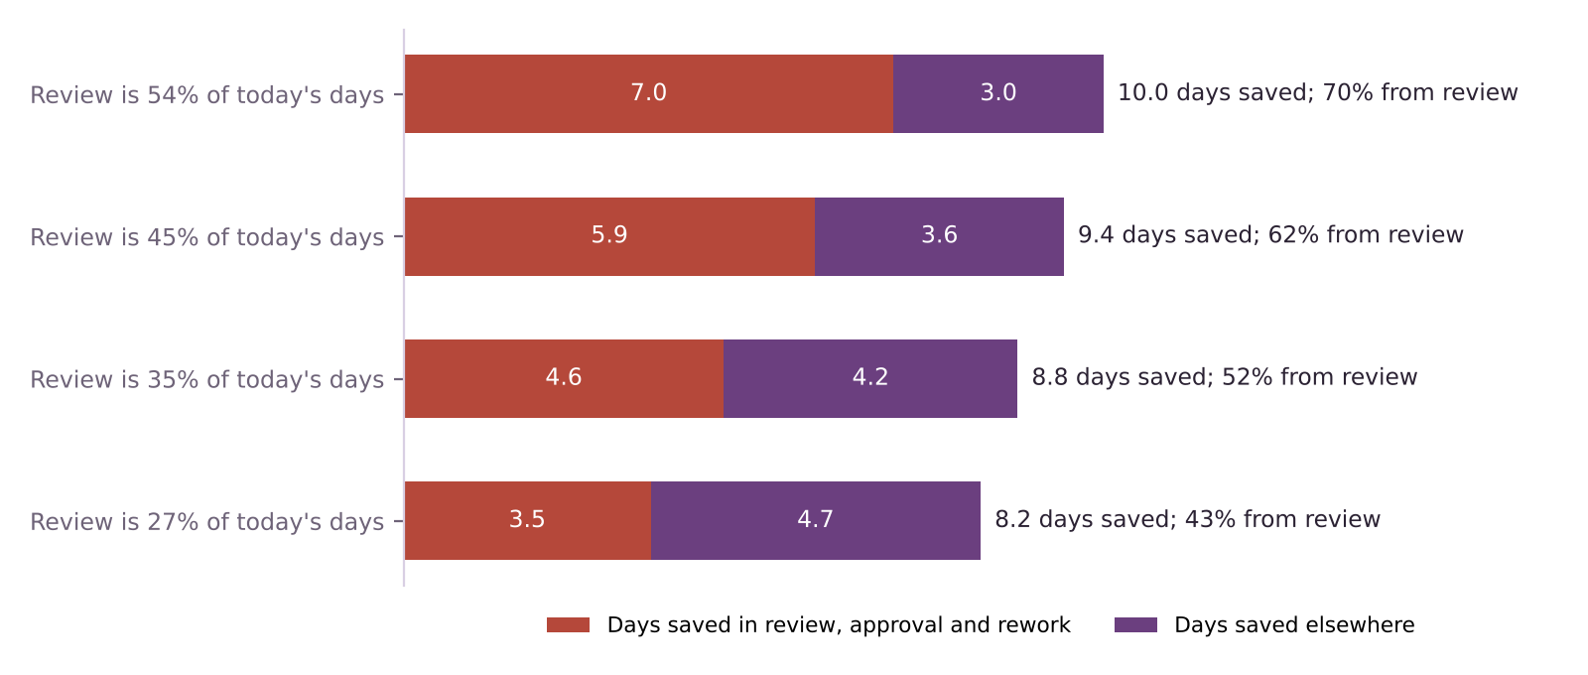
Figure 3. Days saved in review and elsewhere when review is a smaller share of today’s delay.
Review share today | Review days | Other days | Days saved in review | Days saved elsewhere | Total saving | Share from review
54% | 15.0 | 7.0 | 3.0 | 10.0 | 36% | 70%
45% | 12.6 | 5.9 | 3.6 | 9.4 | 34% | 62%
35% | 9.8 | 4.6 | 4.2 | 8.8 | 31% | 52%
27% | 7.6 | 3.5 | 4.7 | 8.2 | 29% | 43%

- The redesign still saves time. At a 27% review share the saving is 8.2 days (29%), against 10.0 days at the base share.
- The reason changes. Below a review share of about 35%, less than half of the days saved come from review. The case would then rest on faster production, which is the part most exposed to tool performance.
- Implication for the pilot. Record the real split between making time, waiting time and review time on the baseline wave before judging the design.

Which assumptions matter most?
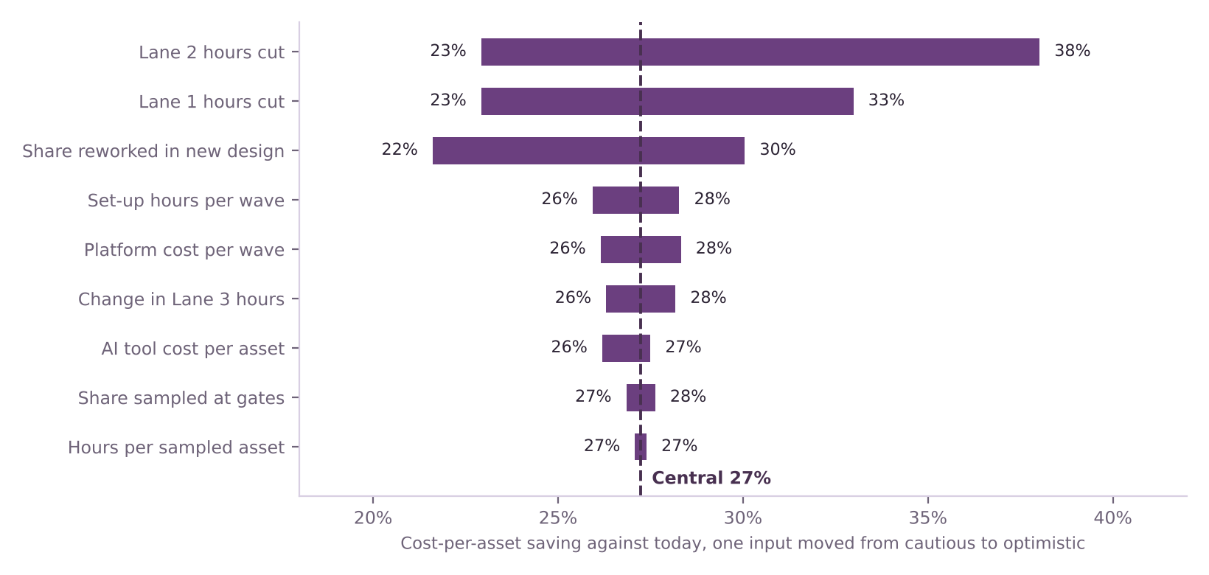
Figure 4. Cost-per-asset saving in the central case when one input moves from cautious to optimistic.
- Three inputs decide the cost result: how much AI cuts Lane 2 hours, how much it cuts Lane 1 hours, and the share of assets still reworked. Together they move the saving from about 22% to 38%.
- Gate and platform details barely matter. Sample size, hours per sampled asset, tool cost and set-up hours each move the saving by less than three points. They matter for trust, not for the arithmetic.
- What to measure first: time per task in Lanes 1 and 2 with and without AI, and the share of assets sent back after review.

Scale and payback
At 60 waves a year | Cautious | Central | Optimistic | Option A
Hours released per year (60 waves) | 11,808 | 27,581 | 47,664 | 11,923
Capacity released (full-time equivalents) | 7.4 | 17.2 | 29.8 | 7.5
Net cost saved per year | £442,080 | £1,506,048 | £2,785,440 | £566,592
One-off programme cost | £2.00m | £1.20m | £0.90m | n/a
Payback on one-off cost (months) | 54.3 | 9.6 | 3.9 | n/a

Payback on the one-off cost depends heavily on how many waves of this size run through the new workflow each year.
Waves per year | Central: saved per year | Cautious: payback (months) | Central: payback (months) | Optimistic: payback (months)
10 | £251,008 | 57.4 | 325.7 | 23.3
20 | £502,016 | 28.7 | 162.9 | 11.6
40 | £1,004,032 | 14.3 | 81.4 | 5.8
60 | £1,506,048 | 9.6 | 54.3 | 3.9
100 | £2,510,080 | 5.7 | 32.6 | 2.3

- Volume is the main business lever. At 10 waves a year even the central case takes about 57 months to pay back. At 60 waves it takes about 9.6. The pilot should therefore be extended only to clients with enough volume.
- The cautious case takes about four and a half years to pay back at 60 waves (about 54 months), which is too slow to justify the investment. That is why the staged approach and stop rules in Deliverable 6 matter.
- Hours released are capacity, not cash. WPP says WPP Production does not anticipate layoffs [11]. The value is realised only if the freed capacity takes on more work, is redeployed, or replaces outside spend. The model does not count extra volume or faster delivery for clients.

What this means for the recommendation
- The case for option B stands. It beats option A on both measures in every scenario tested, and its central results match the starting hypotheses.
- Refine the claim. Present the redesign as faster to market because of fewer review loops, and cheaper because repeatable work runs under rules.
- Gate the investment on measured Lane 1 and Lane 2 savings. Deliverable 9 turns this into stop rules.

Limitations
- Every input is illustrative. The hours, rates, days and costs are modelled for a representative case, not drawn from WPP data [11][12].
- One wave, one rate card, no discounting. Real programmes vary by client, market mix and asset type.
- No second-round effects. The model does not count extra volume from faster delivery, lost fees from clients who automate themselves [5], or quality incidents.
- Days are stage estimates. They come from the design in Deliverable 7 and are not time-and-motion measurements.

Key terms in plain English
Term | What it means
Scenario | A consistent set of assumptions, here called cautious, central and optimistic.
Sensitivity analysis | Changing one input at a time to see how much the result moves.
Full-time equivalent (FTE) | The hours one person works in a year, used to express saved hours as a number of people.
Payback | How many months of savings it takes to cover a one-off cost.
Capacity released | Working hours that no longer have to be spent on a task. They become a saving only if used elsewhere or not paid for.
Live formula | A spreadsheet cell that recalculates when an input changes, rather than a typed-in number.

Sources
Numbers in square brackets match this list and the Source Log (Deliverable 1).
Ref | Source (select the title to open it)
[5] | WPP’s rocky Q4 underscores AI disruption across agencies. eMarketer, 2026.
[6] | WPP bets on $400 million Google AI alliance. Campaign Asia, 2025 (date not shown).
[9] | AI speeds up content production but sameness a problem (CMOtech UK). CMOtech UK, 18 Mar 2026.
[10] | Strategy Update and 2025 Preliminary Results. WPP (RNS via Investegate), 26 Feb 2026.
[11] | Why WPP is rebuilding its production model for always-on marketing. eMarketer, 30 Jan 2026.
[12] | WPP unifies 10,000 creatives into a single global content factory for the AI era. Mediaweek (Australia), 23 Jan 2026.

