PROJECT 2 · DELIVERABLE 9 OF 13
Governance, Risk Register and 12-Month Rollout
How the redesign would be run, measured, stopped if it fails, and introduced step by step
At a glance
- Money is released in four steps, each tied to measured results. The illustrative £1.2m one-off cost is split across four stages (the central figure from Deliverable 8). A stage is paid for only if the stop rules at the previous checkpoint are met.
- 15 risks are rated before and after actions. 2 start in the red zone (brand error and rights or claims exposure); after actions the highest score is 9 of 25 and 0 risks remain at 10 or above. The leading business risk is clients bypassing the agency, which cannot be removed.
- Human control is written into the rules. Every Lane 3 item is checked by a person, anyone at a gate can stop the line, and one critical error in a sample widens the check to the whole batch.

Executive summary
- What this is. The operating plan for the recommended design in Deliverables 6 and 7: who governs it, what is measured, when it stops, what can go wrong and how it is introduced over 12 months.
- How it is governed. A steering group releases money and applies stop rules. A workflow owner runs the process. A rules owner keeps the brand and AI-use rules. Gate owners decide at the four gates.
- How it stops if it does not work. At each checkpoint the steering group applies three rules: continue if elapsed time is at least 25% shorter and critical errors are no higher; re-scope if the saving is 10% to 25%; stop if errors rise or clients reject sampling. The thresholds are my assumptions.
- What can go wrong. 15 risks are rated in the register. The two highest are a brand error reaching the market and an unapproved claim or rights problem, both scored 15 of 25 before actions and 8 after. They are controlled by the human checks at Gate 3.
- What the plan does not settle. Whether clients will accept pattern approval and sampling, and how much time AI really saves in Lanes 1 and 2. The pilot exists to answer both.

Governance

Who is responsible
Body or role | Who | How often | What it does
Steering group | WPP Production leadership (chair), client sponsor, heads of brand review and legal review, AI workflow lead | Monthly, and at each checkpoint | Releases money at checkpoints. Applies the stop rules. Settles disputes between clients and reviewers.
Workflow owner | Production lead | Weekly during the pilot | Accountable for the process, the measures and the gate time limits. Can stop the line.
Rules owner | AI workflow lead with the brand reviewer | Each wave | Keeps the brand and AI-use rules library. Every rule change is logged and approved by the brand reviewer.
Gate owners | Client brand lead (Gates 1, 2 and 4); brand and legal reviewers (Gate 3) | Each wave | Decide at their gate within the time limit and sign the decision record.
Pilot team | Producers, artists, local reviewers | Weekly stand-up | Run the lanes. Report problems early. Their feedback is a standing agenda item at each checkpoint.

Who decides what
Decision | Decides | Consulted | Evidence needed
Approve the brand and AI-use rules for a client | Client brand lead | Brand and legal reviewers, creative lead | Rules library, sample results
Allow a new AI tool | Legal reviewer (with the AI workflow lead) | Production lead, client if their material is used | Terms, data handling, test results
Clear a claim or a rights item | Legal reviewer | Brand reviewer, local team | Evidence for the claim, licence records
Stop a batch | Production lead (any gate owner can call it) | Client brand lead | The error or risk found
Widen a sample to the whole batch | Brand reviewer | Production lead | Sample failure data
Release money at a checkpoint | Steering group | Production lead, finance | Measures against the stop rules

AI-use rules
These rules are agreed at Gate 1 for every client. They apply the principle that AI should augment human creativity rather than replace it, which WPP states as its own [1], and they answer the concerns that agency leaders raise most often: accuracy and bias (63%), legal risk (62%) and privacy and security (55%) [8].
- Approved tools only. No client material goes into a tool that has not been cleared by the legal reviewer.
- Every AI-made asset is logged with the tool, version and settings, so any asset can be traced and checked.
- A named person answers for each set of assets. AI does not sign anything off.
- People decide where judgement or risk is high: claims, rights, sensitive markets and brand interpretation (Lane 3).
- Anyone at a gate can stop the line, and one critical error found in a sample widens the check to the whole batch.
- Disclosure and labelling follow the client’s and the platform’s rules, reviewed each quarter.

Measuring success
Baselines come from the illustrative case in Deliverables 4 and 5 and must be replaced with measured figures in Stage 0. Pilot targets are my assumptions, set at the cautious end of Deliverable 8 so that they are demanding but not unrealistic.
Measure | Baseline | Pilot target | Central case | Owner
Elapsed working days per wave | 28 | 21 or fewer | 18 | Production lead
Hands-on hours per asset | 3.2 | 2.8 or fewer | 2.24 | Production lead
Share of assets reworked | about 33% | 25% or less | 15% | Production lead
Critical errors that reach a client or the market | Measured in the baseline | No higher than baseline | Lower | Brand and legal reviewers
Sample failure rate at Gate 3 | Not applicable | Tracked; above 5% widens the sample | Under 3% | Brand reviewer
Gate decisions inside the time limit | Not applicable | 90% or more | 95% or more | Gate owners
Waves approved within one round of client changes | Not applicable | 80% or more | 90% or more | Client brand lead
AI-made assets with a complete log entry | Not applicable | 100% | 100% | AI workflow lead
Pilot team pulse score and training completed | Measured in the baseline | Not lower than baseline; training 100% | Higher | Production lead

Stop rules and checkpoints
Result at a checkpoint | When it applies
Continue and release the next money | Elapsed time is at least 25% shorter than baseline, critical errors are no higher, clients approve within one round in at least 80% of waves, and every AI-made asset is logged.
Re-scope | Elapsed time is 10% to 25% shorter (the cautious case in Deliverable 8 is 21%), or Lane 1 and Lane 2 hours are cut by less than 35% and 10%. Narrow the design to the tasks and clients where it works, and run another wave before releasing money.
Stop | Critical errors are higher than baseline, or clients will not accept pattern approval and sampling, or time saved is under 10%. Return to option A with written rules.

- The rules are set before the pilot starts, so that results cannot be argued into success afterwards.
- A quality result outranks a time result. Faster work with more critical errors is a stop, not a re-scope.
- Volume is checked too. At Checkpoint 2 the steering group compares expected waves per year with the payback table in Deliverable 8, because payback depends heavily on volume.

Twelve-month rollout
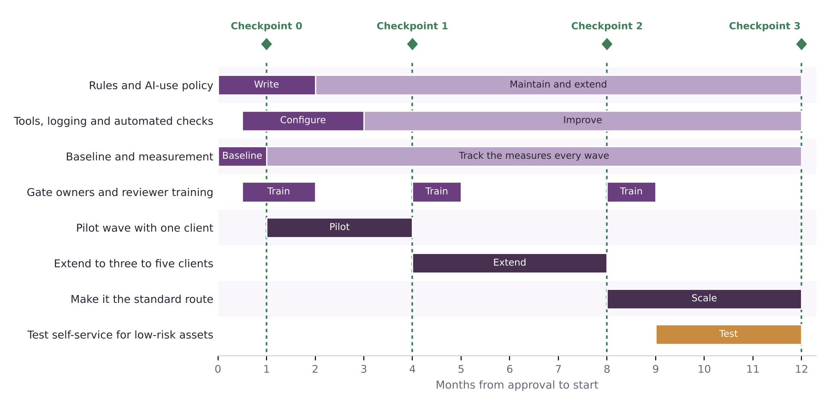
Figure 1. Illustrative 12-month rollout. Dark bars are the main stages; green dashed lines are checkpoints where money is released or withheld.
Stage | When | Spend | What happens | Checkpoint at the end
0. Prepare | Weeks 0 to 4 | £0.2m | Pick the pilot client and campaign. Measure the baseline wave. Write the first brand and AI-use rules. Approve tools. | Checkpoint 0: baseline measured, rules signed, client agreed
1. Pilot | Weeks 5 to 16 | £0.4m | Run one live wave through three lanes and four gates. Measure every KPI. Hold weekly stand-ups. | Checkpoint 1: apply the stop rules
2. Extend | Months 4 to 8 | £0.4m | Add three to five clients with enough volume. Train gate owners and reviewers. Grow the rules library. | Checkpoint 2: apply the stop rules; check payback by volume
3. Scale and review | Months 9 to 12 | £0.2m | Make the workflow the standard route for suitable work. Test self-service for low-risk Lane 1 assets. | Checkpoint 3: year-end review against Deliverable 8

Spend is an illustrative split of the £1.2m central one-off cost in Deliverable 8. It is released stage by stage, so only £0.2m is committed before the baseline and the rules exist.

First 30 days
- Agree the pilot client and campaign wave with the client sponsor.
- Measure the baseline wave: elapsed days by stage, hours by task, share reworked and critical errors.
- Write the first 20 to 30 checkable brand rules and the AI-use rules, and have the client sign them.
- Choose and clear the tools, and set up the asset log.
- Name the gate owners and their deputies, and set the decision time limits.
- Brief the pilot team, including what the design means for their roles.

Risks
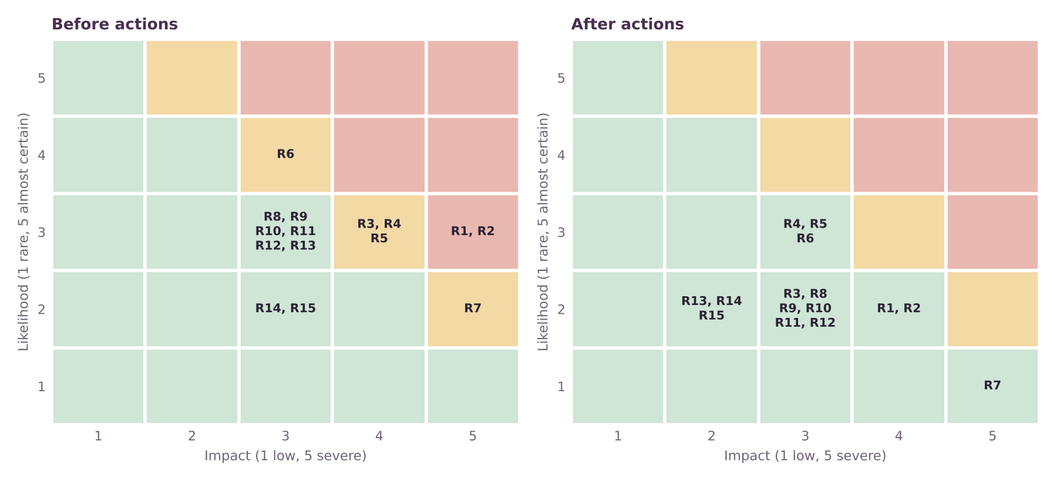
Figure 2. Risks by likelihood and impact, before and after actions. The full register is on the next page.
Scores multiply likelihood by impact, each from 1 to 5. A score of 15 or more is high (red), 10 to 14 is medium (amber) and under 10 is low (green). Before actions, 2 risks are high, 5 are medium and 8 are low. After actions, none is high and 0 stay at 10 or above.
- The two highest risks are about human control. A brand error reaching the market and an unapproved claim or rights problem are the cases where a missing check does most harm. Gate 3 is designed around them.
- The business risks are harder to reduce. Clients refusing sampling, platform tools bypassing the agency and weaker-than-assumed time savings stay at or near 9 after actions, because they depend on clients and the market, not on WPP’s own process.
- One risk is a weakness in this analysis. Risk 13 notes that illustrative model results could be read as forecasts. Every model figure is labelled for that reason.

Risk register
Likelihood (L) and impact (I) are scored 1 to 5 before actions; the last column is the score after the actions in the mitigation column. Owners use the roles in Deliverable 7. Scores are my judgement. Numbers in square brackets refer to the Source Log.
ID | Risk | Why it could happen, and the consequence | L | I | Score | Owner | Mitigation | Early warning | After
R1 | Brand error reaches the market | Lane 1 or 2 output is only sampled, so an AI error can slip through.  Consequence: Public embarrassment, client trust lost. | 3 | 5 | 15 | Production lead | Check every Lane 3 item. Widen the sample to the whole batch after one critical error. Keep the check log. Stop the line | Critical error found in a sample; sample failure rate above 5% | 8
R2 | Rights, copyright or unapproved claim in AI-made content | AI output resembles protected work or states a claim nobody cleared [8].  Consequence: Legal exposure, withdrawn campaign, cost of reshoots. | 3 | 5 | 15 | Legal reviewer | Legal reviewer checks every claim and rights item. AI-use policy bans unapproved sources. Log tool and settings per asset. Review vendor terms | Any claim or rights item found after Gate 3; missing log entries | 8
R3 | Clients refuse pattern approval and sampling | Brand teams want to approve every asset and fear losing control [9].  Consequence: The design reduces to option A and the time saving is lost. | 3 | 4 | 12 | Client brand lead with WPP Production leadership | Co-design the rules with the pilot client. Show Gate 2 sample results early. Start with a client that already wants speed | Client asks to add approval rounds; Gate 4 changes exceed one round | 6
R4 | Time saved in Lanes 1 and 2 is smaller than assumed | Tools perform worse than hoped on real briefs; many exceptions.  Consequence: Cost saving falls to the cautious case or below (Deliverable 8). | 3 | 4 | 12 | AI workflow lead | Measure time per task with and without AI in the pilot. Apply stop rules. Re-scope to the tasks that do work | Lane 1 or Lane 2 hours cut below 35% or 10% after the pilot | 9
R5 | Platform tools let clients bypass the agency | Self-service tools from platforms and WPP Open Pro are adopted directly [5][7][13][14].  Consequence: Fee income falls; production volume shrinks. | 3 | 4 | 12 | WPP Production leadership | Position gates, rules and accountability as the value. Offer a self-service route for low-risk assets. Monitor client adoption | Clients ask for self-service access; fee pressure in renewals | 9
R6 | Agency restructuring leaves little capacity to change | Elevate28 savings, headcount down 6.4% and a new Production unit are all under way [1][10][11].  Consequence: Pilot delayed; reviewers and artists overloaded. | 4 | 3 | 12 | WPP Production leadership | Keep the pilot small. Reuse WPP Open. Name deputies. Schedule training in quiet periods | Pilot milestones slip by more than two weeks | 9
R7 | Client data leaks through AI tools | Confidential assets are entered into tools without approved terms; privacy is a top barrier (55%) [8].  Consequence: Breach of contract, loss of the client. | 2 | 5 | 10 | Legal reviewer | Approved tools only. No client material in public tools. Access controls and audit logs. Contract terms with tool vendors | Use of unapproved tools found; log gaps | 5
R8 | Gate 3 becomes the new bottleneck | Reviewers receive large batches at once and the delay moves rather than disappears.  Consequence: Elapsed time stays near today’s. | 3 | 3 | 9 | Production lead | Set decision-time limits. Spread batches. Name deputies. Track reviewer load | Gate 3 decisions take longer than 2 days | 6
R9 | Brand rules cannot be written as checkable rules | Much brand knowledge is tacit and differs by market.  Consequence: Automated checks miss errors or flag too much. | 3 | 3 | 9 | Brand reviewer | Start with the 20 to 30 most checkable rules. Add rules after each wave. Keep human checks for the rest | High false-alarm or miss rate in automated brand checks | 6
R10 | Production staff disengage or lose skills | Artists and producers fear for their jobs or find the work less skilled; WPP says it does not anticipate layoffs [11].  Consequence: Quality drops; people leave; rules are bypassed. | 3 | 3 | 9 | Production lead | Involve artists in pattern design. Give training and clear role paths. Share results openly | Low pulse scores; rising attrition or unplanned absence in the pilot team | 6
R11 | AI output becomes samey and weakens the creative idea | Machine variants converge on similar looks; sameness is a concern in the survey coverage [9].  Consequence: Campaign loses distinctiveness. | 3 | 3 | 9 | WPP creative lead | Creative lead owns Gate 2 and sets what may not change. Review sample sets for sameness | Creative lead rejects samples more than once per wave | 6
R12 | Dependence on one platform or vendor | WPP Open or an outside model changes price, terms or performance [5][6].  Consequence: Cost and speed gains disappear; switching is costly. | 3 | 3 | 9 | AI workflow lead | Keep rules and logs independent of any single tool. Test an alternative tool each half year | Price or terms change; performance drops after an update | 6
R13 | Model results are read as forecasts | Illustrative inputs are quoted without their caveats.  Consequence: Targets set too high; credibility lost. | 3 | 3 | 9 | Production lead | Label all model figures as illustrative. Replace inputs with pilot measurements before any commitment | Model numbers quoted in a client or internal plan without caveats | 4
R14 | Rules for AI-generated content tighten | Disclosure, labelling or rights rules change (assumption; no source relied on).  Consequence: Rework of past assets; extra checks. | 2 | 3 | 6 | Legal reviewer | Include disclosure and labelling in the AI-use policy. Review the policy every quarter | New guidance from regulators, platforms or clients | 4
R15 | Review share is lower than assumed | The baseline wave shows most delay is in production or waiting, not review (Deliverable 8 test).  Consequence: The time saving falls toward 29% and the case rests on tool speed. | 2 | 3 | 6 | Production lead | Measure the real split in the baseline wave. Re-scope the design if review is under about 35% of the delay | Baseline shows review below 35% of elapsed days | 4

Limitations
- Thresholds, scores and costs are my assumptions. They have not been tested with WPP or clients, and WPP publishes no production hours, volumes or savings [11][12].
- The register is not complete. A real programme would add risks found in the pilot and in conversations with clients, legal teams and artists.
- Governance roles are illustrative. WPP’s own structure for Production, Creative and Media is not public.
- The rollout assumes a willing first client. Without one, Stage 0 would take longer.

Key terms in plain English
Term | What it means
Checkpoint | A planned review where results are compared with the stop rules before more money is released.
Stop rule | A result agreed in advance that ends or narrows the programme.
Risk score | Likelihood multiplied by impact, each rated from 1 to 5, giving a score out of 25.
Residual risk | The risk score that remains after the planned actions.
Decision record | A short signed note of what a gate owner decided and why.
Rules library | The written, checkable brand and AI-use rules that tools and people check work against.

Sources
Numbers in square brackets match this list and the Source Log (Deliverable 1).
Ref | Source (select the title to open it)
[1] | WPP 2026 Interim Results. WPP (RNS via Investegate), Aug 2026.
[5] | WPP’s rocky Q4 underscores AI disruption across agencies. eMarketer, 2026.
[7] | WPP’s AI Tool Lets Brands Skip Agencies for Ad Creation. WebProNews, Undated.
[8] | The State of AI Inside US Marketing Agencies 2026 (reported by MediaPost). MediaPost, 6 Jul 2026.
[9] | AI speeds up content production but sameness a problem (CMOtech UK). CMOtech UK, 18 Mar 2026.
[10] | Strategy Update and 2025 Preliminary Results. WPP (RNS via Investegate), 26 Feb 2026.
[11] | Why WPP is rebuilding its production model for always-on marketing. eMarketer, 30 Jan 2026.
[12] | WPP unifies 10,000 creatives into a single global content factory for the AI era. Mediaweek (Australia), 23 Jan 2026.
[13] | FAQ on ad agencies: Consolidation, AI disruption, and what’s changing in 2026. eMarketer, 2026.
[14] | Meta Plans To Automate All Ad Creation By 2026: Report. MediaPost, 2 Jun 2025.

