# I have used Jupyter notebook for coding. I am also attaching .py files.

1. Use the Market Pricing dataset. We find out what dishes does Mr. Goli have on his menu that are also sold by his competitors. Then we find the average price of these dishes and take them as the price for dishes at Goli.

**See goli1.ipynb**

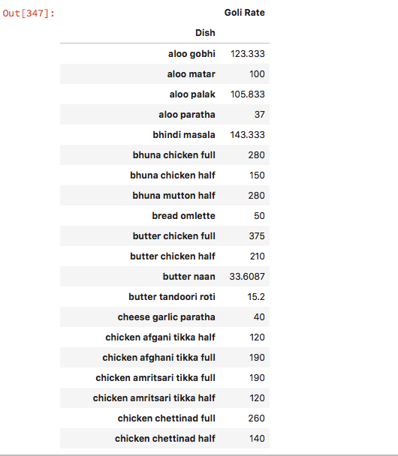

1. The following strategies may be used:

* A market survey can be conducted to find what dishes are popular in other restaurants that are not sold at Goli.
* They should replace the less popular dishes at Goli.
* Combos can be created and sold at a price slightly lower than the total of the individual prices of components.

1. Use the Customer Order Item Details dataset. Find the items ordered the most times in the given period. Dishes ordered more than 200 times should be promoted.

**See goli3_4.ipynb**

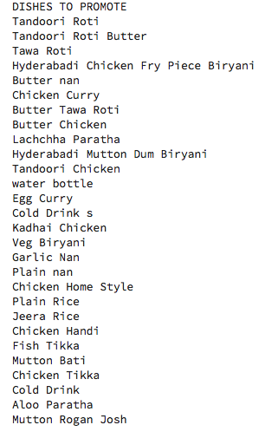

1. Use the Customer Order Item Details dataset. Find the items ordered the least times in the given period. Dishes ordered less than 10 times should be removed.

**See goli3_4.ipynb**

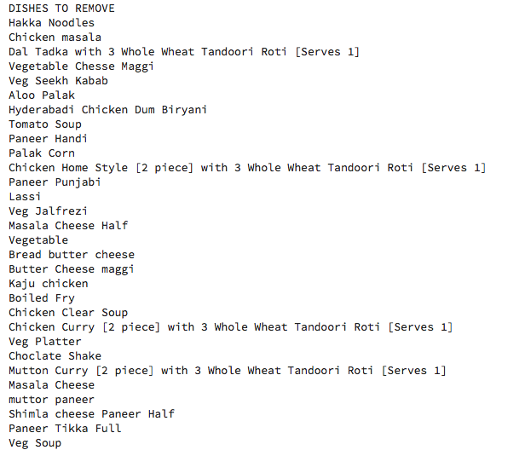

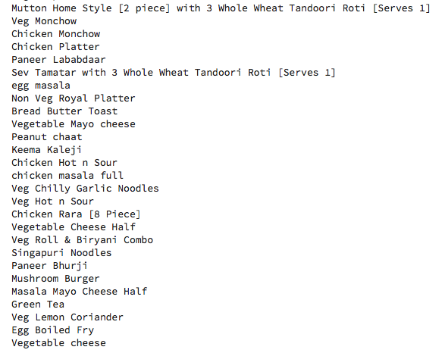

1. Use the Customer Bill Detail dataset. We notice that certain dishes are often ordered in combination with each other, like Tandoori Roti with Chicken Curry. We can price them slightly lower than the sum of their actual prices, say, a discount of 5%, to attract customers.

**See goli5.ipynb**

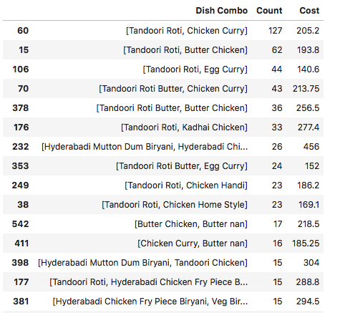

1. a. They can be sorted by the following categories:

* Vegetarian
* Non-vegetarian
* Starters
* Main course
* In restaurant
* Home delivery
* And so on….

b. We see that the bill can comes out to be anywhere between Rs. 10 to Rs. 6338. We can divide the customers into equal sized bins. Or we can segment in a way such that each section has equal number of customers.

**See goli6.ipynb**

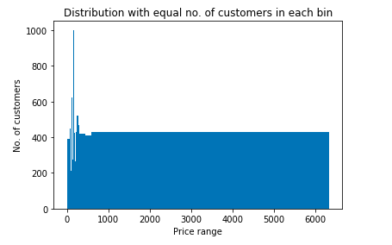

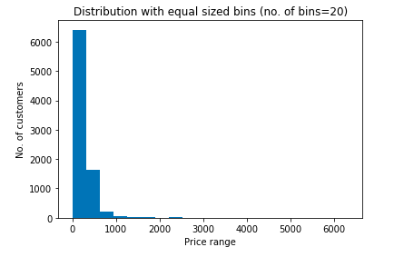

1. Use the Market Pricing dataset. From the ‘What people love here’ column, we find what dishes are popular in other restaurants and how popular they are.

**See goli7.ipynb**

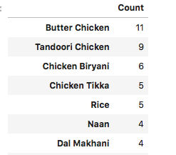

*All images are the screenshots taken from the compiled code in Jupyter notebook.