**Mini Project Report on**



**QuizUp - A Quiz Application**



**Submitted in partial fulfillment of the requirement for the award of the degree of**

**BACHELOR OF TECHNOLOGY**

**IN**

**COMPUTER SCIENCE & ENGINEERING**

**Submitted by:**

**Anushka Rawat**  **2018703**

***Under the Mentorship of***

**Ms. Tanusha Mittal**

**Assistant Professor**



**Department of Computer Science and Engineering**

**Graphic Era (Deemed to be University)**

**Dehradun, Uttarakhand**

**July-2023**

GEU logo

**CANDIDATE’S DECLARATION**

I hereby certify that the work which is being presented in the project report entitled **“QuizUp - a Quiz Application”** in partial fulfillment of the requirements for the award of the Degree of Bachelor of Technology in Computer Science and Engineeringof the Graphic Era (Deemed to be University), Dehradun shall be carried out by the under the mentorship of **Ms. Tanusha Mittal, Assistant Professor**, Department of Computer Science and Engineering, Graphic Era (Deemed to be University), Dehradun.

Anushka Rawat 2018703 

**Table of Contents**

|  |  |  |
| --- | --- | --- |
| **Chapter No.** | **Description** | **Page No.** |
| Chapter 1 | Introduction | 1 |
| Chapter 2 | Literature Survey | 2-3 |
| Chapter 3 | Methodology | 4-6 |
| Chapter 4 | Result and Discussion | 7-10 |
| Chapter 5 | Conclusion and Future Work | 11 |
|  | References | 12 |

**Chapter 1**

**Introduction**

* 1. **Introduction**

In today’s world, smartphones have changed our lives and have become an indispensable part of our lives because of their specialty to simplify our routine work and thereby save our time. With the advancement in mobile technology and the availability of smart mobile devices and networks, we can create a system that can be used to check the knowledge levels of students. Nowadays, mobile devices have become a way of life for students, especially in higher education. Computers are now replaced by compact smartphones that can fit into a pocket and can be carried anywhere. Hence there is an increasing need of developing mobile applications that cater to all the needs of the users.

In this project, a Quiz application has been developed with the help of Android Studio using Kotlin as the programming language. This application aims to test the general knowledge of the user and promote general awareness among the mass. This project offers users to test themselves through their mobile only with a simple and attractive user interface(UI).

The main motive behind this software is to replace the traditional pen-and-paper system. To design this project, smartphones with Android operating systems are chosen because the penetration rate of Android OS is 70 percent. It is an open-source and freeware operating system. The application is compatible with all Android versions starting from 5.0 Lollipop.

**Chapter 2**

**Literature Survey**

Some major existing quiz applications in the area of mobile learning and gamified quiz apps are as follows: -

1. Trivia Crack: Trivia Crack [1] is a well-known quiz app that combines trivia questions with a gameplay element. Users can challenge their friends or random opponents in different categories. The app includes various power-ups, character customization, and social sharing features. Trivia Crack's strengths lie in its addictive gameplay and the ability to compete with friends. However, some users have reported an excessive number of advertisements and a limited question pool.

2. Kahoot!: Kahoot! [2] is a popular gamified learning platform that allows educators to create quizzes, surveys, and discussions for classroom use. It offers real-time multiplayer functionality, where students can participate using their smartphones. Kahoot! focuses on creating an interactive learning environment and includes features like points, rankings, and a leaderboard. The platform has been widely adopted in educational settings, promoting student engagement and knowledge retention.

3. Quizlet: Quizlet [3] is an application that primarily focuses on creating and sharing flashcards for educational purposes. While not a traditional quiz app, Quizlet offers study modes that can be used as a quiz-like experience. It provides various learning tools such as games, practice tests, and audio features. The app's strength lies in its extensive library of user-generated flashcards and collaborative features. However, some users have noted occasional inaccuracies in user-generated content.

QuizDuel: Quiz Duel[4] is a highly popular quiz app that allows users to challenge friends or random opponents in real-time trivia matches. It offers a wide range of categories and question types, including text-based and image-based questions. The app features a global ranking system, achievements, and social features like chat and friend invitations. QuizDuel's intuitive interface and competitive gameplay have contributed to its success.

Sporcle: Sporcle[5] is a quiz app that offers a vast collection of trivia quizzes covering a wide range of topics. Users can choose from various categories and difficulty levels to test their knowledge. Sporcle also includes features like timed challenges, leaderboards, and achievements. The app's extensive quiz library and customizable options provide users with endless opportunities to engage in trivia-based learning.

**Chapter 3**

**Methodology**

**3.1. Applications and Technology Used:**

Android Application Development is possible with a couple of software and development kits to support the software and execution which are as follows: -

**1. Android Studio:** Android Studio is the official Integrated Development Environment (IDE) for designing, coding, debugging, and executing applications for Google’s Smartphone operating system, Android. It has all keywords inbuilt for ease in back-end programming and also design statements, for ease in designing as well [6].

**2. Java Development Kit (JDK):** Since Android applications require Java or Kotlin programming for their backend programming; it needs an environment to support its functions, executions, and syntax. The Java Development Kit (JDK) is essential for Kotlin programming in Android Studio. Kotlin is fully interoperable with Java, which means it can utilize Java libraries, frameworks, and tools. Since Kotlin compiles down to Java bytecode, it requires the JDK to compile Kotlin code and run Kotlin applications.

When developing Android applications with Kotlin in Android Studio, the JDK is used for compiling Kotlin code into bytecode that can be executed on the Java Virtual Machine (JVM). Android Studio, being built on the IntelliJ IDEA platform, provides seamless integration with Kotlin and relies on the JDK for Kotlin compilation.

**3. Xml:** The front-end design of the application involves xml statements for the Relative layouts, Radio buttons, Radio Group, buttons, text boxes, and text views.

**3.2. Procedure**

1. On the welcome screen, register the user by entering the name.

2. After clicking the START button, the questions will start appearing on the screen.

3. However, if the user clicks the START button without entering a name, a toast (pop-up) message will ask the user to enter the name.

4. After submitting all the answers, a new window will display the total score of the user based on the number of correct options chosen.

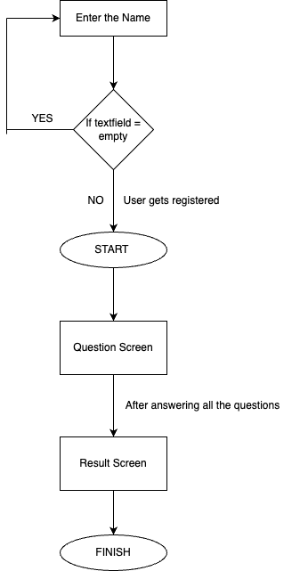

**Figure 3.1** Flowchart of Main Activity

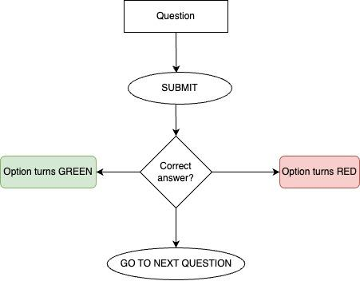

**Figure 3.2** Flowchart of Question Activity

**Chapter 4**

**Result and Discussion**

**4.1. The Welcome/Login Page**

As soon as the Android application starts, the Welcome page is displayed on the screen. The user is required to enter a name in the text field to start the quiz. If the START button is clicked before entering a name, a toast message will pop up prompting the user to enter the name as shown in the figure.

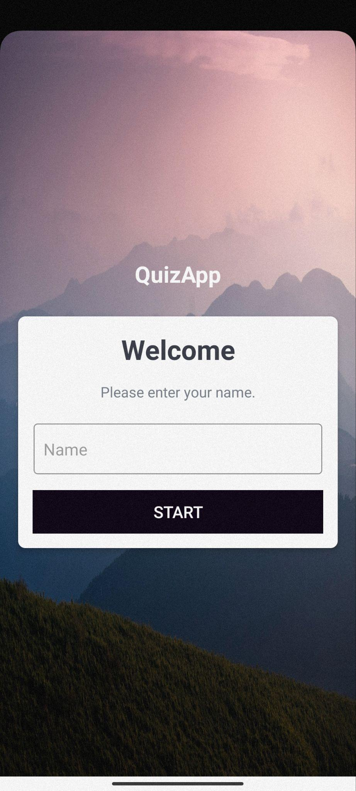 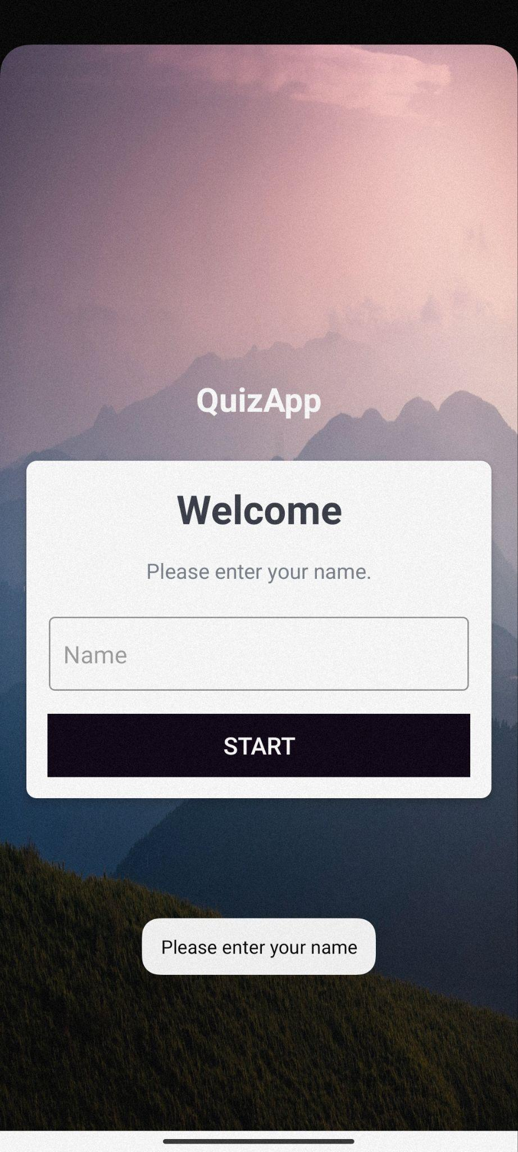

**Figure 4.1** Screenshot of the Welcome Page

**4.2. Questions Activity**

After clicking the START button on the welcome page, the quiz starts and a number of questions each having four options to choose the answer from get displayed on the screen like in the figure.

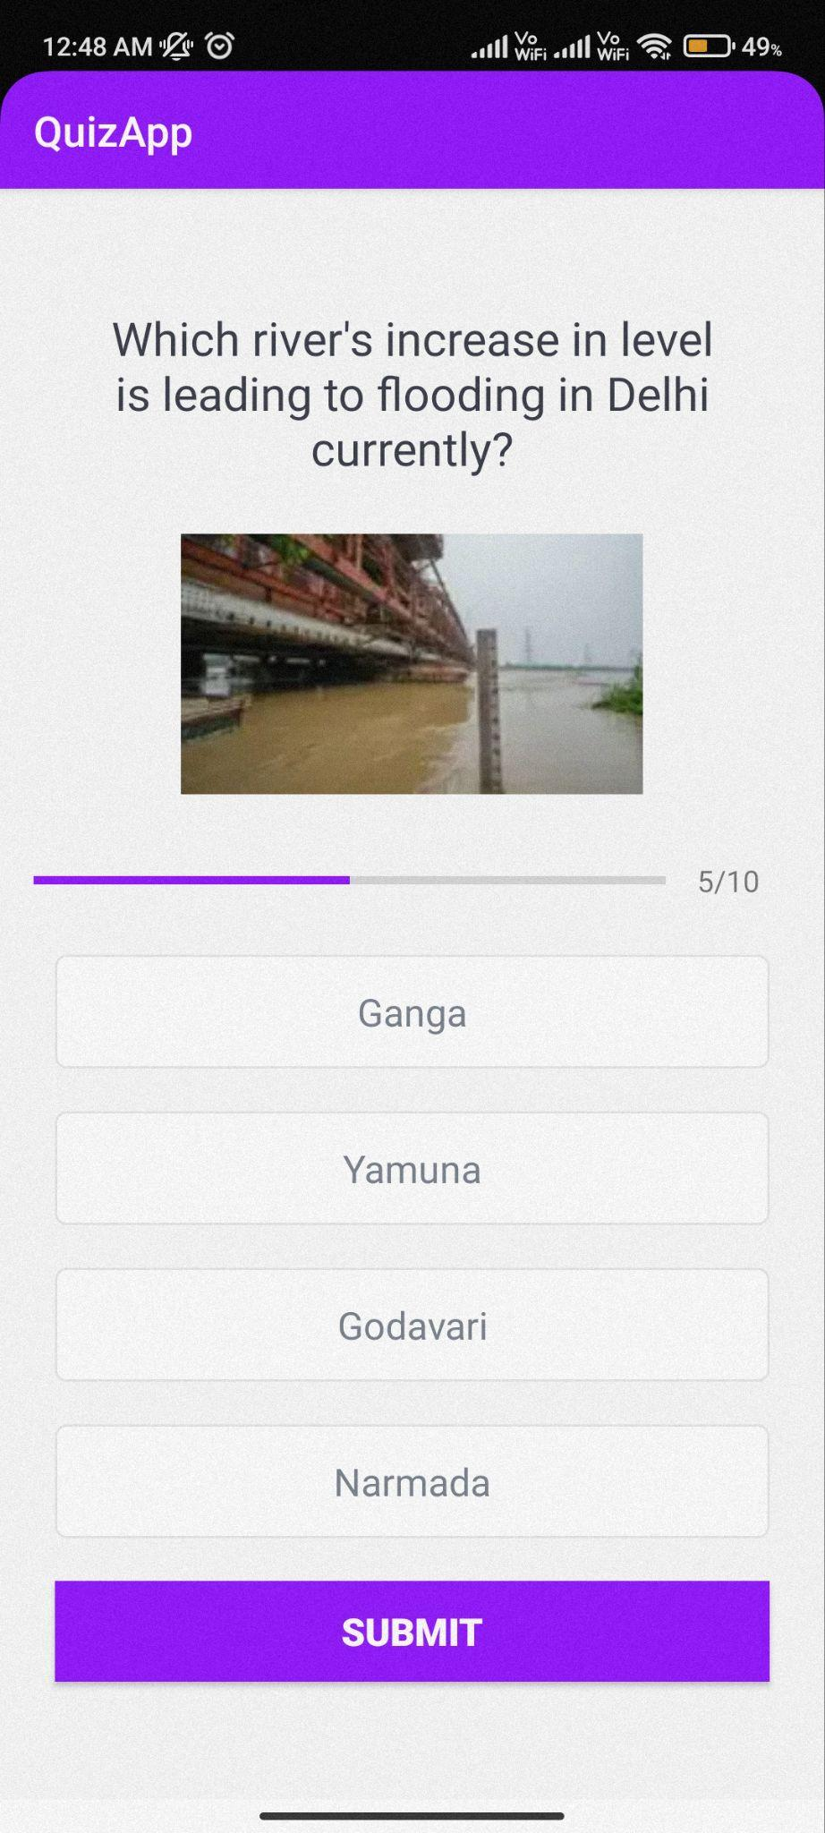

**Figure 4.2** Screenshot of the QuestionPage

On choosing the correct option, the box turns to green colour and the total score gets incremented by 1 point. However, selecting the wrong option causes it to turn red and the correct option is revealed by turning to green colour. The user can then go to the next question by clicking the button “Go To Next Question”.

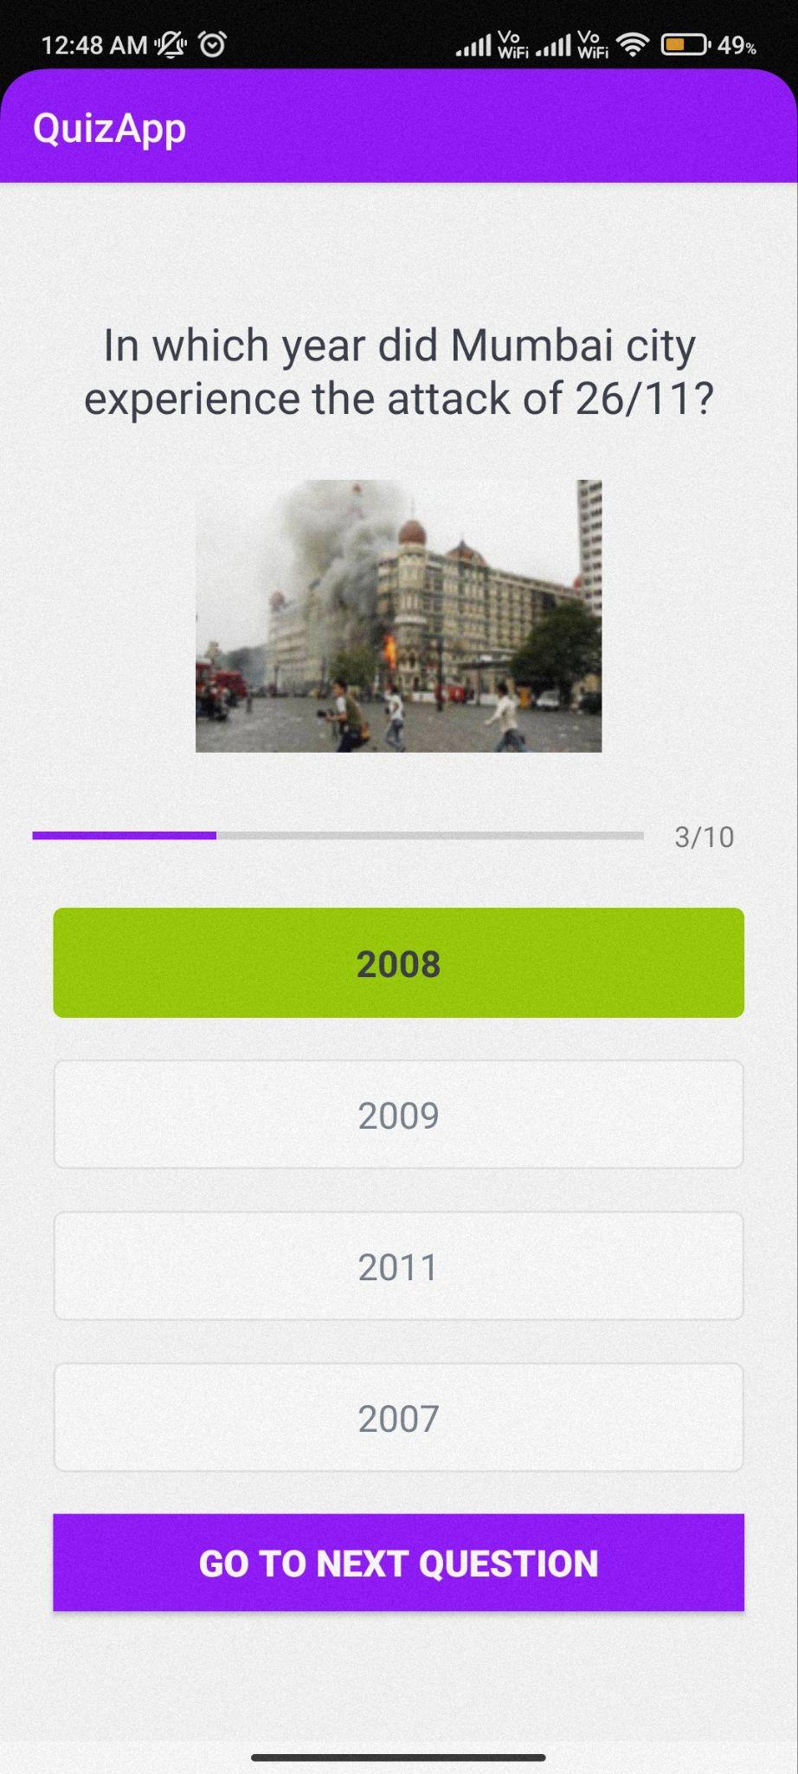 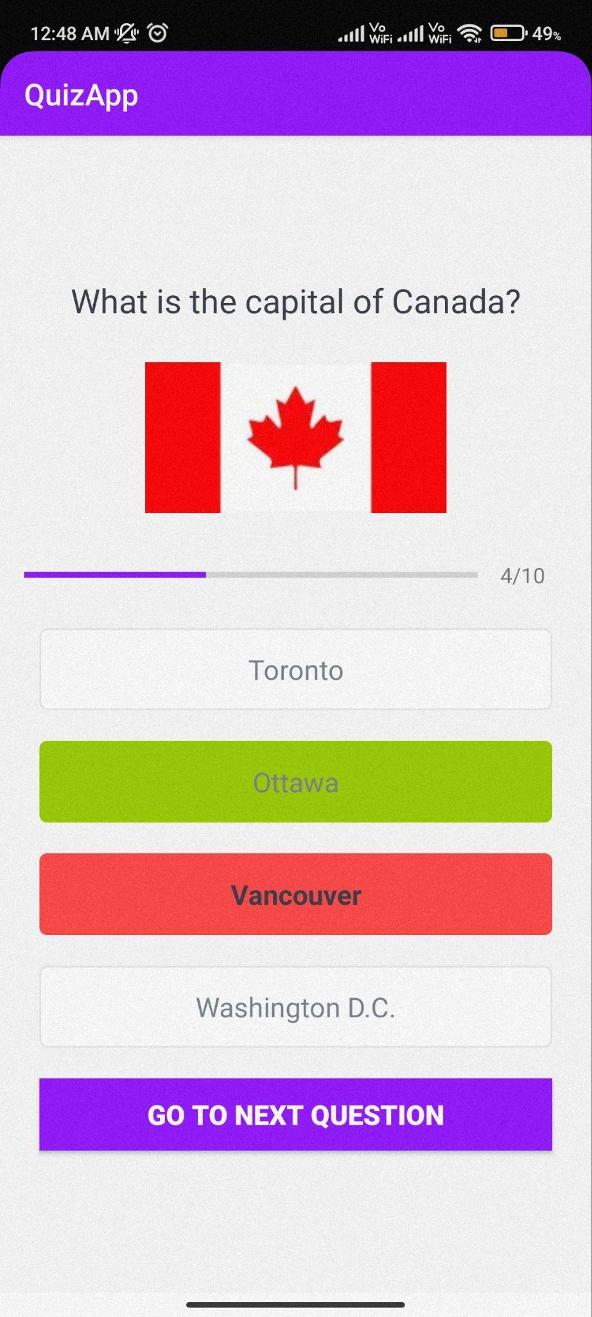

**Figure 4.2** Correct Option chosen **Figure 4.3** Incorrect Option chosen

**4.2. Final Result Page**

After answering all the questions successfully, the result page gets displayed showing the final score achieved by the user. There is also a FINISH button on this page which takes the user back to the Welcome page.

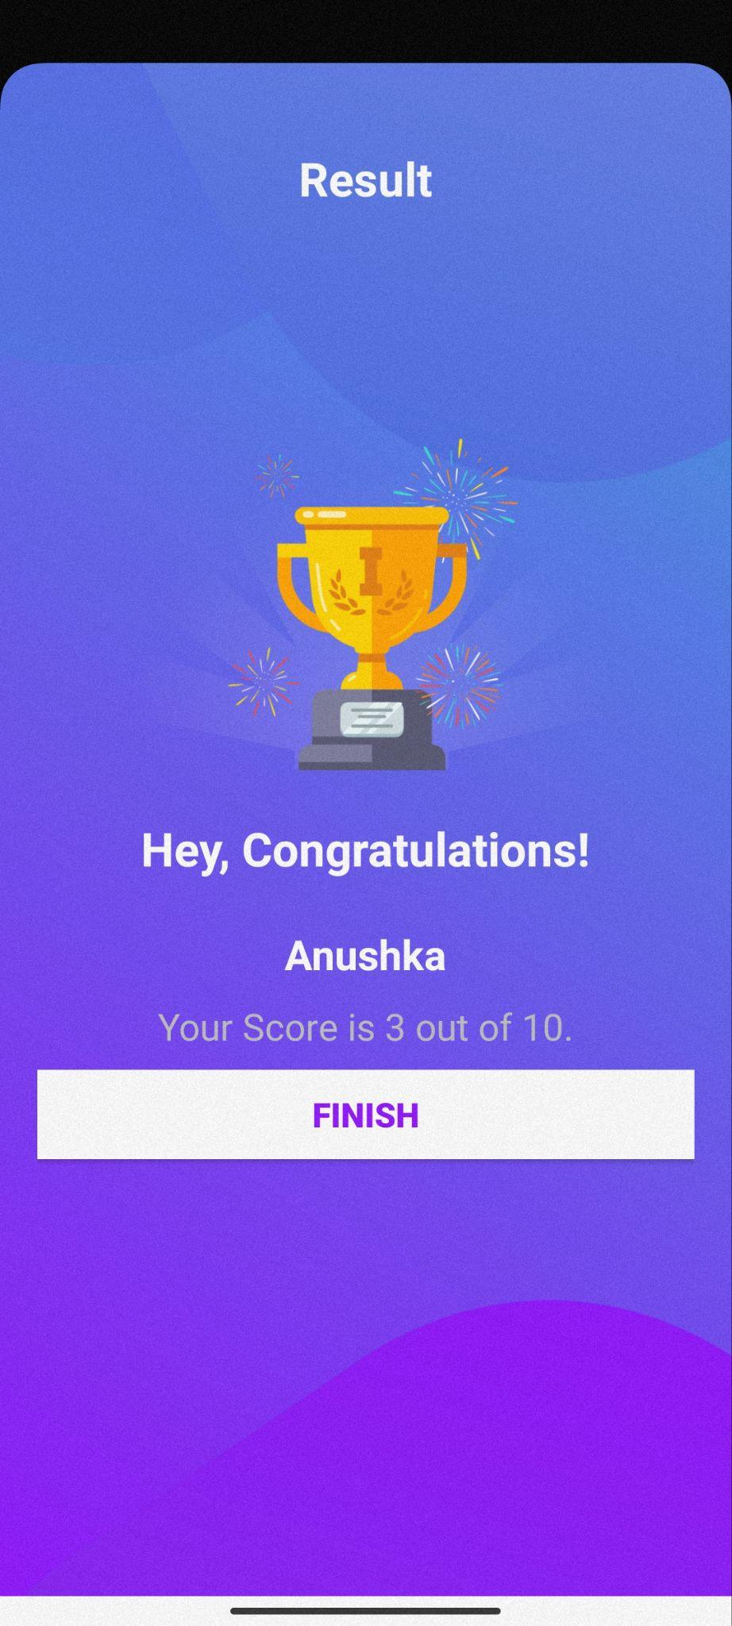

**Figure 4.4** Screenshot of the Result Page

**Chapter 5**

**Conclusion and Future Work**

**5.1. Conclusion**

The era of mobile technology has opened the windows to Android apps. Many users prefer to access information, pass time, test their knowledge, and learn new things through mobile applications in contrast to conventional websites.

To cater to the increasing demand for mobile applications, in this project, a Quiz application has been developed with the help of Android Studio using Kotlin as the programming language. This application aims to test the general knowledge of the user and promote general awareness among the mass. This project offers users to test themselves through their mobile only with a simple and attractive user interface(UI).

**5.1. Future Work**

In this project, a basic quiz application has been developed. It can be made advanced by increasing the number and diversity of questions, distributing the questions topic-wise, and

asking the users the topic they want to be tested on. We can also add a function that randomizes the questions asked to give the user a new experience every time. Some more features like a timer, leaderboard, and inviting friends can be added to the application in the future.

We can also save the answers entered by the user for their future reference by connecting the application with a database to store the necessary information of the user.

**References**

[1] Trivia Crack application [Online]: https://triviacrack.com/

[2] Kahoot! Application [Online]: https://kahoot.it/

[3] Quizlet Application [Online]: https://quizlet.com/

[4]Quiz Duel Application [Online]:

<https://play.google.com/store/apps/details?id=se.maginteractive.quizduel2&hl=en&gl=US&pli=1>

[5] Sporcle Application [Online]: <https://www.sporcle.com/>

[6] Wikipedia [Online]: https://www.wikipedia.org/