--.:..·

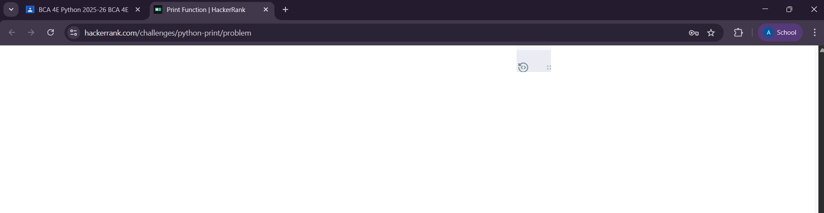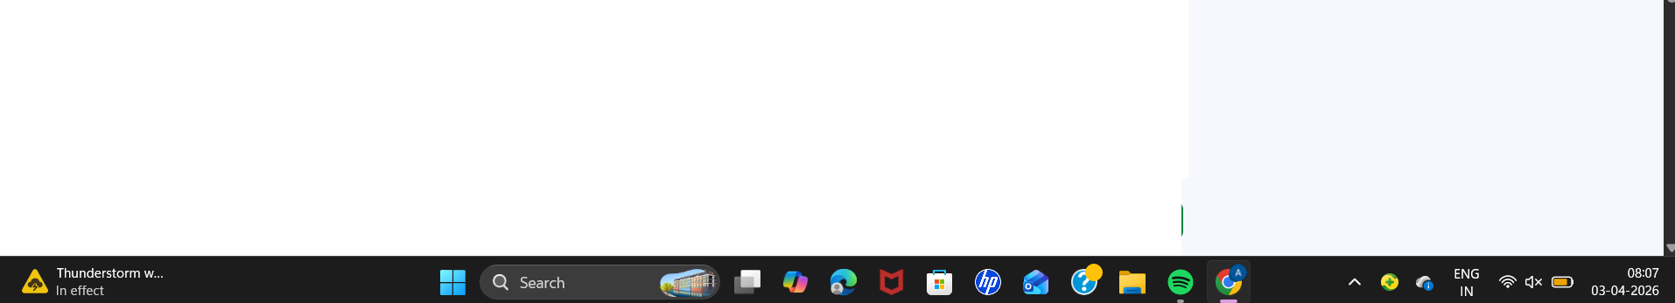
Change Theme Language Pypy 3 V •
1
2 n = int(input())
3v f[:'=o-=r i i-=n:--:r:--:a---:n---:g:--:e:-:(;--:l:--,-n-+:--:l ):--: J
print(i, end="")

Line: 3 Col: 2

( .1 UploadCodeasFile ) Test against custom input ( RunCode ) SubmitCode

Congratulations!
You have passed the sample test cases. Click the submit button to run your code against all the test cases.

0 Sample Test case 0

Input (stdin)

1 3

Download

Your Output (stdout)

1 123

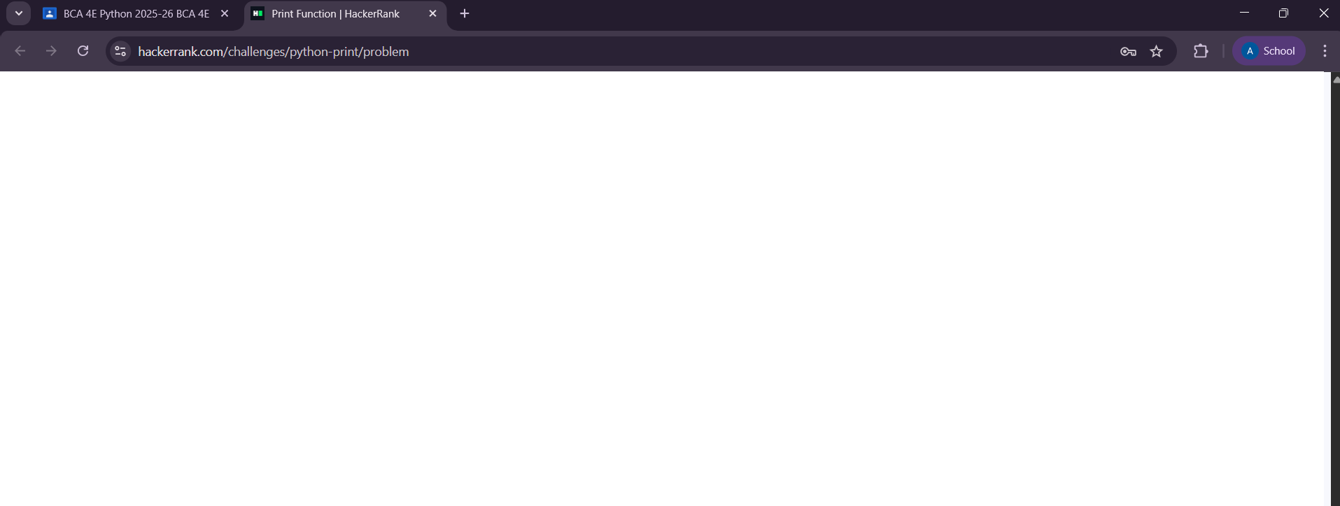Expected Output

1 123
Download

