

g government of india

Name

DOB:DD/MM/YY

FEMALE

1!HT1234 1234 1234

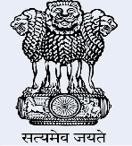

[This Photo](https://sanosanorequetesano.blogspot.com/2013/12/) by Unknown Author is licensed under [CC BY-NC-ND](https://creativecommons.org/licenses/by-nc-nd/3.0/)

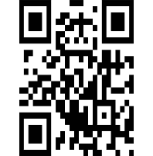

[This Photo](https://www.pngall.com/qr-code-png/) by Unknown Author is licensed under [CC BY-NC](https://creativecommons.org/licenses/by-nc/3.0/)