ANUSHKA_INDOLIKE_TASK1_GLOBAL_TEMP

ANUSHKA SHARMA

2025-02-16

library(readxl)  
data_gt <- read_excel("~/Downloads/dataset_task1_globaltemp.xlsx")  
View(data_gt)

# Load necessary libraries  
library(readxl)  
library(ggplot2)  
library(corrplot)

## Warning: package 'corrplot' was built under R version 4.3.3

## corrplot 0.95 loaded

library(forecast)

## Warning: package 'forecast' was built under R version 4.3.3

## Registered S3 method overwritten by 'quantmod':  
## method from  
## as.zoo.data.frame zoo

# Convert Year to numeric (Ensure it's a DataFrame)  
data_gt$Year <- as.numeric(data_gt$Year)  
  
# Aggregate Annual Anomaly by Year (In case of duplicates)  
annual_data <- aggregate(Annual_Anomaly ~ Year, data = data_gt, mean)  
  
# 📌 1️⃣ Annual Temperature Anomaly Over Time (Line Chart)  
ggplot(annual_data, aes(x = Year, y = Annual_Anomaly)) +  
 geom_line(color = "lightblue", size = 1) +  
 geom_point(color = "black", size = 2) +  
 labs(title = "Annual Temperature Anomaly Over Time",  
 x = "Year",  
 y = "Annual Temperature Anomaly (°C)") +  
 theme_minimal()

## Warning: Using `size` aesthetic for lines was deprecated in ggplot2 3.4.0.  
## ℹ Please use `linewidth` instead.  
## This warning is displayed once every 8 hours.  
## Call `lifecycle::last_lifecycle_warnings()` to see where this warning was  
## generated.

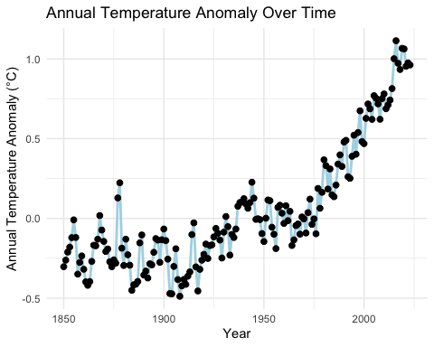

# 📌 Interpretation:  
# - If the trend is rising, it suggests global warming.  
# - Short-term fluctuations may indicate natural climate variations.  
# - Sharp peaks/dips could be linked to volcanic eruptions or El Niño events.

# 📌 2️⃣ Correlation Matrix (Heatmap)  
# Select relevant columns  
cor_data <- data_gt[, c("Monthly_Anomaly", "Annual_Anomaly", "Five_Year_Anomaly",   
 "Ten_Year_Anomaly", "Twenty_Year_Anomaly")]  
  
# Compute correlation matrix  
cor_matrix <- cor(cor_data, use = "complete.obs")  
  
# Plot Correlation Heatmap  
corrplot(cor_matrix, method = "color", col = colorRampPalette(c("pink", "white", "lightblue"))(200),  
 type = "lower", tl.col = "black", tl.srt = 45, addCoef.col = "black")

## Warning in ind1:ind2: numerical expression has 2 elements: only the first used

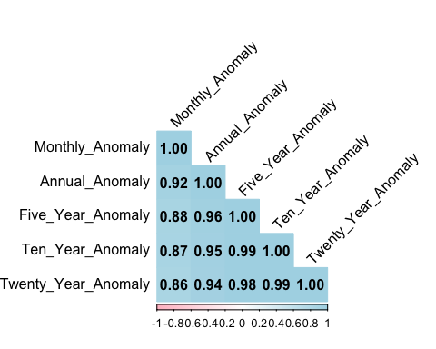

# 📌 Interpretation:  
# - Strong positive correlation (Close to 1): Indicates temperature anomalies move together.  
# - Weak correlation (Close to 0): Shows less dependency.  
# - Monthly anomalies help predict long-term trends but have fluctuations.

# 📌 3️⃣ Time Series Forecasting (ARIMA)  
# Convert to Time Series  
ts_data <- ts(annual_data$Annual_Anomaly, start = min(annual_data$Year), frequency = 1)  
  
# Fit ARIMA model  
arima_model <- auto.arima(ts_data)  
  
# Forecast for the next 20 years  
forecast_data <- forecast(arima_model, h = 20)  
  
# Plot the Forecast  
autoplot(forecast_data) +  
 labs(title = "Temperature Anomaly Forecast",  
 x = "Year",  
 y = "Predicted Temperature Anomaly (°C)")

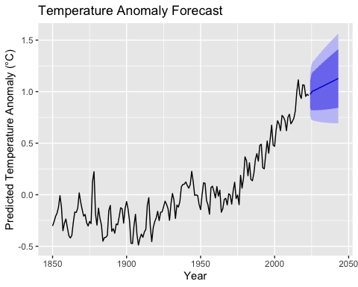

# 📌 Interpretation:  
# - If the forecast continues rising, it suggests ongoing climate change.  
# - Large uncertainty bands mean more unpredictable variations in the future.

#Goal: Check if warming is accelerating over time.  
#Method: Compute the rate of change in temperature anomalies.  
  
# Compute year-over-year change in anomaly  
annual_data$Change_Rate <- c(NA, diff(annual_data$Annual_Anomaly))  
  
# Plot Rate of Change Over Time  
ggplot(annual_data, aes(x = Year, y = Change_Rate)) +  
 geom_line(color = "pink", size = 1) +  
 geom_point(color = "black", size = 2) +  
 labs(title = "Rate of Change in Temperature Anomalies",  
 x = "Year",  
 y = "Yearly Change in Anomaly (°C)") +  
 theme_minimal()

## Warning: Removed 1 row containing missing values or values outside the scale range  
## (`geom_line()`).

## Warning: Removed 1 row containing missing values or values outside the scale range  
## (`geom_point()`).

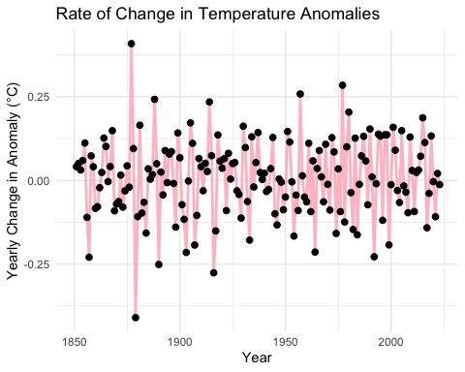

##Interpretation:  
#📈 Increasing Stability But Continued Warming:  
  
#While the year-to-year variability reduces in recent decades, it doesn’t mean climate change has stopped.  
#Instead, the long-term trend still shows a steady rise in global temperatures.  
  
#If recent years show steeper increases, global warming is accelerating.  
#If the change rate fluctuates, it indicates periodic climate variations.