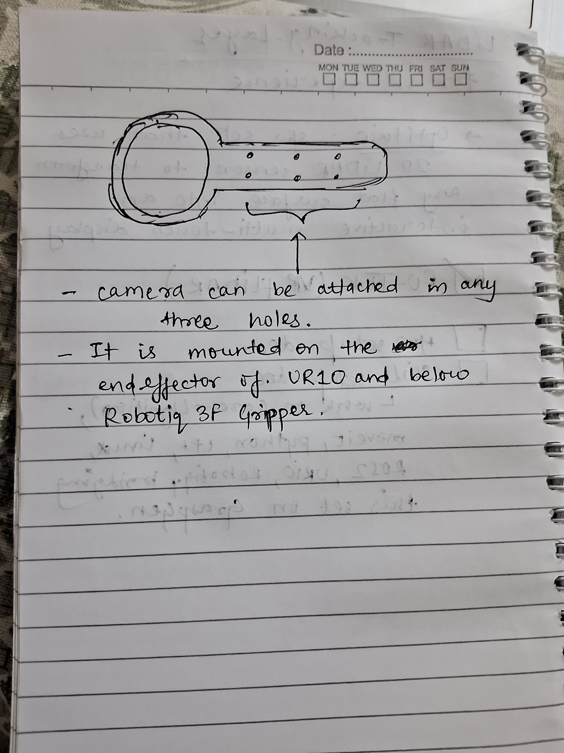
This is the diagram of 3D printed slab where camera on UR10 & Gripper is mounted!

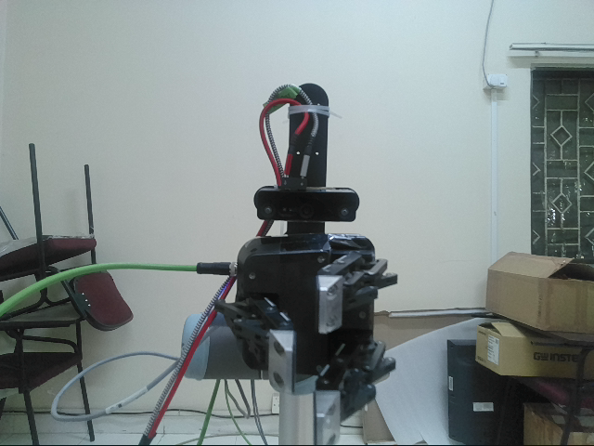

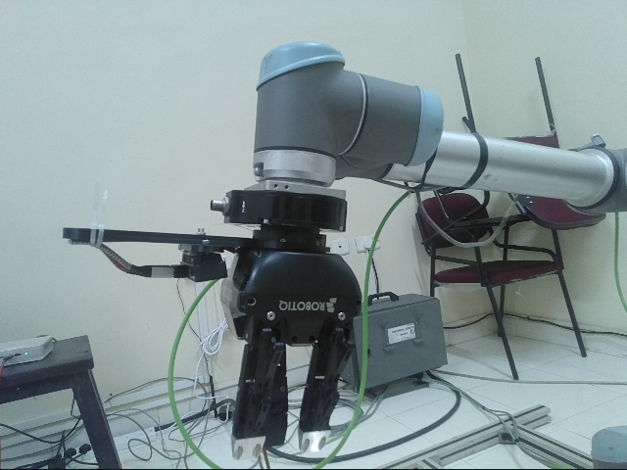
This is how it is attached on the real hardware.
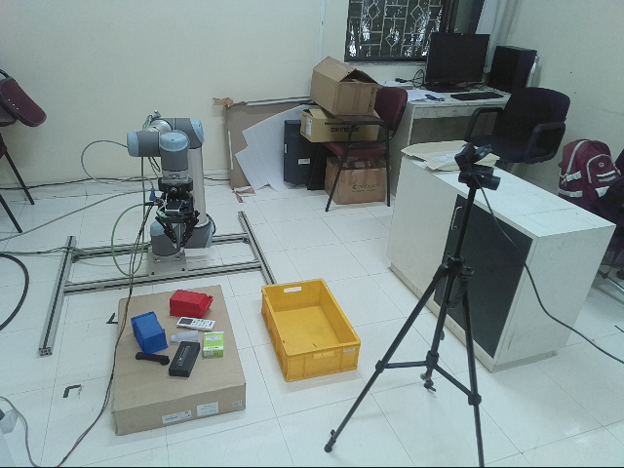
This is the whole Setup of Real hardware!

